TABLE OF CONTENTS
ABSTRACT
CHAPTER 1 INTRODUCTION
1.1 Background and Context
1.2 Problem Statement and Objectives
1.3 Scope and Project Outcomes
CHAPTER 2 LITERATURE REVIEW
2.1 Crop Yield Estimation
2.2 Remote Sensing and Vegetation Indices
2.3 Regression and Feature Fusion
CHAPTER 3 SYSTEM ANALYSIS
3.1 Existing System and Problem Analysis
3.2 Requirements and Feasibility
3.3 Data Sources and Extraction
CHAPTER 4 TECHNOLOGY STACK
4.1 Languages and Libraries
4.2 Data and Model Artifacts
CHAPTER 5 SYSTEM DESIGN
5.1 Architecture and Data Flow
5.2 State-Level Data and Image Samples
5.3 Modeling Tracks
5.4 Dashboard Design and Use Cases
CHAPTER 6 TESTING
6.1 Validation Strategy
6.2 Functional Checks
CHAPTER 7 RESULTS
7.1 Tabular Baseline
7.2 Image-Only Experiment
7.3 Paired Feature-Fusion Evaluation
7.4 Interpretation and Limitations
CHAPTER 8 CHALLENGES FACED
CHAPTER 9 CONCLUSION AND FUTURE SCOPE
REFERENCES
APPENDICES

ABSTRACT
Crop yield prediction can support historical analysis and exploratory planning when agricultural records are combined with information about soil, geography and vegetation. This completed project develops a pipeline and academic prototype for rice, maize and other crop records in India. It harmonizes tabular agricultural data, state coordinates, soil references, satellite-derived spectral summaries and stored RGB and rendered NDVI samples, while excluding production from predictors to avoid target leakage. Three experiments are kept separate: chronological tabular regression; an image-only six-channel CNN trained from scratch; and feature-level fusion that combines cached EfficientNetV2 RGB and NDVI embeddings, scaling, 10-component PCA per image modality, tabular features and a Gradient Boosting estimator. The tabular baseline achieved R² 0.6919 on its documented 68-record test cohort. The image-only test contains 13 aligned 2019 pairs and achieved R² 0.0610. In a distinct paired evaluation, fusion increased R² from 0.8232 to 0.8304, a modest gain of 0.0072; the metric summary does not report that cohort size. A Streamlit academic prototype supports data exploration, state views, stored imagery inspection and supported yield estimates. The work is complete as a project prototype, while the limited image cohort and differing evaluation populations restrict generalization.
Keywords: crop yield prediction; remote sensing; NDVI; Gradient Boosting; feature fusion; India

CHAPTER 1 INTRODUCTION

BACKGROUND AND CONTEXT
Crop yield depends on interactions among crop type, season, soil, rainfall, management practices and changing crop condition. Historical agricultural records provide broad coverage of production outcomes, while remotely sensed observations can summarize vegetation and surface reflectance. The project studies how these sources can be organized for crop-yield estimation across Indian states and how an interactive prototype can make the data and model outputs easier to inspect.

PROBLEM STATEMENT AND OBJECTIVES
A structured yield model may omit spatial crop-condition information, while image-only learning may lack management and climate context. The project therefore addresses data alignment, leakage-controlled modeling and a bounded evaluation of complementary inputs. The objectives were to prepare agricultural and reference data; compare tabular regression approaches; evaluate image-only learning on available aligned pairs; compare tabular-only and image-augmented models on their paired cohort; and implement a dashboard for academic exploration and prediction.

SCOPE AND PROJECT OUTCOMES
The completed implementation covers data preparation, model artifacts, saved metrics and a Streamlit interface. Its dashboard supports historical exploration, maps, inspection of stored imagery and selected yield estimates. It is an academic prototype, not field-level monitoring. Weather forecasting, live satellite monitoring, fertilizer recommendations and farmer login are not implemented features and are treated only as future possibilities. The main outcome is a reproducible applied comparison with explicit cohort limitations, rather than a new learning algorithm.

REPORT ORGANIZATION
Chapter 2 reviews the relevant modeling concepts. Chapter 3 analyzes the system, requirements and source data. Chapter 4 documents the technology stack. Chapter 5 explains system and model design. Chapter 6 describes validation and functional checks. Chapter 7 reports results. Chapter 8 discusses challenges. Chapter 9 concludes and lists future scope.

CHAPTER 2 LITERATURE REVIEW

CROP YIELD ESTIMATION
Yield estimation commonly uses historical crop statistics together with weather, soil and management information. Tree ensembles are useful for tabular data because they represent nonlinear relationships and interactions without requiring a strictly linear response. Random Forests average randomized trees [1], while Gradient Boosting builds an additive model by fitting successive learners to residual structure [3]. These methods provide established baselines for the project’s structured predictors.

REMOTE SENSING AND VEGETATION INDICES
Multispectral imagery observes reflected energy in several wavelength bands. Sentinel-2 provides multispectral observations suitable for land and vegetation analysis [2]. NDVI is computed from near-infrared and red reflectance and is commonly used as a vegetation greenness indicator [5]. Such measures are indirect and depend on acquisition timing, cloud filtering, spatial aggregation and preprocessing. They can complement agricultural records but do not directly encode all management conditions.

REGRESSION AND FEATURE FUSION
Feature fusion combines representations from multiple modalities before prediction. In this project, cached image embeddings are reduced with PCA and concatenated with structured variables for a tree estimator. This differs from a jointly trained CNN and tabular neural network. The design follows the broader multisensor-fusion principle that sources with different characteristics require alignment and explicit representation choices [4]. The project tests a limited paired comparison and does not treat a small metric increase as universal evidence of improvement.

PROJECT POSITIONING
The project applies established methods to a specific data pipeline. The literature supports the choice of tree regressors and vegetation indicators, while the implementation evaluates whether a reduced image representation adds predictive value to tabular inputs. It does not claim causal effects of vegetation indices, novel model architecture or operational readiness.

CHAPTER 3 SYSTEM ANALYSIS

EXISTING SYSTEM AND PROBLEM ANALYSIS
The repository contains historical crop statistics, engineering scripts, satellite-derived features and sample images. Without consistent keys and leakage checks, these sources cannot be compared reliably. In particular, production divided by area defines yield; therefore production must not be included as a predictor when yield is the target. Image availability is also sparse for the aligned CNN evaluation, requiring separate cohort reporting.

REQUIREMENTS AND FEASIBILITY
The system requires local data files, preprocessing and inference libraries, saved estimator artifacts, and a browser-based Streamlit interface. The academic scope is feasible using the repository’s historical data and local computation. The dashboard supports exploration and prediction using implemented artifacts; it does not require a live data service. The study’s research feasibility is bounded by state-level aggregation and the small image-only test cohort.
Table 3.1 Functional requirements
ID | Requirement | Implementation evidence
FR1 | Prepare and join agricultural, soil, geographic and satellite-derived records | CSV data and preprocessing pipeline
FR2 | Compare tabular regression models using chronological partitions | Saved model metrics and predictions
FR3 | Evaluate image-only prediction using aligned RGB and NDVI pairs | CNN model artifact and image test metrics
FR4 | Evaluate feature-level fusion against paired tabular inputs | Cached embeddings, PCA and Gradient Boosting artifact
FR5 | Explore data and request yield estimates in the application | Streamlit dashboard in app.py

DATA SOURCES AND EXTRACTION
The project data include crop and yield records, state centroids, state-linked soil references, satellite spectral summaries, stored RGB and rendered NDVI images, and cached image embeddings. The state-selection script filters the source crop table to Rice and Maize, normalizes state names and prints unique state lists for downstream lookup. It prepares reference keys; it does not retrieve satellite imagery. Stored samples are shown in Figure 3.2, and the extraction step is summarized in Figure 3.1.
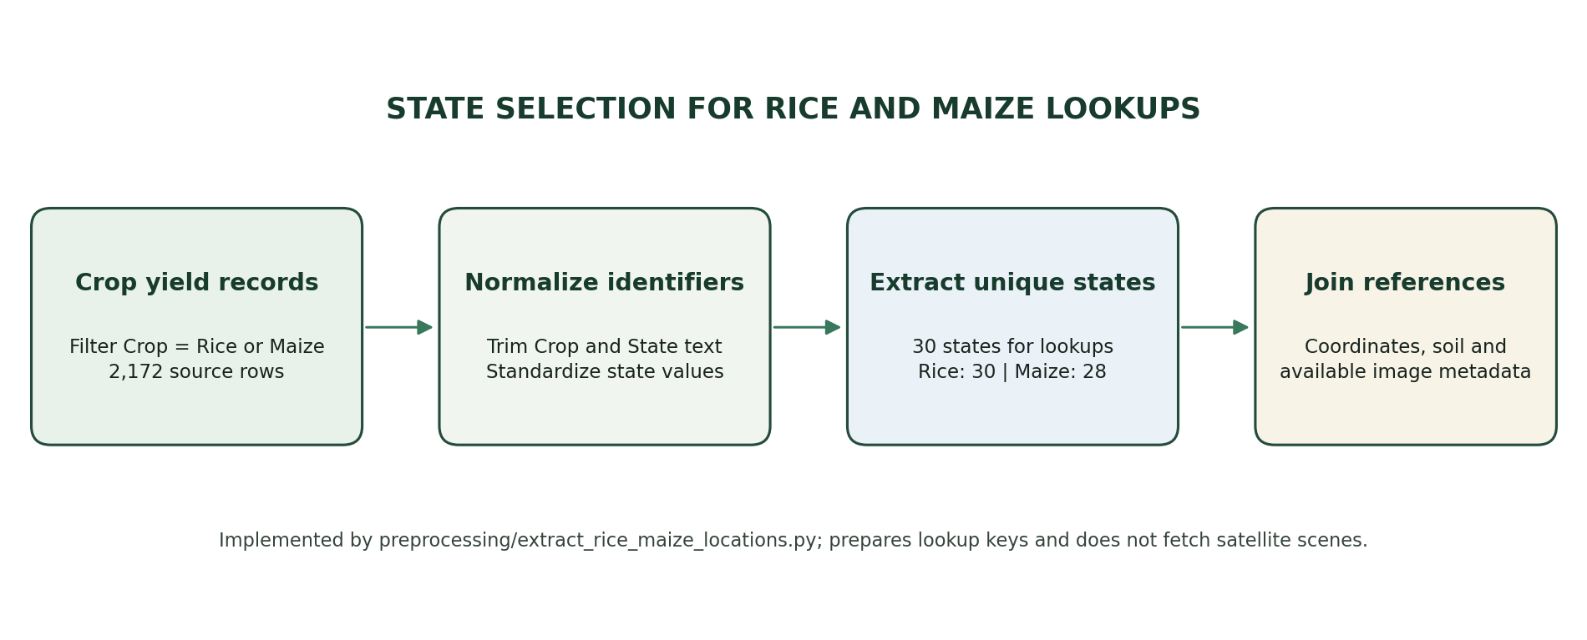
Fig. 3.1 State Selection for Rice and Maize Reference Lookup
Source: preprocessing/extract_rice_maize_locations.py; counts are taken from its output for the current crop_yield.csv file.
Table 3.2 Data modalities and project role
Data modality | Repository artifact | Role in the project
Agricultural | crop_yield.csv; modeling_dataset.csv | Crop, state, year, season, area, production, rainfall, inputs and yield
Geographic | state_coordinates.csv | Latitude and longitude for state-level display
Soil | state_soil_lookup.csv | State-linked soil profile reference values
Satellite summaries | harmonized_satellite_features.csv; sentinel2_features.csv | Spectral bands and vegetation-index summaries
Images | test_images/; CNN manifests | Stored RGB and rendered NDVI image pairs
Embeddings | embeddings/*.npy | Cached RGB and NDVI representations for fusion

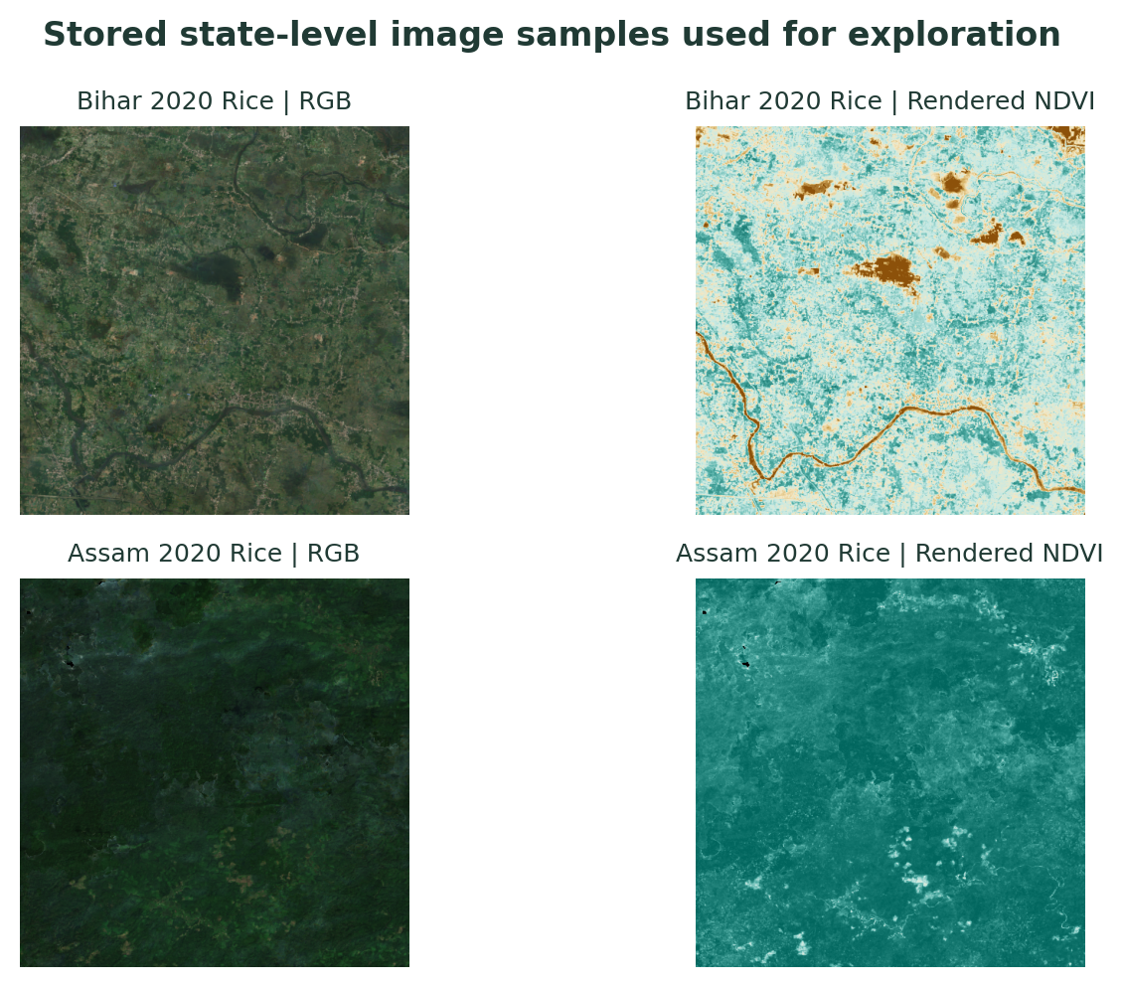
Fig. 3.2 Stored State-Level RGB and Rendered NDVI Samples
Examples from the local image archive for Bihar and Assam, 2020 rice records; shown for inspection, not live monitoring.

DATA QUALITY AND LEAKAGE CONTROLS
The documented modeling workflow removes seven implausible target rows above 15 tonnes per hectare in the broader modeling dataset and normalizes key fields. The separate tabular baseline evaluated 68 later-year test records. Production is excluded from predictor inputs because it is mathematically tied to yield and area. Chronological splits reduce the risk of using later-year information to predict earlier observations.

CHAPTER 4 TECHNOLOGY STACK

LANGUAGES AND LIBRARIES
Python is used for data preparation, model training and the application. Pandas and NumPy support tabular and numerical operations; scikit-learn provides preprocessing, regression and evaluation tools [6]. TensorFlow/Keras supports the independent image-only CNN [8]. Streamlit provides the interactive interface [7], and Plotly supports charts and spatial visualizations. Matplotlib and Pillow are used for saved diagnostic figures and image handling. Joblib persists scikit-learn estimators.
Table 4.1 Technology components
Component | Technology | Project use
Data processing | Python, pandas, NumPy | Cleaning, joining, feature preparation
Tabular and fusion models | scikit-learn | Transformations, regression, PCA and metrics
Image-only experiment | TensorFlow / Keras | Six-channel CNN training and evaluation
Dashboard | Streamlit, Plotly | Exploratory views, maps and prediction forms
Image and report figures | Pillow, Matplotlib | Image inspection and diagnostic visualizations
Model persistence | Joblib, Keras formats | Load saved estimators and CNN artifact

DATA AND MODEL ARTIFACTS
The project stores intermediate CSV files, image manifests, model objects, metric JSON files, prediction CSVs and plots under datasets/ and models/. The saved assets allow the dashboard and report to refer to completed work. Reproduction requires the corresponding compatible dependencies and repository data files.

CHAPTER 5 SYSTEM DESIGN

ARCHITECTURE AND DATA FLOW
The pipeline begins with agricultural records and reference sources, then normalizes identifiers, joins available features and constructs modeling partitions. After preparation, three modeling tracks remain distinct. The tabular track uses structured variables. The image-only track trains a CNN on paired RGB and rendered NDVI channels. The feature-fusion track loads cached EfficientNetV2 embeddings, scales them, applies separate PCA transforms with 10 components per modality, joins the resulting 20 image features with tabular inputs and fits Gradient Boosting. The dashboard presents supported exploration and prediction workflows.
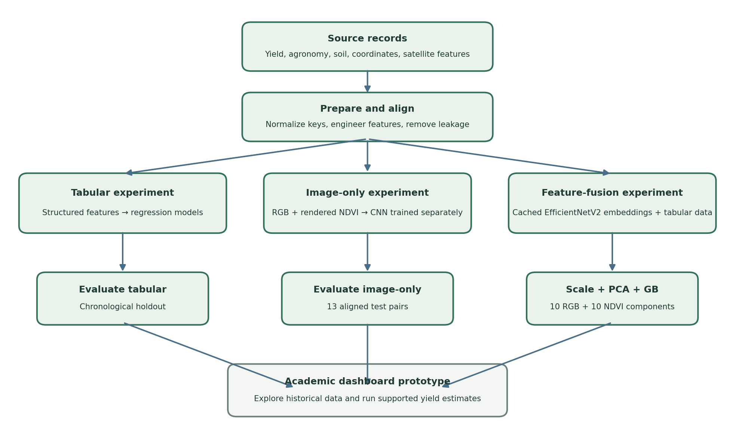
Fig. 5.1 Project Data Flow and Independent Modeling Tracks

STATE-LEVEL DATA AND IMAGE SAMPLES
State coordinates support map displays in the application. State-level image samples in Figure 3.2 allow users to inspect stored imagery alongside historical records. The interface displays archived samples and metadata; it does not fetch new scenes continuously. Consequently, a displayed image should be interpreted as a project dataset example with its associated state, crop and year, not as a current field condition.

MODELING TRACKS
Table 5.1 Implemented modeling tracks
Track | Inputs | Processing and estimator | Evaluation role
Tabular baseline | Agricultural, soil, geographic and spectral variables | Structured feature preprocessing; Gradient Boosting among compared models | Chronological baseline; 68 test records in documented experiment
Image-only CNN | Aligned RGB and rendered NDVI pairs | Six-channel 96×96 image input; CNN trained from scratch | Independent exploratory image test; 13 aligned pairs
Feature-level fusion | Cached EfficientNetV2 RGB and NDVI embeddings plus tabular features | Scaling; PCA 10+10 components; concatenated features; Gradient Boosting | Paired tabular-versus-fusion evaluation; summary omits test count

DASHBOARD DESIGN AND USE CASES
The implemented Streamlit application contains navigation for Home, Data Overview, Crop Prediction, Visualizations, Map View, Reports and Settings. It presents historical summaries, maps, stored satellite samples and yield-prediction controls. The screenshot-like panel in Figure 5.2 is an explanatory recreation of the implemented interface structure, not a captured browser screenshot. The available prediction interface is an academic demonstration and should be interpreted within the model’s data and evaluation limits.
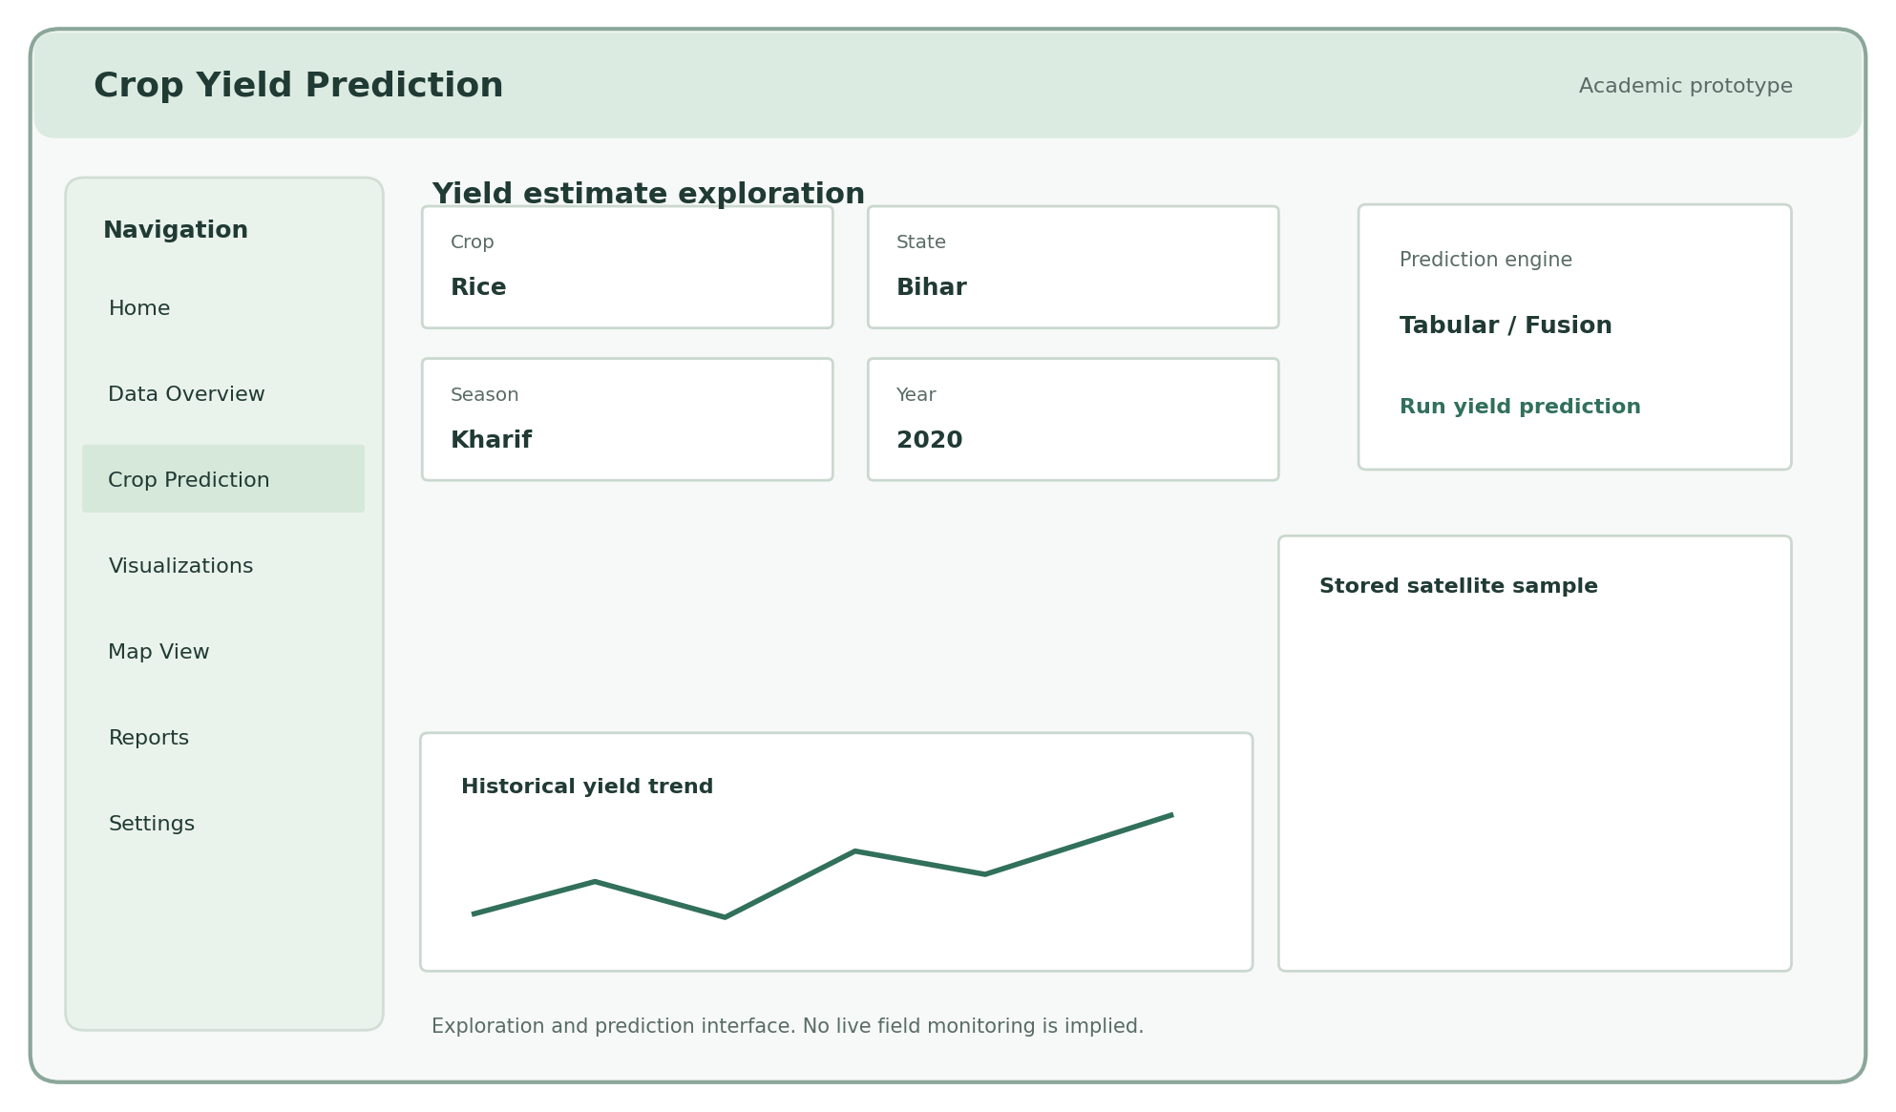
Fig. 5.2 Dashboard Layout and Supported Exploration Workflow
Illustrative recreation based on the implemented Streamlit page components; not a browser capture.
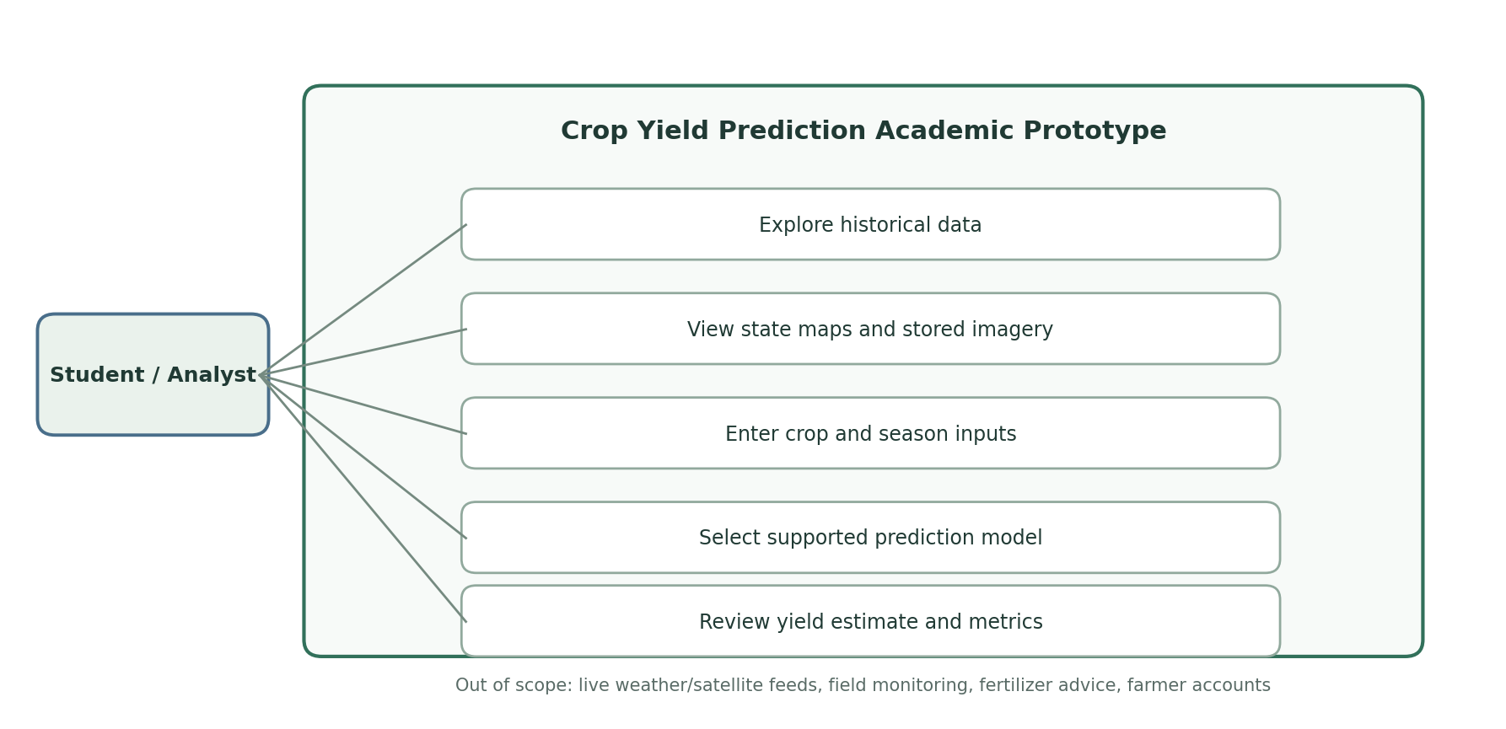
Fig. 5.3 Use Case Diagram for the Academic Prototype
Table 5.2 Dashboard use cases
Actor action | System response | Boundary
Explore historical records | Shows filtered summaries and trends | Historical project data
Inspect state and image examples | Displays state views and stored RGB/NDVI samples | No live satellite feed
Enter crop and scenario inputs | Provides supported input fields | Only implemented controls
Choose a prediction engine | Runs the selected saved model path | Tabular or implemented feature-fusion option
Review estimated yield | Shows estimate and explanatory output | Not a field-level decision or guarantee

CHAPTER 6 TESTING

VALIDATION STRATEGY
The tabular baseline uses a chronological split: training through 2016, validation in 2017–2018 and test in 2019–2020. The image-only test is restricted to 13 aligned pairs from 2019. The feature-fusion score is reported against its own paired tabular comparator. The evaluation populations differ; comparisons across those experiments are not treated as a single controlled three-way benchmark.
Table 6.1 Evaluation cohorts
Experiment | Training / validation | Test cohort | Comparison boundary
Tabular baseline | Chronological records through 2016; validation 2017–2018 | 68 records, 2019–2020 | Standalone tabular metric
Image-only CNN | Image pairs in earlier years; validation before test years | 13 aligned pairs, 2019 | Exploratory; small test sample
Feature fusion | Paired pipeline with cached embeddings and tabular values | Count not reported in saved metric summary | Compare paired tabular R² 0.8232 with fusion R² 0.8304

FUNCTIONAL CHECKS
Functional checks are based on the completed artifacts and implemented application paths: input records can be loaded, trained models and metrics are saved, stored image samples are available for inspection, and the Streamlit interface exposes data exploration and yield estimation. The report does not claim automated end-to-end test coverage beyond the evidence present in the repository.
Leakage review confirms that production is removed from the tabular predictor set. Cohort review confirms that the image-only CNN and paired fusion experiments use distinct data and pipelines. The dashboard description is limited to historical exploration, stored imagery and supported model inference.

CHAPTER 7 RESULTS

TABULAR BASELINE
On its documented chronological test cohort of 68 records, the tabular Gradient Boosting baseline achieved RMSE 0.8035 tonnes per hectare, MAE 0.5104 tonnes per hectare and R² 0.6919. Crop-level error differed between rice and maize, reflecting varying ranges and sample sizes. The feature-importance plot is descriptive of the fitted model and should not be interpreted as causal evidence.
Table 7.1 Tabular Gradient Boosting test results
Cohort | RMSE (t/ha) | MAE (t/ha) | R²
68 chronological test records | 0.8035 | 0.5104 | 0.6919

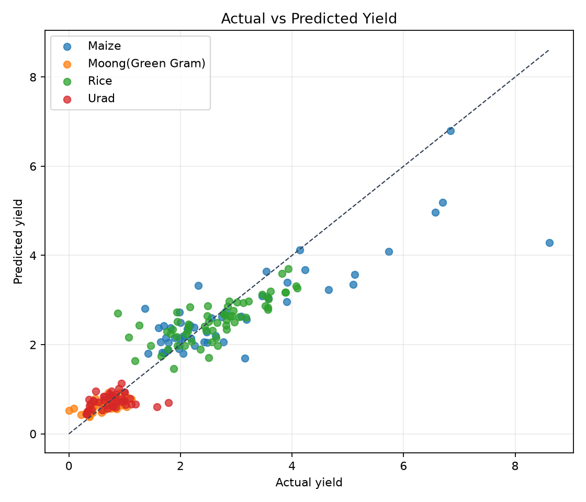
Fig. 7.1 Actual Versus Predicted Yield for the Tabular Test Set
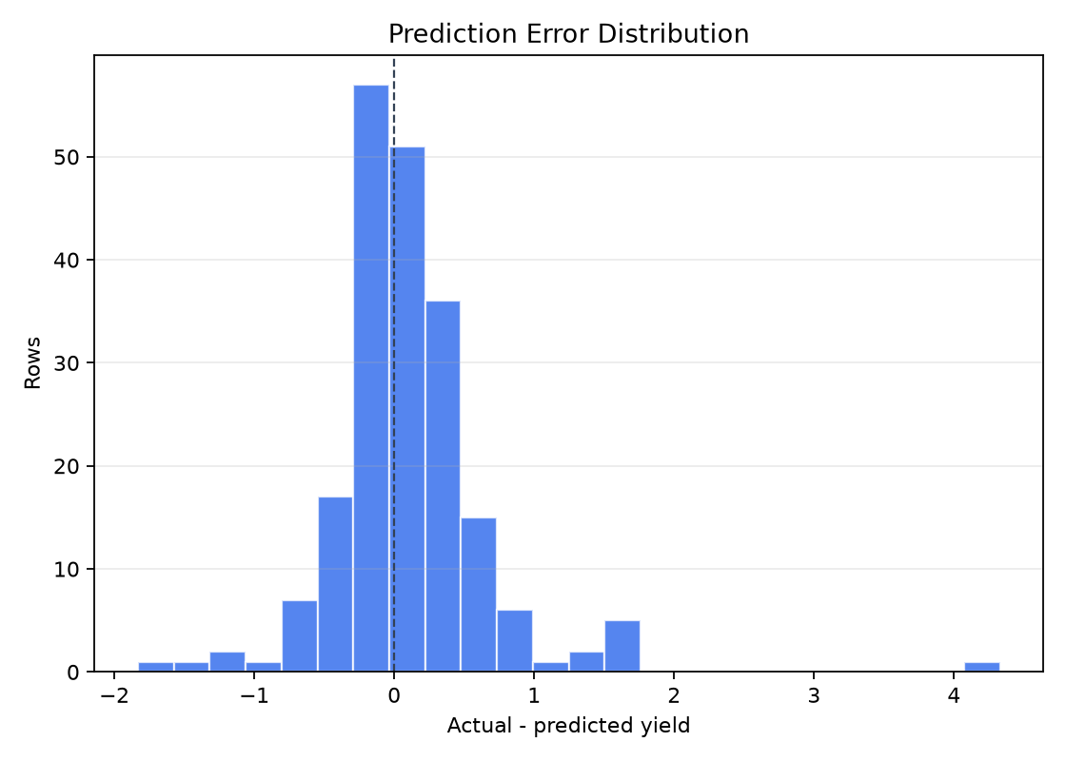
Fig. 7.2 Prediction Error Distribution for the Tabular Test Set
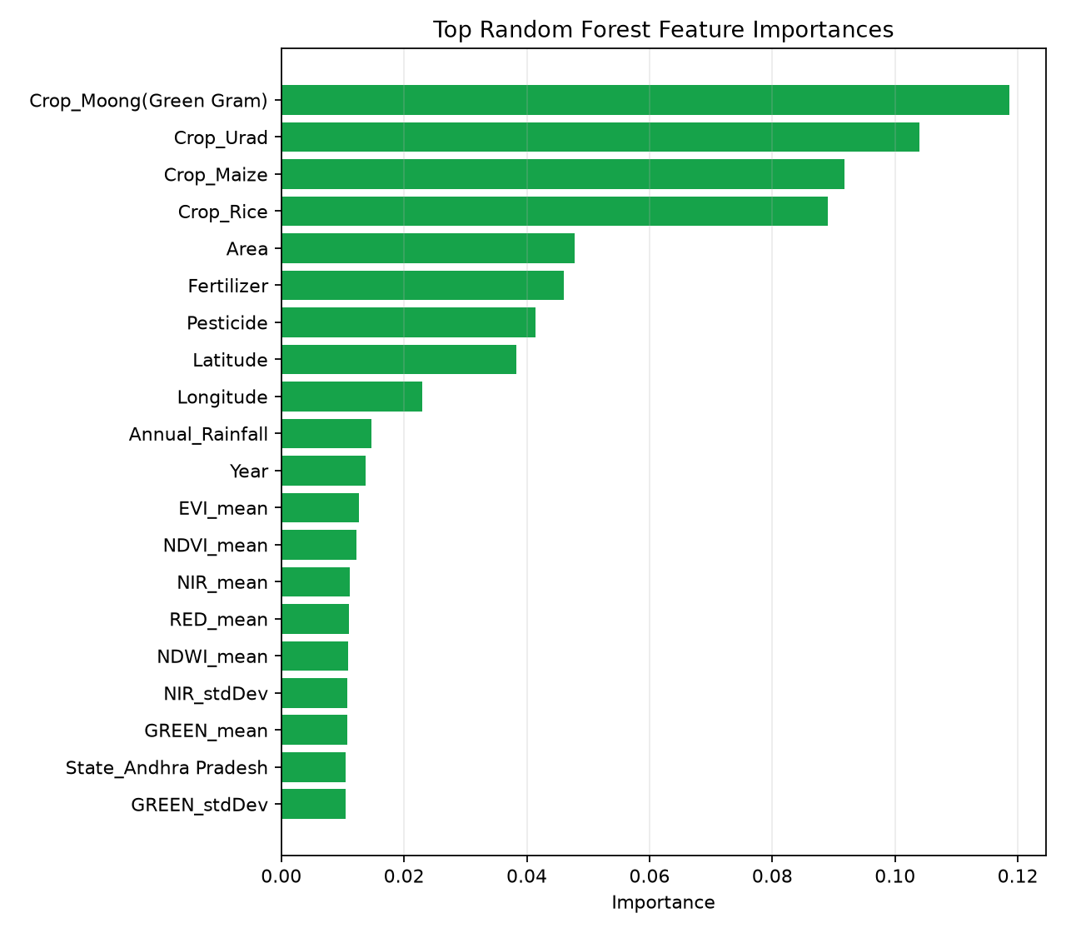
Fig. 7.3 Feature Importance for the Tabular Gradient Boosting Model

IMAGE-ONLY EXPERIMENT
The separate image-only CNN combines RGB and rendered NDVI into a six-channel input and learns from images alone. On the 13 aligned test pairs from 2019, it achieved RMSE 1.3560 tonnes per hectare, MAE 0.9282 tonnes per hectare and R² 0.0610. These values are exploratory because the test set is small and no eligible 2020 pairs were available. They do not describe the fusion model.
Table 7.2 Image-only and reference test metrics
Model and inputs | Test n | RMSE (t/ha) | MAE (t/ha) | R²
Six-channel CNN; RGB + rendered NDVI | 13 | 1.3560 | 0.9282 | 0.0610
RGB summary; Extra Trees | 13 | 1.1762 | 0.7446 | 0.2935
NDVI image summary; Extra Trees | 13 | 1.0987 | 0.7723 | 0.3836
RGB + NDVI summaries; Ridge | 13 | 1.1226 | 0.7639 | 0.3565

PAIRED FEATURE-FUSION EVALUATION
The fusion artifact uses 20 PCA-reduced image features (10 RGB and 10 NDVI) combined with tabular variables and a Gradient Boosting estimator. In the paired comparison, R² increased from 0.8232 for the tabular arm to 0.8304 for the feature-fusion arm, a difference of 0.0072. This is a modest improvement. The saved fusion metric summary does not report the test count, so precision and generalization cannot be inferred from the R² difference alone.
Table 7.3 Paired feature-fusion comparison
Model arm | Image representation | Estimator | Test R²
Paired tabular | None | Gradient Boosting | 0.8232
Feature fusion | Cached EfficientNetV2 embeddings; PCA 10 RGB + 10 NDVI components | Gradient Boosting | 0.8304
Difference | 20 reduced image features added | — | +0.0072

INTERPRETATION AND LIMITATIONS
The results show predictive signal in structured features and a small paired R² increase after adding reduced image embeddings. The image-only result is weak on its 13-pair test and is not directly comparable to the fusion evaluation. The fusion test count is missing from the saved summary. The experiments therefore support continued investigation rather than a broad claim that imagery improves yield prediction in general.
Table 7.4 Results and evidence limitations
Finding | Evidence | Interpretive limit
Tabular model has useful signal | R² 0.6919 on documented 68-record test | Specific cohort and split
Image-only learning is exploratory | 13 aligned test pairs; R² 0.0610 | Small image cohort; 2019 only
Fusion improves paired R² modestly | 0.8232 to 0.8304 | Test count absent; gain is +0.0072
Dashboard supports academic exploration | Implemented Streamlit app | Not live monitoring or field advice

CHAPTER 8 CHALLENGES FACED

DATA ALIGNMENT AND COVERAGE
The main engineering challenge was aligning heterogeneous sources with different identifiers, years, seasons and spatial support. State-level records do not perfectly describe field-level variation. Complete RGB and NDVI pairs are limited, reducing the test sample available to the image-only CNN. Some source periods and imagery products also differ in sensor and processing characteristics.

LEAKAGE AND EVALUATION DESIGN
Yield is derived from production and cultivated area, making production an invalid predictor for a yield target. The workflow excludes it to avoid target leakage. A second challenge was keeping experimental cohorts distinct: the tabular benchmark, image-only CNN and fusion comparison use different evaluation populations. The fusion artifact’s missing test count is an additional reporting limitation.

MODEL AND INTERFACE BOUNDARIES
The image-only CNN is trained from scratch with few aligned test pairs, which limits conclusions about its generalization. The feature-fusion approach uses cached embeddings and classical Gradient Boosting rather than joint end-to-end multimodal neural training. The interface brings several exploration and prediction functions together, but this does not make it a live agricultural monitoring or recommendation service.

CHAPTER 9 CONCLUSION AND FUTURE SCOPE

CONCLUSION
The project is complete as an academic crop-yield prediction prototype. It includes data preparation, leakage-aware tabular modeling, an independent image-only CNN experiment, a separate cached-embedding feature-fusion experiment, saved evaluation artifacts and a Streamlit dashboard for exploration and prediction. On its documented cohort the tabular baseline achieved R² 0.6919. The image-only test contained 13 aligned pairs and achieved R² 0.0610. The paired fusion R² increased modestly from 0.8232 to 0.8304. These findings are constrained by small and differing cohorts and the absent fusion test count.

FUTURE SCOPE
Future work can build a larger, consistently aligned image dataset; evaluate all modalities on the same chronological complete-case test set; report uncertainty intervals and exact cohort counts; and test spatial holdouts across states and years. Further work may improve calibration, investigate sensor and season effects, and refine dashboard accessibility. Live satellite or weather feeds, field-level monitoring, fertilizer recommendations and farmer accounts are possible future features only; they are not part of the completed implementation.

REFERENCES
[1] L. Breiman, “Random forests,” Machine Learning, vol. 45, no. 1, pp. 5–32, 2001, doi: 10.1023/A:1010933404324.
This article presents Random Forests, an ensemble of randomized decision trees. It is cited as background for the tabular regression model family considered in the project.
[2] European Space Agency, Sentinel-2 User Handbook. Paris, France: ESA, 2015.
The handbook describes the Sentinel-2 mission, its instrument and data products. It provides background for the satellite-derived spectral summaries and imagery referenced in the report.
[3] J. H. Friedman, “Greedy function approximation: A gradient boosting machine,” Annals of Statistics, vol. 29, no. 5, pp. 1189–1232, 2001, doi: 10.1214/aos/1013203451.
This paper develops gradient boosting as a function-approximation method. It supports the description of the Gradient Boosting estimator used in the tabular and feature-fusion experiments.
[4] H. G. Pohl and J. L. Van Genderen, “Multisensor image fusion in remote sensing: Concepts, methods and applications,” International Journal of Remote Sensing, vol. 19, no. 5, pp. 823–854, 1998, doi: 10.1080/014311698215748.
This review discusses fusion of remote-sensing observations with different properties. It provides conceptual background for aligning and combining image-derived and structured features.
[5] J. W. Rouse, R. H. Haas, J. A. Schell, and D. W. Deering, “Monitoring vegetation systems in the Great Plains with ERTS,” in Proc. 3rd Earth Resources Technology Satellite Symposium, vol. 1, pp. 309–317, 1974.
This early remote-sensing study describes vegetation monitoring using spectral observations, including the normalized difference vegetation index. It provides background for NDVI as an image-derived vegetation indicator.
[6] Scikit-learn Developers, “Ensemble methods,” scikit-learn documentation. https://scikit-learn.org/stable/modules/ensemble.html (accessed Oct. 22, 2026).
The documentation describes ensemble estimators, including Random Forest and Gradient Boosting implementations. It supports the implementation and terminology used for the project’s scikit-learn models.
[7] Streamlit, “Streamlit documentation.” https://docs.streamlit.io/ (accessed Oct. 22, 2026).
The official documentation describes Streamlit’s Python interface for interactive applications. It is referenced for the dashboard framework used in app.py.
[8] TensorFlow, “Keras: The high-level API for TensorFlow.” https://www.tensorflow.org/guide/keras (accessed Oct. 22, 2026).
The Keras guide documents model construction and training within TensorFlow. It provides background for the separate image-only CNN implementation.

APPENDICES

APPENDIX A KEY PROJECT ARTIFACTS
Table A.1 Key artifacts in the repository
Artifact | Purpose
datasets/modeling_dataset.csv | Prepared modeling table
datasets/cnn_samples.csv and image manifests | Aligned sample metadata for the image experiment
datasets/embeddings/rgb_embeddings.npy and ndvi_embeddings.npy | Cached image embeddings used for the fusion path
models/tabular_baseline_metrics.json | Tabular baseline evaluation summary
models/cnn_image_baseline_metrics.json | Image-only CNN evaluation summary
models/multimodal_best_tuned_metrics.json | Paired fusion metrics and PCA dimensions
app.py | Streamlit dashboard implementation

APPENDIX B METRIC DEFINITIONS
For n held-out observations with observed yield y and prediction ŷ, RMSE = sqrt(Σ(y−ŷ)²/n), MAE = Σ|y−ŷ|/n, and R² = 1−Σ(y−ŷ)²/Σ(y−ȳ)². RMSE and MAE are measured in tonnes per hectare when the target uses that unit. R² can be negative when predictions are worse than the test-set mean baseline.

APPENDIX C SUBMISSION DETAILS TO COMPLETE
Before printing and spiral binding, replace the bracketed candidate, enrollment number, guide, date and place fields. For group submissions, prepare a separate candidate certificate page for every student. Confirm project identification details with the department office and update the Table of Contents page numbers after final pagination.

