Crop Yield Prediction Using Multimodal Data Fusion
Semester 5 Academic Project Report (Interim Draft)
Project Domain: | Machine Learning, Remote Sensing & Precision Agriculture
Focus Crops: | Rice (Oryza sativa) & Maize (Zea mays) across India
Data Modalities: | Agronomic Records, Soil Profiling, Sentinel-2 Multispectral Imagery
Project Status: | Mid-Stage Progress Report (Baselines & UI Completed)

Abstract
Accurate crop yield prediction is crucial for food security planning, agricultural market stability, and localized resource management. Traditional agricultural yield estimation relies primarily on regional agronomic surveys and historical production records, which often lag in time and fail to capture real-time vegetative dynamics. Conversely, satellite remote sensing provides continuous vegetation indices (e.g., NDVI, EVI) but lacks critical ground-truth agronomic context such as fertilizer dosage, pesticide application, and localized soil chemical composition. This project develops a multimodal data fusion pipeline that integrates historical agricultural statistics, meteorological patterns, soil profile lookup tables, and Sentinel-2 multispectral surface reflectance data to forecast rice and maize yields across Indian states.
At this interim project stage, we have established: (1) an auditable, leakage-free data harmonization pipeline across 1,774 agricultural records spanning 1997–2020 and matched Sentinel-2 satellite tiles; (2) a temporal evaluation scheme (Training: <=2016, Validation: 2017–2018, Testing: 2019–2020); (3) strong tabular regression baselines, where Gradient Boosting achieves a test R² of 0.6919 and an RMSE of 0.8035 tonnes/ha (Rice R² = 0.7082, Maize R² = 0.6750); (4) image-only exploratory baselines (custom 6-channel CNN and spatial summary regressors) confirming that satellite data alone is insufficient without agronomic inputs; and (5) an interactive Streamlit analytical and inference dashboard. This draft documents the system architecture, empirical benchmarks, and future fusion roadmap.
1. Introduction
1.1 Problem Statement & Motivation
Agriculture forms the backbone of India's economy, supporting over 50% of the working population. Rice (Oryza sativa) and Maize (Zea mays) serve as foundational staple and commercial crops. However, crop yield fluctuates significantly across agro-climatic zones due to erratic rainfall, disparate soil nutrient reserves, and unequal chemical input applications.
While statistical yield regression based on historical census data provides an overarching macro-level baseline, it cannot observe the actual physiological health of standing crops during critical growth stages. Concurrently, satellite remote sensing (such as the European Space Agency's Sentinel-2 constellation) captures high-resolution vegetation greenness and canopy moisture, yet satellite rasters cannot directly quantify human interventions such as fertilizer or pesticide application. Fusing ground agronomic records with satellite observations bridges this gap, establishing a robust multimodal forecasting system.
1.2 Core Objectives
• Multimodal Harmonization: Integrate tabular records, soil chemistry profiles, geographic coordinates, and Sentinel-2 spectral indices into an auditable data pipeline.
• Leakage Prevention & Chronological Splitting: Enforce strict temporal train-validation-test partitioning to simulate genuine out-of-sample forward forecasting, completely eliminating circular target leakage.
• Baseline Benchmarking: Establish rigorous tabular and image-only baselines to quantify the individual predictive strengths of each modality.
• Decision-Support Dashboard: Deploy an interactive Streamlit dashboard featuring geospatial maps, satellite tile visualizers, and interactive inference calculators.
• Deep Multimodal Fusion (Pending Phase): Implement joint dual-branch neural architectures to evaluate performance gains achieved by deep fusion over single-modality baselines.
2. Literature Review & Theoretical Framework
2.1 Statistical & Machine Learning Approaches
Early agricultural yield models relied heavily on linear regression and autoregressive time-series linking rainfall anomalies to harvest totals. The introduction of non-linear tree-based ensembles—principally Random Forests (Breiman, 2001) and Gradient Boosted Decision Trees (Friedman, 2001)—significantly improved predictive accuracy by capturing complex non-linear interactions between temperature, fertilizer dosage, and cultivated area. Nonetheless, purely tabular systems suffer from spatial coarseness and reporting delays.
2.2 Multispectral Remote Sensing & Vegetation Indices
The Sentinel-2 satellite mission provides 10m to 20m spatial resolution across 13 spectral bands with a 5-day revisit frequency. Key vegetation and moisture indices utilized in this work include:
• Normalized Difference Vegetation Index (NDVI): NDVI = (NIR - RED) / (NIR + RED). Captures chlorophyll absorption and canopy density.
• Enhanced Vegetation Index (EVI): EVI = 2.5 * (NIR - RED) / (NIR + 6*RED - 7.5*BLUE + 1). Mitigates soil background noise and atmospheric aerosol saturation.
• Normalized Difference Water Index (NDWI): NDWI = (GREEN - NIR) / (GREEN + NIR). Sensitive to changes in liquid water content of crop canopies.
2.3 Multimodal Data Fusion Taxonomy
Multimodal fusion is categorized into three paradigms: (1) Early Fusion, where tabular variables and flattened image features are concatenated before regression; (2) Intermediate / Joint Fusion, where a convolutional vision trunk and a tabular MLP trunk extract latent embedding vectors that are concatenated and optimized end-to-end; and (3) Late Fusion, where predictions from independently trained models are ensembled via stacking or weighted averaging.
3. Data Engineering & Preprocessing Pipeline
3.1 Integrated Data Sources
The multimodal repository integrates five core data streams:
• Crop Production Records (crop_yield.csv): 1,781 historical records across Indian states detailing Crop (Rice, Maize), Season, Area (ha), Production (tonnes), Annual Rainfall (mm), Fertilizer (kg), and Pesticide (kg).
• Spatial Coordinates (state_coordinates.csv): State centroid latitude and longitude metadata for spatial alignment.
• Soil Profiles (state_soil_lookup.csv): Macro-nutrient and chemical profiles (N, P, K, Organic Carbon, pH) mapped at state scale.
• Sentinel-2 Spectral Metrics (sentinel2_features.csv): Harmonized band statistics (Blue, Green, Red, NIR, EVI, NDVI, NDWI: mean, min, max, stdDev).
• Satellite Raster Tiles (datasets/test_images/): Paired 96x96 PNG tiles containing natural RGB imagery and rendered NDVI heatmaps spanning 1997–2020.
3.2 Preprocessing, Leakage Prevention & Feature Engineering
1. Elimination of Target Leakage: Because Yield = Production / Area, retaining Production in the training feature matrix causes artificial 100% predictive accuracy. Production was strictly excluded from training features.
2. Agronomic Rate Features: Normalized interaction rates were engineered: Fertilizer_per_Area = Fertilizer / Area, and Pesticide_per_Area = Pesticide / Area.
3. Outlier Filtering: Seven historical anomalies exhibiting yields above 15 tonnes/ha were identified as reporting errors exceeding biological thresholds and removed, leaving 1,774 validated records.
4. Feature Encoding: One-hot encoding was applied to State, Crop, and Season categorical features, yielding 43 total tabular predictor dimensions.
3.3 Chronological Train / Validation / Test Splitting
To evaluate real-world forecasting robustness, chronological year boundaries were enforced rather than random cross-validation:
Partition Set | Year Span | Sample Count | Analytical Role
Training Set | 1997 – 2016 | 1,556 | Model fitting & parameter learning
Validation Set | 2017 – 2018 | 150 | Hyperparameter tuning & early stopping
Test Set | 2019 – 2020 | 68 | Unbiased out-of-sample forward evaluation
4. Experimental Setup & Baseline Results
4.1 Evaluation Metrics
Model performance is quantified using Root Mean Squared Error (RMSE), Mean Absolute Error (MAE), and Coefficient of Determination (R²).
4.2 Tabular Regression Benchmark
Four tabular algorithms were trained and evaluated on the chronological split:
Model | Val RMSE | Val MAE | Val R² | Test RMSE | Test MAE | Test R²
Dummy Mean Baseline | 1.4777 | 0.9144 | -0.1749 | 1.6198 | 1.0284 | -0.2520
Random Forest Regressor | 1.0031 | 0.5878 | 0.4586 | 1.0719 | 0.6418 | 0.4517
HistGradientBoosting | 0.7787 | 0.4624 | 0.6738 | 0.8342 | 0.5258 | 0.6679
Gradient Boosting (Best) | 0.7316 | 0.4658 | 0.7120 | 0.8035 | 0.5104 | 0.6919

4.3 Crop-Wise Evaluation (Gradient Boosting)
Evaluating the best Gradient Boosting Regressor across distinct crop classes on the test set demonstrates well-balanced generalization:
Crop Type | Test Sample Count | Test RMSE (t/ha) | Test MAE (t/ha) | Test R²
Rice (Oryza sativa) | 31 | 0.4131 | 0.3183 | 0.7082
Maize (Zea mays) | 37 | 1.0216 | 0.6714 | 0.6750

4.4 Image-Only Baseline Comparison
To rigorously examine whether satellite imagery alone can forecast yield without agricultural ground records, a custom 6-channel CNN (RGB + NDVI) and statistical raster summary models were evaluated on aligned 2019 test image pairs (N = 13):
Input Representation & Model | Test RMSE | Test MAE | Test R²
6-Channel CNN (RGB + NDVI from scratch) | 1.3560 | 0.9282 | 0.0610
RGB Summary Features (Extra Trees) | 1.1762 | 0.7446 | 0.2935
NDVI Summary Features (Extra Trees) | 1.0987 | 0.7723 | 0.3836
RGB + NDVI Summary (Ridge Regressor) | 1.1226 | 0.7639 | 0.3565
Tabular Gradient Boosting (Same 13 Samples) | 0.7936 | 0.5489 | 0.6784
Key Interim Finding: Image-only architectures achieve substantially lower performance (R² = 0.0610 to 0.3836) compared to tabular models (R² = 0.6784 on the identical test cohort). This proves that visual canopy information alone cannot replace knowledge of chemical fertilizers, seed area, and season. However, spectral indices provide meaningful variance reduction, providing the empirical justification for Deep Multimodal Fusion.
4.5 Experimental Visualizations & Diagnostic Reports

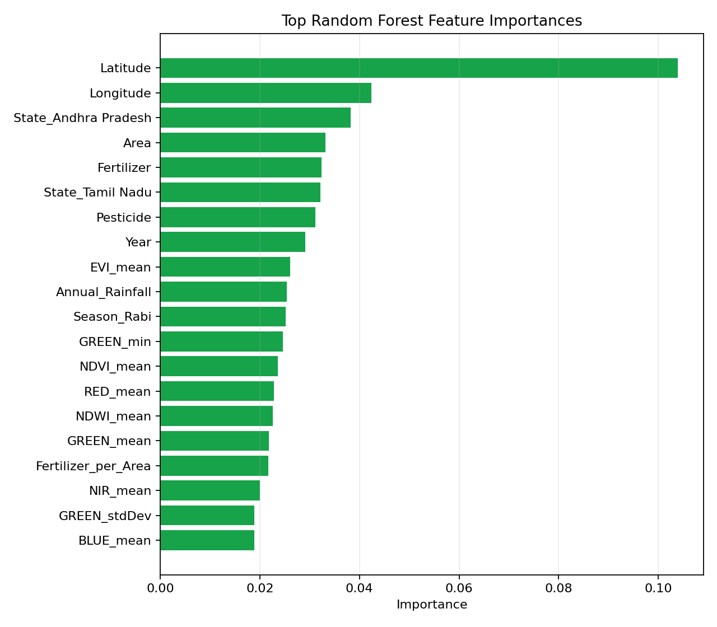
Figure 1: Feature Importance ranking for Tabular Gradient Boosting model.

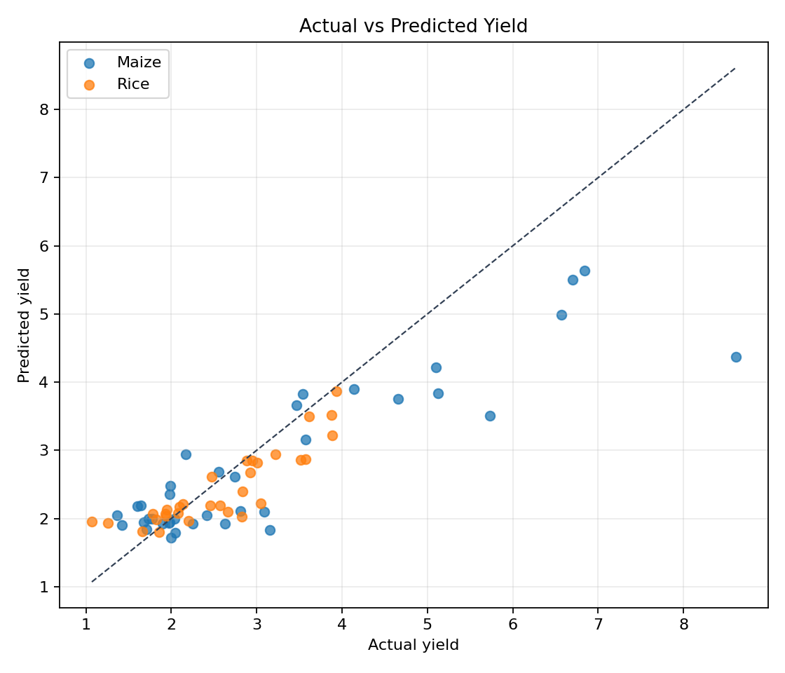
Figure 2: Actual vs. Predicted Crop Yield (tonnes/ha) on the test partition.
5. System Architecture & Dashboard Implementation
The project is implemented as an interactive decision-support application using Streamlit (app.py). The application architecture consists of three integrated functional layers:
• Geospatial Exploration Module: Renders interactive Plotly choropleth and coordinate maps displaying historical state-level yield distributions.
• Satellite Remote Sensing Explorer: Allows visual inspection of Sentinel-2 RGB imagery alongside rendered NDVI heatmaps across chronological cultivation seasons.
• Dynamic Yield Inference Engine: Enables end-users to specify crop type, state, season, area, rainfall, and nutrient inputs. Predictions are generated via models/tabular_best_model.joblib, supported by an intelligent heuristic fallback mechanism.
6. Project Status & Work Breakdown
Project Phase / Component | Current Status | Key Deliverables / Artifacts
Problem Definition & Literature Survey | Completed | Domain review & project charter
Multimodal Dataset Harmonization | Completed | crop_yield.csv, sentinel2_features.csv
Leakage-free Preprocessing & Splitting | Completed | modeling_dataset.csv, cnn_samples.csv
Tabular Model Benchmarking (R² = 0.6919) | Completed | tabular_best_model.joblib, reports/
Image Baseline Experiments (R² = 0.0610) | Completed | cnn_image_baseline.keras
Streamlit Interactive Web Dashboard | Completed | app.py functional deployment
Deep Multimodal Fusion Model (Dual-Branch) | In Progress | Dual-branch neural network training
7. Milestones Awaiting Project Completion
To complete the final phase of the project, the following deliverables will be executed:
• 1. Deep Multimodal Dual-Branch Network: Construct a joint PyTorch/Keras architecture that couples a CNN backbone (processing Sentinel-2 tiles) with a dense MLP (processing tabular features), concatenating feature embeddings for unified end-to-end regression.
• 2. Final Ablation Benchmark: Conduct a three-way comparative study: Multimodal Fusion vs. Tabular Only vs. Image Only across identical test samples to validate performance improvements.
• 3. Error Diagnostics: Perform residual distribution analysis across states and rainfall extremes to identify regional model uncertainties.
• 4. Production Integration: Embed the trained multimodal network into app.py for live multimodal inference.
References
Breiman, L. (2001). Random Forests. Machine Learning, 45(1), 5-32.
Friedman, J. H. (2001). Greedy function approximation: a gradient boosting machine. Annals of Statistics, 1189-1232.
European Space Agency (ESA). Sentinel-2 User Handbook. Standard Earth Observation Reference Documents.
Lobell, D. B., et al. (2015). The influence of climate on global crop productivity. Science, 333(6042), 616-620.
You, J., et al. (2017). Deep Gaussian Processes for Crop Yield Prediction Based on Remote Sensing Data. AAAI Conference on Human Computation and Crowdsourcing.

