**WEEK 3**

**Spring Core and Maven**

**Exercise 1: Configuring a Basic Spring Application**

**Code1: pom.xml**

<project xmlns="http://maven.apache.org/POM/4.0.0"

xmlns:xsi="http://www.w3.org/2001/XMLSchema-instance"

xsi:schemaLocation="http://maven.apache.org/POM/4.0.0

https://maven.apache.org/xsd/maven-4.0.0.xsd">

<modelVersion>4.0.0</modelVersion>

<groupId>com.library</groupId>

<artifactId>LibraryManagement</artifactId>

<version>1.0-SNAPSHOT</version>

<dependencies>

<!-- Spring Core -->

<dependency>

<groupId>org.springframework</groupId>

<artifactId>spring-context</artifactId>

<version>5.3.32</version>

</dependency>

</dependencies>

<build>

<plugins>

<!-- Plugin to run the app -->

<plugin>

<groupId>org.codehaus.mojo</groupId>

<artifactId>exec-maven-plugin</artifactId>

<version>3.1.0</version>

<configuration>

<mainClass>com.library.MainApp</mainClass>

</configuration>

</plugin>

</plugins>

</build>

</project>

**Code 2: applicationContext.xml**

<?xml version="1.0" encoding="UTF-8"?>

<beans xmlns="http://www.springframework.org/schema/beans"

xmlns:xsi="http://www.w3.org/2001/XMLSchema-instance"

xsi:schemaLocation="

http://www.springframework.org/schema/beans

http://www.springframework.org/schema/beans/spring-beans.xsd">

<!-- Repository Bean -->

<bean id="bookRepository" class="com.library.repository.BookRepository" />

<!-- Service Bean with DI -->

<bean id="bookService" class="com.library.service.BookService">

<property name="bookRepository" ref="bookRepository" />

</bean>

</beans>

**Code 3: MainApp.java**

package com.library;

import org.springframework.context.ApplicationContext;

import org.springframework.context.support.ClassPathXmlApplicationContext;

import com.library.service.BookService;

public class MainApp {

public static void main(String[] args) {

ApplicationContext context = new ClassPathXmlApplicationContext("applicationContext.xml");

BookService bookService = (BookService) context.getBean("bookService");

bookService.addBook("The Great Gatsby");

}

}

**Code 4: BookService.java**

package com.library.service;

import com.library.repository.BookRepository;

public class BookService {

private BookRepository bookRepository;

public void setBookRepository(BookRepository bookRepository) {

this.bookRepository = bookRepository;

}

public void addBook(String bookName) {

System.out.println("Adding book: " + bookName);

bookRepository.saveBook(bookName);

}

}

**Code 5: BookRepository.java**

package com.library.repository;

public class BookRepository {

public void saveBook(String bookName) {

System.out.println("Book '" + bookName + "' saved to the database.");

}

}

**Output:**

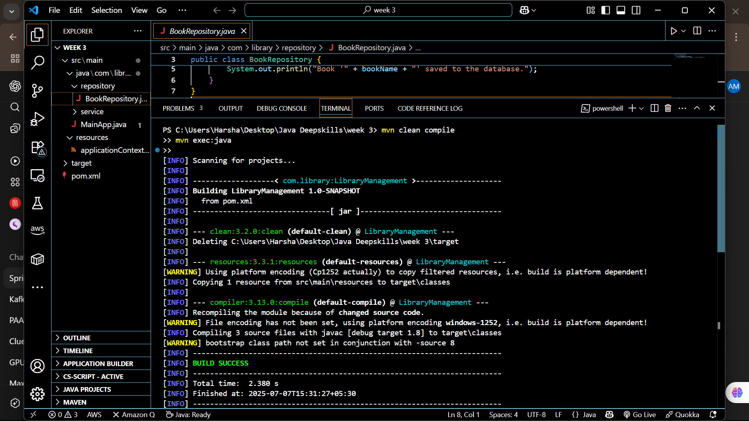

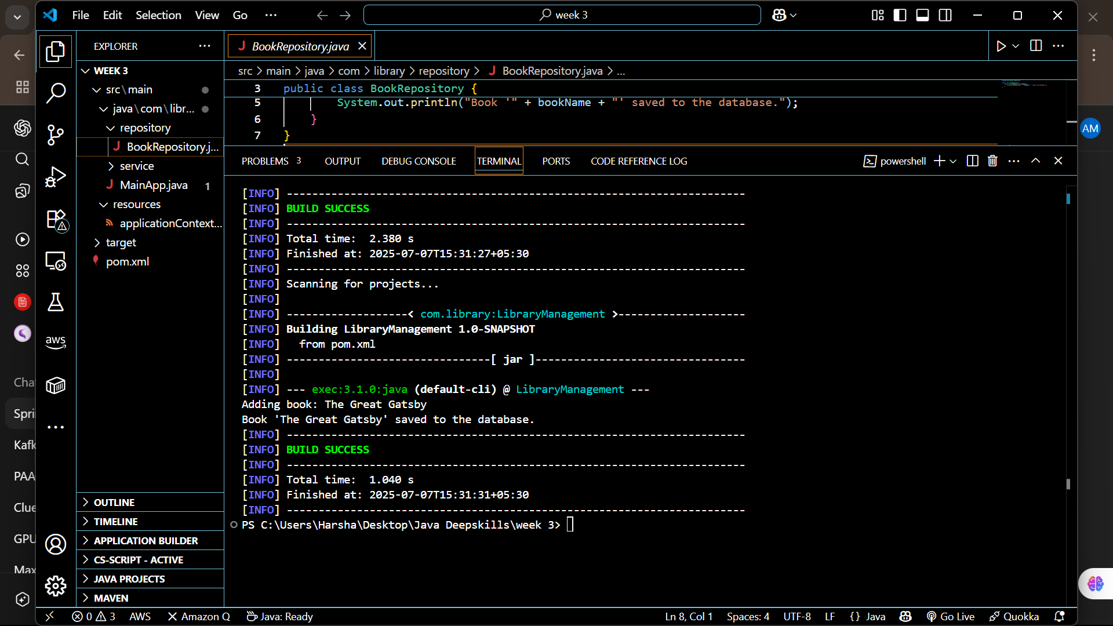

**Exercise 2: Implementing Dependency Injection**

**Code 1: pom.xml**

<project xmlns="http://maven.apache.org/POM/4.0.0"

xmlns:xsi="http://www.w3.org/2001/XMLSchema-instance"

xsi:schemaLocation="http://maven.apache.org/POM/4.0.0

http://maven.apache.org/xsd/maven-4.0.0.xsd">

<modelVersion>4.0.0</modelVersion>

<groupId>com.example</groupId>

<artifactId>LibraryManagement</artifactId>

<version>1.0-SNAPSHOT</version>

<properties>

<maven.compiler.source>1.8</maven.compiler.source>

<maven.compiler.target>1.8</maven.compiler.target>

</properties>

<dependencies>

<!-- Spring Core -->

<dependency>

<groupId>org.springframework</groupId>

<artifactId>spring-core</artifactId>

<version>5.3.33</version>

</dependency>

<!-- Spring Context -->

<dependency>

<groupId>org.springframework</groupId>

<artifactId>spring-context</artifactId>

<version>5.3.33</version>

</dependency>

<!-- Spring Beans -->

<dependency>

<groupId>org.springframework</groupId>

<artifactId>spring-beans</artifactId>

<version>5.3.33</version>

</dependency>

</dependencies>

<build>

<plugins>

<!-- Plugin to run main class -->

<plugin>

<groupId>org.codehaus.mojo</groupId>

<artifactId>exec-maven-plugin</artifactId>

<version>3.1.0</version>

<configuration>

<mainClass>com.example.library.LibraryManagementApplication</mainClass>

</configuration>

</plugin>

</plugins>

</build>

</project>

**Code 2: BookRepository.java**

package com.example.library.repository;

public class BookRepository {

public void printAllBooks() {

System.out.println("Printing all books...");

}

}

**Code 3: BookService.java**

package com.example.library.service;

import com.example.library.repository.BookRepository;

public class BookService {

private BookRepository bookRepository;

// Setter for dependency injection

public void setBookRepository(BookRepository bookRepository) {

this.bookRepository = bookRepository;

}

public void listBooks() {

bookRepository.printAllBooks();

}

}

**Code 4: applicationContext.xml**

<?xml version="1.0" encoding="UTF-8"?>

<beans xmlns="http://www.springframework.org/schema/beans"

xmlns:xsi="http://www.w3.org/2001/XMLSchema-instance"

xsi:schemaLocation="http://www.springframework.org/schema/beans

http://www.springframework.org/schema/beans/spring-beans.xsd">

<bean id="bookRepository" class="com.example.library.repository.BookRepository" />

<bean id="bookService" class="com.example.library.service.BookService">

<property name="bookRepository" ref="bookRepository" />

</bean>

</beans>

**Code 5: LibraryManagementApplication.java**

package com.example.library;

import com.example.library.service.BookService;

import org.springframework.context.ApplicationContext;

import org.springframework.context.support.ClassPathXmlApplicationContext;

public class LibraryManagementApplication {

public static void main(String[] args) {

ApplicationContext context = new ClassPathXmlApplicationContext("applicationContext.xml");

BookService bookService = context.getBean("bookService", BookService.class);

bookService.listBooks();

}

}

**Output:**

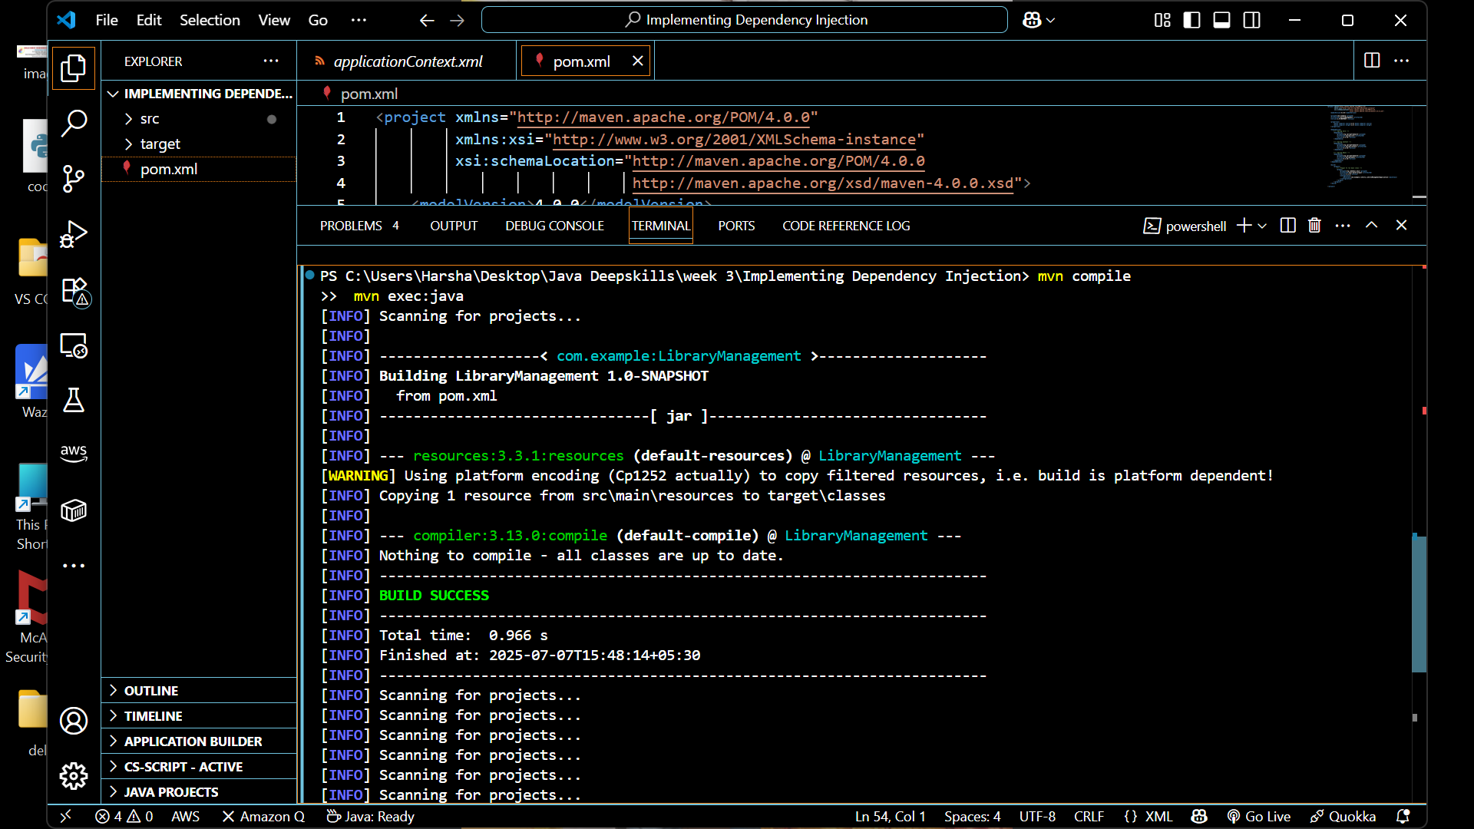

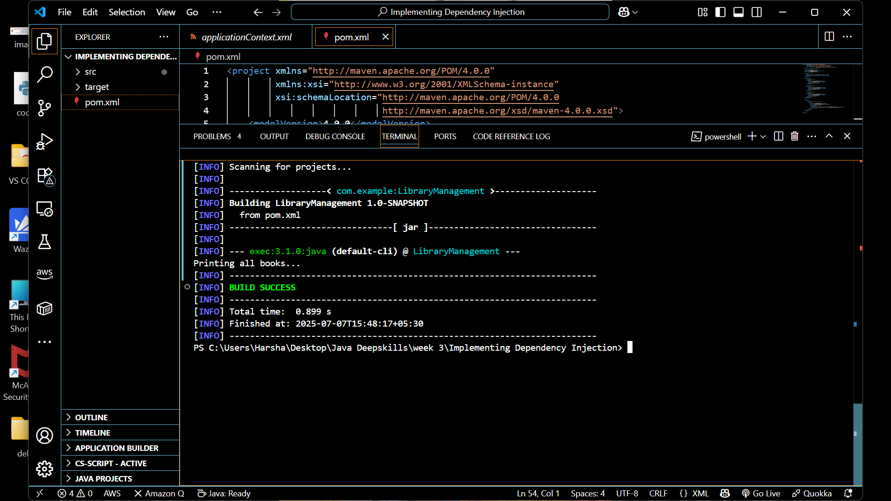

**Exercise 4: Creating and Configuring a Maven Project**

**Code 1: pom.xml**

<project xmlns="http://maven.apache.org/POM/4.0.0"

xmlns:xsi="http://www.w3.org/2001/XMLSchema-instance"

xsi:schemaLocation="http://maven.apache.org/POM/4.0.0

http://maven.apache.org/xsd/maven-4.0.0.xsd">

<modelVersion>4.0.0</modelVersion>

<groupId>com.example</groupId>

<artifactId>LibraryManagement</artifactId>

<version>1.0-SNAPSHOT</version>

<properties>

<maven.compiler.source>1.8</maven.compiler.source>

<maven.compiler.target>1.8</maven.compiler.target>

</properties>

<dependencies>

<!-- Spring Core -->

<dependency>

<groupId>org.springframework</groupId>

<artifactId>spring-core</artifactId>

<version>5.3.33</version>

</dependency>

<!-- Spring Context -->

<dependency>

<groupId>org.springframework</groupId>

<artifactId>spring-context</artifactId>

<version>5.3.33</version>

</dependency>

<!-- Spring Beans -->

<dependency>

<groupId>org.springframework</groupId>

<artifactId>spring-beans</artifactId>

<version>5.3.33</version>

</dependency>

</dependencies>

<build>

<plugins>

<!-- Plugin to run main class -->

<plugin>

<groupId>org.codehaus.mojo</groupId>

<artifactId>exec-maven-plugin</artifactId>

<version>3.1.0</version>

<configuration>

<mainClass>com.example.library.LibraryManagementApplication</mainClass>

</configuration>

</plugin>

</plugins>

</build>

</project>

**Code 2: BookRepository.java**

package com.example.library.repository;

public class BookRepository {

public void printAllBooks() {

System.out.println("Printing all books...");

}

}

**Code 3 : BookService.java**

package com.example.library.service;

import com.example.library.repository.BookRepository;

public class BookService {

private BookRepository bookRepository;

// Setter for dependency injection

public void setBookRepository(BookRepository bookRepository) {

this.bookRepository = bookRepository;

}

public void listBooks() {

bookRepository.printAllBooks();

}

}

**Code 4: LibraryManagementApplication.java**

package com.example.library;

import com.example.library.service.BookService;

import org.springframework.context.ApplicationContext;

import org.springframework.context.support.ClassPathXmlApplicationContext;

public class LibraryManagementApplication {

public static void main(String[] args) {

ApplicationContext context = new ClassPathXmlApplicationContext("applicationContext.xml");

BookService bookService = context.getBean("bookService", BookService.class);

bookService.listBooks();

}

}

**Code 5 : applicationContext.xml**

<?xml version="1.0" encoding="UTF-8"?>

<beans xmlns="http://www.springframework.org/schema/beans"

xmlns:xsi="http://www.w3.org/2001/XMLSchema-instance"

xsi:schemaLocation="http://www.springframework.org/schema/beans

http://www.springframework.org/schema/beans/spring-beans.xsd">

<bean id="bookRepository" class="com.example.library.repository.BookRepository" />

<bean id="bookService" class="com.example.library.service.BookService">

<property name="bookRepository" ref="bookRepository" />

</bean>

</beans>

**Output:**

