**WEEK 6**

**ReactJS**

1. **Create a new React Application with the name “myfirstreact”, Run the application to print “welcome to the first session of React” as heading of that page.**

**Code1: index.html**

<!DOCTYPE html>

<html lang="en">

<head>

<meta charset="utf-8" />

<meta name="viewport" content="width=device-width, initial-scale=1" />

<title>My First React App</title>

</head>

<body>

<div id="root"></div>

</body>

</html>

**Code2: App.js**

import React from 'react';

function App() {

return (

<div>

<h1>Welcome to the first session of React</h1>

</div>

);

}

export default App;

**Code3: index.js**

import React from 'react';

import ReactDOM from 'react-dom/client';

import App from './App';

const root = ReactDOM.createRoot(document.getElementById('root'));

root.render(

<React.StrictMode>

<App />

</React.StrictMode>

);

**Output:**

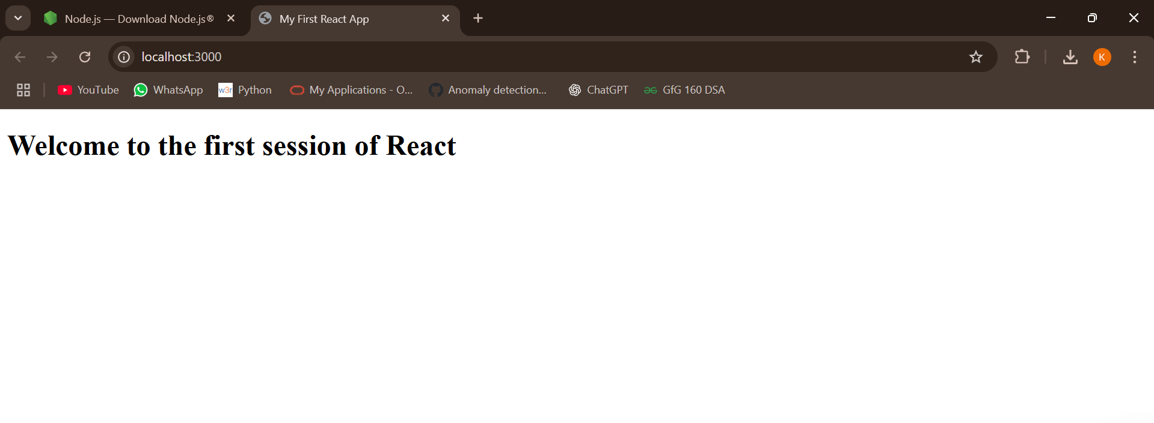

1. **Create a react app for Student Management Portal named StudentApp and create a component named Home which will display the Message “Welcome to the Home page of Student Management Portal”. Create another component named About and display the Message “Welcome to the About page of the Student Management Portal”. Create a third component named Contact and display the Message “Welcome to the Contact page of the Student Management Portal”. Call all the three components.**

**Code1:index.html**

<!DOCTYPE html>

<html lang="en">

<head>

<meta charset="utf-8" />

<meta name="viewport" content="width=device-width, initial-scale=1" />

<title>Student Management Portal</title>

</head>

<body>

<div id="root"></div>

</body>

</html>

**Code2: App.js**

import React from 'react';

import Home from './Components/Home';

import About from './Components/About';

import Contact from './Components/Contact';

function App() {

return (

<div>

<Home />

<About />

<Contact />

</div>

);

}

export default App;

**Code3: index.js**

import React from 'react';

import ReactDOM from 'react-dom/client';

import App from './App';

const root = ReactDOM.createRoot(document.getElementById('root'));

root.render(

<React.StrictMode>

<App />

</React.StrictMode>

);

**Output:**

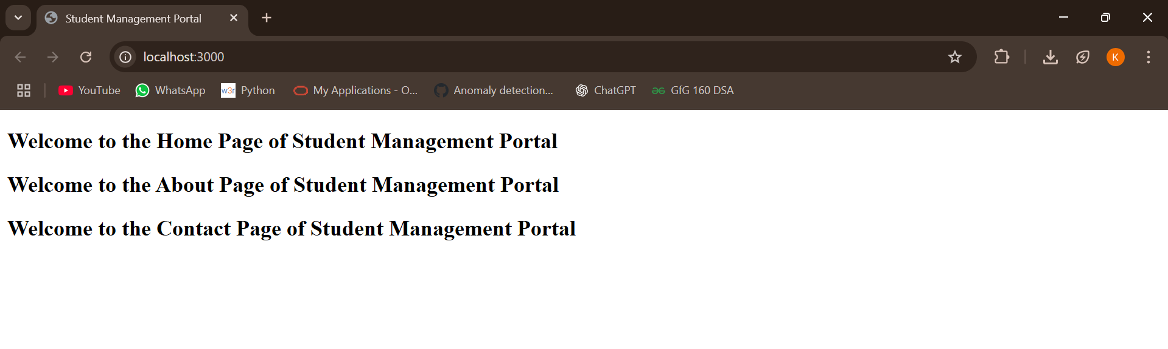

1. **Create a react app for Student Management Portal named scorecalculatorapp and create a function component named “CalculateScore” which will accept Name, School, Total and goal in order to calculate the average score of a student and display the same.**

**Code1: index.html**

<!DOCTYPE html>

<html lang="en">

<head>

<meta charset="utf-8" />

<meta name="viewport" content="width=device-width, initial-scale=1" />

<title>Score Calculator App</title>

</head>

<body>

<div id="root"></div>

</body>

</html>

**Code2: App.js**

import React from 'react';

import CalculateScore from './Components/CalculateScore';

function App() {

return (

<div className="App">

<CalculateScore

name="John Doe"

school="ABC High School"

total={450}

goal={5}

/>

</div>

);

}

export default App;

**Code3: index.js**

import React from 'react';

import ReactDOM from 'react-dom/client';

import App from './App';

const root = ReactDOM.createRoot(document.getElementById('root'));

root.render(

<React.StrictMode>

<App />

</React.StrictMode>

);

**Code4: CalculatorScore.js**

import React from 'react';

import '../Stylesheets/mystyle.css';

function CalculateScore(props) {

const average = props.total / props.goal;

return (

<div className="score-container">

<h2>Student Score Calculator</h2>

<p><strong>Name:</strong> {props.name}</p>

<p><strong>School:</strong> {props.school}</p>

<p><strong>Total Score:</strong> {props.total}</p>

<p><strong>Goal:</strong> {props.goal}</p>

<p><strong>Average Score:</strong> {average}</p>

</div>

);

}

export default CalculateScore;

**Output:**

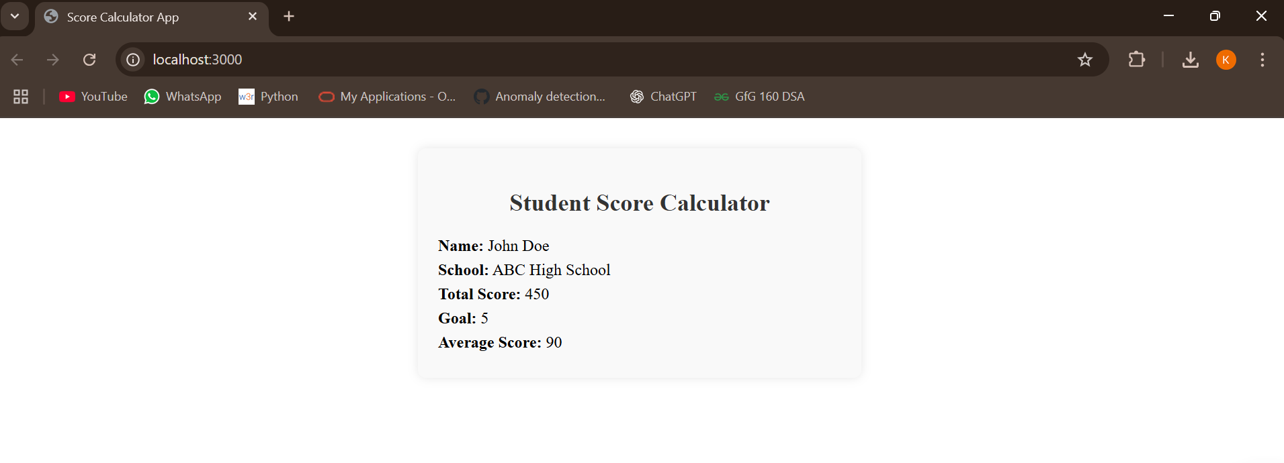

**4.Create a new react application using *create-react-app* tool with the name as “blogapp”.**

**Code1: index.html**

<!DOCTYPE html>

<html lang="en">

<head>

<meta charset="utf-8" />

<meta name="viewport" content="width=device-width, initial-scale=1" />

<title> Blog App </title>

</head>

<body>

<div id="root"></div>

</body>

</html>

**Code2: App.js**

import React from 'react';

import Posts from './Posts';

function App() {

return (

<div className="App">

<Posts />

</div>

);

}

export default App;

**Code3: index.js**

import React from 'react';

import ReactDOM from 'react-dom/client';

import App from './App';

const root = ReactDOM.createRoot(document.getElementById('root'));

root.render(

<React.StrictMode>

<App />

</React.StrictMode>

);

**Code4: post.js**

import React from 'react';

class Post extends React.Component {

render() {

return (

<div className="post">

<h3>{this.props.title}</h3>

<p>{this.props.body}</p>

</div>

);

}

}

export default Post;

**Code5: posts.js**

import React, { Component } from 'react';

import Post from './Post';

class Posts extends Component {

constructor(props) {

super(props);

this.state = {

posts: [],

error: null

};

}

loadPosts() {

fetch('https://jsonplaceholder.typicode.com/posts')

.then(response => response.json())

.then(data => this.setState({ posts: data }))

.catch(error => this.setState({ error }));

}

componentDidMount() {

this.loadPosts();

}

componentDidCatch(error, info) {

alert('An error occurred: ' + error);

this.setState({ error });

}

render() {

return (

<div>

<h2>Blog Posts</h2>

{this.state.posts.map(post => (

<Post key={post.id} title={post.title} body={post.body} />

))}

</div>

);

}

}

export default Posts;

**Output:**

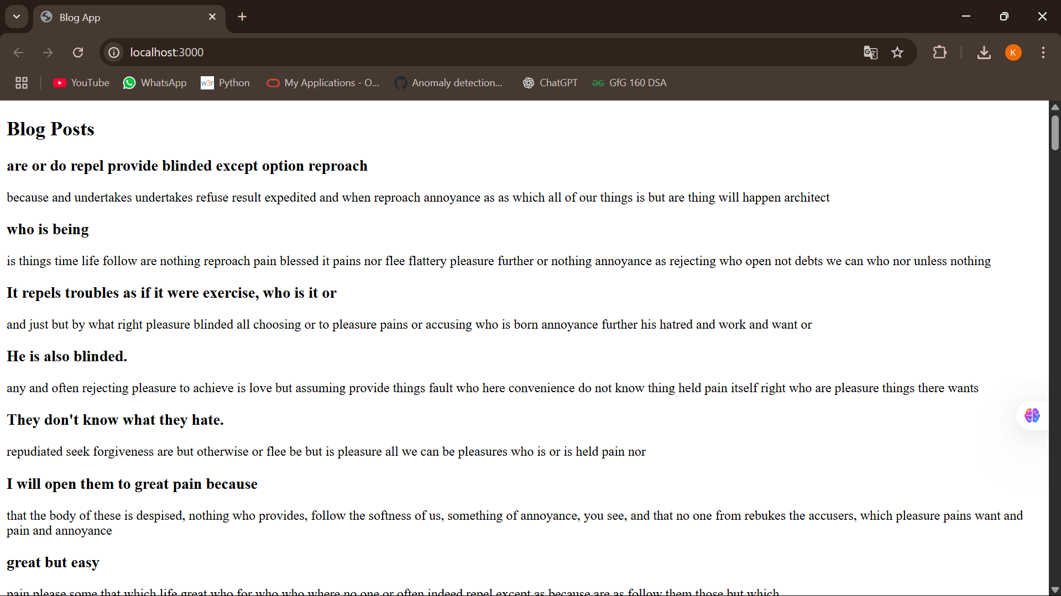

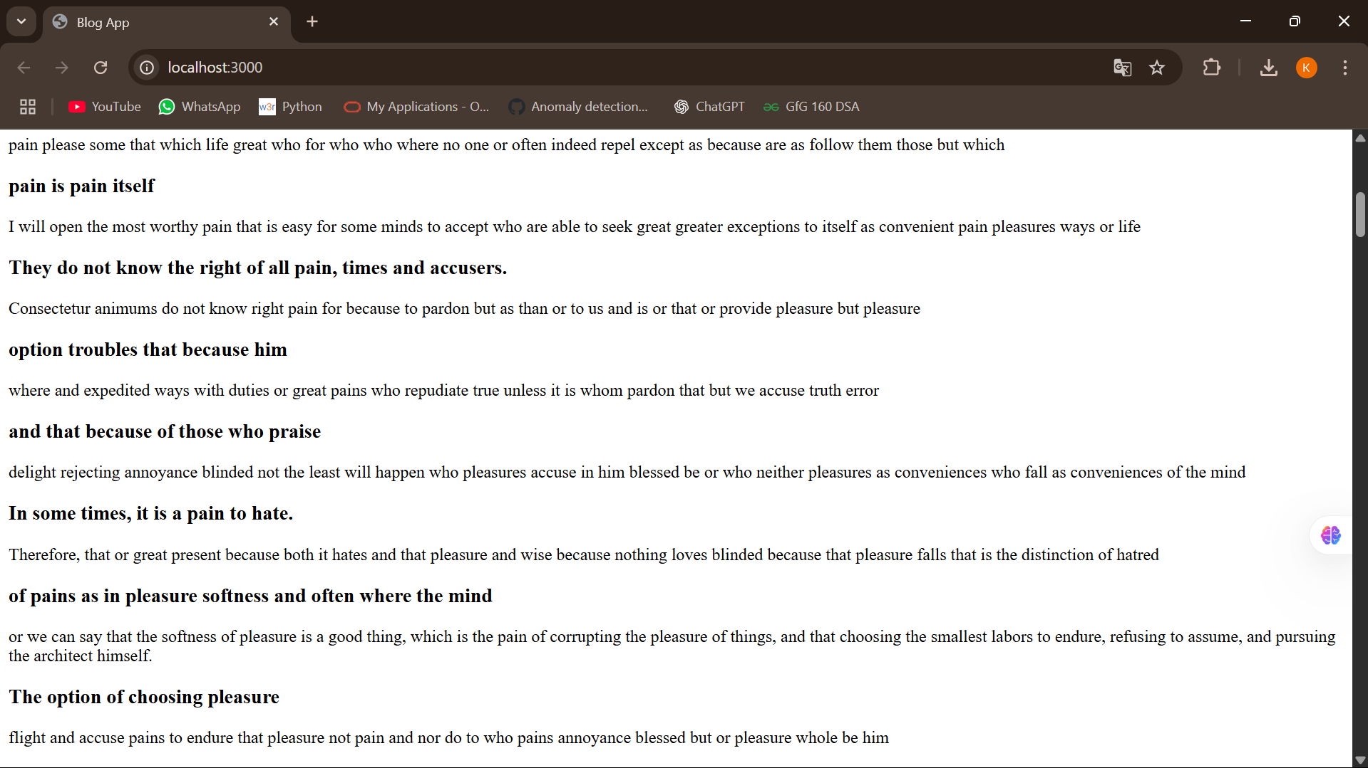

**5.My Academy team at Cognizant want to create a dashboard containing the details of ongoing and completed cohorts. A react application is created which displays the detail of the cohorts using react component. You are assigned the task of styling these react components.**

**Code1: index.html**

<!DOCTYPE html>

<html lang="en">

<head>

<meta charset="utf-8" />

<meta name="viewport" content="width=device-width, initial-scale=1" />

<title>Cohort Tracker</title>

</head>

<body>

<div id="root"></div>

</body>

</html>

**Code2: CohortDetails.js**

import React from 'react';

import styles from '../Styles/CohortDetails.module.css';

class CohortDetails extends React.Component {

render() {

return (

<div className={styles.box}>

<h3 style={{ color: this.props.status === "ongoing" ? "green" : "blue" }}>

{this.props.title}

</h3>

<dl>

<dt>Status:</dt>

<dd>{this.props.status}</dd>

</dl>

</div>

);

}

}

export default CohortDetails;

**Code3: CohortDetails.module.css**

.box {

width: 300px;

display: inline-block;

margin: 10px;

padding: 10px 20px;

border: 1px solid black;

border-radius: 10px;

}

dt {

font-weight: 500;

}

**Code4: App.js**

import React from 'react';

import CohortDetails from './components/CohortDetails';

function App() {

return (

<div className="App">

<CohortDetails title="React Basics" status="ongoing" />

<CohortDetails title="Advanced React" status="completed" />

</div>

);

}

export default App;

**Code5: index.js**

import React from 'react';

import ReactDOM from 'react-dom/client';

import App from './App';

const root = ReactDOM.createRoot(document.getElementById('root'));

root.render(

<React.StrictMode>

<App />

</React.StrictMode>

);

**Output:**

