**WEEK – 7**

**React**

**1. ReactJS-HOL - cricketapp**

**Step-by-Step Instructions**

**Step 1: Create the React App**

Open terminal (CMD or VS Code terminal) and run:

npx create-react-app cricketapp

cd cricketapp

**Step 2: Open in VS Code**

code .

**Step 3: Create Components Folder**

In src/, create a folder named: Components

**Step 4: Create ListofPlayers.js**

* src/Components/ListofPlayers.js

import React from 'react';

const ListofPlayers = () => {

  const players = [

    { name: "Virat", score: 85 },

    { name: "Rohit", score: 95 },

    { name: "Gill", score: 60 },

    { name: "Hardik", score: 40 },

    { name: "Dhoni", score: 92 },

    { name: "Kohli", score: 55 },

    { name: "Pant", score: 70 },

    { name: "Jadeja", score: 30 },

    { name: "Ashwin", score: 88 },

    { name: "Bumrah", score: 76 },

    { name: "Kuldeep", score: 62 }

  ];

  // Players below 70 using arrow function

  const filteredPlayers = players.filter(player => player.score < 70);

  return (

    <div>

      <h2>All Players</h2>

      {players.map((player, index) => (

        <p key={index}>{player.name} - {player.score}</p>

      ))}

      <h3>Players with score below 70</h3>

      {filteredPlayers.map((player, index) => (

        <p key={index}>{player.name} - {player.score}</p>

      ))}

    </div>

  );

};

export default ListofPlayers;

**Step 5: Create IndianPlayers.js**

* src/Components/IndianPlayers.js

import React from 'react';

const IndianPlayers = () => {

  const team = ["Dhoni", "Virat", "Rohit", "Ashwin", "Jadeja", "Pant"];

  // Destructuring to get odd/even players

  const oddTeam = team.filter((_, index) => index % 2 !== 0);

  const evenTeam = team.filter((_, index) => index % 2 === 0);

  // Merging two player arrays

  const T20players = ["Gill", "Surya", "Ishan"];

  const RanjiTrophyPlayers = ["Pujara", "Rahane"];

  const allPlayers = [...T20players, ...RanjiTrophyPlayers];

  return (

    <div>

      <h2>Even Team Players</h2>

      {evenTeam.map((name, index) => <p key={index}>{name}</p>)}

      <h2>Odd Team Players</h2>

      {oddTeam.map((name, index) => <p key={index}>{name}</p>)}

      <h2>All Players (Merged)</h2>

      {allPlayers.map((name, index) => <p key={index}>{name}</p>)}

    </div>

  );

};

export default IndianPlayers;

**Step 6: Update App.js with a Flag**

* src/App.js

import React from 'react';

import './App.css';

import ListofPlayers from './Components/ListofPlayers';

import IndianPlayers from './Components/IndianPlayers';

function App() {

  const flag = true; // Change to false to show IndianPlayers

  return (

    <div className="App">

      <h1>🏏 Cricket App</h1>

      {flag ? <ListofPlayers /> : <IndianPlayers />}

    </div>

  );

}

export default App;

**Step 7: Run the App**

npm start

Open browser:  
 <http://localhost:3001>

**Output:**

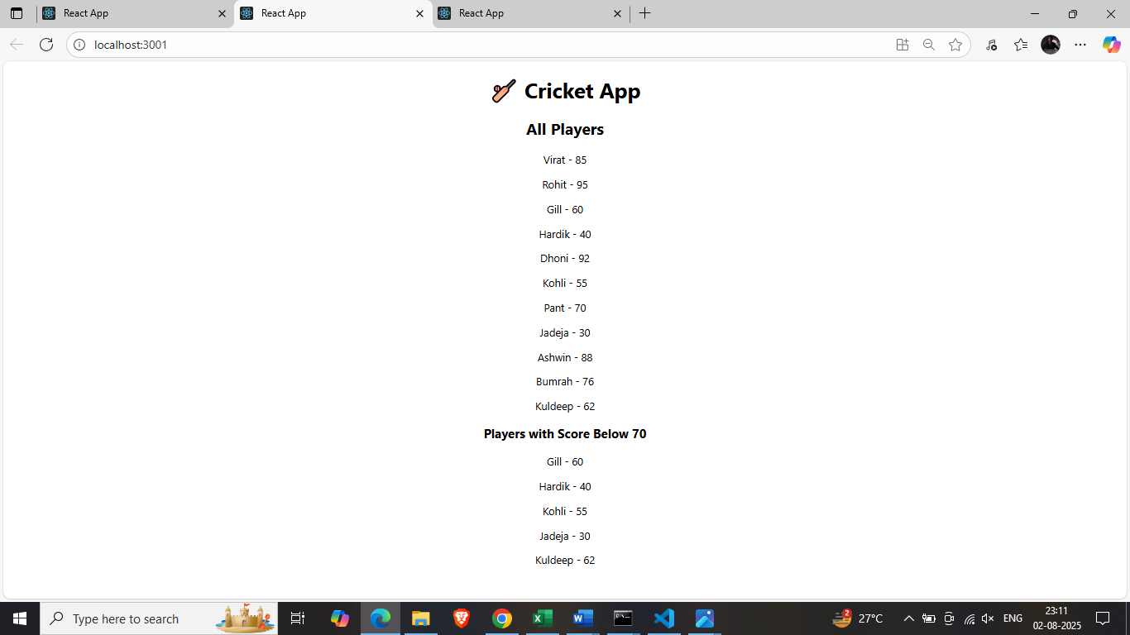

**2. ReactJS-HOL - officespacerentalapp**

**Step 1: Create the React App**

In **Command Prompt** or **VS Code terminal**, type:

npx create-react-app officespacerentalapp

Once it's created:

cd officespacerentalapp

**Step 2: Set Custom Port (e.g., 3007)**

In the root of officespacerentalapp, create a file: .env

Inside .env, add: PORT=3007

**Step 3: Open the Project in VS Code** code .

**Step 4: Edit App.js** Path: src/App.js

Replace everything with this code:

import React from 'react';

function App() {

  // Object for a single office space

  const office = {

    name: "Skyline Tower",

    rent: 55000,

    address: "MG Road, Bengaluru",

    image: "https://via.placeholder.com/300x200.png?text=Office+Image"

  };

  // Array of multiple office listings

  const officeList = [

    { name: "Skyline Tower", rent: 55000, address: "MG Road, Bengaluru" },

    { name: "Tech Park", rent: 75000, address: "Whitefield, Bengaluru" },

    { name: "Global Hub", rent: 60000, address: "Hitech City, Hyderabad" },

    { name: "Business Bay", rent: 45000, address: "T-Nagar, Chennai" }

  ];

  return (

    <div style={{ padding: '20px' }}>

      <h1 style={{ color: 'navy' }}>🏢 Office Space Rental Portal</h1>

      {/* Display single office with image */}

      <img src={office.image} alt="Office" width="300" height="200" />

      <h2>{office.name}</h2>

      <p><strong>Rent:</strong> <span style={{ color: office.rent > 60000 ? 'green' : 'red' }}>{office.rent}</span></p>

      <p><strong>Address:</strong> {office.address}</p>

      <hr />

      {/* Display multiple offices */}

      <h2>All Office Listings</h2>

      {officeList.map((o, index) => (

        <div key={index} style={{ marginBottom: '20px' }}>

          <h3>{o.name}</h3>

          <p><strong>Rent:</strong> <span style={{ color: o.rent > 60000 ? 'green' : 'red' }}>{o.rent}</span></p>

          <p><strong>Address:</strong> {o.address}</p>

        </div>

      ))}

    </div>

  );

}

export default App;

**Step 5: Run the React App**

In the terminal: npm start

This will open the browser at: <http://localhost:3007>

**Output:**

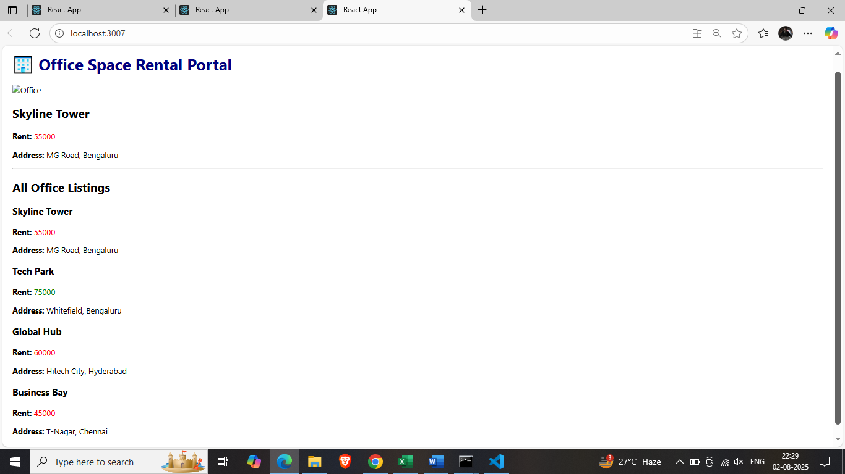

**3.ReactJS-HOL- eventexamplesapp**

**Step 1: Create the React App**

npx create-react-app eventexamplesapp

cd eventexamplesapp

npm start

**Step 2: Open in Visual Studio Code**

code .

**Step 3: Clean up App.js**

Replace the contents of src/App.js with this boilerplate:

import React from 'react';

import './App.css';

import Counter from './components/Counter';

import WelcomeButton from './components/WelcomeButton';

import SyntheticEventButton from './components/SyntheticEventButton';

import CurrencyConverter from './components/CurrencyConverter';

function App() {

  return (

    <div className="App">

      <h1>React Events Example</h1>

      <Counter />

      <WelcomeButton />

      <SyntheticEventButton />

      <CurrencyConverter />

    </div>

  );

}

export default App;

**Step 4: Create components Folder**

In src/, create a folder called components.

**Code 1: Counter.js**

**File**: src/components/Counter.js

import React, { useState } from 'react';

function Counter() {

  const [count, setCount] = useState(0);

  const increment = () => {

    setCount(count + 1);

    sayHello();

  };

  const decrement = () => {

    setCount(count - 1);

  };

  const sayHello = () => {

    console.log("Hello! This is a static message.");

  };

  return (

    <div>

      <h2>Counter: {count}</h2>

      <button onClick={increment}>Increment</button>

      <button onClick={decrement}>Decrement</button>

    </div>

  );

}

export default Counter;

**Code 2: WelcomeButton.js**

**File**: src/components/WelcomeButton.js

import React from 'react';

function WelcomeButton() {

  const sayMessage = (msg) => {

    alert("Message: " + msg);

  };

  return (

    <div>

      <button onClick={() => sayMessage("welcome")}>Say Welcome</button>

    </div>

  );

}

export default WelcomeButton;

## **Code 3: SyntheticEventButton.js**

**File**: src/components/SyntheticEventButton.js

import React from 'react';

function SyntheticEventButton() {

  const handleClick = (e) => {

    e.preventDefault(); // Just to show it's synthetic

    alert("I was clicked");

    console.log("Synthetic Event:", e);

  };

  return (

    <div>

      <button onClick={handleClick}>Synthetic OnPress</button>

    </div>

  );

}

export default SyntheticEventButton;

* **Code 4: CurrencyConverter.js**

**File:** src/components/CurrencyConverter.js

import React, { useState } from 'react';

function CurrencyConverter() {

  const [rupees, setRupees] = useState('');

  const [euros, setEuros] = useState('');

  const handleSubmit = () => {

    const converted = (parseFloat(rupees) / 88.0).toFixed(2); // example: 1 Euro = 88 INR

    setEuros(converted);

  };

  return (

    <div>

      <h3>Currency Converter</h3>

      <input

        type="number"

        value={rupees}

        placeholder="Enter Rupees"

        onChange={(e) => setRupees(e.target.value)}

      />

      <button onClick={handleSubmit}>Convert</button>

      {euros && <p>€ {euros}</p>}

    </div>

  );

}

export default CurrencyConverter;

**Step 5: Run the App** npm start

This will open the browser at: <http://localhost:3006>

**OUTPUT:**

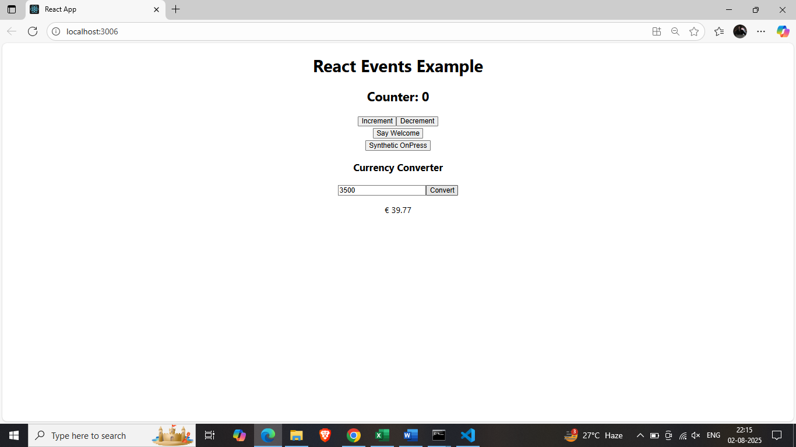

**4.ReactJS-HOL eventexamplesapp**

**Step 1:App.js**

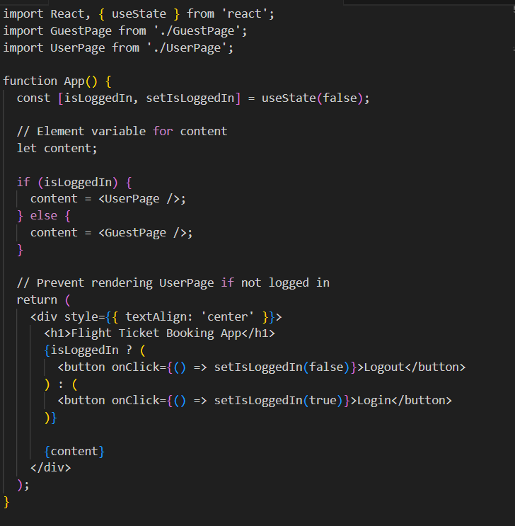

**Step 2: GuestPage.js – Visible to everyone**

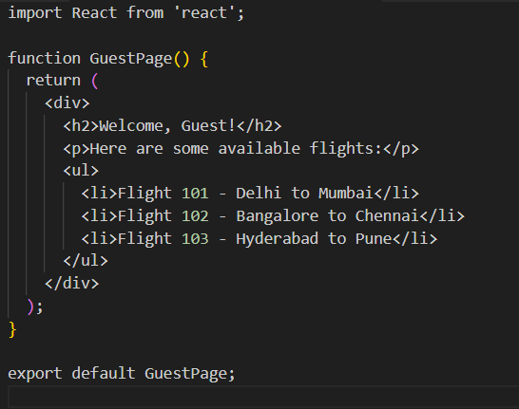

**Step 3: UserPage.js – Only for logged-in users**



**Output:**

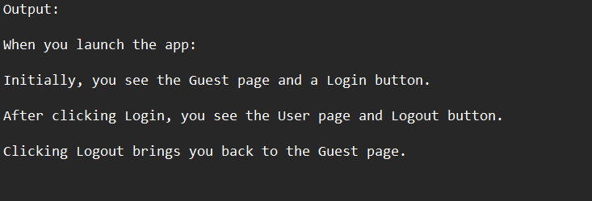

**5. ReactJS-HOL - eventexamplesapp**

**Step 1: Create App**

npx create-react-app bloggerapp

cd bloggerapp

npm start

**Step 2: Project Structure**

**bloggerapp/**

**├── src/**

**│ ├── App.js**

**│ ├── BookDetails.js**

**│ ├── BlogDetails.js**

**│ └── CourseDetails.js**

**Step 3:App.js (Main Component)**

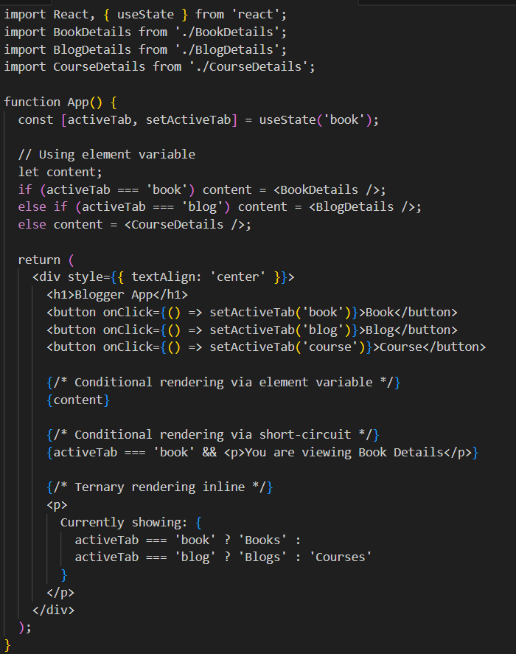

**Step 4:** **BookDetails.js**

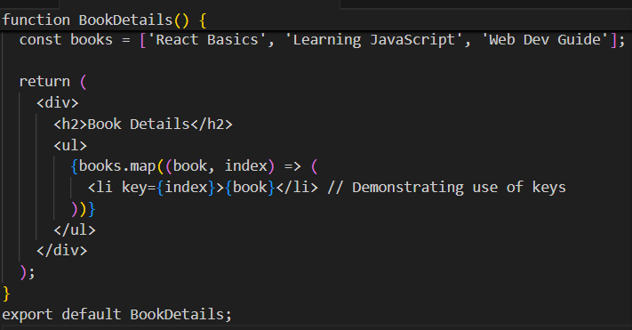

**Step 5:** **BlogDetails.js**

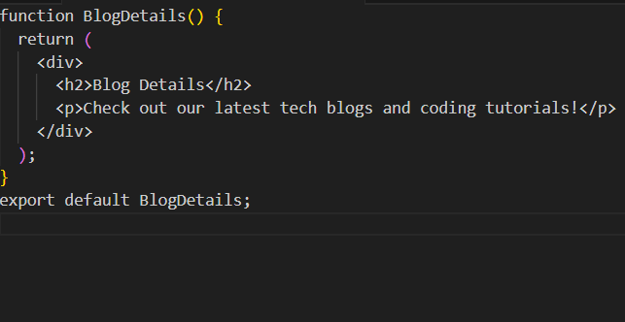

**Step 6:CourseDetails.js**

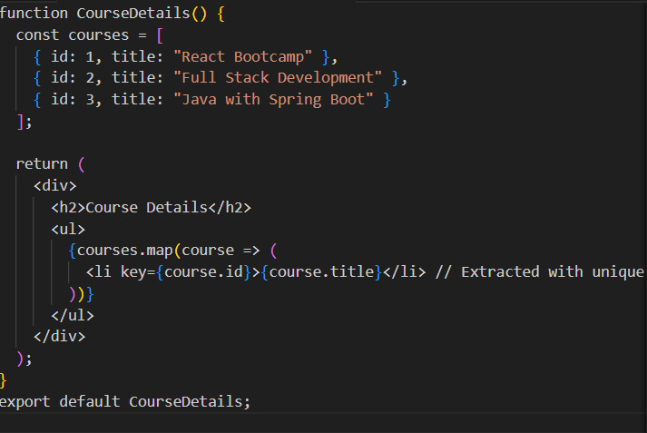

**Output:**

**After Clicking "Book"**

Blogger App

[Book] [Blog] [Course]

Book Details

- React Basics

- Learning JavaScript

- Web Dev Guide

Currently showing: Books

**After Clicking "Course"**

Blogger App

[Book] [Blog] [Course]

Course Details

- React Bootcamp

- Full Stack Development

- Java with Spring Boot

Currently showing: Courses