HirePerfect — Detailed Assessment Reporting Showcase
Platform Architecture, Verification & Visual Audit

Executive Overview
The HirePerfect Detailed Assessment Reporting Architecture delivers a defensible, multi-dimensional diagnostic report following every completed assessment. The platform strictly decouples subject-matter competency from AI proctoring signals, enforces statistical suppression rules to eliminate noisy data, and maintains immutable, versioned report records.

1. Candidate / User View (/results/[attemptId])
The candidate report provides an actionable breakdown of performance across topic areas, pacing behaviors, and integrity status without overwhelming the user.

Figure 1: Candidate Desktop Report (1440px Viewport)
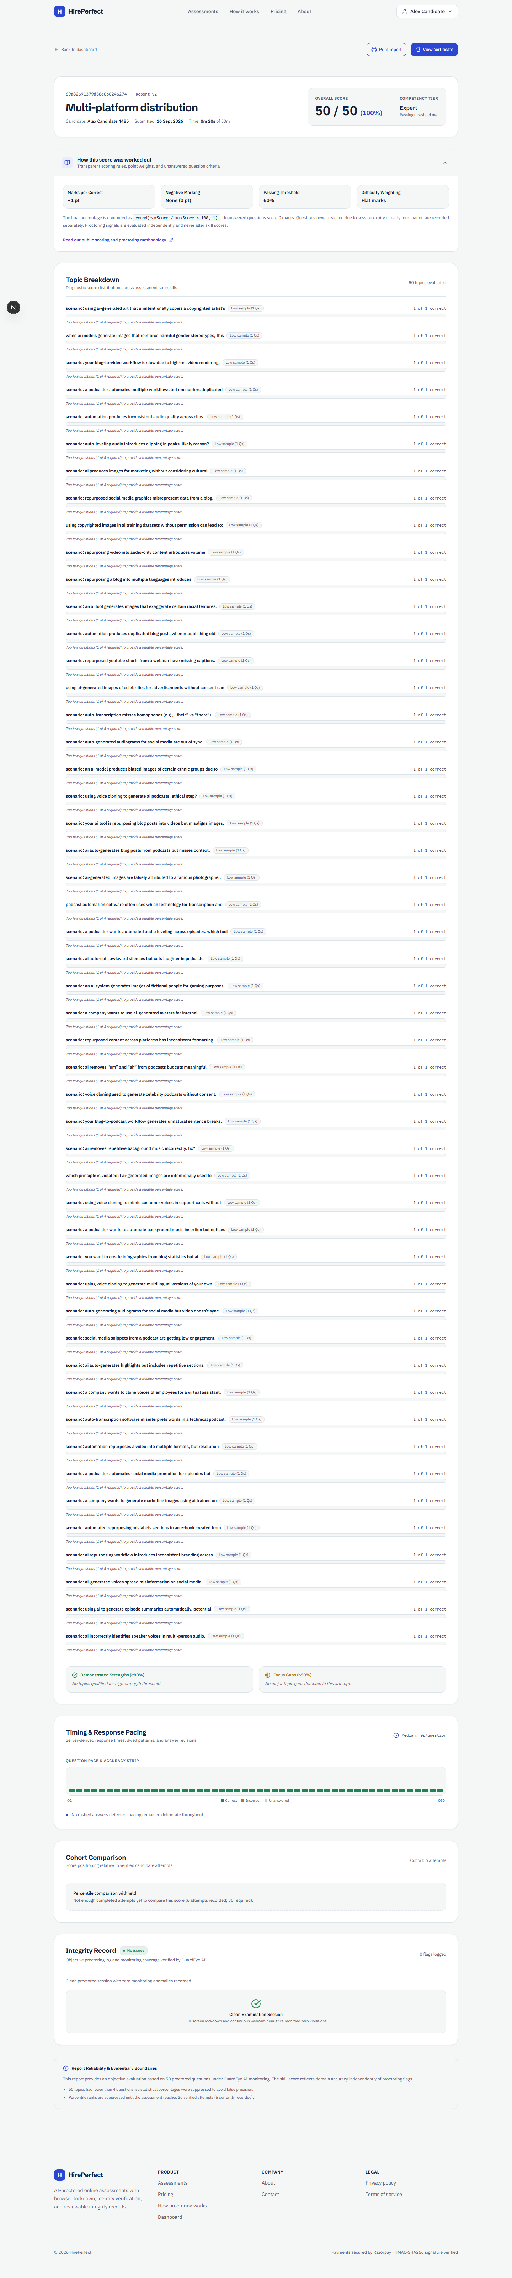

Figure 2: Candidate Mobile Responsive View (390px Viewport)
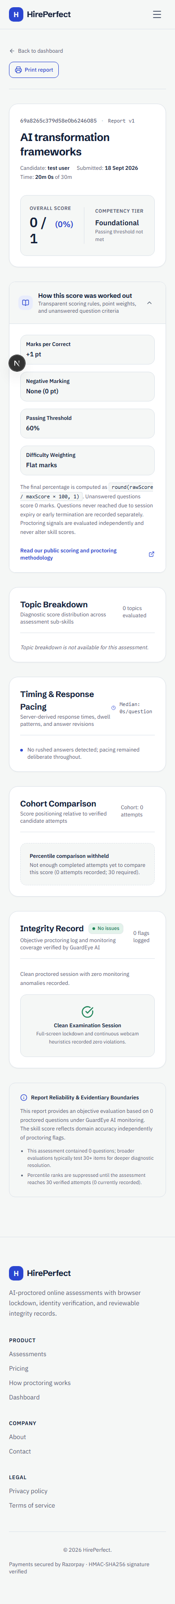

Candidate Report Components & Score Basis
Section | Displayed Content | Underlying Math & Basis
1. Outcome Header | Raw score (e.g. 50/50), percentage (100%), and Proficiency Band chip (Expert). | Percentage = round(rawScore / maxScore * 100, 1). Bands: Expert (85-100%), Proficient (70-84%), Developing (55-69%), Foundational (0-54%).
2. Methodology Panel | Marks per correct (+1 pt), Negative marking (0 pt), Pass threshold (60%), Difficulty weighting (Flat marks). | Config-driven transparency. Clearly explains unanswered questions score 0 and proctoring never alters test percentage.
3. Topic Breakdown | Sub-skill mastery bars with low-confidence suppression tags. | Minimum-Sample Gate: Topics with <4 questions suppress percentage, show raw count ("1 of 1"), and explain low sample size.
4. Timing Analysis | Visual question pace strip (Q1-Q50), median response duration, rushed answer count. | Server-derived timestamps. Rushed = duration <8s. Unreliable timing clamp at 600s.
5. Cohort Benchmark | Percentile ranking relative to verified completed attempts. | Normal CDF modeling. Suppressed when cohort <30 attempts, showing exact sample count instead.
6. Integrity Record | GuardEye verification tier (Clean, Needs Review, Major) and coverage duration. | Independent monitoring heuristic. Signals are strictly decoupled and never deduct test marks.

2. Admin / Recruiter Diagnostic View (/admin/attempts/[attemptId])
The administrator diagnostic screen gives recruiters an item-level question audit table, answer keys, response durations, persistent recruiter notes, and verification workflows.

Figure 3: Admin Diagnostic Audit & 50-Question Response Table
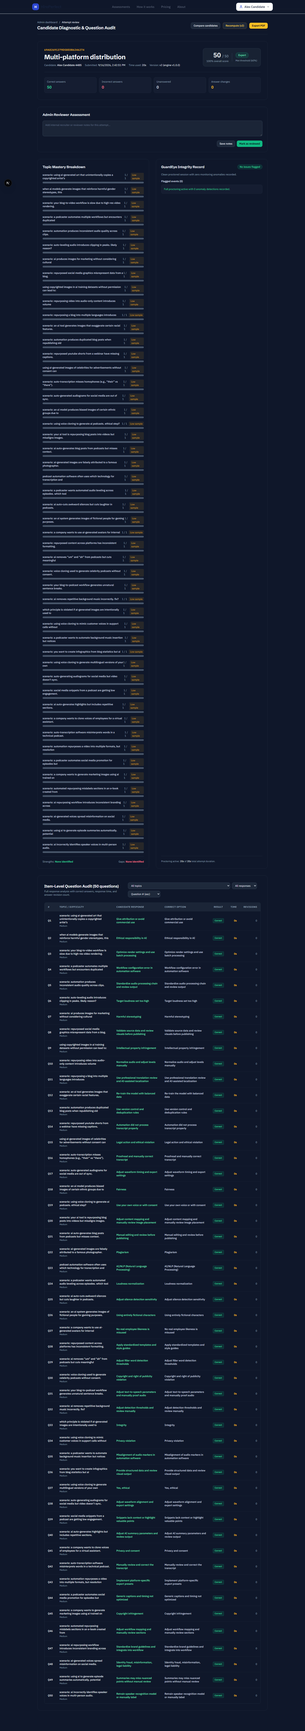

Admin-Specific Capabilities & Controls
Feature | Admin Capability | Candidate Policy Difference
Full Question Audit Table | Inspects topic, difficulty, candidate choice, unmasked correct answer, duration, and revision count per question. | Correct options are hidden from candidates to prevent question bank leaks.
Interactive Filters | Filter by topic, incorrect answers, rushed answers (<8s), and unanswered questions. | Recruiters can quickly diagnose specific domain gaps.
Reviewer Notes & Verification | Save internal hiring notes and click "Mark as Reviewed" with audit logging. | Internal to hiring teams only.
Immutable Recomputation | Trigger recomputation creating version v2 without destroying historical records. | Candidate sees latest active version while history is preserved.

3. Core Architectural Principles
1. Zero Score Merging: Integrity flags and skill percentages are strictly decoupled. A proctoring anomaly never lowers a test score; human reviewers make the final decision.
2. Statistical Suppression: Scores are never reported on insufficient sample sizes. Topics with <4 questions and cohorts with <30 attempts are suppressed with honest notices.
3. Deterministic & Pure Engine: Scoring calculators are pure functions. Identical attempt data and configuration versions always generate byte-identical report JSON.
4. Immutable Versioned Reports: Published reports are stored as versioned records. Recomputations create version v2 and supersede old records rather than mutating existing data.

4. Performance & Test Verification Summary
• Unit Test Suite: 12 / 12 tests passed covering all calculators, edge cases, suppression gates, and anti-tampering rules.
• Engine Latency: p50 = 0.021 ms, p95 = 0.062 ms (well below 500 ms target threshold).
• TypeScript Type Check: 0 errors across the entire codebase.

