**1.Write a program to create an item collection and clones the items using AngularJS directives.**

**Index.js**:-  
<!doctype html>  
<html lang="en">  
<head>  
<meta charset="UTF-8">  
<title>Example - example-ngRepeat-tracking-production</title>  
<link href="animations.css" rel="stylesheet" type="text/css">  
<script src="//code.angularjs.org/snapshot/angular.min.js"></script>  
<script src="//code.angularjs.org/snapshot/angular-animate.js"></script>  
<script src="script.js"></script>  
</head>  
<body ng-app="ngRepeat">  
<div ng-controller="repeatController">  
<button ng-click="removeFirst()">Remove First</button>  
<button ng-click="updateAge()">Update Age</button>  
<button ng-click="copy()">Copy</button>  
<br><button ng-click="reset()">Reset List</button>  
<br>  
<code>track by $id(friend)</code> (default):  
<ul class="example-animate-container">  
<li class="animate-repeat" ng-repeat="friend in friends">  
{{friend.name}} is {{friend.age}} years old.  
</li>  
</ul>  
<code>track by $id(friend)</code> (default), with age one-time binding:  
<ul class="example-animate-container">  
<li class="animate-repeat" ng-repeat="friend in friends">  
{{friend.name}} is {{::friend.age}} years old.  
</li>  
</ul>  
<code>track by friend.name</code>, with age one-time binding:  
<ul class="example-animate-container">  
<li class="animate-repeat" ng-repeat="friend in friends track by friend.name">  
{{friend.name}} is {{::friend.age}} years old.  
</li>  
</ul>  
<code>track by $index</code>, with age one-time binding:  
<ul class="example-animate-container">  
<li class="animate-repeat" ng-repeat="friend in friends track by $index">  
{{friend.name}} is {{::friend.age}} years old.  
</li>

</ul>  
</div>  
</body>  
</html>

**Script.js**:-

(function(angular) { 'use  
strict';  
angular.module('ngRepeat', ['ngAnimate']).controller('repeatController', function($scope) { var  
friends = [  
{name:'Suraj', age:21},  
{name:'Pankaj', age:22},  
];  
$scope.removeFirst = function() {  
$scope.friends.shift();  
};  
$scope.updateAge = function() {  
$scope.friends.forEach(function(el) {  
el.age = el.age + 5;  
});  
};  
$scope.copy = function() {  
$scope.friends = angular.copy($scope.friends);  
};  
$scope.reset = function() {  
$scope.friends = angular.copy(friends);  
};  
$scope.reset();  
});  
})(window.angular);

**OUTPUT:-**

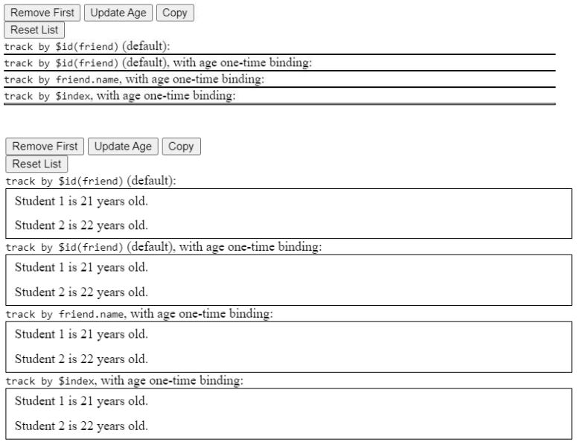

**2. Write a program to create an HTTP server which can communicate between client and the server.**

const http = require("http")

const server = http.createServer((req,res) =>{

if(req.url=="/")

res.end("You are at home page")

else if(req.url=="/contact")

res.end("You are at contacts")

else

res.writeHead(404)

res.end()

})

server.listen(4002,"127.0.0.1",()=>{

console.log("Listening to the server")

})

**OUTPUT:-**

