**Difference between HTTP1.1 vs HTTP2**

**HTTP 1.1**

* + Follows textual protocol
  + Single request /response for every TCP connection. Therefore, slower compared to HTTP2
  + Synchronous

**HTTP 2**

* + Follows binary Protocol
  + Throws request/response over a single TCP connection. Hence, Faster and reliable.
  + Asynchronous

|  |  |  |
| --- | --- | --- |
| Differentiator | HTTP/1.1 | HTTP/2 |
| Year | 1997 | 2015 |
| Key Features | It supports connection reuse  i.e. for every TCP connection there could be multiple requests and responses, and pipelining where the client can request several resources from the server at once.  However, pipelining was hard to implement due to issues such as head-of-line blocking and was not a feasible solution. | Uses multiplexing, where over a single TCP connection resources to be delivered are interleaved and arrive at the client almost at the same time.  It is done using streams which can be prioritized, can have dependencies and individual flow control. It also provides a feature called server push that allows the server to send data that the client will need but has not yet requested. |
| Status Code | Introduces a warning header field to carry additional information about the status of a message. Can define 24 status codes, error reporting is quicker and more efficient. | Underlying semantics of HTTP such as headers, status codes remains the same. |
| Authentication Mechanism | It is relatively secure since it uses digest authentication, NTLM authentication. | Security concerns from previous versions will continue to be seen in HTTP/2. However, it is better equipped to deal with them due to new TLS features like connection error of type Inadequate Security. |
| Caching | Expands on the caching support by using additional headers like cache-control, conditional headers like If-Match and by using entity tags. | HTTP/2 does not change much in terms of caching. With the server push feature if the client finds the resources are already present in the cache, it can cancel the pushed stream. |
| Web Traffic | HTTP/1.1 provides faster delivery of web pages and reduces web traffic. However, TCP starts slowly and with domain sharing (resources can be downloaded simultaneously by using multiple domains), connection reuse and pipelining, there is an increased risk of network congestion. | HTTP/2 utilizes multiplexing and server push to effectively reduce the page load time by a greater margin along with being less sensitive to network delays. |

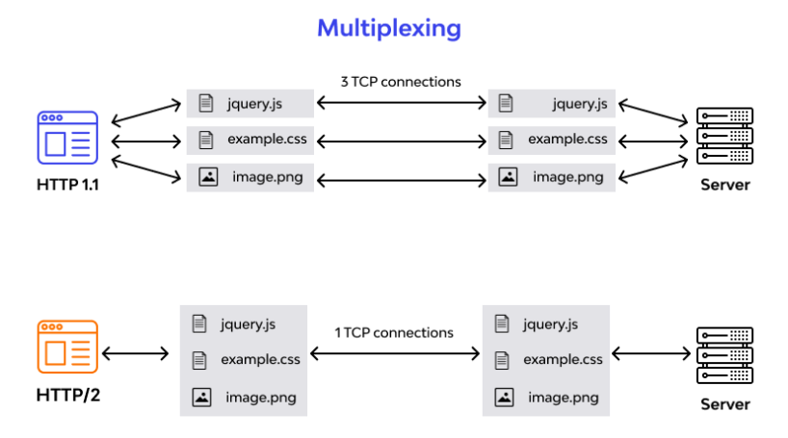

**Objects and its internal representation in JavaScript**

In JavaScript, an object is a standalone entity, with properties and type.

Compare it with a car, for example. A car is an object, with properties. A car has a name, color, weight, model, a material it is made of, etc. The same way, JavaScript objects can have properties, which define their characteristics.

**Creating Objects in JavaScript**

* By object literal
* By creating instance of Object directly (using new keyword)

**By object literal**

The syntax of creating object using object literal is given below:

var Object = {property1:value1, property2:value2, ….. , property:valueN};

Property and value is separated by colon(:).

**Example:**

var employee1 = { firstName: “XXXX”, lastName:”YYYY”, age: 30};

**By creating instance of Object directly (using new keyword)**

The syntax of creating object directly is given below:

var objectName = new Object();

Here, **new keyword** is used to create object

**Example:**

var employee2 = new Object();

employee2.Id = 101;

employee2.Name = “XXXX”;

employee2.Salary = 50000;

**Accessing JavaScript Objects**

The syntax for accessing the property of an object is:

*objectName.property*

or

*objectName*[“*property*”]

From the above examples, object property can be accessed like below.

employee1.firstName or employee1[“firstName”]

employee2.Name or employee2[“Name”]