BANK LOAN ANALYSIS REPORT

1. Project Overview
This project focuses on analyzing bank loan data to evaluate lending performance, borrower behavior, and credit risk patterns. The primary objective is to generate actionable insights that can help financial institutions improve decision-making in loan approvals, risk management, and portfolio optimization.
The analysis aims to:
- Identify trends in loan applications and funding
- Evaluate repayment behavior and loan performance
- Understand borrower demographics and financial profiles
- Measure risk through loan status and debt indicators

2. Dataset Summary
- Total Records: 38,576
- Total Features: 24

Key Data Categories:
Loan Information: - Loan Amount - Interest Rate - Installment - Loan Term - Loan Purpose - Grade & Sub-grade
Borrower Details: - Annual Income - Employment Length - Home Ownership - State
Loan Performance: - Loan Status (Fully Paid, Current, Charged Off)
Payment Data: - Total Payment Received - Last Payment Date - Next Payment Date
Verification: - Verification Status

3. Data Cleaning & Preparation (Python)
Data preprocessing was performed using Python to ensure accuracy and consistency before analysis.

Key Steps:
- Data Loading: Imported dataset using Pandas.
- Initial Exploration: Used info() and describe() to understand structure and distributions.
- Date Standardization: Converted all date fields into consistent datetime format.
- Data Cleaning:
  - Removed extra spaces from text columns
  - Standardized categorical values
- Feature Engineering:
  - Converted employment length into numeric format
- Missing Values Handling:
  - Filled missing emp_title values with “Unknown”
- Duplicate Check: Ensured dataset contained no duplicate records
- Data Consistency: Standardized purpose column naming format
- Database Integration: Cleaned dataset exported to MySQL for further analysis

4. Data Analysis (SQL)
A. BANK LOAN REPORT | SUMMARY
Total Loan Applications
SELECT COUNT(id) AS Total_Applications
FROM bank_loan_data;
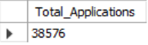
MTD Loan Applications
SELECT COUNT(id) AS MTD_Total_Applications
FROM bank_loan_data
WHERE MONTH(issue_date) = 12;
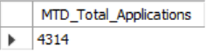
PMTD Loan Applications
SELECT COUNT(id) AS PMTD_Total_Applications
FROM bank_loan_data
WHERE MONTH(issue_date) = 11;

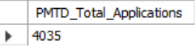

Total Funded Amount
SELECT SUM(loan_amount) AS Total_Funded_Amount
FROM bank_loan_data;
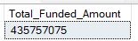
MTD Total Funded Amount
SELECT SUM(loan_amount) AS MTD_Total_Funded_Amount
FROM bank_loan_data
WHERE MONTH(issue_date) = 12;
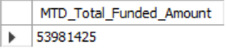
PMTD Total Funded Amount
SELECT SUM(loan_amount) AS PMTD_Total_Funded_Amount
FROM bank_loan_data
WHERE MONTH(issue_date) = 11;
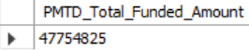

Total Amount Received
SELECT SUM(total_payment) AS Total_Amount_Received
FROM bank_loan_data;
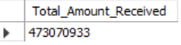
MTD Total Amount Received
SELECT SUM(total_payment) AS MTD_Total_Amount_Received
FROM bank_loan_data
WHERE MONTH(issue_date) = 12;
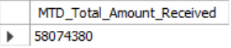
PMTD Total Amount Received
SELECT SUM(total_payment) AS PMTD_Total_Amount_Received
FROM bank_loan_data
WHERE MONTH(issue_date) = 11;
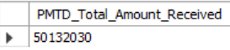

Average Interest Rate
SELECT AVG(int_rate) * 100 AS Avg_Int_Rate
FROM bank_loan_data;
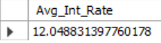

MTD Average Interest
SELECT AVG(int_rate) * 100 AS MTD_Avg_Int_Rate
FROM bank_loan_data
WHERE MONTH(issue_date) = 12;
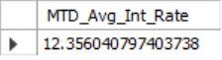
PMTD Average Interest
SELECT AVG(int_rate) * 100 AS PMTD_Avg_Int_Rate
FROM bank_loan_data
WHERE MONTH(issue_date) = 11;
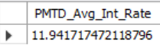

Avg DTI
SELECT AVG(dti) * 100 AS Avg_DTI
FROM bank_loan_data;
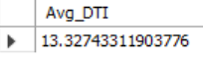
MTD Avg DTI
SELECT AVG(dti) * 100 AS MTD_Avg_DTI
FROM bank_loan_data
WHERE MONTH(issue_date) = 12;
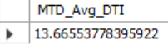
PMTD Avg DTI
SELECT AVG(dti) * 100 AS PMTD_Avg_DTI
FROM bank_loan_data
WHERE MONTH(issue_date) = 11;
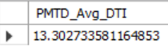

GOOD LOAN ISSUED
Good Loan Percentage
SELECT
(COUNT(CASE WHEN loan_status IN ('Fully Paid', 'Current') THEN id END) * 100.0) /
COUNT(id) AS Good_Loan_Percentage
FROM bank_loan_data;
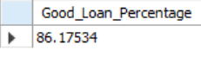
Good Loan Applications
SELECT COUNT(id) AS Good_Loan_Applications
FROM bank_loan_data
WHERE loan_status IN ('Fully Paid', 'Current');
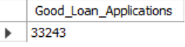
Good Loan Funded Amount
SELECT SUM(loan_amount) AS Good_Loan_Funded_Amount
FROM bank_loan_data
WHERE loan_status IN ('Fully Paid', 'Current');
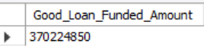

Good Loan Amount Received
SELECT SUM(total_payment) AS Good_Loan_Amount_Received
FROM bank_loan_data
WHERE loan_status IN ('Fully Paid', 'Current');
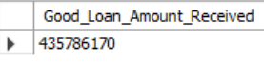

BAD LOAN ISSUED
Bad Loan Percentage
SELECT
(COUNT(CASE WHEN loan_status = 'Charged Off' THEN id END) * 100.0) /
COUNT(id) AS Bad_Loan_Percentage
FROM bank_loan_data;
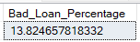
Bad Loan Applications
SELECT COUNT(id) AS Bad_Loan_Applications
FROM bank_loan_data
WHERE loan_status = 'Charged Off';
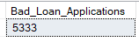
Bad Loan Funded Amount
SELECT SUM(loan_amount) AS Bad_Loan_Funded_Amount
FROM bank_loan_data
WHERE loan_status = 'Charged Off';
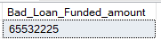
Bad Loan Amount Received
SELECT SUM(total_payment) AS Bad_Loan_Amount_Received
FROM bank_loan_data
WHERE loan_status = 'Charged Off';
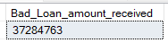
LOAN STATUS
SELECT
loan_status,
COUNT(id) AS Loan_Count,
SUM(total_payment) AS Total_Amount_Received,
SUM(loan_amount) AS Total_Funded_Amount,
AVG(int_rate * 100) AS Avg_Interest_Rate,
AVG(dti * 100) AS Avg_DTI
FROM bank_loan_data
GROUP BY loan_status;

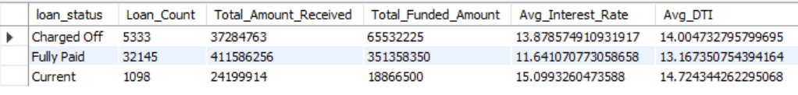

MTD breakdown
SELECT
loan_status,
SUM(total_payment) AS MTD_Total_Amount_Received,
SUM(loan_amount) AS MTD_Total_Funded_Amount
FROM bank_loan_data
WHERE MONTH(issue_date) = 12
GROUP BY loan_status;

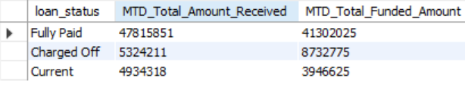

B. BANK LOAN REPORT | OVERVIEW
MONTH
SELECT
MONTH(issue_date) AS Month_Number,
MONTHNAME(issue_date) AS Month_Name,
COUNT(id) AS Total_Loan_Applications,
SUM(loan_amount) AS Total_Funded_Amount,
SUM(total_payment) AS Total_Amount_Received
FROM bank_loan_data
GROUP BY MONTH(issue_date), MONTHNAME(issue_date)ORDER BY MONTH(issue_date);

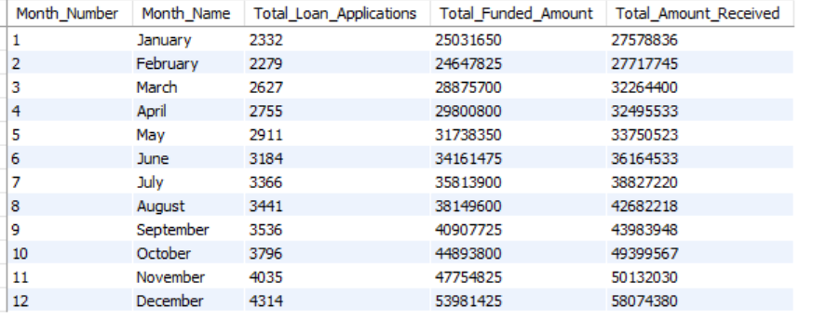
STATE
SELECT
address_state AS State,
COUNT(id) AS Total_Loan_Applications,
SUM(loan_amount) AS Total_Funded_Amount,
SUM(total_payment) AS Total_Amount_Received
FROM bank_loan_data
GROUP BY address_state
ORDER BY address_state;
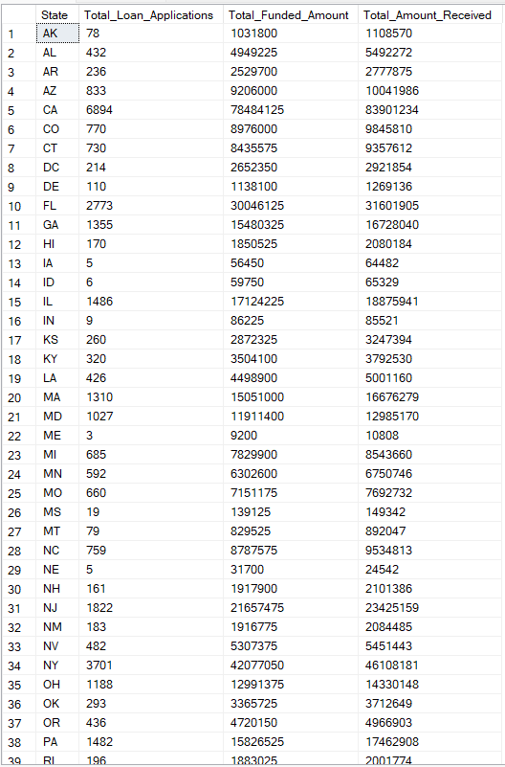
TERM
SELECT
term AS Term,
COUNT(id) AS Total_Loan_Applications,
SUM(loan_amount) AS Total_Funded_Amount,
SUM(total_payment) AS Total_Amount_Received
FROM bank_loan_data
GROUP BY term
ORDER BY term;
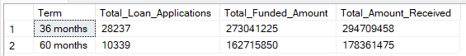

EMPLOYEE LENGTH
SELECT
emp_length AS Employee_Length,
COUNT(id) AS Total_Loan_Applications,
SUM(loan_amount) AS Total_Funded_Amount,
SUM(total_payment) AS Total_Amount_Received
FROM bank_loan_data
GROUP BY emp_length
ORDER BY emp_length;
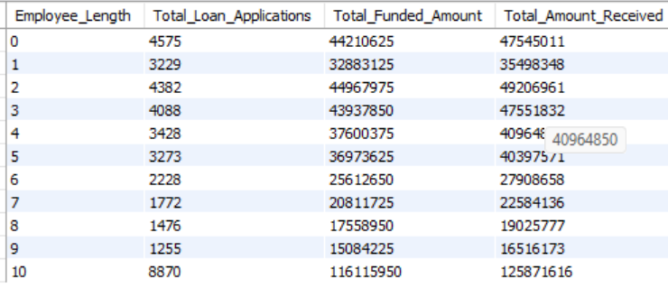
PURPOSE
SELECT
purpose AS Purpose,
COUNT(id) AS Total_Loan_Applications,
SUM(loan_amount) AS Total_Funded_Amount,
SUM(total_payment) AS Total_Amount_Received
FROM bank_loan_data
GROUP BY purpose
ORDER BY purpose;
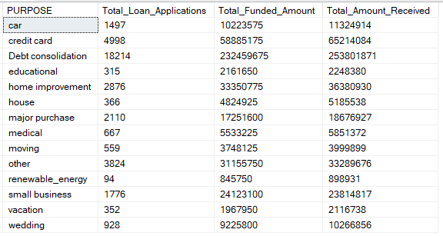

HOME OWNERSHIP
SELECT
home_ownership AS Home_Ownership,
COUNT(id) AS Total_Loan_Applications,
SUM(loan_amount) AS Total_Funded_Amount,
SUM(total_payment) AS Total_Amount_Received
FROM bank_loan_data
GROUP BY home_ownership
ORDER BY home_ownership;
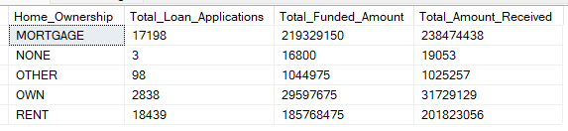

5. Exploratory Insights
Based on SQL analysis, the following insights can be derived:
- Loan applications show monthly variation, indicating seasonality in borrowing behavior
- Higher loan amounts are often associated with higher risk categories
- Borrowers with higher DTI ratios are more likely to default
- Certain purposes (e.g., debt consolidation) dominate loan applications
- Employment length and home ownership influence repayment behavior

6. Dashboard (Power BI)
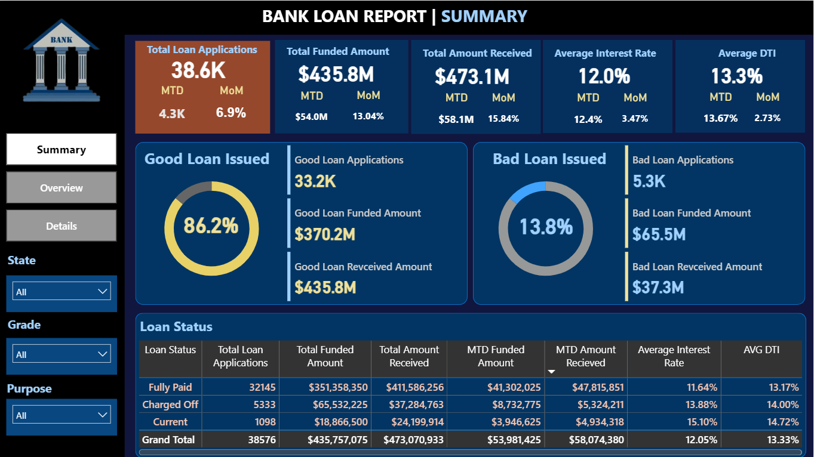
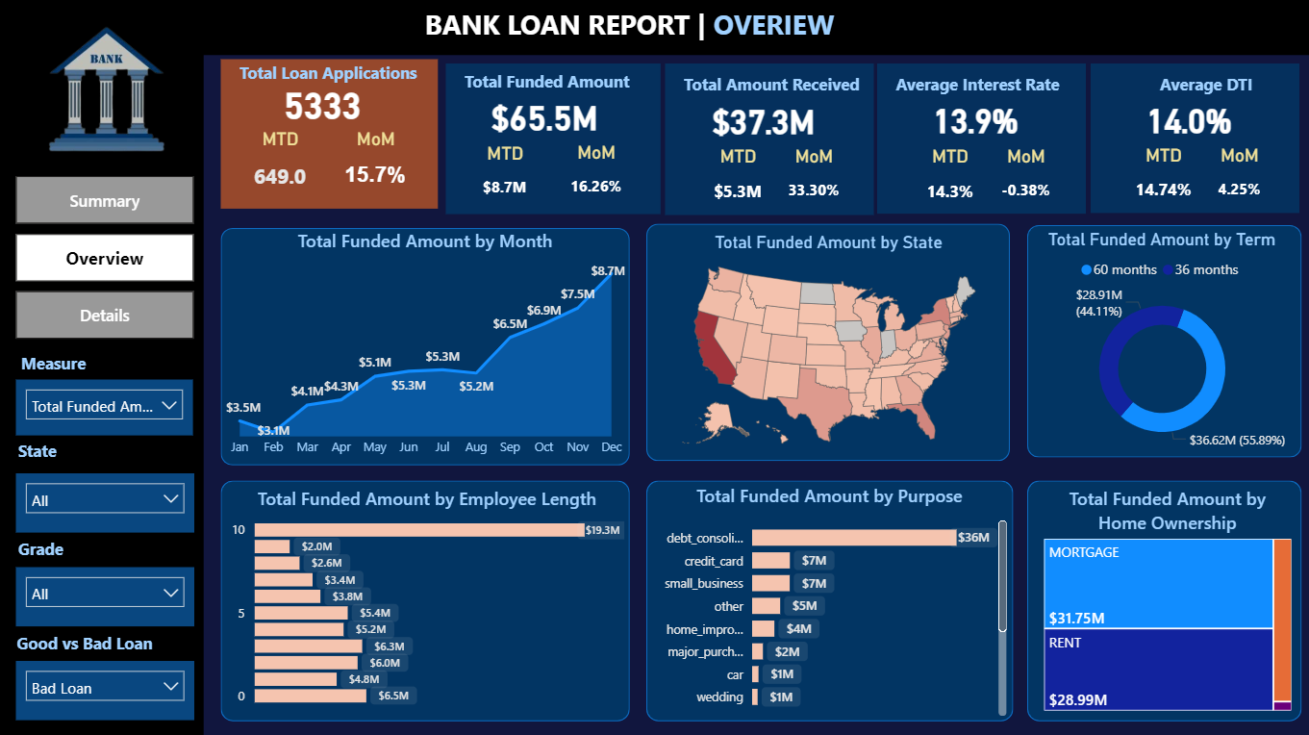
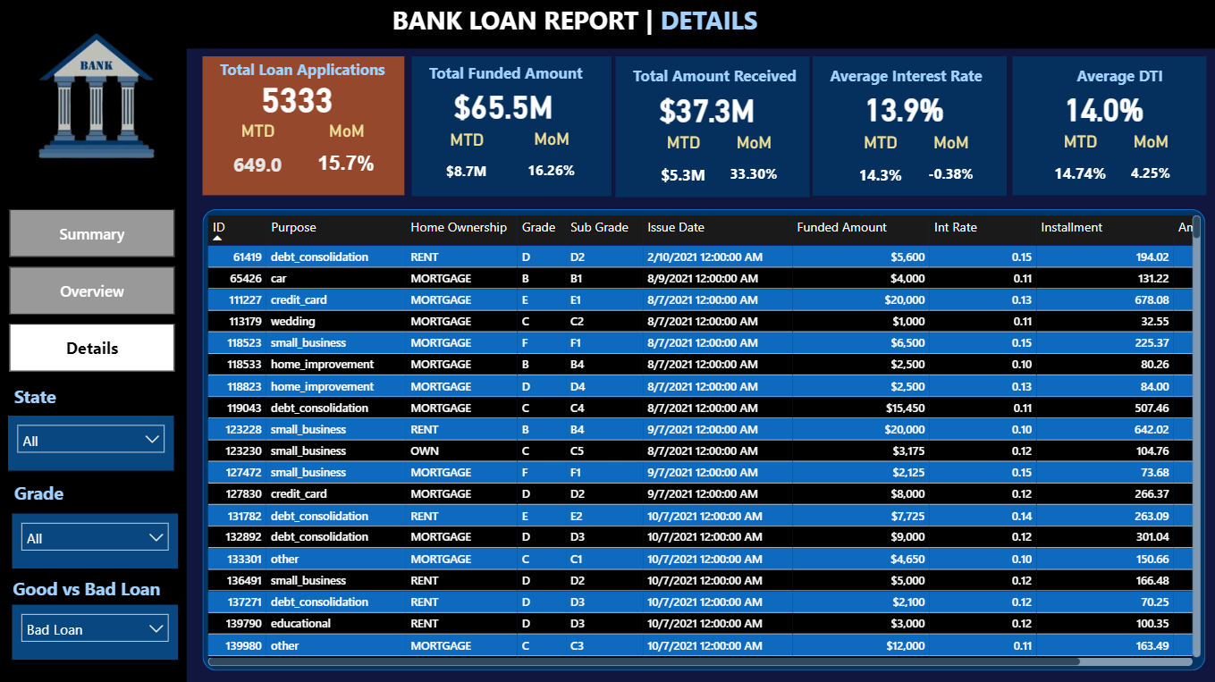

7. Business Recommendations
Based on the analysis, the following recommendations are proposed:

Risk Management
- Implement stricter approval criteria for high DTI borrowers
- Monitor “Charged Off” loans to identify early warning signals

Lending Strategy
- Focus on low-risk borrower segments (stable employment, lower DTI)
- Optimize interest rates based on borrower risk profiles

Portfolio Optimization
- Diversify loan portfolio across purposes and regions
- Reduce exposure to high-risk loan categories

Operational Improvements
- Improve data collection for better risk modeling
- Automate loan monitoring using dashboards

