|  |  |
| --- | --- |
|  | LAB 8: OSPF. |
|  |  |
|  | Akshar Panchani ID- 202101522  IT304 Computer Networks  11/7/23 |



* 1. **Experiment:**

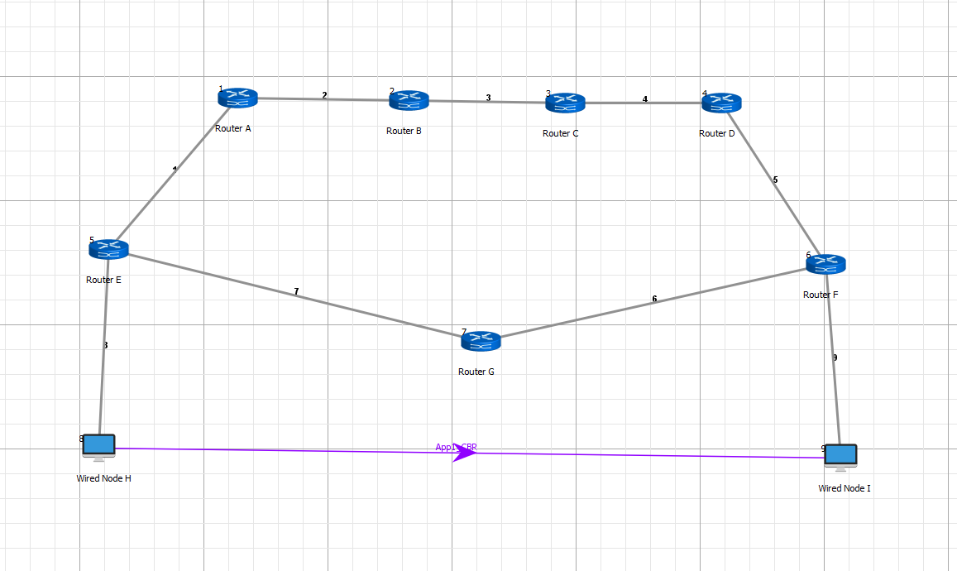

* 1. **Exercise:**

1. **Explain the packets used in OSPF: LSR, LSA, D-D, LSU and Hello packet.**
2. **Hello Packet**:
3. **Is it exchanged between neighbor or all routers?**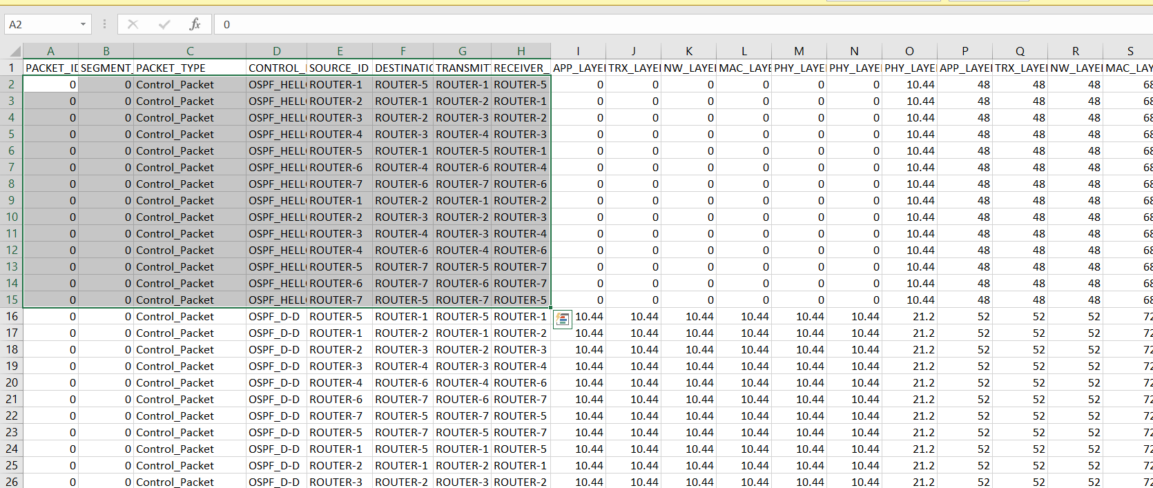

It is exchanged between only neighbor routers.

**ii) What is its use?**

To elect DR and BDR.

**iii) What is the time duration of its exchange in theory? Write time duration you observed during your simulation?**

The simulation time seen in the first case was 10.44 microseconds, whereas in the second example, the simulation time observed for links 1, 2, 3, 5, and 6 and 7 was 10.44 microseconds and 59.4 microseconds, respectively.

**iv) Explain the core fields of the packet.**

**Network Mask:** Subnet mask of the advertising OSPF interface.

**Hello Interval:** The frequency at which Hello packets are promoted. By default, NBMA/Broadcast connections run for 30 seconds while point-to-point links run for 10 seconds (2-bytes).

Options: The local router advertises its capabilities in this field. (1-byte)

**RTR Priority:** The local router's priority. Elections for DR and BDR are held using it. The router is not eligible for the election if it is set to 0. One byte

**Router Dead Interval:** The Dead Interval that the advertising router has requested. By default, NBMA/Broadcast links (4-bytes) are broadcast for 120 seconds, and point-to-point connections for 40 seconds. Designated Router: The IP address of the current DR. Set to 0.0.0.0 if no DR is elected yet. (4-bytes)

**Backup Designated Router:** The BDR's IP address at the moment. If no BDR has yet been chosen, set to 0.0.0.0. Four bytes

**Neighbor:** The BDR's IP address at the moment. If no BDR has yet been chosen, set to 0.0.0.0. Four bytes

1. **D-D Packets**:

**i) Is it exchanged between neighbor or all routers?**

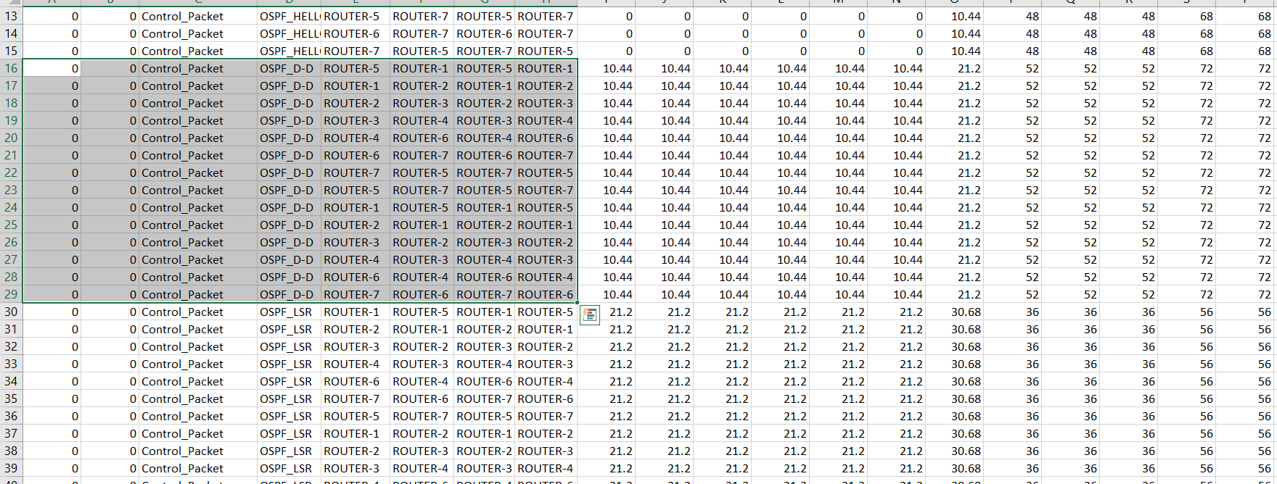

It is exchanged between only neighbor routers.

**ii) What is its use?**

Since link-state routing protocols necessitate that all routers' link-state databases stay synchronized, D-D (Data-Descriptor) packets are utilized.

**iii) What is the time duration of its exchange in theory? Write time duration you observed during your simulation?**

The simulation duration in example 1 was found to be 10.76 microseconds, whereas case 2 showed that the simulation time was 6.2.6 microseconds for links 6 and 7 and 10.76 microseconds for links 1, 2, 3, and 5.

**iv) Explain the core fields of the packet.**

**Interface MTU:** For virtual links, this field is set to 0x0000. (2-bytes)

**Options:** Same as Options field (1-byte)

**I (Initial Bit):** It is the first in the series of DBD packets (1-bit)

**M (More bit):** Specifies if the DBD packet comes last in the sequence of packets. Every packet before it has had a value of 1, but the most recent packet has a value of 0. One bit

**MS (Master/ Slave bit):** Master=1, Slave=0 (1-bit)

**DD Sequence Number:** Used for sorting the DBD packet collection. There should be just one starting value. After that, the sequence number increases by 1 until the entire DD is sent. 4 bytes

**LSA Header:** The LSA headers that describe the database of the local router are contained in this field. (changeable duration)

1. **LSR Packets**:

**i) Is it exchanged between neighbour or all routers?**

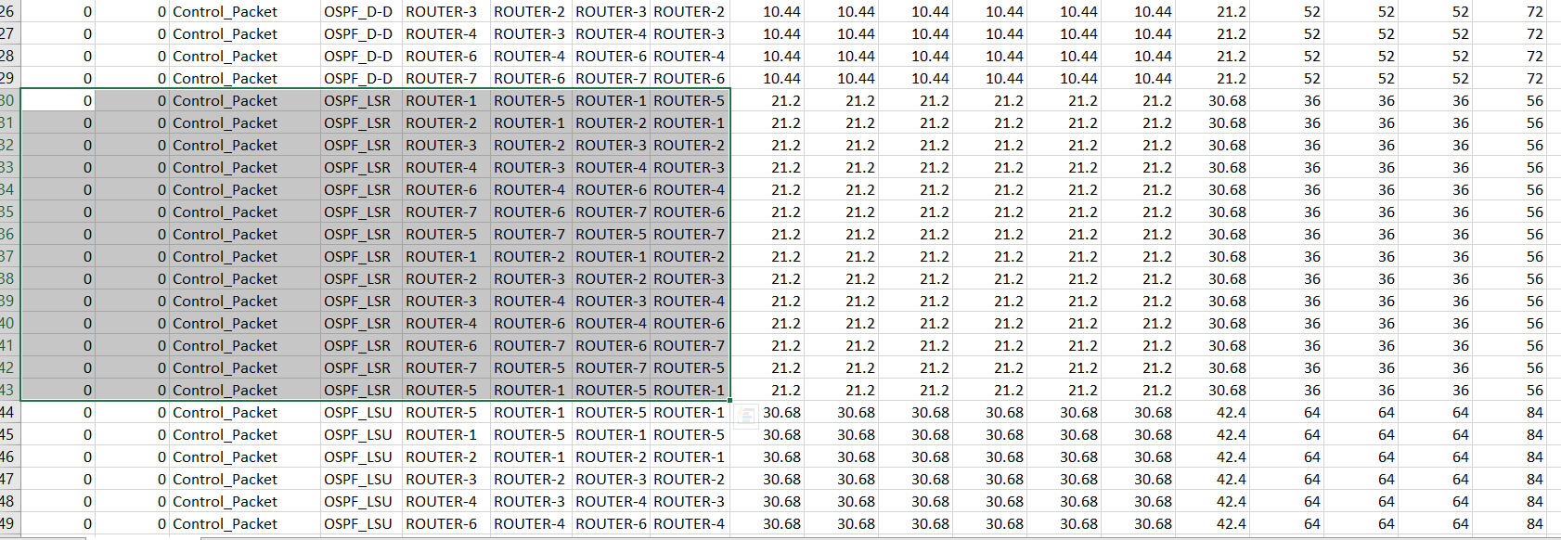

It is exchanged between only neighbor routers.

**ii) What is its use?**

Pieces from the most recent neighbor database update are requested using it.

**iii) What is the time duration of its exchange in theory? Write time duration you observed during your simulation?**

The simulation time in the first example was determined to be 9.48 microseconds, whereas in the second case, the simulation time was determined to be 49.8 microseconds for links 6 and 7 and 9.45 microseconds for links 1, 2, 3, and 4.

**iv) Explain the core fields of the packet.**

**LS Type:** Shows type of LSA requested

**Link State ID:** Depends upon the type of LSA

**Advertising Router:** Gives Router ID of the requesting router.

1. **LSU Packets**:

**i) Is it exchanged between neighbor or all routers?**

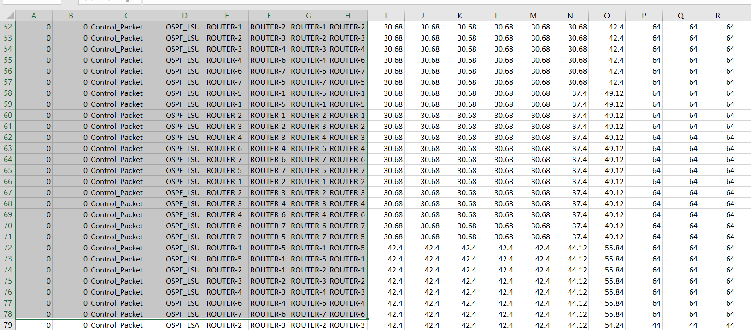

It is exchanged between only neighbor routers.

**ii) What is its use?**

To implement flooding of packets

**iii) What is the time duration of its exchange in theory? Write time duration you observed during your simulation?**

The simulation time in the first example was found to be 11.72 microseconds, whereas in the second case, the simulation time was found to be 72.2 microseconds for links 6 and 7 and 11.72 microseconds for links 1, 2, 3, and 4.

**iv) Explain the core fields of the packet.**

**LSAs:** Number of LSAs within an LSU packet. The complete LSA is encoded within this field and may contain single or multiple LSAs.

1. **LSA Packets**:

**i) Is it exchanged between neighbors or all routers?**

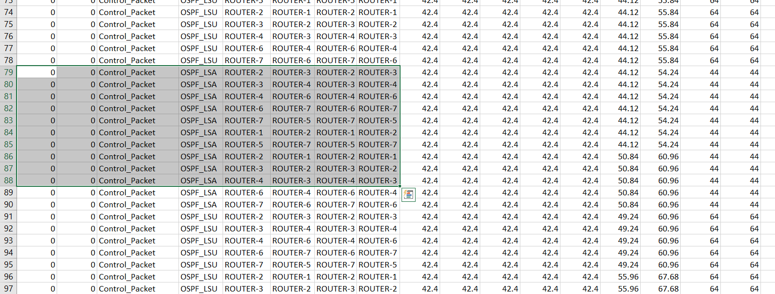

It is exchanged between only neighbor routers.

**ii) What is its use?**

To send acknowledgements of received packets.

**iii) What is the time duration of its exchange in theory? Write time duration you observed during your simulation?**

The simulation time in the first example was found to be 10.12 microseconds, whereas in the second case, the simulation time was found to be 5.6.2 microseconds for links 6 and 7, and 10.12 microseconds for links 1, 2, 3, and 5.

**iv) Explain the core fields of the packet.**

**LS Advertisement Type:** Shows the type of LSA.

**Link State ID:** It depends upon the type of LSA.

**Advertising Router:** Router ID of the advertising router.

**LS Sequence Number:** Sequence number of the packet being acknowledged.

**2) What is the cost of each link in each scenario?**

**Case 1:** Cost of all links: 100/100= 1.

**Case 2:** Cost of links 1,2,3,4 and 5: 100/100=1

Cost of links 6 and 7: 100/10=10.

**3) How the cost is calculated in Net-Sim?**

We use reference bandwidth as 100 Mbps and hence Cost=100/uplink speed.

**Case 1:** Cost of all links: 100/100= 1.

**Case 2:** Cost of links 1,2,3,4 and 5: 100/100= 1

Cost of links 6 and 7 is 100/10=10.

**4) What is the total cost of two paths in each scenario? Show the cost of each link in a graph.**

**Case 1:** Path 1 (1-2-3-4-5): 7

Path 2 (6-7): 4

**Case 2:** Path 1 (1-2-3-4-5): 7

Path 2 (6-7): 22

**5) Write your observation from the two scenarios.**

**For Case 1** as the Cost of path 2 < Cost of path 1, path 2 will be chosen.

**For Case 2** as the Cost of path 1 < Cost of path 2, path 1 will be chosen.

* 1. **Exercise:**

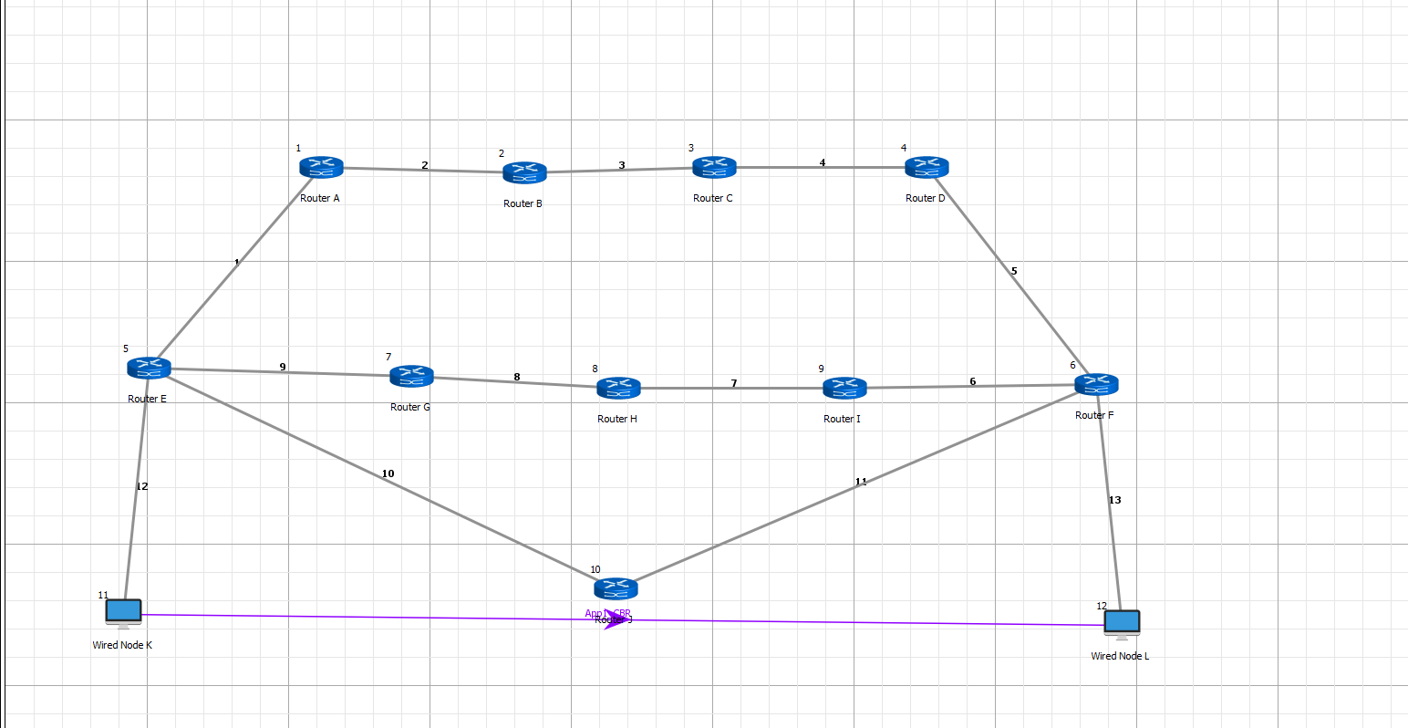

1. **What is cost for all three paths?**

The cost of Path 1 (1-2-3-4-5) is: 52

The cost of Path 2 (8-9-10-11) is: 22

The cost of Path 3 (6-7) is: 22.

1. **What path the data packets take and why? Explain in detail.**

Packets will choose a path with minimum cost. However, here path 2 and path 3 both have a minimum cost of 22. In this case, fewer routers will be given preference as there will be less indexing in the forwarding table. So, path 3 will be chosen.

1. **Question set:**

**4.1. Answer the following:**

**I. Does all the interfaces of routers belong to same network or different network? List down all interfaces of Router A and Router C of exercise 3.3.**

All the interfaces of the router belong to different networks.

**Router A:** Interfaces are 11.1.1.1, 11.3.1.1, 11.9.1.2, 11.11.1.1

**Router B:** Interfaces are 11.4.1.2, 11.5.1.1

**II. Does the router sharing same link belong to same network or different? Observe for any link and write down their Network IP address.**

IP addresses are distinct even though routers connected by the same link share a network. Routers A and B are connected by Link 1, which establishes their network address of 11.3.0.0. However, as every router must have a unique IP address, Router A's address is 11.3.1.1, while Router B's address is 11.3.1.2.

* 1. **Observe and list down parameters of Routing table in detail.**

**Network Destination:** Shows the destination network address.

**Netmask/Prefix length:** Shows subnet mask for destination IP.

**Gateway:** The following device in the path and its IP address.

**Interface:** the router's interface that the packet uses to get to its destination.

**Metrics:** It displays the bare minimum of hops needed to get to the desired location.

**Type:** Gives the kind of routing algorithm that is being used.