Git – Commands Assignment
Name: Akshar Thakkar
Intern_id: INT_1046

Task 1: Repository Setup
- Create a folder named git-assignment-yourfullname
- Navigate into the folder
- Initialize Git repository
- Create a file named index.txt
- Check repository status
- Stage the file
- Commit with message: Initial project setup
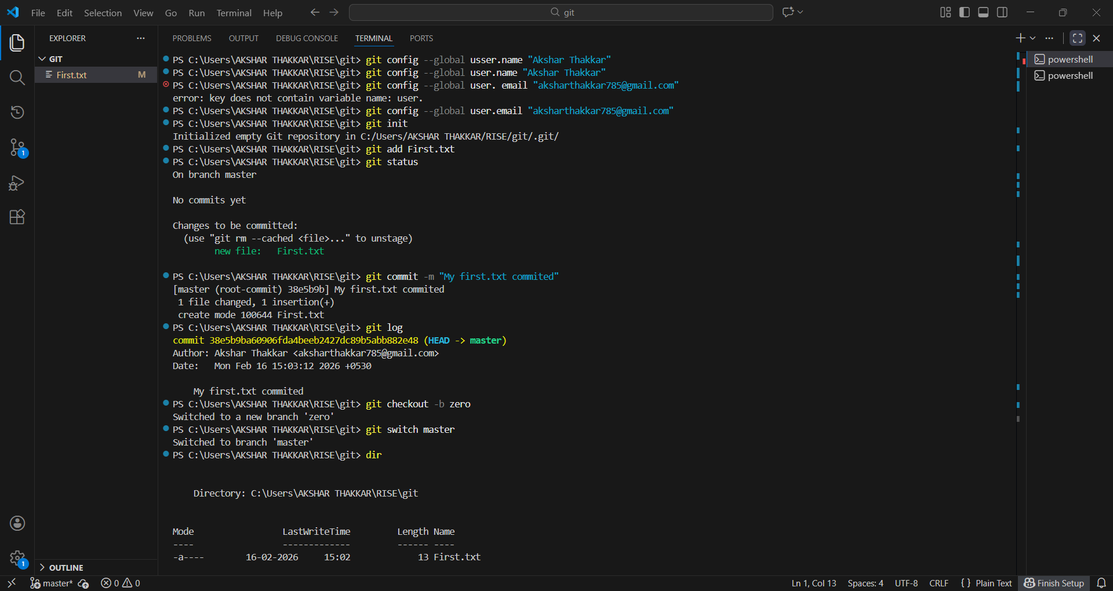
Task 2: Branch Creation & Work
- Create a branch named feature-header
- Switch to feature-header
- Create a file named header.txt
- Stage the file
- Commit with message: Added header section
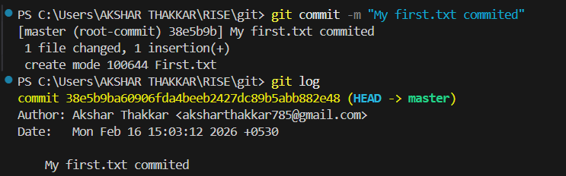
Task 3: Branch Switching Observation
- Switch back to master
- List files and observe
- Switch again to feature-header
- List files and observe
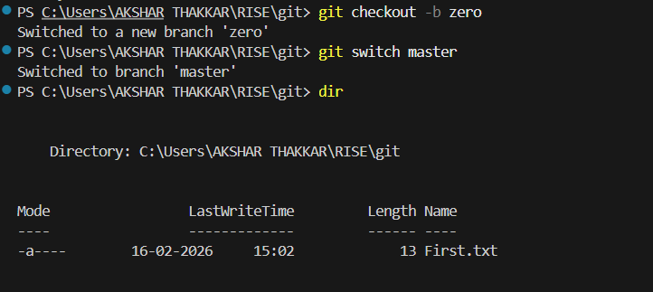
Task 4: Undo a Mistake
- In feature-header, modify index.txt
- Check repository status
- Undo the change using Git
- Verify status again
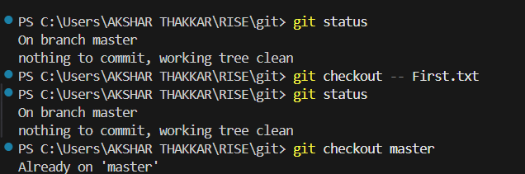
Task 5: Merge Feature Branch
- Switch to master
- Merge feature-header
- Verify merged files
- Check commit history
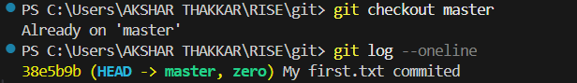

Task 6: Checkout a Commit (Detached HEAD)
- View commit history
- Checkout any older commit
- Check current branch status
- Switch back safely to master
