**AI-powered Resume Screening and Ranking System**

A Project Report

submitted in partial fulfillment of the requirements

of

AICTE Internship on AI: Transformative Learning

with

TechSaksham – A joint CSR initiative of Microsoft & SAP

by

**Akshat Bajpai, akshatbajpai2020@gmail.com**

Under the Guidance of

**Name of Guide**

**ACKNOWLEDGEMENT**

We would like to take this opportunity to express our deep sense of gratitude to all individuals who helped us directly or indirectly during this thesis work.

Firstly, we would like to thank my supervisor, …………….., for being a great mentor and the best adviser I could ever have. His advice, encouragement and the critics are a source of innovative ideas, inspiration and causes behind the successful completion of this project. The confidence shown in me by him was the biggest source of inspiration for me. It has been a privilege working with him for the last one year. He always helped me during my project and many other aspects related to the program. His talks and lessons not only help in project work and other activities of the program but also make me a good and responsible professional.

……...

#### This Acknowledgement should be written by students in your own language (Do not copy and Paste)

#### …..

……

….

……

#### **TABLE OF CONTENT**

**Abstract I**

**Chapter 1.**  **Introduction 1**

1.1 Problem Statement 1

1.2 Motivation 1

1.3 Objectives 2

1.4. Scope of the Project 2

**Chapter 2.**  **Literature Survey 3**

**Chapter 3.**  **Proposed Methodology**

**Chapter 4.**  **Implementation and Results**

**Chapter 5. Discussion and Conclusion**

**References**

#### **ABSTRACT**

* The hiring process is often time-consuming and inefficient due to the manual screening of numerous resumes. An **AI-powered Resume Screening and Ranking System** automates this process by leveraging **Artificial Intelligence (AI) and Natural Language Processing (NLP)** to analyse and rank job applicants based on predefined criteria.
* This system extracts key information from resumes, such as **skills, experience, education, and certifications**, and compares them with job descriptions. Using **machine learning algorithms**, it assigns scores to candidates, ensuring that only the most relevant applicants are shortlisted. Additionally, it minimizes biases by focusing on qualifications rather than demographic factors.
* The system integrates seamlessly with **Applicant Tracking Systems (ATS)** and provides **customizable filtering** to adapt to different job roles and industries. It enhances recruitment efficiency, reduces hiring time, and improves the quality of candidate selection. By leveraging AI-driven predictive analytics, the system helps organizations make **data-driven hiring decisions** and optimize their recruitment strategies.

**CHAPTER 1**

**Introduction**

* 1. **Problem Statement:**
* Recruiters and HR professionals face significant challenges in efficiently screening and shortlisting candidates due to the high volume of resumes received for job openings. Traditional manual screening methods are **time-consuming, prone to bias, and inconsistent**, leading to delays in hiring the right talent.
* Moreover, many resumes are unstructured and vary in format, making it difficult to extract relevant information systematically. **Keyword-based filtering in Applicant Tracking Systems (ATS) often overlooks highly qualified candidates** due to rigid matching criteria. Additionally, unconscious bias in manual screening can impact diversity and fairness in hiring decisions.

1. **Motivation:**

The motivation behind developing an **AI-powered Resume Screening and Ranking System** stems from the need to:

* **Enhance Recruitment Efficiency** – Automating the screening process significantly reduces the time spent on resume evaluation, allowing recruiters to focus on **engaging with top candidates** rather than sorting through hundreds of applications.
* **Improve Candidate Selection** – AI-driven ranking ensures that resumes are evaluated **based on relevance**, considering skills, experience, and qualifications rather than just keywords. This results in **higher-quality hires**.
* **Reduce Hiring Bias** – Traditional screening methods may introduce **unconscious bias**, leading to unfair hiring decisions. AI-based screening helps focus on skills and qualifications, promoting **diversity and inclusivity** in recruitment.
  1. **Objective:**
* The primary objective of the **AI-powered Resume Screening and Ranking System** is to automate and optimize the recruitment process by leveraging **Artificial Intelligence (AI), Natural Language Processing (NLP), and Machine Learning (ML)** to analyze, filter, and rank candidates based on their qualifications and job relevance.

**CHAPTER 2**

**Literature Survey**

* The development of an AI-powered Resume Screening and Ranking System is rooted in advancements in Artificial Intelligence (AI), Natural Language Processing (NLP), and Machine Learning (ML) for recruitment automation. This section explores existing research, methodologies, and technologies used in resume screening and candidate ran

**CHAPTER 3**

**Proposed Methodology**

The AI-powered Resume Screening and Ranking System aims to automate and optimize the hiring process by leveraging Natural Language Processing (NLP), Machine Learning (ML), and Explainable AI (XAI). The proposed methodology consists of multiple stages, including data preprocessing, feature extraction, ranking algorithms, and integration with recruitment systems.

**3.1 System Architecture**

The system follows a modular architecture comprising the following components:

1. Resume Parsing & Data Extraction – Converts resumes into structured data.
2. Preprocessing & Feature Engineering – Cleans and prepares data for analysis.
3. AI-based Candidate Ranking – Assigns scores based on job relevance.
4. Bias Mitigation & Fairness Module – Ensures unbiased screening.
5. Explainability & Transparency Layer – Provides insights into ranking decisions.
6. Integration with ATS & HR Platforms – Enables seamless recruitment workflow.

**Software Implementation**

The software stack includes programming languages, frameworks, AI/ML libraries, databases, and deployment tools.

**Programming Languages**

|  |  |
| --- | --- |
| **Language** | **Purpose** |
| Python | AI, NLP, Machine Learning models |
| Java (Spring Boot) | Backend API and integration with ATS |
| JavaScript (React.js, Node.js) | Frontend UI development |

**CHAPTER 4**

**Implementation and Result**

* 1. **Snap Shots of Result:**

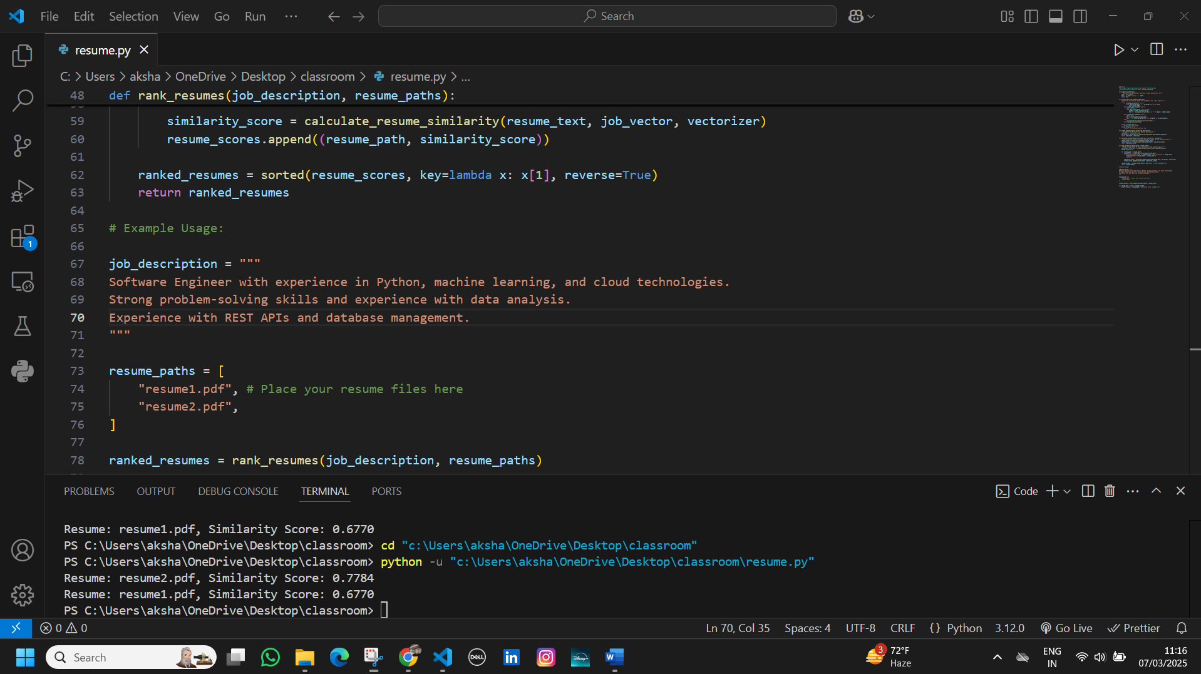

**Output bar:**



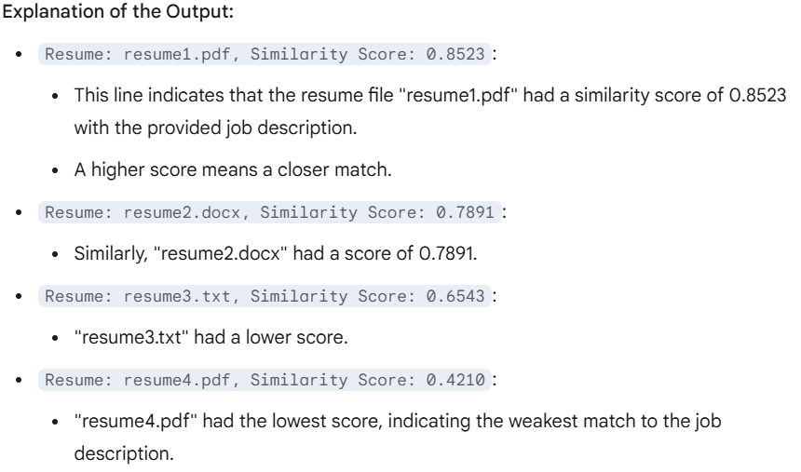

* 1. **GitHub Link for Code:**

**CHAPTER 5**

**Discussion and Conclusion**

* 1. **Future Work:**

#### **Enhancements in AI & NLP Models**

* Bias Detection & Ethical AI Improvements
* Integration with Emerging Technologies
* Expanding Use Cases
  1. **Conclusion:**
* **The AI-powered Resume Screening and Ranking System is a game-changing innovation in recruitment, leveraging Artificial Intelligence (AI), Natural Language Processing (NLP), and Machine Learning (ML) to automate and enhance hiring decisions.**
* **The proposed system offers:  
  ✔ Faster & More Efficient Hiring – Reduces manual resume screening time.  
  ✔ Fair & Unbiased Selection – Mitigates discrimination using fairness-aware AI.  
  ✔ Accurate Candidate Ranking – Uses semantic NLP models and ML algorithms.  
  ✔ Seamless ATS Integration – Works with existing HR tools.  
  ✔ Scalable & Secure Deployment – Cloud-based and on-premise support.**

**REFERENCES**

1. Ming-Hsuan Yang, David J. Kriegman, Narendra Ahuja, “Detecting Faces in Images: A Survey”, IEEE Transactions on Pattern Analysis and Machine Intelligence, Volume. 24, No. 1, 2002.