Name - Akshat Sharma
Section - B
Batch - B2 Roll No - 28
Subject - Computer Vision TA-2 Mini Project

1. Implement the SIFT algorithm to detect and match key points between two images.

Original Images

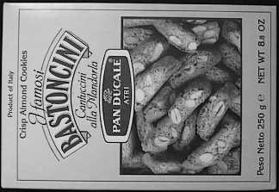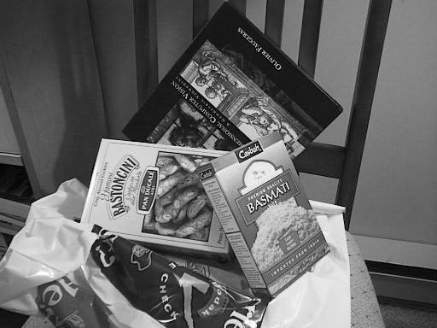

Output Image
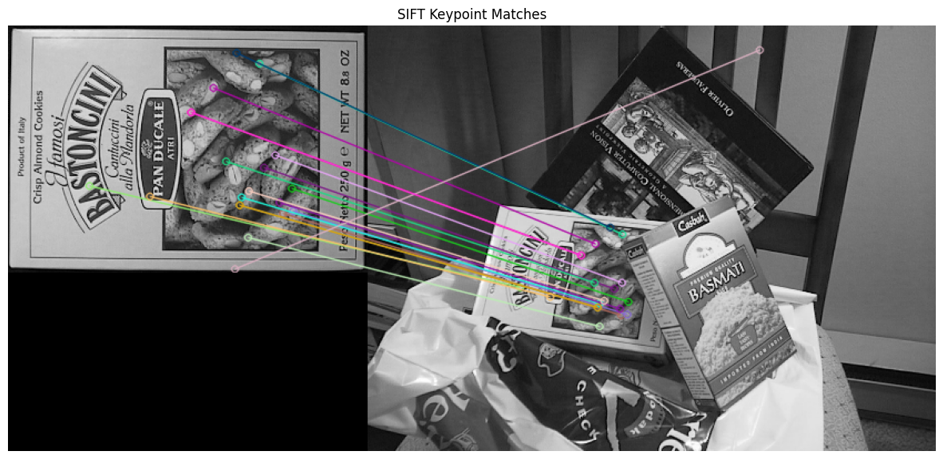

2. Use RANSAC to remove outlier key point matches and fit a transformation model between two images.

Original image
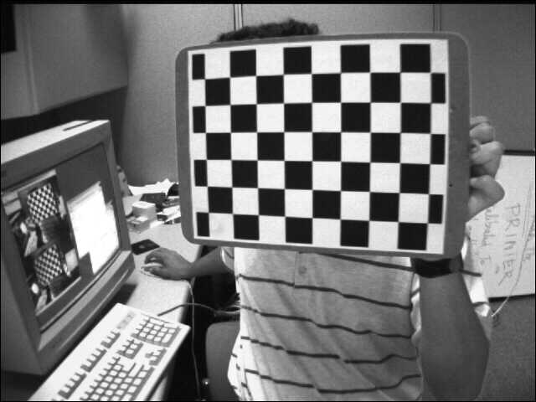
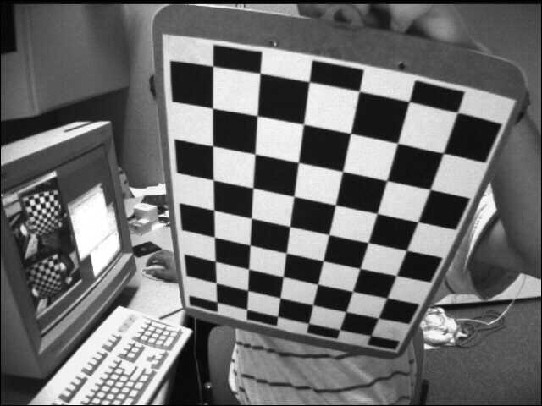

Output Image
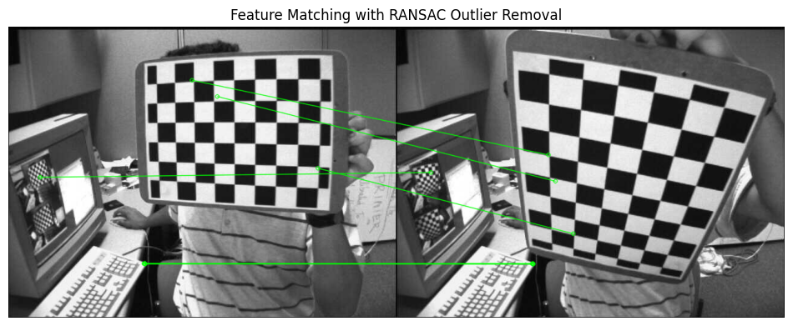

3. Implement the Harris corner detector to find and visualize corners in a grayscale image.

Original image
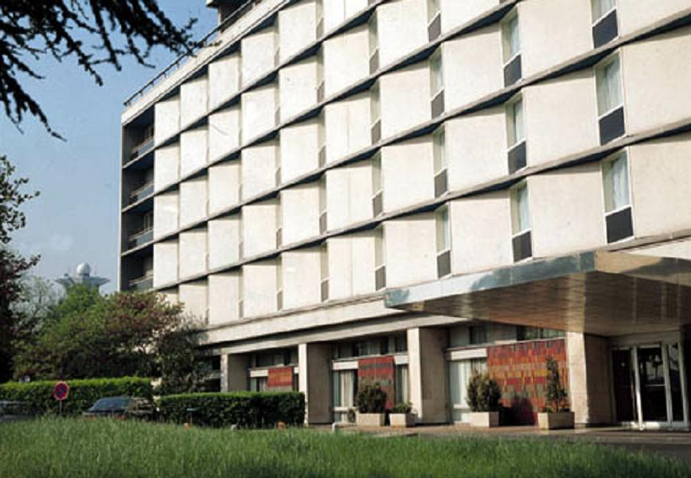

Output Image

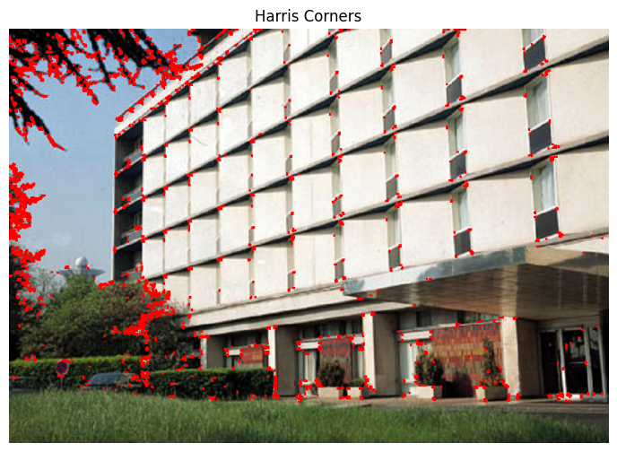

GitHub Link - https://github.com/Akshat-6/Computer-Vision-

