- Create a Google Form Quiz with the following requirements:
a) Convert the form into a Quiz mode with automatic grading.
b) Add 5 MCQ questions, each carrying 2 marks.
c) Add 1 short answer question that requires manual evaluation.
d) Turn ON the setting:
a. Limit to 1 response
b. Shuffle question order
c. Release marks after manual review
e) Add a timer add-on (like form presenter) and set up a 10-minute time limit.
f) Finally, send the quiz link and view the response summary.

Form:
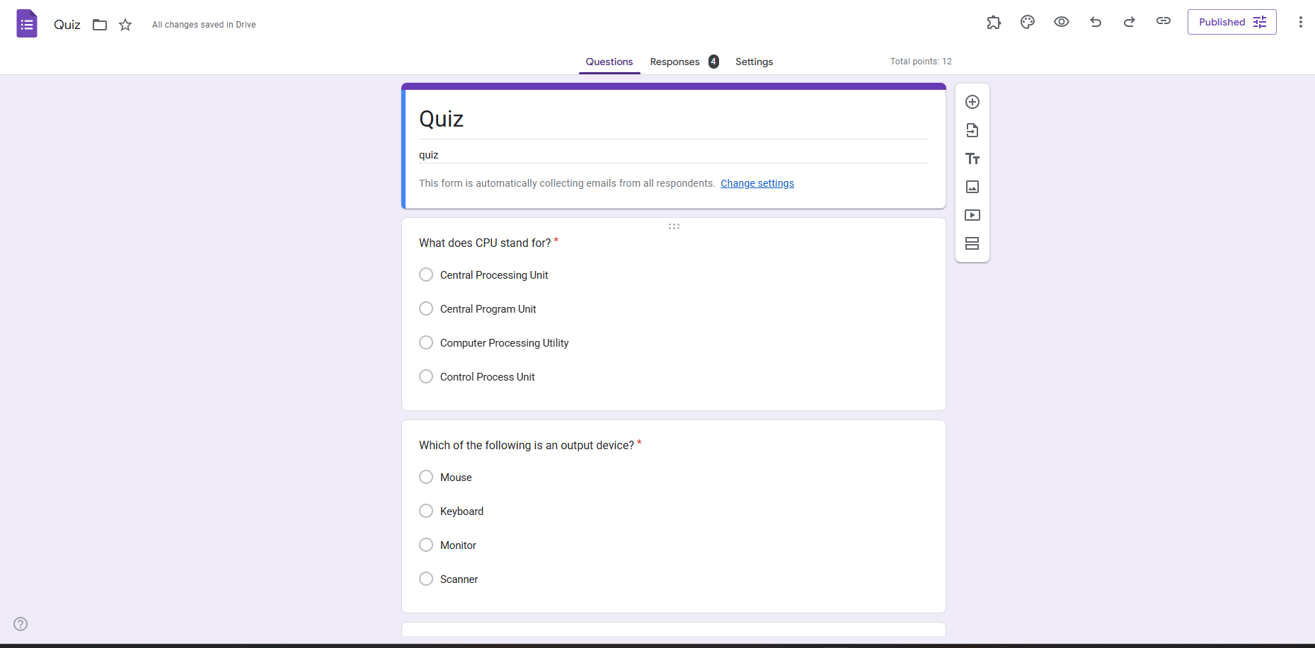
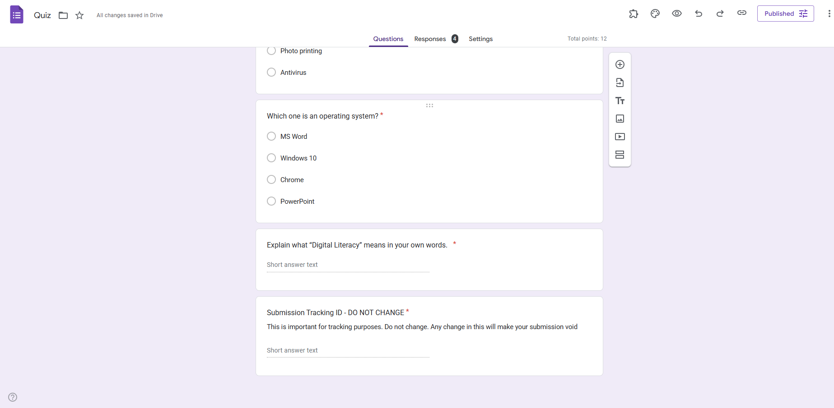

The Response charts:
