- Design a complete Google Form survey and analyze responses.
a) Create a Google Form titled “Student Attendence Report”.
b) Include the following question types:
a. 5 MCQs
b. 1 Rating scale (1–5)
c. 1 Short answer
d. 1 Checkbox question
c) Customize the theme (header image + color).
d) Share the form link with 5 friends and collect responses.
e) Generate charts from responses and take screenshots of the analysis page.

The form looks like this:
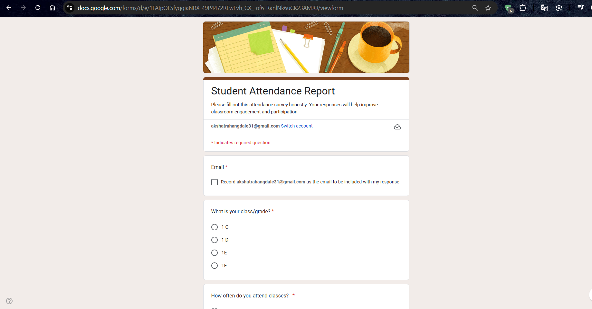
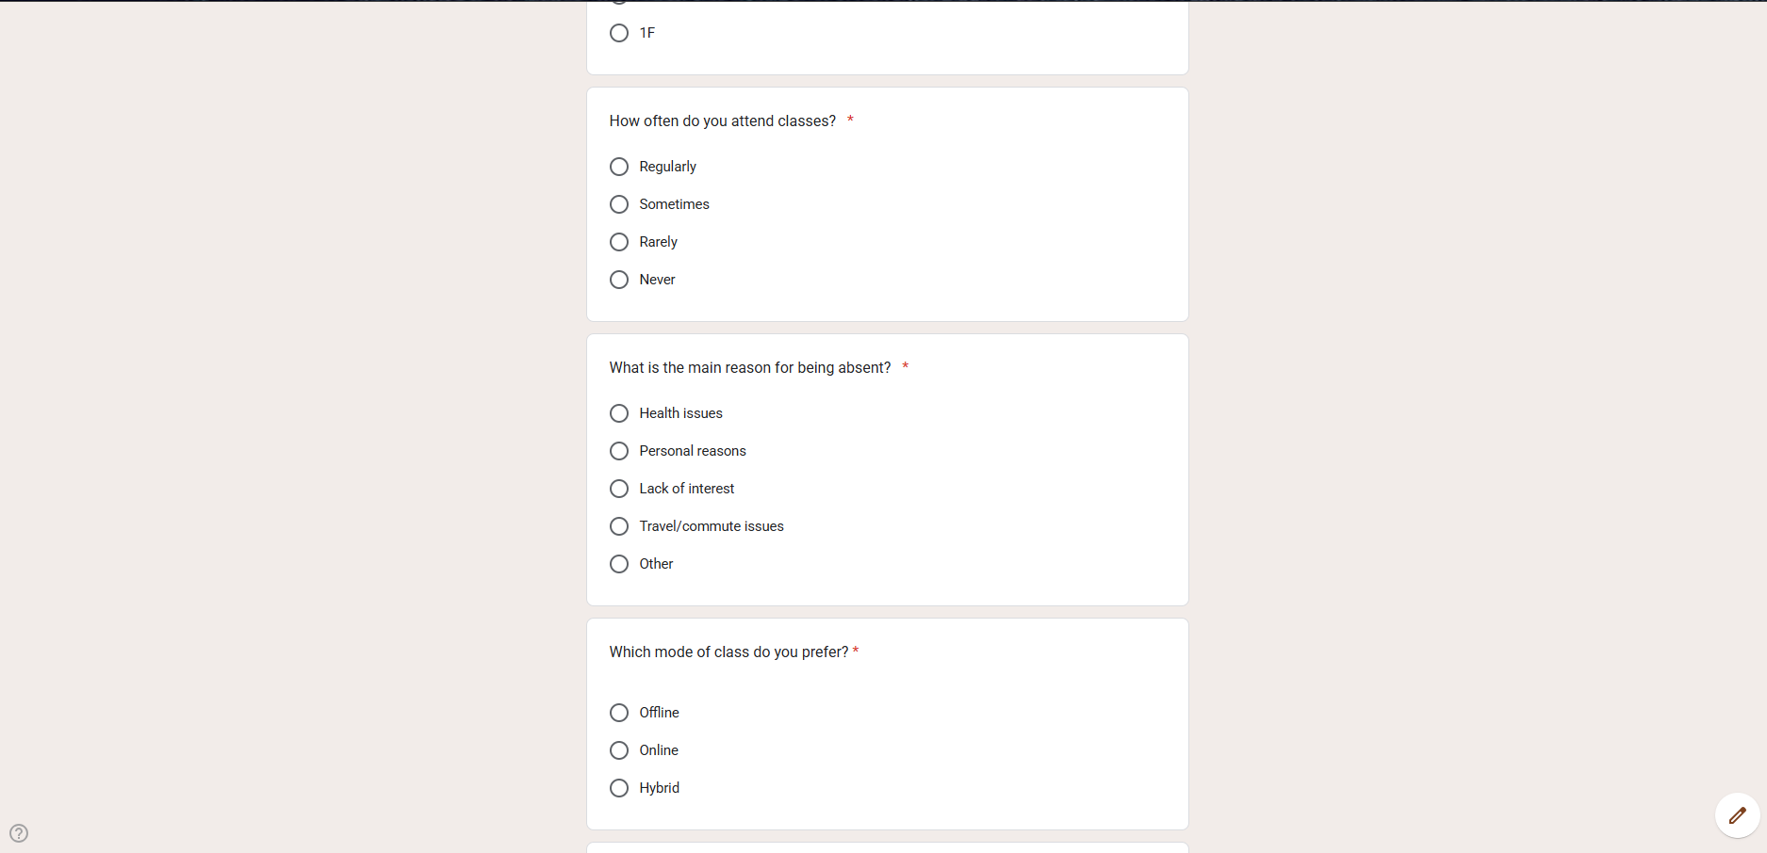
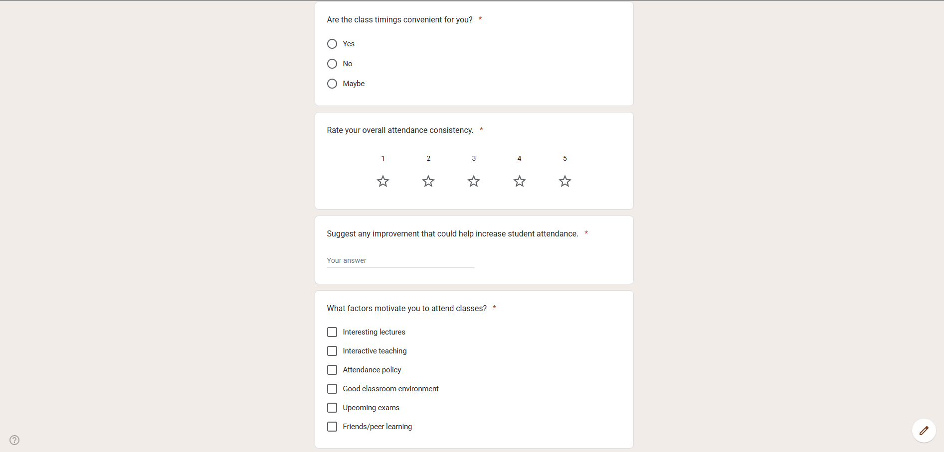

The Response charts:

