- Demonstrate the creation and management of your digital identity.
a) Create a social media profile (LinkedIn preferred).
b) Add a profile photo, short bio, skills, and education details.
c) Create a simple post about “My Learning Journey in Digital Literacy.”
d) Change your privacy settings to:
a. Who can see your posts.
b. Who can message you

Screen Shot of the profile page:
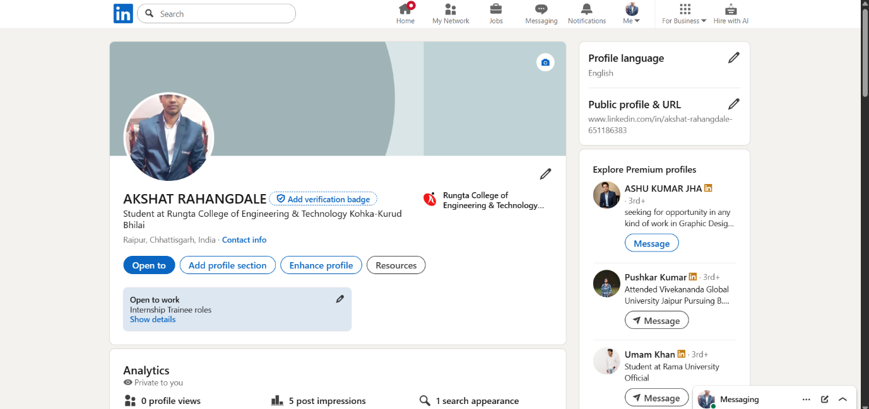

Screen Shot of the post:
