PROJECT REPORT
AI-Driven Digital Twin for Smart Factory Operations

Submitted by | Akshat Kaushal
Programme | B.Tech – Electronics & Communication Engineering
Institution | ABES Engineering College, Ghaziabad
Academic session | 2026–27
Project domain | Embedded Systems & IoT
Implementation status | Simulated telemetry prototype; physical ESP32 integration pending

Abstract
This project presents an educational prototype of an AI-assisted digital-twin monitoring pipeline for a smart-factory machine. Simulated machine telemetry is received through a message-ingestion service, stored in InfluxDB Cloud, analysed by a PyTorch neural-network classifier and visualized in Grafana. The current software accepts seven parameters: temperature, pressure, motor speed, vibration, current, voltage and humidity. The prototype demonstrates the software flow from telemetry ingestion to status visualization. The supplied AI training set is very small and has not been independently validated; therefore, the output is treated as an experimental classification score rather than an industrial failure probability. Physical ESP32 and sensor integration remains a planned step pending firmware and hardware verification.

Chapter 1 – Introduction
Smart manufacturing uses connected devices and software systems to make machine information easier to monitor. A digital-twin concept maintains a digital representation of an asset using data associated with that asset. This project focuses on a small-scale monitoring prototype rather than a production-grade digital twin.

Chapter 2 – Problem and objectives
The project aims to demonstrate how machine telemetry can be collected, stored, classified and visualized. The objectives are to receive seven numeric parameters, store time-series records, run a prototype classifier, show status and trends, and document verification.

Chapter 3 – System design
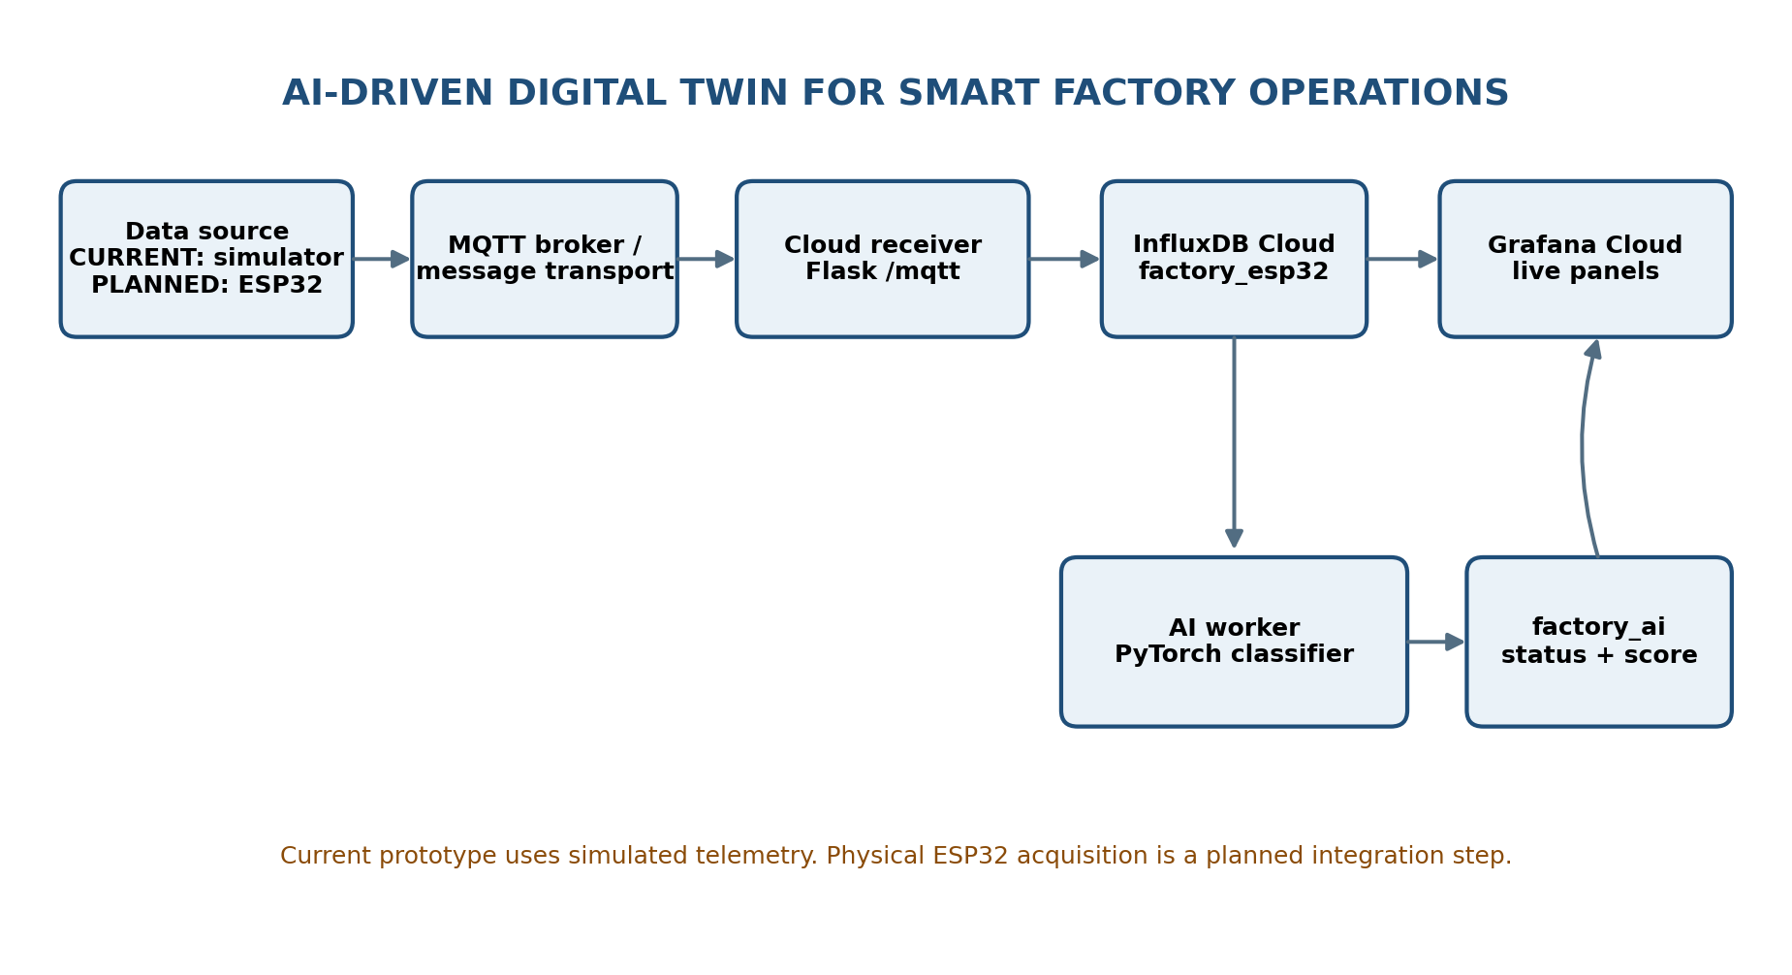
The current software architecture comprises a simulated data source, message transport, Flask receiver, InfluxDB Cloud, PyTorch AI worker and Grafana Cloud. The Flask endpoint maps incoming topic names to fields and writes them to factory_esp32. The AI worker queries the latest complete field values and writes its output to factory_ai.

Chapter 4 – Implementation
The supplied cloud_receiver/app.py implements the HTTP health endpoint and /mqtt ingestion route. It validates JSON presence, recognized topic names and numeric payloads. cloud_receiver/ai_worker.py defines a feed-forward neural network with seven inputs and trains it on eight hard-coded examples. It queries InfluxDB, checks that all seven fields are present and that the latest timestamp is not older than 15 seconds, then assigns NORMAL, WARNING or FAULT using 0.50 and 0.80 thresholds. src/esp32_ai.py contains a second local AI/InfluxDB processing implementation; it should not be run concurrently with the cloud AI worker unless duplicate writes are intentionally managed.

Chapter 5 – Results and testing
No test execution evidence was supplied with the repository ZIP. Therefore, this report does not claim measured latency, accuracy, recall, uptime, successful physical sensor acquisition or passing test cases. The accompanying Test_Cases.xlsx lists the tests and starts each test in Not Run status. Results must be filled after execution.

Chapter 6 – Limitations
- The current telemetry source for demonstration is simulated.
- The ZIP contains no Arduino firmware file; the owner reports firmware is in a separate local HCL folder.
- The classifier is trained on only eight examples and lacks an independent test set.
- No feature normalization or probability calibration is shown in the supplied AI code.
- The receiver does not currently check InfluxDB HTTP error status before returning success.
- The existing Grafana query file uses a measurement name inconsistent with the receiver.
- The current receiver maps seven fields; power is not a supported telemetry field in this implementation.

Chapter 7 – Future work
- Review and integrate the local ESP32 firmware and verify each sensor pin and unit.
- Create a repeatable simulator with labelled normal and fault scenarios.
- Expand the training dataset, scale features, split train/validation/test data and report metrics.
- Persist a trained model artifact and version its preprocessing/model parameters.
- Correct receiver error handling and add structured logging.
- Verify Grafana queries, alerts and dashboard screenshots.
- Add multi-machine support and additional digital-twin features only after core telemetry is stable.

Conclusion
The project provides a foundation for an Industrial IoT monitoring prototype with cloud time-series storage, AI-assisted classification and dashboard visualization. The current deliverable should be evaluated as a simulated software prototype. Hardware integration and reliable AI validation are important next steps before describing it as a validated physical predictive-maintenance system.

References / project artefacts
- HCLTech, Project Creation Guide – Embedded Systems & IoT, Version 1.0, September 2026 (user-provided guide).
- Project source repository ZIP supplied by the project owner (README.md, cloud_receiver/app.py, cloud_receiver/ai_worker.py, src/esp32_ai.py, grafana/queries.md, requirements files and docs/SRS.docx).

