SOFTWARE REQUIREMENTS SPECIFICATION
AI-Driven Digital Twin for Smart Factory Operations

Version | 1.0 – Revised implementation-aligned draft
Date | 30 October 2026
Prepared by | Akshat Kaushal
Programme | B.Tech ECE-A, 3rd Year
Institution | ABES Engineering College, Ghaziabad
Reference implementation | GitHub ZIP supplied by the project owner
Current operating mode | Simulated telemetry; physical ESP32 integration pending verification

Revision note
This SRS replaces aspirational requirements in the earlier draft with a clear separation between implemented prototype requirements and future requirements. Requirements are not evidence of successful testing.

1. Introduction
This document specifies the software requirements for an educational Industrial IoT prototype that receives simulated machine telemetry, stores it in InfluxDB Cloud, performs AI-assisted classification and presents results through Grafana.

1.1 Purpose
The purpose is to define the current software behaviour, interfaces, constraints and verification approach so that implementation and evaluation can be performed consistently.

1.2 Scope
The current scope is a single logical machine (machine1) and seven telemetry fields. Physical ESP32 acquisition, multi-machine management, user accounts, RUL prediction and control of industrial equipment are outside the demonstrated scope.

2. Overall description
The prototype consists of a telemetry source (currently simulated), message transport, a Flask receiver, InfluxDB Cloud, a PyTorch background worker and Grafana Cloud. The receiver accepts JSON containing topic and payload, maps a recognized topic substring to a measurement field, converts the payload to a floating-point value and submits a line-protocol write to InfluxDB.

2.1 User classes
The current prototype is intended for a student developer or evaluator who can configure environment variables, run the Python service and inspect the Grafana dashboard. Authentication and role separation are not implemented in the supplied code.

2.2 Operating environment
- Python environment with the dependencies listed in requirements.txt.
- Flask application exposed through a local or hosted HTTP endpoint.
- InfluxDB Cloud v2-compatible write/query API.
- Grafana configured with the matching InfluxDB organization, bucket and queries.
- MQTT/message integration capable of forwarding topic and payload as JSON to /mqtt.

3. System architecture
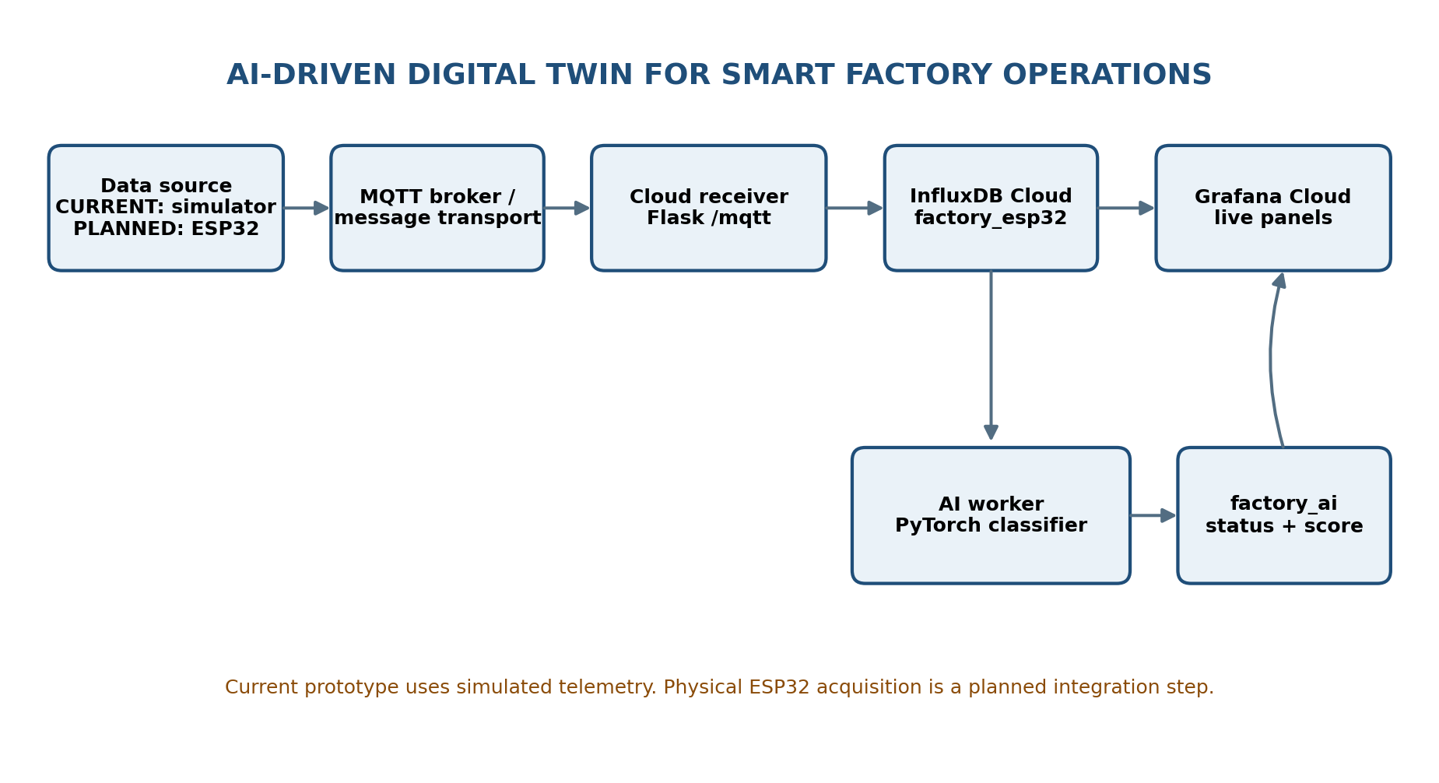
The diagram shows the intended prototype data path. The current source code implements the Flask receiver and AI worker; the actual simulator/broker configuration is external to the supplied ZIP and must be verified during setup.

4. Functional requirements
ID | Requirement | Implementation status / note | Priority
FR-01 | The receiver shall expose a GET / health endpoint. | Implemented in supplied app.py | High
FR-02 | The receiver shall expose a POST /mqtt endpoint accepting JSON. | Implemented in supplied app.py | High
FR-03 | The receiver shall reject missing or invalid JSON. | Implemented in supplied app.py | High
FR-04 | The receiver shall map topic names containing temperature, pressure, motor_speed, vibration, current, voltage or humidity to the matching field. | Implemented in supplied app.py | High
FR-05 | The receiver shall reject unrecognized topics. | Implemented in supplied app.py | High
FR-06 | The receiver shall reject payloads that cannot be converted to numeric values. | Implemented in supplied app.py | High
FR-07 | The receiver shall write accepted telemetry to the InfluxDB measurement factory_esp32 with machine and source tags. | Present; InfluxDB HTTP response is not currently checked with raise_for_status(). | High
FR-08 | The AI worker shall query recent factory_esp32 records for the seven required fields. | Implemented in supplied ai_worker.py | High
FR-09 | The AI worker shall wait until all seven fields are available and sufficiently recent. | Implemented in supplied ai_worker.py; verify timestamps and query semantics in testing. | High
FR-10 | The AI worker shall run a PyTorch binary classifier and calculate a sigmoid score. | Implemented in supplied ai_worker.py | High
FR-11 | The AI worker shall classify the score as NORMAL (<0.50), WARNING (0.50–<0.80) or FAULT (≥0.80). | Implemented in supplied ai_worker.py; thresholds are configurable project values. | High
FR-12 | The AI worker shall write score, status and parameter values to factory_ai. | Implemented in supplied ai_worker.py | High
FR-13 | Grafana shall display time-series telemetry and AI output from the configured InfluxDB bucket. | Dashboard configuration is external; queries require correction and verification. | High

5. Non-functional requirements
ID | Category | Requirement | Status
NFR-01 | Configuration | Secrets and service configuration shall be provided through environment variables, not committed source code. | To verify
NFR-02 | Data validation | Malformed JSON, unknown topics and non-numeric payloads shall be rejected with a client error response. | Partly implemented; test
NFR-03 | Reliability | The receiver shall report an InfluxDB write failure rather than return success when the write API rejects the request. | Gap in supplied app.py
NFR-04 | Freshness | The AI worker shall not classify stale telemetry beyond its configured freshness window. | Implemented as 15-second age check; test
NFR-05 | Maintainability | Modules, configuration and documentation shall use consistent names and field definitions. | Needs cleanup
NFR-06 | Security | Credentials shall be kept out of Git and rotated if previously exposed. | Operational requirement
NFR-07 | Model validity | Model performance shall be evaluated on a separate, representative labelled dataset before accuracy claims are made. | Not yet satisfied

6. External interfaces
Interface | Current specification
HTTP input | POST /mqtt with JSON keys topic and payload; payload must be numeric after string conversion.
Telemetry topics | Topic string must contain one of: temperature, pressure, motor_speed, vibration, current, voltage, humidity.
InfluxDB telemetry | Measurement factory_esp32; tags machine=machine1 and source=ESP32; one numeric field per incoming request.
InfluxDB AI output | Measurement factory_ai; tags machine=machine1 and source=ESP32_AI; fields include fault_probability, seven input values and ai_status.
Dashboard | Grafana Cloud using InfluxDB Cloud bucket Smart_factory (confirm exact bucket spelling and case in deployed account).

7. Data definitions
Field | Meaning | Unit
temperature | Machine/environment temperature | Confirm sensor/model unit; commonly °C
pressure | Machine pressure | Confirm sensor unit; e.g. bar or kPa
motor_speed | Rotational speed | rpm
vibration | Vibration magnitude | Confirm sensor scaling and unit
current | Electrical current | A
voltage | Electrical voltage | V
humidity | Relative humidity | %RH

The supplied code does not define or validate engineering units, calibration, physical ranges or a power field. Units and valid operating ranges must be confirmed against the actual sensors and machine specification.

8. AI model constraints
The supplied AI worker uses seven input features, a feed-forward neural network with layers 7→16→8→1, ReLU hidden activations, BCEWithLogitsLoss, Adam optimizer and 2,000 training epochs. Its training set contains eight examples. No independent validation/test set, feature scaling, saved model artifact or calibration process is supplied. Accordingly, its output is a prototype classification score only.

9. Exclusions and future enhancements
- Physical ESP32 sensor acquisition and verified firmware-to-cloud operation.
- Power as a separate telemetry field (not mapped by the current receiver).
- User login, role-based access and device administration.
- Health index, remaining useful life (RUL), predictive maintenance scheduling and what-if simulation.
- Automated email/SMS alerts and actuator control.
- Multi-machine scaling and production-line digital-twin visualization.
- Model retraining pipeline, held-out validation, model versioning and calibrated confidence.

10. Verification approach
Each requirement shall be verified using the test cases in Test_Cases.xlsx. Test status must remain Not Run until the test is executed and evidence (logs, screenshots, query output or measured values) is captured.

11. Approval
Role | Name | Signature / date
Student developer | Akshat Kaushal | Pending
Project mentor | To be filled by mentor | Pending

