**Software Requirements Specification (SRS) Document**

|  |  |
| --- | --- |
|  | Demand Forecasting of Air Conditioning for Commercial Complex  Team 12  Akshat Goyal, Kanish Anand, Nikunj Nawal and Sridhar M |

# Brief problem statement

Given the energy consumption data of any building, we have to estimate the future energy demand of the complex on an hourly and daily basis. We are supposed to create a web application for the same problem statement.

# System requirements

# Frontend - HTML, CSS , JavaScript, React

# Backend - NodeJS

# Database - MongoDB

# Machine Learning - Python3, Mathematics and ML libraries

# Cloud Hosting - Azure or AWS (NOT NECESSARY FOR THE PROJECT)

# API - Open Weather API

# Users profile

# The different users (wrt a particular complex) who would be using the software include :

|  |  |  |
| --- | --- | --- |
| S.No. | USER | Description |
| 1 | Owner | The Owner will have full access to the product, will be familiar with using the software and can monitor the energy consumption rate, generate reports and act accordingly. |
| 2. | Finance Team | The Finance team will use future energy consumption to plan expenditure and predict the cost of electricity. |
| 3. | Maintenance/Tech Team | The Maintenance team will ensure the maintenance of the software with the changing system environment and will provide updates. |

# Feature requirements (described using use cases)

|  |  |  |  |
| --- | --- | --- | --- |
| **No.** | **Use Case Name** | **Description** | **Release** |
| 1. | View predicted values for energy consumption on Jupyter notebook | Users can get the prediction of hourly and daily energy consumption by using the Jupyter Notebook. Functional Web-app not included | R1 |
| 2. | View energy consumption graph of data provided on Jupyter notebook | Users can get a graphical analysis of energy consumption.The output should correspond to the given data | R1 |
| 3. | Login and Register for different roles for the system | Different type of users can firstly register and then log in to access pages customized to their needs | R1 |
| 4. | View predicted value for energy consumption | Users can get the prediction of hourly and daily energy consumption in the functional Web-app. | R2 |
| 5. | Get help regarding the web-app | User will be able to contact the maintainer of the Web-app for any kind of help using automated mail | R2 |
| 6. | Give user feedback via the web-app | User will be able to give feedback using the feedback form and mail to the help person | R2 |
| 7. | View graphical analysis of energy consumption | Users can get a graphical analysis of energy consumption using Web-app. | R2 |
| 8. | Download the generated energy consumption prediction graphs | Users will be able to download the generated graph of energy consumption predictions. | R2 |
| 9. | Download the given energy consumption data in form of graphs | Users will be able to download the generated graph for energy consumption data. | R2 |
| 10. | Download the generated budget prediction graphs | Users will be able to download the generated graph of budget predictions. | R2 |
| 11. | View budget Prediction | Users will be able to get a predicted value of budget after giving desired inputs. | R2 |
| 12. | View notification for an anomaly | In case of some forged anomalous data a notification will be given to the user | R2 |
| 13. | View actual data of energy consumption | User will be able to check the actual data of energy consumptions | R2 |
| 14. | View current energy consumption | User will be able to check live energy consumption data which will be updating with time | R2 |
| 15. | Check the total consumption of energy | User will be able to view the total energy consumption | R2 |
| 16. | Update profile of the logged-in user | User can update their profiles after log in | R2 |
| 17. | Update the email for receiving the anomalous data updates | User can update the email to receive the emails about  the anomalous data and other notifications. | R2 |
| 18. | View weather forecast | User will be able to view weather related forecast(e.g. temperature) | R2 |
| 19. | View anomaly cases as a list | A list for all the anomalies will be available to the user | R2 |
| 20. | Select API for weather forecast | Selecting API will give value corresponding to their site | R2 |

**Use case diagram**

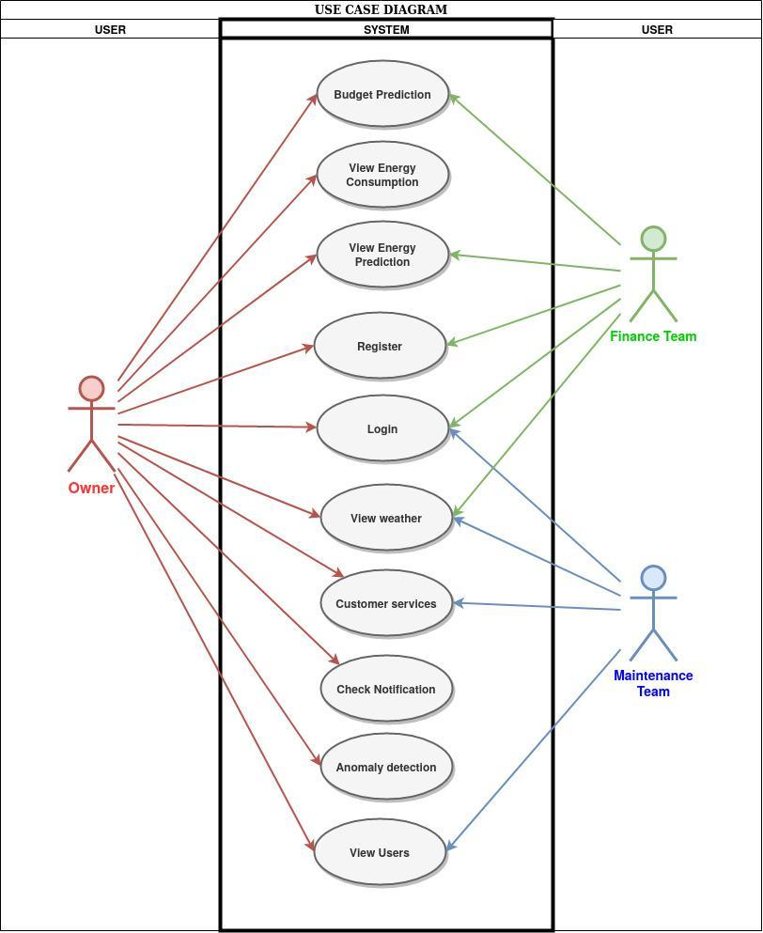

**Use case description**

|  |  |
| --- | --- |
| **Use Case :** | 1 |
| **Use Case Name:** | View predicted values for energy consumption on Jupyter notebook. |
| **Overview:** | Users can get the prediction of hourly and daily energy consumption by using the Jupyter Notebook. This can be very useful for the customer to already know the future consumption and therefore can take measures to reduce consumption. |
| **Actors:** | Owner, Finance Department |
| **Precondition:** | The data of the building is required to train the model. Data cleaning and feature engineering are required before training the model. |
| **Flow:** | Users will give the date and time to get to know data consumption. |
| **Post Condition:** | Users will get a real-time prediction of energy consumption. |

|  |  |
| --- | --- |
| **Use Case :** | 2 |
| **Use Case Name:** | View energy consumption graph of data provided on Jupyter notebook |
| **Overview:** | Users can get a graphical analysis of energy consumption. The graph will show monthly, weekly, daily, hourly energy consumption. This will help the user to know which time has the peak energy consumption, why and so on. |
| **Actors:** | Finance Department |
| **Precondition:** | The database of past energy consumption is required. |
| **Flow:** | The user will give the time range for which graphical analysis is to be done. |
| **Post Condition:** | The graph of energy consumption will be displayed |

|  |  |
| --- | --- |
| **Use Case :** | 3 |
| **Use Case Name:** | Login and Register |
| **Overview:** | The user can register and login to access functions specific to them |
| **Actors:** | Owner, Maintenance Team, Finance team |
| **Precondition:** | The owner has to authorize to use system |
| **Flow:** | Users need to go to the register section and register according to the role. |
| **Post Condition:** | The maintenance team will respond to the query through mail or SMS or call and resolve the query. |

|  |  |
| --- | --- |
| **Use Case :** | 4 |
| **Use Case Name:** | View predicted value for energy consumption |
| **Overview:** | The user can see predicted energy consumptions |
| **Actors:** | Owner, finance team |
| **Precondition:** | Energy consumption data should be provided or API should be available |
| **Flow:** | select predictions option on the home page predicted data will be fetched |
| **Post Condition:** | - |

|  |  |
| --- | --- |
| **Use Case :** | 5 |
| **Use Case Name:** | Get help regarding the web-app |
| **Overview:** | The user can ask the queries in case of any trouble. |
| **Actors:** | Owner, Maintenance Team |
| **Precondition:** | The user has the query to ask the Maintenance Team. |
| **Flow:** | Users need to go to the query section, write the query and submit. |
| **Post Condition:** | The maintenance team will respond to the query through mail or SMS or call and resolve the query. |

|  |  |
| --- | --- |
| **Use Case :** | 6 |
| **Use Case Name:** | Give user feedback via the web-app |
| **Overview:** | User will be able to give feedback using the feedback form and mail to the help person in the maintenance team |
| **Actors:** | Owner, Finance team, Maintenance Team |
| **Precondition:** | Functional email sending options/ information should be available, feedback form should be available |
| **Flow:** | Select the required functionality |
| **Post Condition:** | The form will be sent help person in maintenance team as a mail |

|  |  |
| --- | --- |
| **Use Case :** | 7 |
| **Use Case Name:** | View graphical analysis for energy consumption |
| **Overview:** | The user can view graphical analysis for energy consumption |
| **Actors:** | Owner, finance team |
| **Precondition:** | Energy consumption data should be provided or API should be available |
| **Flow:** | select options on the home page predicted graph will be displayed |
| **Post Condition:** | - |

|  |  |
| --- | --- |
| **Use Case :** | 8 |
| **Use Case Name:** | Download the generated energy consumption prediction graphs |
| **Overview:** | Users will be able to download the generated graph of energy consumption predictions. |
| **Actors:** | Owner, finance team |
| **Precondition:** | graphs should be generated, data should be available |
| **Flow:** | select options on the home page and chose download graph option |
| **Post Condition:** | - |

|  |  |
| --- | --- |
| **Use Case :** | 9 |
| **Use Case Name:** | Download the given energy consumption data in form of graphs |
| **Overview:** | Users will be able to download the generated graph for energy consumption data |
| **Actors:** | Owner, finance team |
| **Precondition:** | graphs should be generated, data should be available |
| **Flow:** | select options on the home page and chose download graph option |
| **Post Condition:** | - |

|  |  |
| --- | --- |
| **Use Case :** | 10 |
| **Use Case Name:** | Download the generated budget prediction graphs |
| **Overview:** | Users will be able to download the generated graph of budget predictions. |
| **Actors:** | Owner, finance team |
| **Precondition:** | graphs should be generated, data should be available |
| **Flow:** | select options on the home page and chose download graph option |
| **Post Condition:** | - |

|  |  |
| --- | --- |
| **Use Case :** | 11 |
| **Use Case Name:** | View Budget prediction |
| **Overview:** | The user can see predicted energy consumptions and derived budget |
| **Actors:** | Owner, finance team |
| **Precondition:** | Energy consumption data should be provided or API should be available, the rate per unit of energy should be known |
| **Flow:** | Users need to go to the budget prediction section and enter the rate per unit. |
| **Post Condition:** | The maintenance team will respond to the query through mail or SMS or call and resolve the query. |

|  |  |
| --- | --- |
| **Use Case :** | 12 |
| **Use Case Name:** | View notification for an anomaly |
| **Overview:** | SMS notifications and emails will be sent to the user in case of high energy consumption than expected. If it continues, it may mean their device has some fault due to which it’s consuming more energy. |
| **Actors:** | Owner |
| **Precondition:** | Requires Email and mobile number |
| **Flow:** | Automatic Anomaly Detection |
| **Post Condition:** | The Email or SMS sent to the user |

|  |  |
| --- | --- |
| **Use Case :** | 13 |
| **Use Case Name:** | View actual data of energy consumption |
| **Overview:** | The user can check the consumption of the complex. |
| **Actors:** | Owner , Finance Team |
| **Precondition:** | Data is required. Data fetching mechanism to be developed |
| **Flow:** | Users need to go to show the consumption option on the home page, write the query and submit. Graphs and tabular data fetched will be presented |
| **Post Condition:** | - |

|  |  |
| --- | --- |
| **Use Case :** | 14 |
| **Use Case Name:** | View current energy consumption |
| **Overview:** | The system will fetch the current energy consumption of the building to improve the model and will keep the statistics of past energy consumption. |
| **Actors:** | Owner |
| **Precondition:** | Cloud API of the current energy consumption data. |
| **Flow:** | Data will be fetched on an hourly basis automatically. |
| **Post Condition:** | Data will help the model to give more accurate predictions. |

|  |  |
| --- | --- |
| **Use Case :** | 15 |
| **Use Case Name:** | Check the total consumption of energy |
| **Overview:** | The user can check the consumption of the complex. |
| **Actors:** | Owner , Finance Team |
| **Precondition:** | data should be available |
| **Flow:** | Users need to go to show the consumption option on the home page, write the query and submit. Graphs and tabular data fetched will be presented |
| **Post Condition:** | - |

|  |  |
| --- | --- |
| **Use Case :** | 16 |
| **Use Case Name:** | Update Profile of a Logged-In User |
| **Overview:** | The user can update their profile after logging in |
| **Actors:** | Owner, Maintenance Team, Finance team |
| **Precondition:** | User should log in, types of users to be finalized, backend should be functional to save data |
| **Flow:** | Users need to go to and chose update profile and then submit new credentials |
| **Post Condition:** | The maintenance team will respond to the query through mail or SMS or call and resolve the query. |

|  |  |
| --- | --- |
| **Use Case :** | 17 |
| **Use Case Name:** | Update the email for receiving the anomalous data updates |
| **Overview:** | User can update the email to receive the emails about  the anomalous data and other notifications |
| **Actors:** | Owner, Maintenance Team, Finance team |
| **Precondition:** | email should be given/updated, anomaly function should be decided, data should be available |
| **Flow:** | Users need to go to and chose update email |
| **Post Condition:** | The maintenance team will respond to the query through mail or SMS or call and resolve the query. |

|  |  |
| --- | --- |
| **Use Case :** | 18 |
| **Use Case Name:** | View weather forecast |
| **Overview:** | The user can view the present weather. |
| **Actors:** | Owner, Maintenance Team, Finance Team |
| **Precondition:** | finalize APIs to be used, functional UI frame should be available |
| **Flow:** | Users need to go to the home page, data fetched from weather API will be displayed there. |
| **Post Condition:** | - |

|  |  |
| --- | --- |
| **Use Case :** | 19 |
| **Use Case Name:** | View anomaly cases as a list |
| **Overview:** | A list for all the anomalies will be available to the user |
| **Actors:** | Owner and Maintenance team |
| **Precondition:** | anomaly function should be decided, data should be available. functional UI should be available |
| **Flow:** | Users need to go to the button view anomaly list |
| **Post Condition:** | - |

|  |  |
| --- | --- |
| **Use Case :** | 20 |
| **Use Case Name:** | Select API for weather forecast |
| **Overview:** | The user can select the weather forecast API. |
| **Actors:** | Maintenance Team |
| **Precondition:** | Finalize APIs to be used, functional UI frame should be available |
| **Flow:** | Users need to go to the home page, data fetched from weather API will be displayed there. |
| **Post Condition:** | - |