**CELESTA 2K17……..** 



PRESENTS….

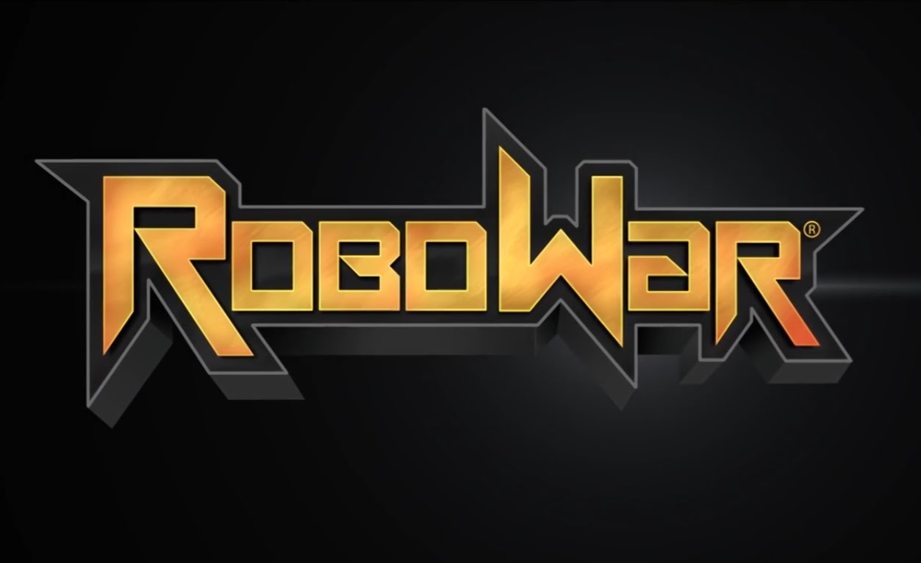

**LEARN TO BUILD,BUILD TO FIGHT,FIGHT TO WIN !!!!!!**

**1.INTRODUCTION…**

**THIS IS THE MOST POPULAR EVENT OF IIT PATNA.AFTER FEELING THE ADRENALINE RUSH OF DEATH RACE ITS TIME TO SHOW POWER OF YOUR BOT AND YOUR STRATEGY IN THE BATTLEFIELD..THIS EVENT WILL TEST THE CO-ORDINATION BETWEEN SPEED ,POWER AND STRATEGY ….**

**2.BUDGET…APPROX—15000 INR**

**1.ARENA CONSTRUCTION----🡪5000 (4000 FOR PLYWOOD AND 1000 FOR ADHESIVE AND CONNECTING MATERIALS)**

**2.MUSIC SYSTEM AND LIGHTS---🡪4000**

**3.PRIZE DISTRIBUTION--🡪1STPRIZE ---2500, 2ND PRIZE---1500**

**4.MISCELLANEOUS-🡪2000**

**3.ARENA AND BOT SIZE ..**

**1.BOT TYPE🡪WIRED/WIRELESS.(MAX VOLTAGE 24VOLTS)**

**2.ARENA SHAPE--🡪REGULAR OCTAGON OF SIDE 80CM AND SIDE BOUNDARY HEIGHT🡪50CM**

**3.BOT WEIGHT-🡪MAX 15KG**

**4.BOT DIMENSIONS🡪MAX 40CM*40CM*40CM**

**4.GENERAL RULES..**

**1.TOURNAMENT WOULD BE IN FORM OF A LEAGUE WHICH WILL LEAD TO SEMI-FINALS AND FINALS.**

**2.EACH MATCH CONSISTS OF 2 ROUNDS…**

**1ST ROUND----DURATION 3 MINUTES.**

**RULES---THERE WILL BE 4 BALLOONS IN EACH TEAM’S STATE.BOTH TEAMS WILL START FROM THEIR STATE AND WILL ATTACK THE OPPOSITION TEAM’S BALLOONS. BY THE END OF THREE MINUTES IF ANY TEAM GOT SUCCESS IN PRICKING ALL THE 4 BALLOONS OF OPPOSITION AND MANAGES TO SAVE ITS AT LEAST ONE FROM THE OPPOSITION TEAM THEN THAT TEAM WILL BE DECLARED AS WINNER AND MATCH WILL END HERE…**

**FOR PRICKING OPPOSITION TEAM’S BALLOONS 15 POINTS WILL BE PROVIDED.**

**IF NONE OF THE TEAM MANAGES TO WIN IN THIS ROUND THEN MATCH WOULD PASS INTO THE SECOND ROUND AND WINNER WILL BE DECIDED ON THE BASIS OF POINTS SCORED….**

**2ND ROUND DURATION---- 2 MINUTES..**

**HERE THE MAIN GOAL OF THE TEAM WOULD BE TO HIT AND DAMAGE THE OPPOSITION TEAM AS MUCH AS POSSIBLE..**

**FOR EACH HIT IN THE SECOND ROUND 5 POINTS WOULD BE PROVIDED..**

**IF A TEAM MANAGES TO THROW OPPOSITION TEAM’S BOT OUT OF ARENA THAN 30 POINTS WOULD BE PROVIDED TO THAT TEAM.**

**AT THE END OF SECOND ROUND TEAM HAVING HIGHER SCORE WILL BE DECLARED AS WINNER.**

**3.TROUBLESHOOTING….**

**ANY TEAM COULD TAKE MAXIMUM 3 TECHNICAL HALTS TO OVERCOME ANY TECHNICAL ISSUE BETWEEN THE MATCH. THE MATCH WILL SET TO FREEZE DURING THIS TIME INTERVAL ALONG WITH OPPOSITION TEAM’S BOT.**

**DURATION OF HALT----1MIN 30 SEC(MAX)**

**PENALTY FOR FIRST HALT 5 POINTS**

**PENALTY FOR SECOND HALT 7 POINTS**

**PENALTY FOR THIRD HALT 10 POINTS**

**TEAM WOULD BE DISQUALIFIED IF THE BOT REMAIN IMMOBALISED FOR MORE THAN 1MIN 30 SECOND..**

**4.USE OF FIRE OR ANYTHING THAT HARM THE ARENA IS NOT ALLOWED AND WOULD LEAD TO IMMEDIATE DISQUALIFICATION..**

**5.IN CASE OF ANY DISPUTE DECISION OF THE ORGANISERS WOULD BE FINAL.**

**ORGANISERS----**

**1.RAHUL KUMAR**

**2.SOHID TURE**

**3.REDDY SAI VAMSI**

**4.VIVEK RAJ**

**5.VIJAY SHARMA**