**JAVA PROJECT**

**QUIZ – APPLICATION**

* **TEAM MEMBERS:**
* **Akshat Shah (20124005)**
* **Ayush Jangid (20124011)**
* **Kanishka Gour (20124025)**
* **DESCRIPTION:**
* We have built a Quiz Application in which one can enter his/her name (which is compulsory) and then proceed to play the fun Quiz. The questions in the Quiz are based on general knowledge and recent facts about the happenings in the world.
* **STRUCTURE AND WORKING:**
* At first the main window opens which shows two buttons - “rules” and “exit”. On pressing the “exit” button you will exit from the window. For proceeding to play the quiz you need to enter your username and click the rules “button”. Now you will be directed to a page where you should go through the rules of the quiz, then clicking on the “start” button would start the quiz.
* In the quiz you have three main options - “next” - directs you to next question, “50-50 lifeline” - eliminates two wrong options, but you can use this only once in whole play time, and the “submit” - which is disabled till the last question and is enabled only when the user reaches last question. For each question you will be given 10 seconds and rewarded 10 marks for right answer.
* Bonus for you guys – no negative marking and in case you fill the answer and ran out of time clicking the next button, don’t worry, we have got your back, your answer is saved automatically if it is marked.
* Submitting the quiz, you will get your report card and a chance to play it again.
* **ABOUT THE PROJECT:**
* It is a basic java project in which some basic functions of java are used to decorate the frame and use of if-else has been made for functions like “timer”.
* **PICTURES:**

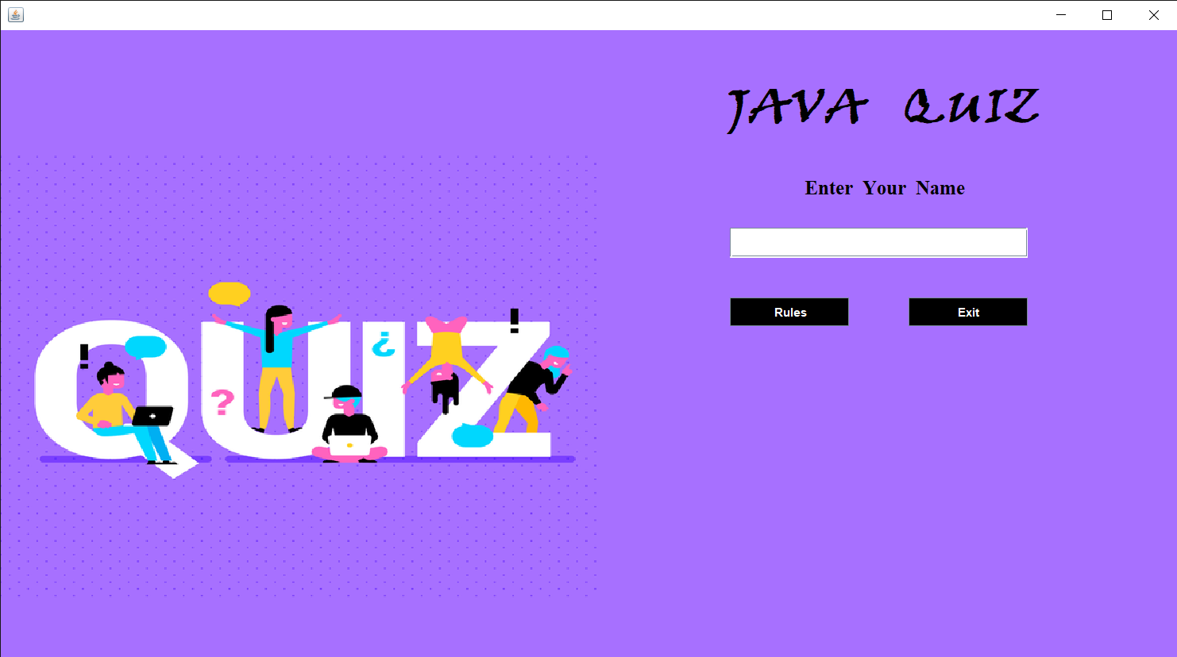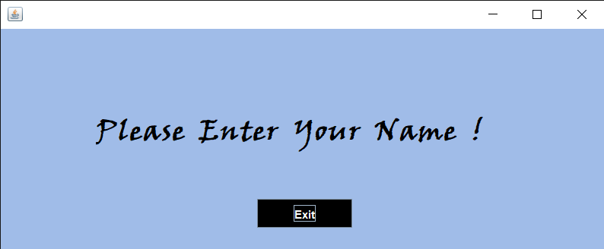

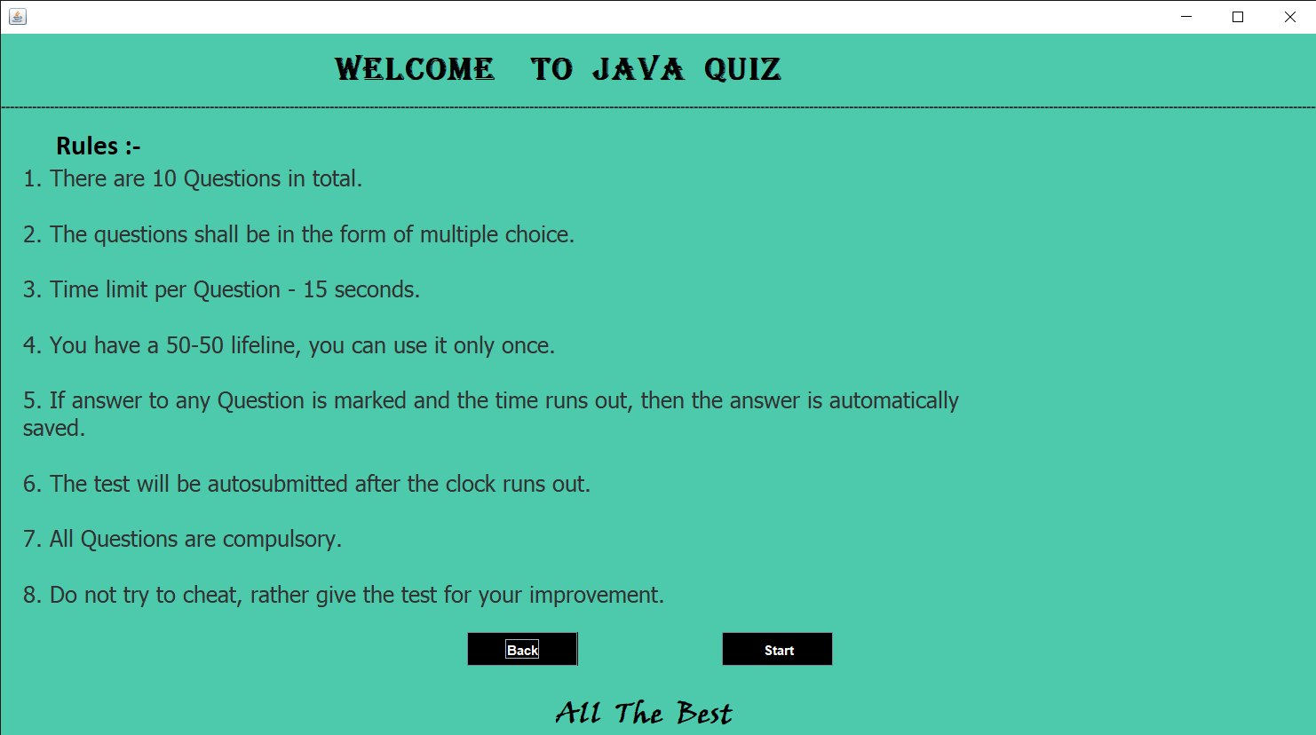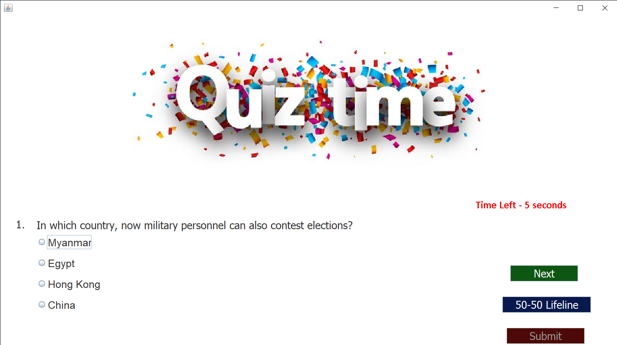

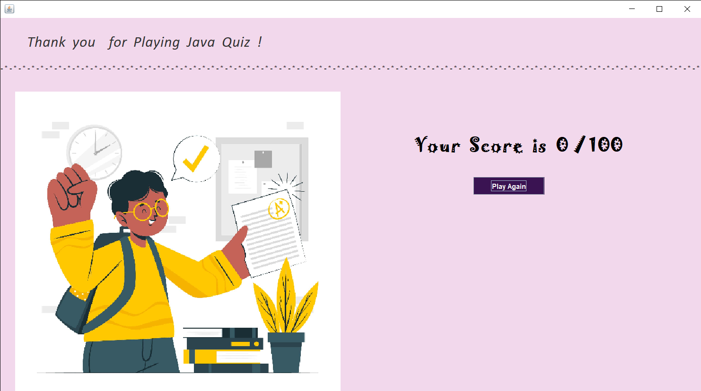

***ERROR:***

*We did not find any error running it in our vs-code several times, also we ran each file several times but it ran successfully.*

***WE HOPE YOU ENJOY THE QUIZ !***