**Real Time Weather Forecast Application**



**Project Introduction**

“*Weather is an integral part of our daily lives, impacting our choices and activities. Whether it's deciding what to wear, planning outdoor events, or even making travel arrangements, having access to accurate and up-to-date weather information is essential. In an era where information is readily available at our fingertips, I introduce "WeatherLite" – a state-of-the-art weather application designed to provide users with a seamless and personalized weather experience. This project aims to deliver real time weather analysis for any country/city/state* .”

1. **Project Aim**

The aim of a weather app project is to provide users with a reliable, convenient, and personalized tool for accessing accurate weather information. The project should focus on several key objectives:

1. **Accurate Weather Data:** The primary aim of the weather app is to deliver precise and up-to-date weather information. It should source data from trusted meteorological sources or use advanced forecasting techniques to provide reliable forecasts.
2. User-Friendly Interface**:** The weather app should have a user-friendly and intuitive interface, making it easy for users to access weather data, view forecasts, and interpret the information effectively. The aim is to create a seamless user experience.
3. **Hyper-Local Weather:** The app should aim to offer hyper-local weather forecasts, ensuring that users receive information specific to their exact location. This helps users plan their activities with precision.
4. **Extended Forecasts:** Offer both short-term (hourly) and long-term (7-day) forecasts to assist users in planning their daily and weekly activities.
5. **Submitted by -**

Name – Akshat Pandya

Enrollment number – 0801CS221014

Section – A 1

Class – II year

1. **License –**

This project is licensed under the MIT License :MIT

1. **Screenshots of the Application –**

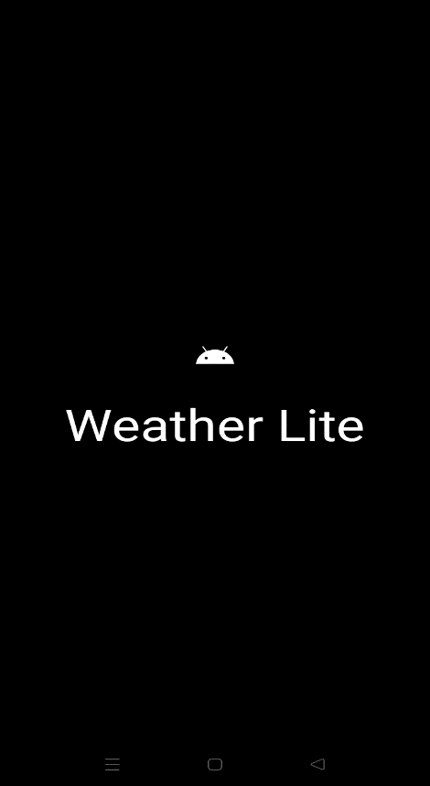

Splash Screen

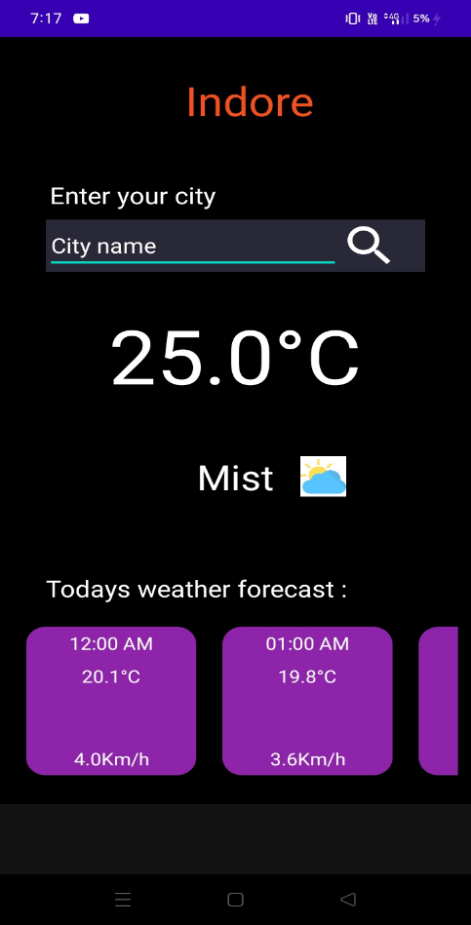

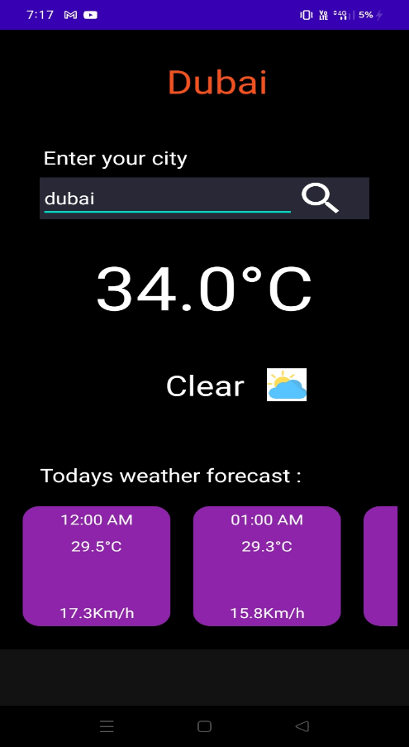 Application demo – 1

Application demo – 2

1. **Features**

* **Energy Efficiency:** Optimize the app to minimize its impact on device battery life, especially for mobile users.
* **Feedback and Reporting:** Allow users to provide feedback and report inaccuracies or issues with weather data, contributing to data improvement.
* **Offline Mode:** Offer limited functionality for users without an internet connection, ensuring access to basic weather data even in offline mode.
* **Current Weather Conditions:** Display real-time weather data for the user's current location, including temperature, humidity, wind speed and direction, air pressure, and visibility.
* **Hyper-Local Weather:** Provide highly localized weather forecasts by using GPS or location services to pinpoint the user's exact location.
* **Hourly Forecast:** Offer hour-by-hour weather forecasts for the next 24 hours, enabling users to plan their day more effectively.