Task 4 Observations

1) PART_1

code snippet:

def step(self, u):
th, thdot = self.state # th := theta

g = self.g
m = self.m
l = self.l
dt = self.dt

u = np.clip(u, -self.max_torque, self.max_torque)[0]
self.last_u = u # for rendering
costs = 10*angle_normalize(th)**2 + .05*thdot**2 + .001*(u**2)

newthdot = thdot + (-3*g/(2*l) * np.sin(th + np.pi) + 3./(m*l**2)*u) * dt
newth = th + newthdot*dt
newthdot = np.clip(newthdot, -self.max_speed, self.max_speed) #pylint: disable=E1111

self.state = np.array([newth, newthdot])
return self._get_obs(), -costs, False, {}

PPO TRANING

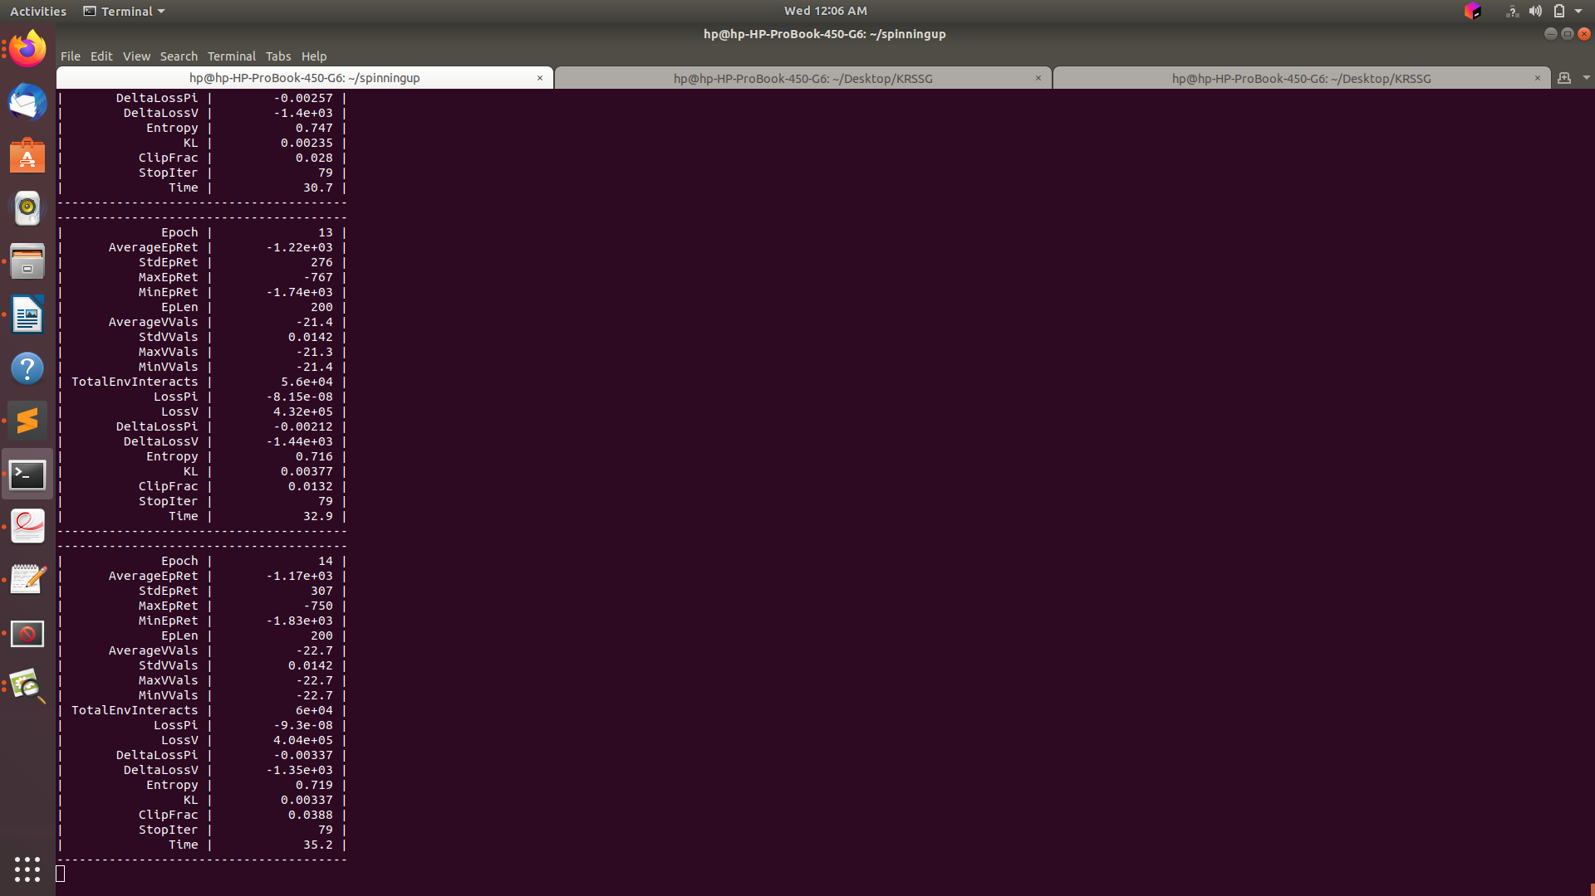

PPO SHOT

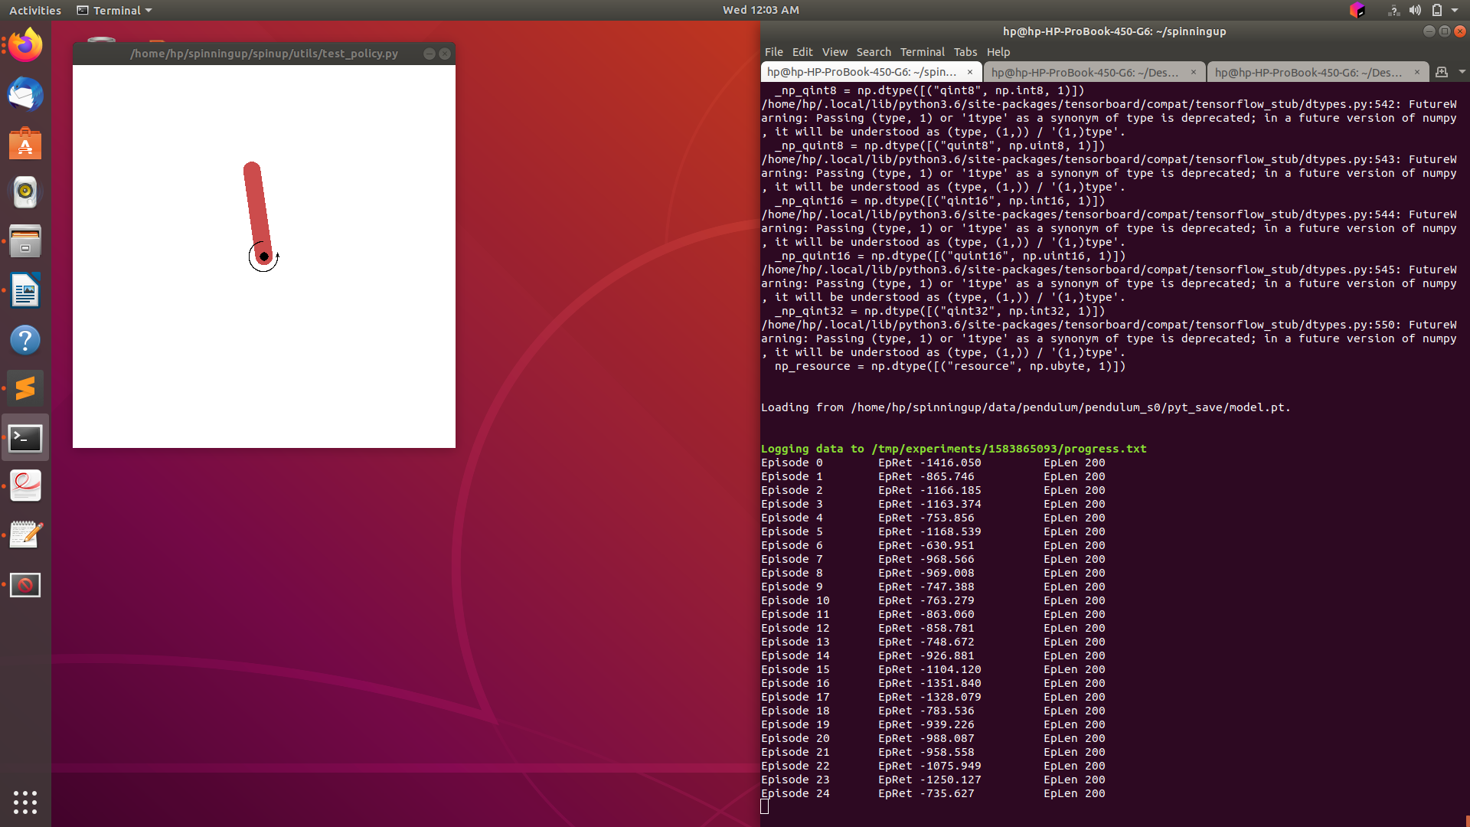

PERFORMANCE PLOT

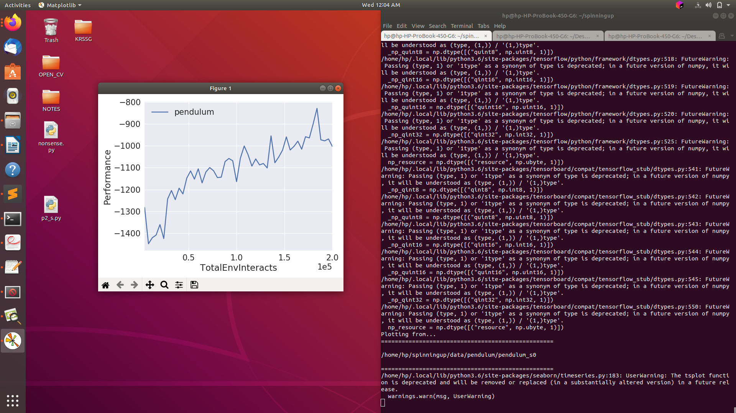

2)

PART_2

CODE_SNIPPET

def step(self, u):
th, thdot = self.state # th := theta

g = self.g
m = self.m
l = self.l
dt = self.dt

u = np.clip(u, -self.max_torque, self.max_torque)[0]
self.last_u = u # for rendering
if u<0:
costs = angle_normalize(th)**2 + .05*thdot**2 + 1*(u**2)
else:
costs = angle_normalize(th)**2 + .05*thdot**2 + 0.01*(u**2)

newthdot = thdot + (-3*g/(2*l) * np.sin(th + np.pi) + 3./(m*l**2)*u) * dt
newth = th + newthdot*dt
newthdot = np.clip(newthdot, -self.max_speed, self.max_speed) #pylint: disable=E1111

self.state = np.array([newth, newthdot])
return self._get_obs(), -costs, False, {}

TRANING

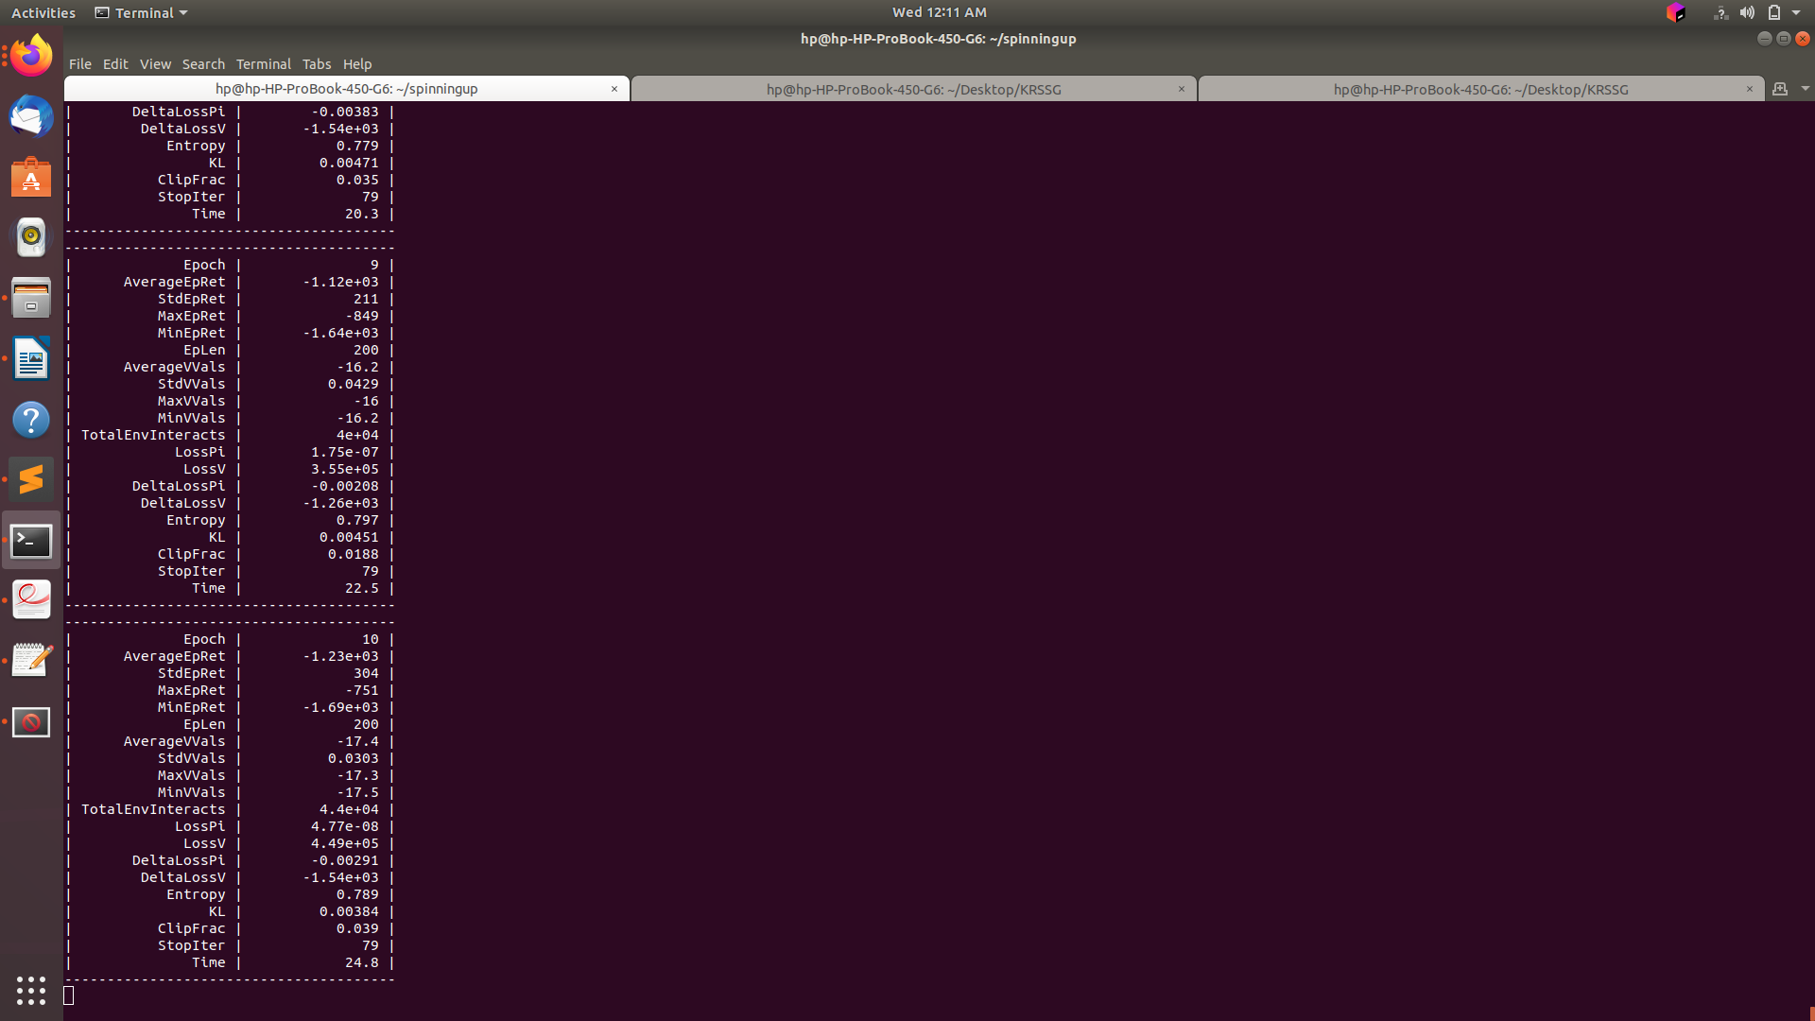

PPO SHOT

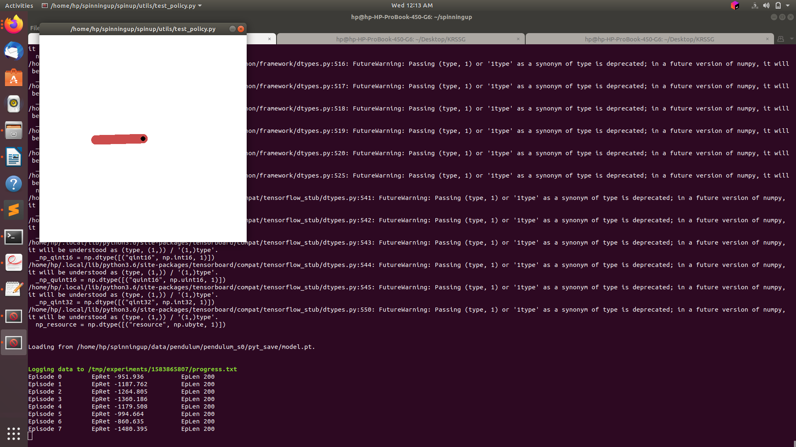

PERFORMANCE_PLOT:

