Week 10

**Question 1:**

**Given a string, *s*, consisting of alphabets and digits, find the frequency of each digit in the given string.**

**Input Format:**

**The first line contains a string, *num*which is the given number.**

**Output Format:**

**Print ten space-separated integers in a single line denoting the frequency of each digit from *0* to *9*.**

**Sample Input 1:**

**a11472o5t6**

**Sample Output 1:**

**0 2 1 0 1 1 1 1 0 0**

**Program:**

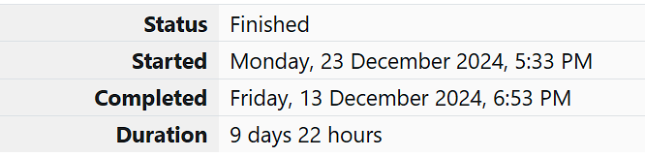

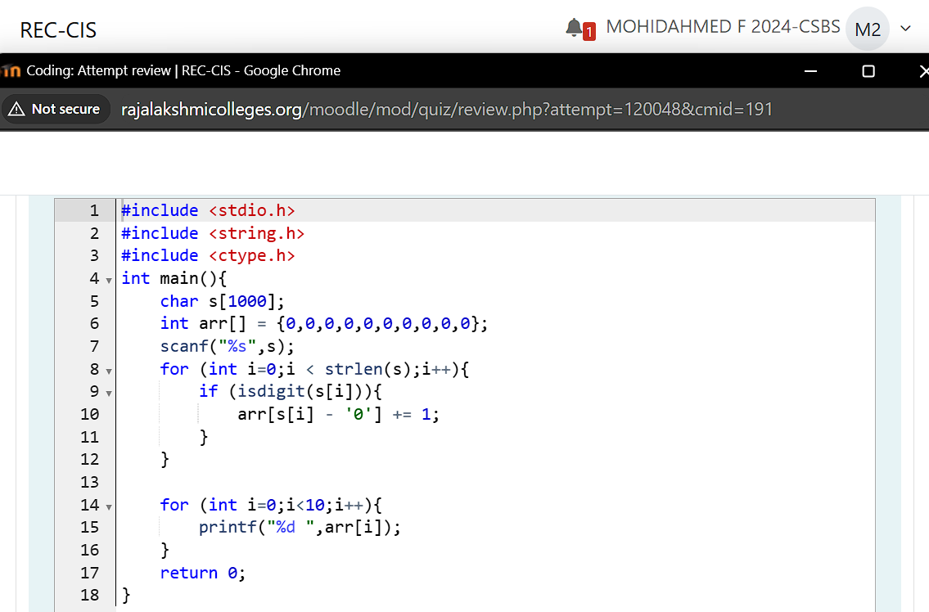

**Output:**

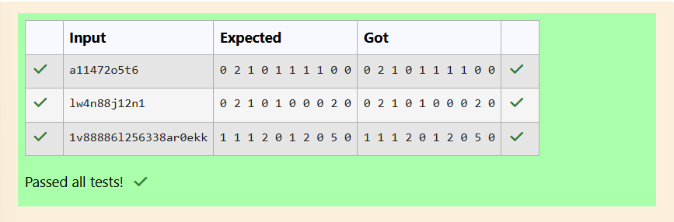

**Question 2:**

**Today, Monk went for a walk in a garden. There are many trees in the garden and each tree has an English alphabet on it. While Monk was walking, he noticed that all trees with vowels on it are not in good state. He decided to take care of them. So, he asked you to tell him the count of such trees in the garden.**

**Input Format:**

**The first line consists of an integer *T* denoting the number of test cases. Each test case consists of only one string, each character of string denoting the alphabet (may be lowercase or uppercase) on a tree in the garden.**

**Sample Input 1:**

**2**

**nBBZLaosnm**

**JHkIsnZtTL**

**Sample Output 1:**

**2**

**1**

**Program:**



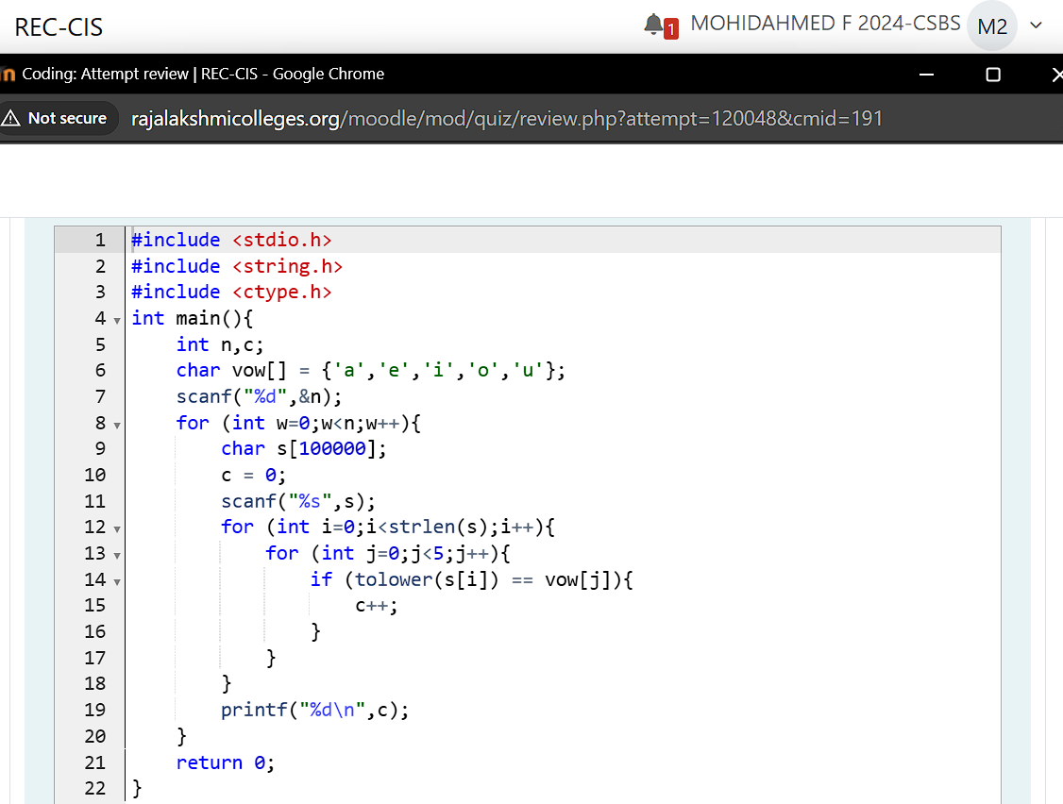

**Output:**

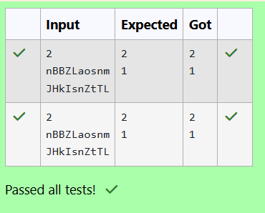

**Question 3:**

**Given a sentence, *s*, print each word of the sentence in a new line.**

**Input Format:**

**The first and only line contains a sentence, *s*.**

**Sample Input 1:**

**This is C**

**Sample Output 1:**

**This**

**is**

**C**

**Program:**



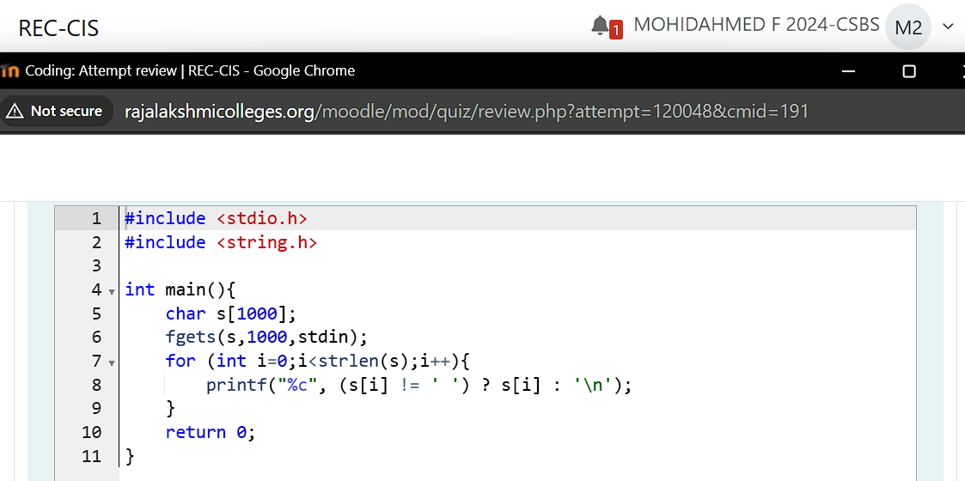

**Output:**

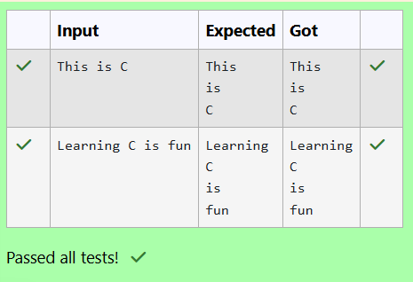

**Question 4:**

**You are given two strings, *a* and *b*, separated by a new line. Each string will consist of lower case Latin characters ('a'-'z').**

**Output Format:**

**In the first line print two space-separated integers, representing the length of *a* and *b* respectively.**

**In the second line print the string produced by concatenating *a* and *b* (*a + b*).**

**In the third line print two strings separated by a space, *a'* and *b'*. *a'* and *b'* are the same as*a*and *b*, respectively, except that their first characters are swapped.**

**Sample Input 1:**

**abcd**

**ef**

**Sample Output 1:**

**4 2**

**abcdef**

**ebcd af**

**Program:**



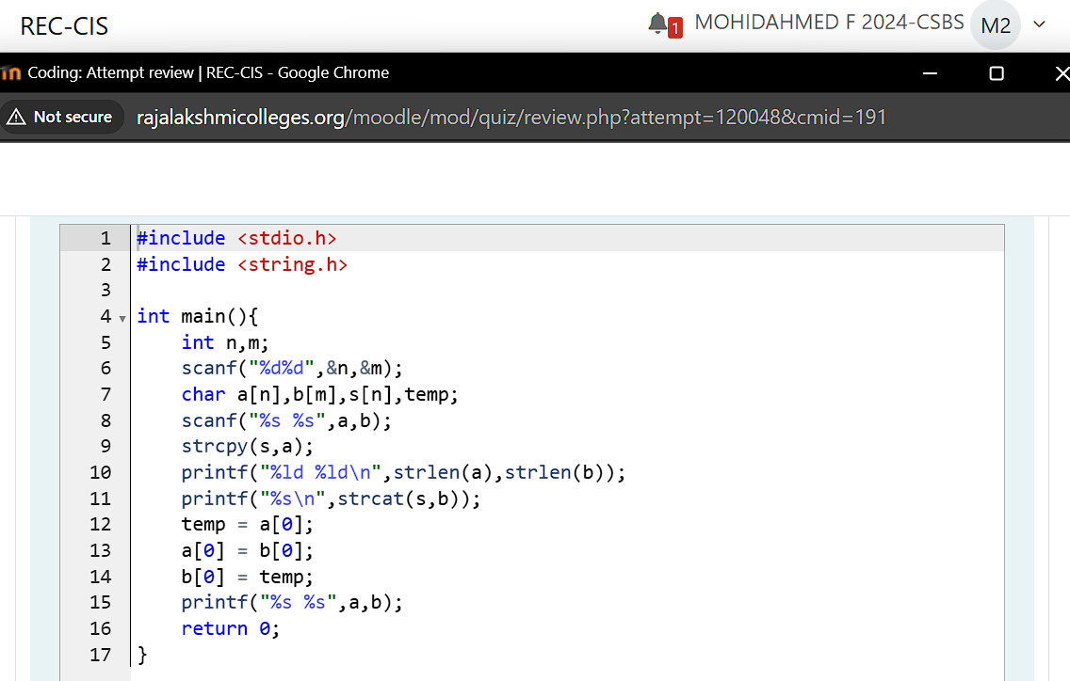

**Output:**

