Week 14

**Question 1:**

**You are transporting some boxes through a tunnel, where each box is a parallelepiped,**

**and is characterized by its length, width and height.**

**The height of the tunnel 41 feet and the width can be assumed to be infinite. A box can be**

**carried through the tunnel only if its height is strictly less than the tunnel's height. Find the**

**volume of each box that can be successfully transported to the other end of the tunnel.**

**Note: Boxes cannot be rotated.**

**Input Format**

**The first line contains a single integer n, denoting the number of boxes.**

**n lines follow with three integers on each separated by single spaces - lengthi, widthi and**

**height i which are length, width and height in feet of the i-th box.**

**Constraints**

**1 ≤ n ≤ 100**

**1 ≤ lengthi, widthi, heighti ≤ 100**

**Output Format**

**For every box from the input which has a height lesser than 41 feet, print its volume in a**

**separate line.**

**Sample Input**

**4**

**5 5 5**

**1 2 40**

**10 5 41**

**7 2 42**

**Sample Output**

**125**

**80**

**Explanation**

**The first box is really low, only 5 feet tall, so it can pass through the tunnel and its volume**

**is 5 x 5 x 5 = 125.**

**The second box is sufficiently low, its volume is 1 x 2 x 4= = 80.**

**The third box is exactly 41 feet tall, so it cannot pass. The same can be said about the fourth box.**

**Program:**

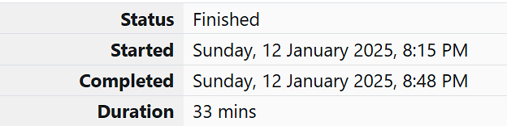

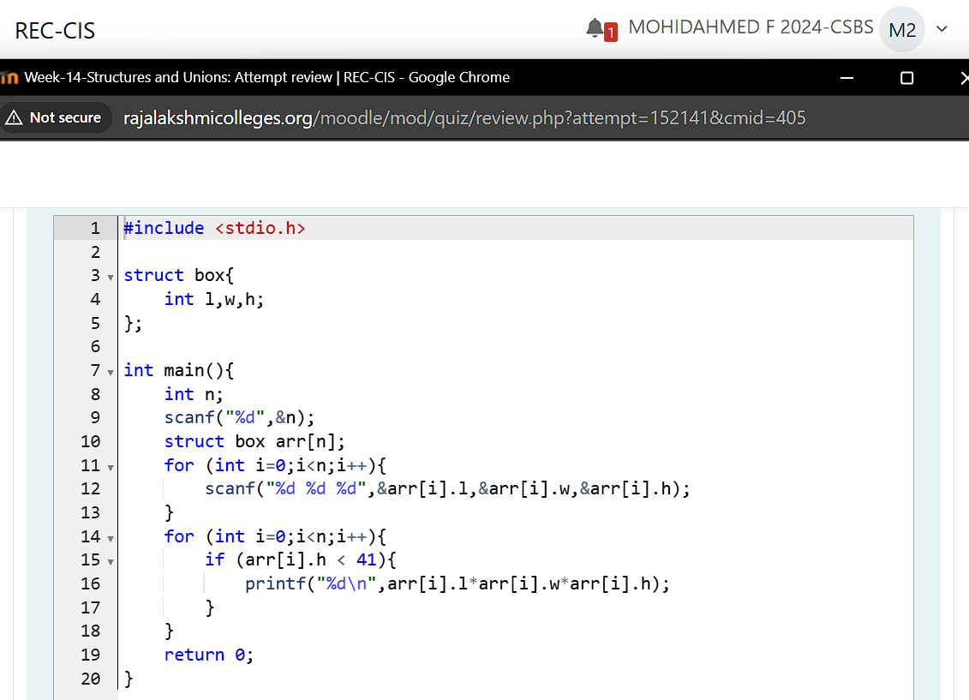

**Output:**

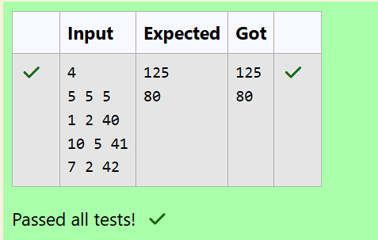

**Question 2:**

**You are given n triangles, specifically, their sides ai, bi and ci. Print them in the same style**

**but sorted by their areas from the smallest one to the largest one. It is guaranteed that all**

**the areas are different.**

**The best way to calculate a volume of the triangle with sides a, b and c is Heron's formula:**

**S =  p * (p – a) * (p - b) * (p – c) where p = (a + b + c) / 2.**

**Input Format**

**First line of each test file contains single integer n. n lines follow with ai, bi and ci on each**

**separated by single spaces.**

**Constraints**

**1 ≤ n ≤ 100**

**1 ≤ ai, bi, ci ≤ 70**

**ai + bi > ci, ai + ci > bi and bi + ci > ai**

**Output Format**

**Print exactly n lines. On each line print 3 integers separated by single spaces, which are**

**ai, bi and ci of the corresponding triangle.**

**Sample Input**

**3**

**7 24 25**

**5 12 13**

**3 4 5**

**Sample Output**

**3 4 5**

**5 12 13**

**7 24 25**

**Explanation**

**The square of the first triangle is 84. The square of the second triangle is 30. The square of**

**the third triangle is 6. So, the sorted order is the reverse one.**

**Program:**



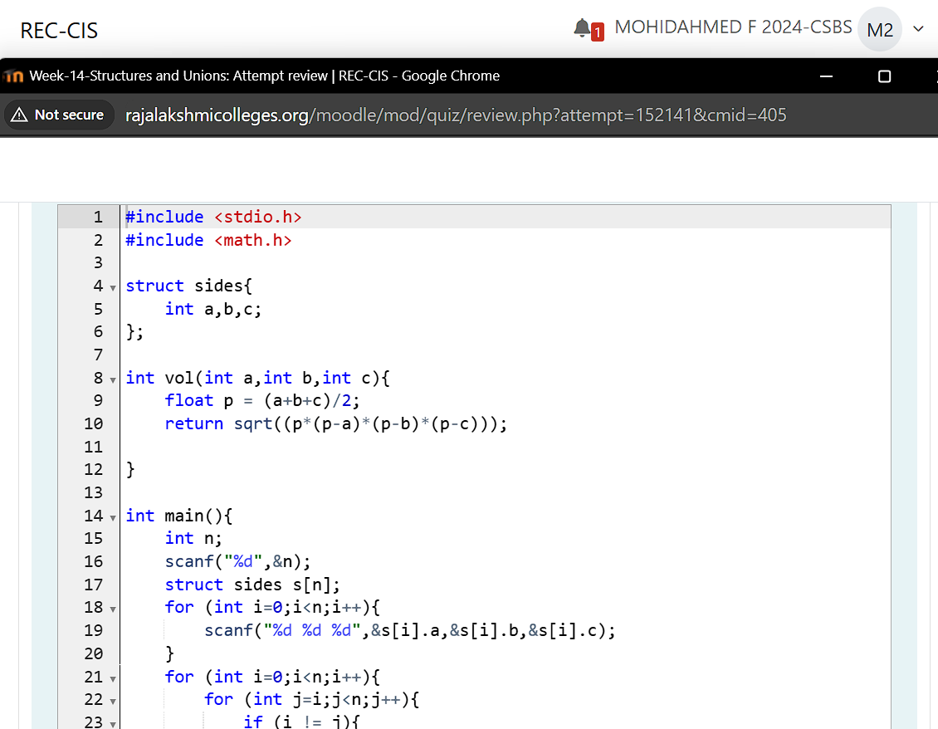

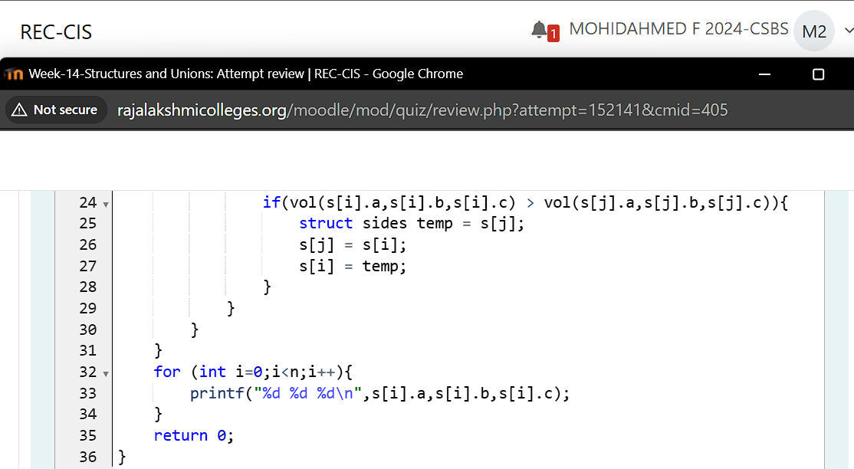

**Output:**

