**WEEK-1**

**Solutions of Design Principles and Patterns**

**Exercise 1: Implementing the Singleton Pattern.**

**Code:**

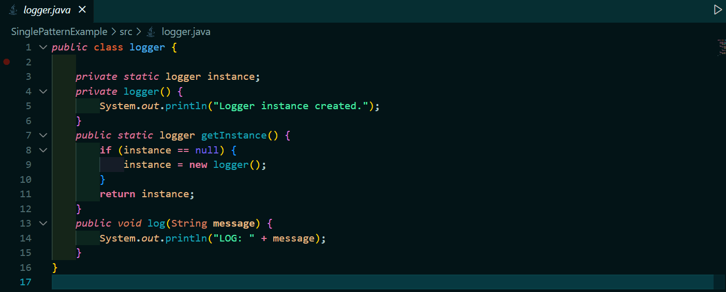

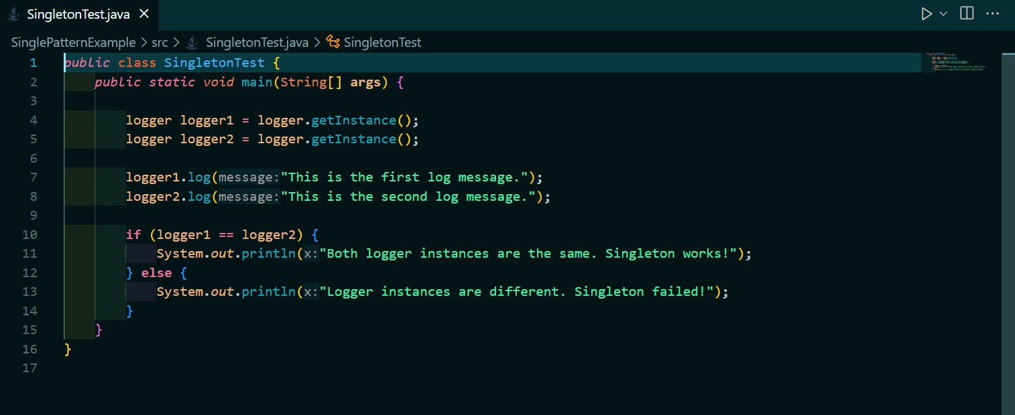

**Output:**

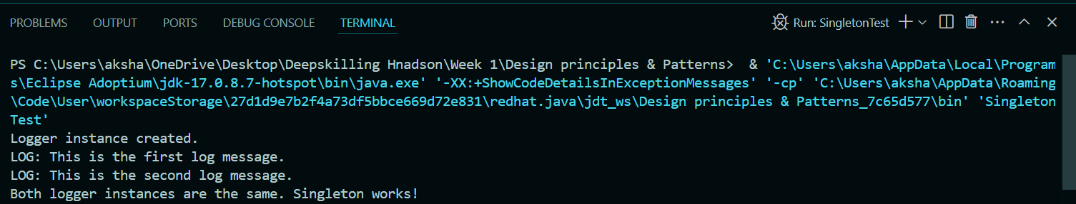

**Exercise 2: Implementing the Factory Method Pattern**

**Code:**

**>Document Interface**

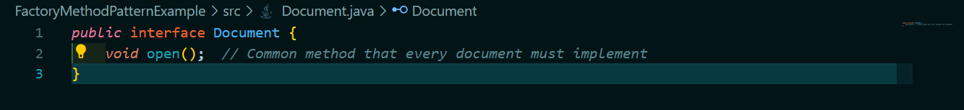

**>Word Document**

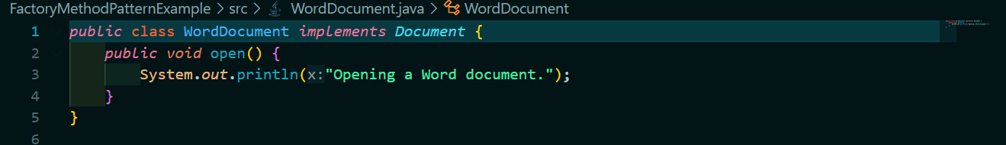

**>PDF Document**

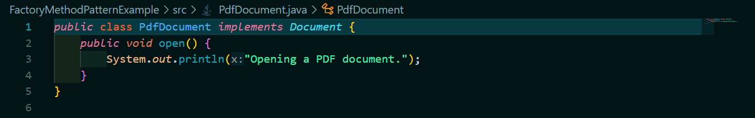

**>Excel Document**

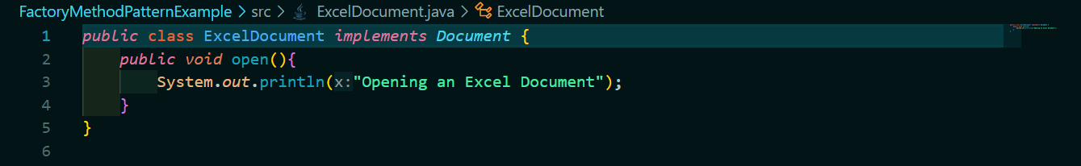

**#Implementing Factory Methods**

**>Document Factory**

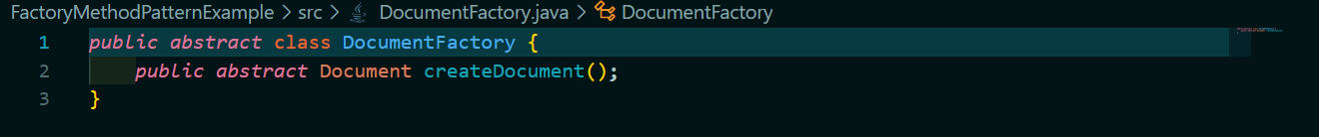

**>Word Document Factory**

**>PDF Document Factory**

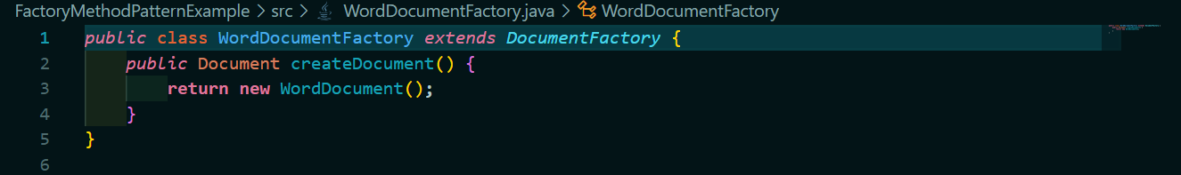

**>Excel Document Factory**

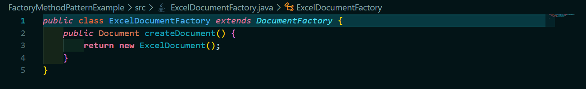

**#Testing the Factory Method**

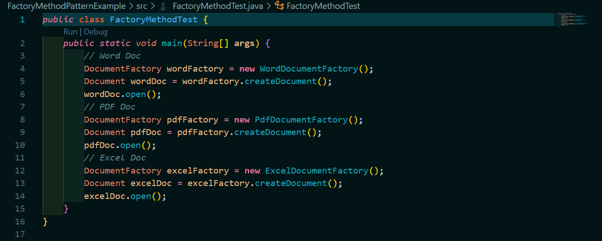

**Output:**

