Code Coverage Report — Pizza Order
Lab 6: Code and Branch Coverage Analysis | Application: pizza_order.py (SETAPESU26/L6_L7_24_pizza_order, Lab 6)
Student: Akshat Agarwal, PES1UG24AM024 | Repository: github.com/Akshat1686/L6_pizza_order_024
Environment verified: Python 3.12.3 / pytest 9.2.0 / coverage 7.17.0 on Linux, and Python 3.12.10 / pytest 9.2.0 on Akshat's Windows terminal (screenshots in this report). The application file pizza_order.py was not changed; only test files were added.

1. What code (line) coverage means
Code coverage, also called line coverage, asks one question about each executable line of source code: did it run at least once during testing? It does not ask whether every decision went both ways — that is branch coverage, covered in the companion report. A line can therefore be 'covered' even if only one side of the if statement guarding it was ever tested. That is why the lab requires both reports, and why a 100% line score is a necessary, but not sufficient, proof of thorough testing.
The lab's pass mark is at least 90% code coverage. This suite exceeds it at 100%.

2. Application under test
pizza_order.py has three functions and 34 executable statements. No function was edited for this lab.
- pizza_price(size, toppings, is_cheese_burst) — base prices small 200, medium 350, large 500; toppings cost 40 each up to 3, then 40 each for the first 3 plus 30 for each extra topping; cheese burst adds 100, but is rejected for small. Unknown sizes and negative toppings raise ValueError.
- order_discount(order_total, day, is_student) — orders under 300 get no discount at all (an early return, so even a student gets 0); Tuesday gives half the total; Saturday/Sunday give 0; any other day gives a tenth; a student adds 50 on top of whichever day discount applied.
- delivery_status(minutes_taken, distance_km) — over 10 km is 'not deliverable'; up to 30 minutes is 'on time'; up to 45 minutes is 'late'; anything longer is 'free pizza'.

3. Starting point: the starter tests
The template's test_pizza_order.py contained only two tests: a plain medium pizza and an on-time delivery. Measured before any new test was written, pizza_order.py was at 41% line coverage — 20 of its 34 statements never ran, namely lines 6, 8, 11, 15–17, 22–32, 37 and 40–42. In other words, every error case, the >3-toppings tier, cheese burst, the whole discount function, and the late / free-pizza delivery paths were completely untested.

4. The code-coverage test suite
File: CodeCoverageTest_024_pizza_order.py (024 = PES1UG24AM024). 20 tests, grouped by function. Each test below names its input, the expected result, and the lines it exists to cover; line numbers refer to pizza_order.py.

4.1 pizza_price — 9 tests
# | Test | Input -> Expected | What it covers
1 | test_plain_medium_pizza | medium, 0, False -> 350 | Base price; toppings else-branch (line 13); return (18)
2 | test_small_two_toppings_no_cheese | small, 2, False -> 280 | 200 + 2x40; toppings else-branch
3 | test_large_three_toppings_no_cheese | large, 3, False -> 620 | Top of the <=3 tier: 500 + 3x40
4 | test_large_five_toppings_no_cheese | large, 5, False -> 680 | >3 tier (line 11): 500 + 120 + 2x30
5 | test_medium_cheese_burst | medium, 2, True -> 530 | Cheese-burst addition (line 17): 350 + 80 + 100
6 | test_large_cheese_burst_no_toppings | large, 0, True -> 600 | Cheese burst with no toppings: 500 + 100
7 | test_unknown_size_raises | extra-large, 1, False -> ValueError | Unknown-size guard (line 6)
8 | test_negative_toppings_raises | medium, -1, False -> ValueError | Negative-toppings guard (line 8)
9 | test_cheese_burst_small_raises | small, 1, True -> ValueError | Cheese-burst-on-small guard (line 16)

4.2 order_discount — 7 tests
# | Test | Input -> Expected | What it covers
10 | test_discount_below_minimum_is_zero | 250, tuesday, False -> 0 | Early return (line 23): under 300, no discount even on Tuesday
11 | test_discount_tuesday_half | 400, tuesday, False -> 200 | Tuesday half (line 25)
12 | test_discount_tuesday_half_plus_student | 400, tuesday, True -> 250 | Tuesday half + student +50 (lines 25, 31)
13 | test_discount_weekend_is_zero | 400, saturday, False -> 0 | Weekend discount 0 (line 27)
14 | test_discount_weekend_student_only | 500, sunday, True -> 50 | Weekend 0, but student +50 still applies
15 | test_discount_weekday_tenth | 400, monday, False -> 40 | Other-day tenth (line 29)
16 | test_discount_weekday_tenth_plus_student | 400, wednesday, True -> 90 | Other-day tenth + student +50

4.3 delivery_status — 4 tests
# | Test | Input -> Expected | What it covers
17 | test_delivery_not_deliverable_over_10km | 20 min, 11 km -> not deliverable | Distance guard (line 37)
18 | test_delivery_on_time | 20 min, 3 km -> on time | Up to 30 minutes (line 39)
19 | test_delivery_late | 40 min, 5 km -> late | Up to 45 minutes (line 41)
20 | test_delivery_free_pizza | 60 min, 5 km -> free pizza | Over 45 minutes (line 42)

5. Results
Commands run (from the folder containing pizza_order.py):
coverage run -m pytest CodeCoverageTest_024_pizza_order.py -v
coverage report -m
File | Statements | Missed | Coverage | Missing
CodeCoverageTest_024_pizza_order.py | 45 | 0 | 100% | —
pizza_order.py | 34 | 0 | 100% | —
TOTAL | 79 | 0 | 100% | —
All 20 tests passed, in 0.04 s on the Linux verification run and in Akshat's own Windows run (Python 3.12.10, pytest 9.2.0). The single warning in the Windows run is an unrelated anyio/pytest deprecation notice (CallSpec2 renamed to CallSpec, to be removed in pytest 10); it is not a test failure and does not affect coverage. The lab requirement (>=90%) is met with 10 points of headroom, and no line of pizza_order.py is left unexecuted.

6. Screenshots (Akshat's Windows terminal)
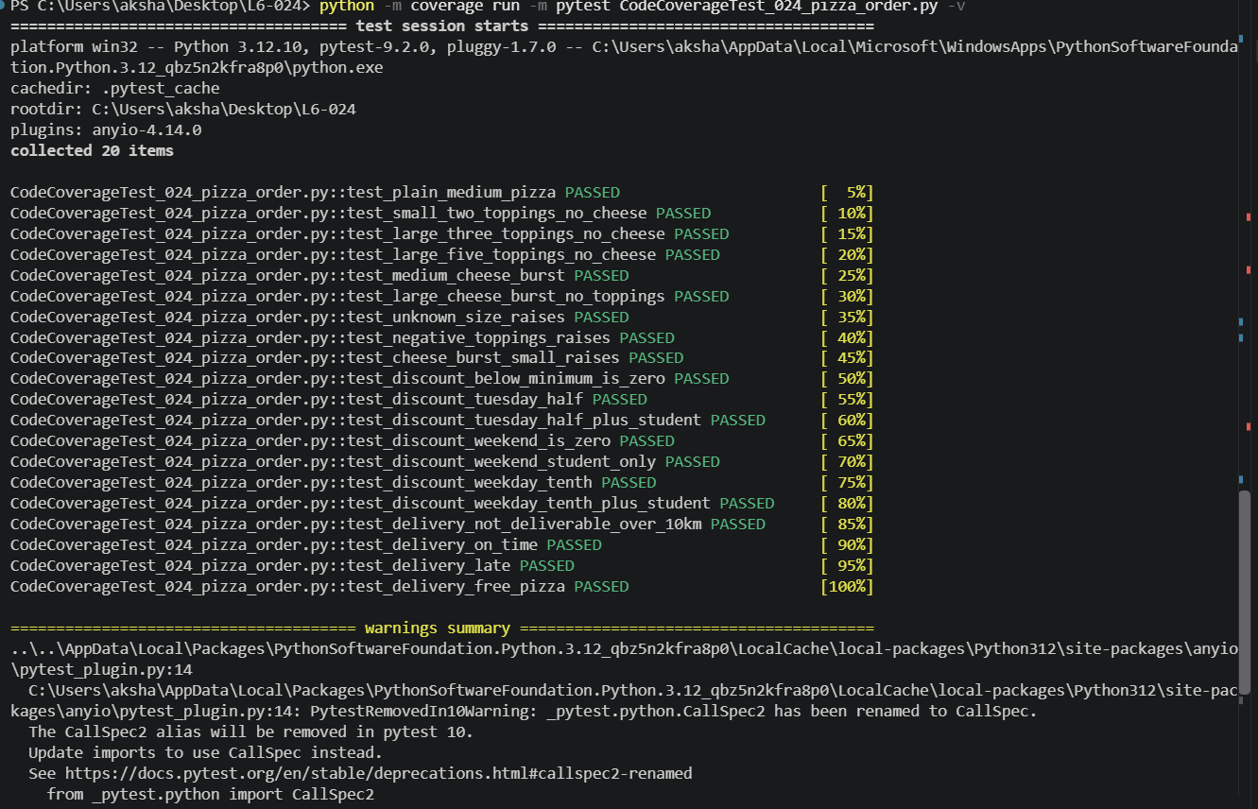
Figure 1 — Code-coverage test run: 20 tests, all PASSED.
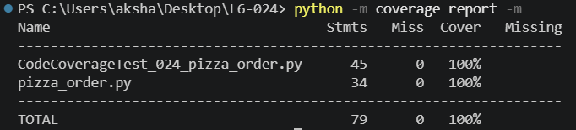
Figure 2 — Code-coverage report: pizza_order.py 34 statements, 0 missed, 100%.

7. Interpretation and limits
- What 100% line coverage proves: every statement, including every error raise and every return, executes under at least one test. The starter suite's blind spots — discounts, errors, cheese burst — are gone.
- What it does not prove: that every decision was tested both ways. For example, a test that only ever ordered cheese-burst pizzas would still execute the '+100' line. That gap is exactly what branch coverage closes, and it is why the companion Branch Coverage Report exists — and why, honestly, this code suite already reaches 100% branch as well, because its tests happen to include both outcomes of the cheese-burst and student flags.
- What it does not prove either: correctness for inputs outside the tested set (other sizes are rejected by design, but untested topping counts above 5 or totals above 500 follow the same arithmetic and were not enumerated). Coverage measures execution, not a proof of correctness.
Conclusion: the code-coverage deliverable is complete — 20 tests, 100% line coverage, all tests passing, with terminal screenshots as evidence.

