Name: Akshat Bhargava
Roll No: BEAD22563
Subject: CL – II
Assignment 3
Predict the 3D structure of a given protein sequence using either homology modelling or threading techniques.
Code -
import numpy as np
import pandas as pd
import matplotlib.pyplot as plt
import seaborn as sns
from sklearn.feature_extraction.text import CountVectorizer
from sklearn.model_selection import train_test_split
from sklearn.ensemble import RandomForestClassifier
from sklearn.svm import SVC
from sklearn.metrics import accuracy_score, precision_score, recall_score, f1_score, confusion_matrix, classification_report

file_path = r"C:\Users\athar\OneDrive\Desktop\Practical\Bioinformatics\human.txt"
df = pd.read_csv(file_path, sep='\t')
print(df.head())

sequences = df['sequence']
labels = df['class']

def get_kmers(seq, k=3):
return [seq[i:i+k] for i in range(len(seq)-k+1)]

vectorizer = CountVectorizer(analyzer=get_kmers)
X = vectorizer.fit_transform(sequences)
y = labels

X_df = pd.DataFrame(X.toarray(), columns=vectorizer.get_feature_names_out())

X_train, X_test, y_train, y_test = train_test_split(X_df, y, test_size=0.2, random_state=42)

rf = RandomForestClassifier(random_state=42).fit(X_train, y_train)
svm = SVC(kernel="linear").fit(X_train, y_train)

rf_pred, svm_pred = rf.predict(X_test), svm.predict(X_test)

def evaluate(name, y_true, y_pred):
print(f"\n{name} Results:")
print("Accuracy:", accuracy_score(y_true, y_pred))
print("Precision:", precision_score(y_true, y_pred, average='weighted'))
print("Recall:", recall_score(y_true, y_pred, average='weighted'))
print("F1 Score:", f1_score(y_true, y_pred, average='weighted'))
print(classification_report(y_true, y_pred))

evaluate("Random Forest", y_test, rf_pred)
evaluate("SVM", y_test, svm_pred)

def plot_cm(y_true, y_pred, title):
sns.heatmap(confusion_matrix(y_true, y_pred), annot=True, fmt="d", cmap="Blues",
xticklabels=["Healthy","Disease"], yticklabels=["Healthy","Disease"])
plt.title(title); plt.xlabel("Predicted"); plt.ylabel("Actual"); plt.show()

plot_cm(y_test, rf_pred, "Random Forest Confusion Matrix")
plot_cm(y_test, svm_pred, "SVM Confusion Matrix")

imp = rf.feature_importances_
idx = np.argsort(imp)[-10:][::-1]
plt.figure(figsize=(12,6))
plt.bar(range(10), imp[idx], tick_label=[X_df.columns[i] for i in idx])
plt.title("Top 10 Important k-mer Features"); plt.xticks(rotation=90); plt.show()

Output:
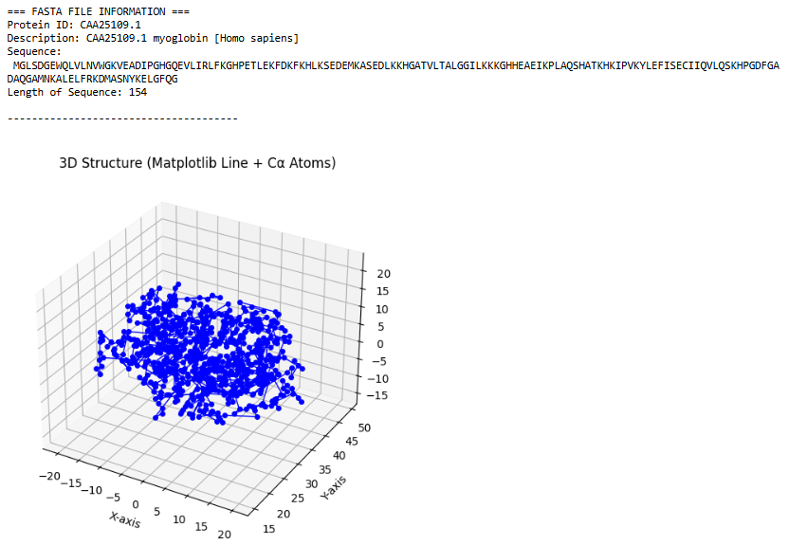
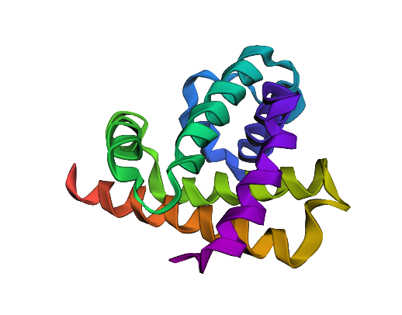

Name: Akshat Bhargava
Roll No: BEAD22563
Subject: CL – II
Assignment 4
Perform molecular docking simulations to predict the binding affinity between a protein target and a small molecule ligand. Additionally, you will conduct virtual screening to identify potential drug candidates.

import os
import sys
import numpy as np
import pandas as pd
import matplotlib.pyplot as plt
import seaborn as sns

from Bio.PDB import PDBParser, PDBIO, Select
from rdkit import Chem
from rdkit.Chem import AllChem, DataStructs
import py3Dmol

import warnings
warnings.filterwarnings("ignore")

PDB_FILE = r"C:\Users\athar\Downloads\SASDL82_fit1_model1.pdb"
OUTPUT_DIR = "ligand_files"
RESULT_CSV = "protein_ligand_docking_results.csv"

IGNORE_RESIDUES = {"HOH", "WAT", "H2O", "NA", "CL", "CA", "K", "MG", "ZN", "MN", "SO4"}

RDKIT_SEED = 42
np.random.seed(42)

class LigandSelect(Select):
def __init__(self, ligand_name):
self.ligand_name = ligand_name
def accept_residue(self, residue):
return residue.get_resname() == self.ligand_name

parser = PDBParser(QUIET=True)
try:
structure = parser.get_structure("protein", PDB_FILE)
except Exception as e:
print(f"ERROR reading file: {e}")
sys.exit(1)

ligands_found = []
for model in structure:
for chain in model:
for residue in chain:
resname = residue.get_resname().strip()
if residue.id[0] != " " and resname not in IGNORE_RESIDUES:
if resname not in ligands_found:
ligands_found.append(resname)

print("Detected ligands:", ligands_found)
if not ligands_found:
print("No valid ligands found. Exiting.")
sys.exit(0)

os.makedirs(OUTPUT_DIR, exist_ok=True)
io = PDBIO()
ligand_paths = []
for lig in ligands_found:
outpath = os.path.join(OUTPUT_DIR, f"{lig}.pdb")
io.set_structure(structure)
io.save(outpath, LigandSelect(lig))
ligand_paths.append(outpath)

rdkit_mols = []
rdkit_names = []

for path in ligand_paths:
name = os.path.basename(path).replace(".pdb", "")
mol = Chem.MolFromPDBFile(path, removeHs=False, sanitize=False)
if mol is None:
print(f"WARNING: Could not parse {path}")
continue
try:
Chem.SanitizeMol(mol)
except Exception:
try:
Chem.SanitizeMol(mol, Chem.SANITIZE_ALL ^ Chem.SANITIZE_PROPERTIES)
except Exception:
pass

mol = Chem.AddHs(mol, addCoords=True)
try:
params = AllChem.ETKDGv3()
params.randomSeed = RDKIT_SEED
res = AllChem.EmbedMolecule(mol, params)
if res != 0:
AllChem.EmbedMolecule(mol, AllChem.ETKDG())
except Exception as ex:
print(f"Embedding failed for {name}: {ex}")

try:
AllChem.MMFFOptimizeMolecule(mol)
except Exception:
pass

rdkit_mols.append(mol)
rdkit_names.append(name)

if not rdkit_mols:
print("No ligands successfully converted. Exiting.")
sys.exit(0)

fps = []
for mol in rdkit_mols:
try:
fp = AllChem.GetMorganFingerprintAsBitVect(mol, radius=2, nBits=2048)
except Exception:
fp = AllChem.GetMorganFingerprintAsBitVect(Chem.RemoveHs(mol), radius=2, nBits=2048)
fps.append(fp)

ref_fp = fps[0]
ref_name = rdkit_names[0]

def sim_to_score(sim, low=-4.0, high=-12.0):
return round(low + (high - low) * sim, 3)

scores, sims = [], []
for fp in fps:
sim = DataStructs.TanimotoSimilarity(ref_fp, fp)
sims.append(sim)
scores.append(sim_to_score(sim))

results_df = pd.DataFrame({
"Ligand": rdkit_names,
f"Tanimoto_Similarity_to_{ref_name}": sims,
"Pseudo_Docking_Score_kcal_per_mol": scores
}).sort_values("Pseudo_Docking_Score_kcal_per_mol").reset_index(drop=True)

print("\n=== Docking / Virtual Screening Results ===")
print(results_df)
results_df.to_csv(RESULT_CSV, index=False)
print(f"\nResults saved to {RESULT_CSV}")

best_row = results_df.iloc[0]
best_name = best_row["Ligand"]
best_score = best_row["Pseudo_Docking_Score_kcal_per_mol"]

print("\n=== BEST LIGAND ===")
print(f"Ligand: {best_name}")
print(f"Predicted Docking Score: {best_score} kcal/mol")
print(f"Reference Ligand: {ref_name}")

plt.figure(figsize=(max(6, len(results_df)*0.6), 4))
sns.barplot(x="Ligand", y="Pseudo_Docking_Score_kcal_per_mol", data=results_df, palette="viridis")
plt.xticks(rotation=45, ha="right")
plt.title("Pseudo Docking Scores (lower = better)")
plt.ylabel("Docking Score (kcal/mol)")
plt.tight_layout()
plt.show()

best_file = os.path.join(OUTPUT_DIR, f"{best_name}.pdb")
with open(PDB_FILE, "r") as f:
pdb_block = f.read()
with open(best_file, "r") as f:
lig_block = f.read()

view = py3Dmol.view(width=700, height=500)
view.addModel(pdb_block, 'pdb')
view.setStyle({'cartoon': {'color': 'spectrum'}})
view.addModel(lig_block, 'pdb')
view.setStyle({'model': 1}, {'stick': {'radius': 0.25, 'color': 'red'}})
view.setBackgroundColor('0xeeeeee')
view.zoomTo()
view.show()

sdf_out = r"C:\Users\athar\OneDrive\Desktop\Practical\Bioinformatics\results.sdf"
writer = Chem.SDWriter(sdf_out)
for mol, name in zip(rdkit_mols, rdkit_names):
mol.SetProp("_Name", name)
writer.write(mol)
writer.close()
print(f"\nExtracted ligand SDF saved to {sdf_out}")

Outtput:

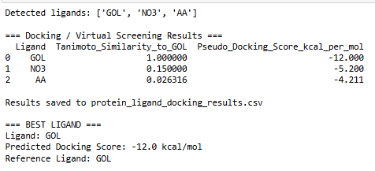
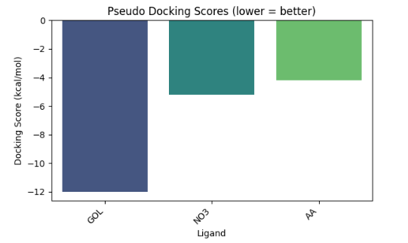
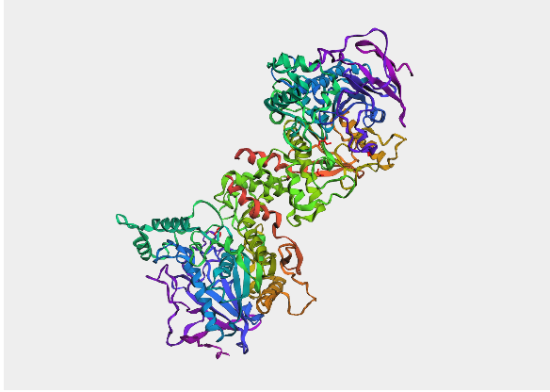

Name: Akshat Bhargava
Roll No: BEAD22563
Subject: CL – II
Assignment 5
Apply machine learning algorithms, such as random forests or support vector machines, to classify genomic data based on specific features or markers

import numpy as np
import pandas as pd
import matplotlib.pyplot as plt
import seaborn as sns
from sklearn.feature_extraction.text import CountVectorizer
from sklearn.model_selection import train_test_split
from sklearn.ensemble import RandomForestClassifier
from sklearn.svm import SVC
from sklearn.metrics import accuracy_score, precision_score, recall_score, f1_score, confusion_matrix, classification_report

file_path = r"C:\Users\athar\OneDrive\Desktop\Practical\Bioinformatics\human.txt"
df = pd.read_csv(file_path, sep='\t')
print(df.head())

sequences = df['sequence']
labels = df['class']

def get_kmers(seq, k=3):
return [seq[i:i+k] for i in range(len(seq)-k+1)]

vectorizer = CountVectorizer(analyzer=get_kmers)
X = vectorizer.fit_transform(sequences)
y = labels

X_df = pd.DataFrame(X.toarray(), columns=vectorizer.get_feature_names_out())

X_train, X_test, y_train, y_test = train_test_split(X_df, y, test_size=0.2, random_state=42)

rf = RandomForestClassifier(random_state=42).fit(X_train, y_train)
svm = SVC(kernel="linear").fit(X_train, y_train)

rf_pred, svm_pred = rf.predict(X_test), svm.predict(X_test)

def evaluate(name, y_true, y_pred):
print(f"\n{name} Results:")
print("Accuracy:", accuracy_score(y_true, y_pred))
print("Precision:", precision_score(y_true, y_pred, average='weighted'))
print("Recall:", recall_score(y_true, y_pred, average='weighted'))
print("F1 Score:", f1_score(y_true, y_pred, average='weighted'))
print(classification_report(y_true, y_pred))

evaluate("Random Forest", y_test, rf_pred)
evaluate("SVM", y_test, svm_pred)

def plot_cm(y_true, y_pred, title):
sns.heatmap(confusion_matrix(y_true, y_pred), annot=True, fmt="d", cmap="Blues",
xticklabels=["Healthy","Disease"], yticklabels=["Healthy","Disease"])
plt.title(title); plt.xlabel("Predicted"); plt.ylabel("Actual"); plt.show()
plot_cm(y_test, rf_pred, "Random Forest Confusion Matrix")
plot_cm(y_test, svm_pred, "SVM Confusion Matrix")
imp = rf.feature_importances_
idx = np.argsort(imp)[-10:][::-1]
plt.figure(figsize=(12,6))
plt.bar(range(10), imp[idx], tick_label=[X_df.columns[i] for i in idx])
plt.title("Top 10 Important k-mer Features"); plt.xticks(rotation=90); plt.show()
Output:
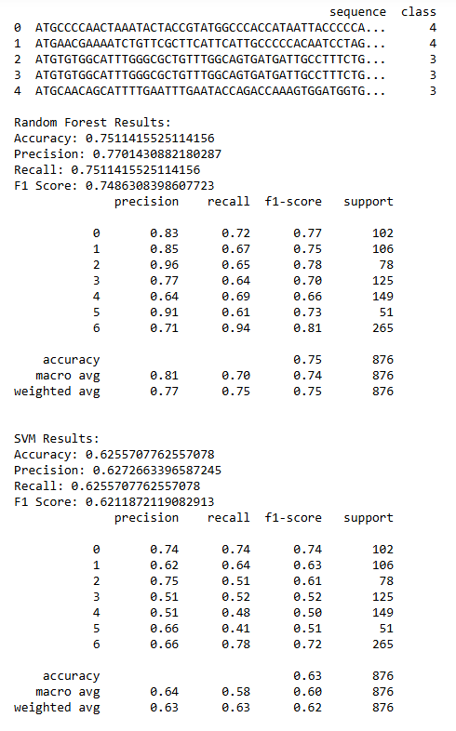

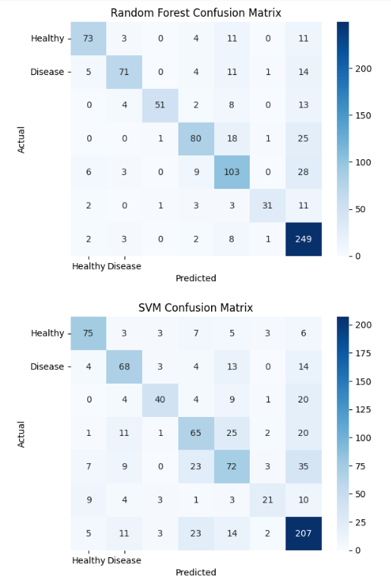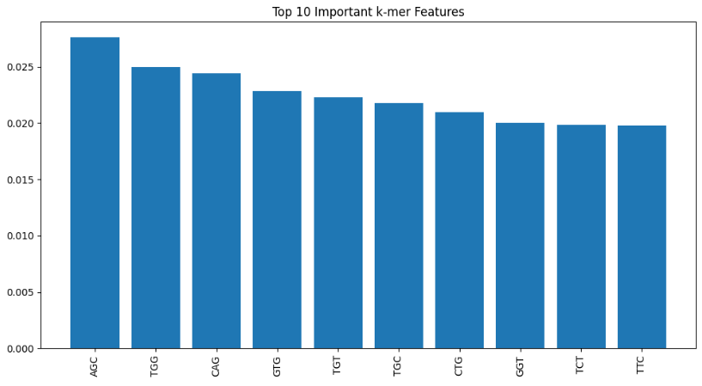

Name: Akshat Bhargava
Roll No: BEAD22563
Subject: CL – II
Assignment 6
Analyze genomic data from crops to identify genetic markers associated with desirable traits, such as disease resistance or yield.

# Requirements (install if needed):
# pip install pandas numpy statsmodels matplotlib

import numpy as np
import pandas as pd
import statsmodels.api as sm
import matplotlib.pyplot as plt
import os

# ---------- Config ----------
PHENOS_PATH = r"C:\Users\athar\Downloads\phenos.csv" # input phenotypes file
OUT_DIR = r"C:\Users\athar\OneDrive\Desktop\Practical\Bioinformatics"
N_SNPS = 5000 # number of simulated SNPs
TRAITS = ["Yield", "Plant_height", "Grain_weight"] # traits to analyze
np.random.seed(42)
# ----------------------------

os.makedirs(OUT_DIR, exist_ok=True)

# Load phenotype data
phenos = pd.read_csv(PHENOS_PATH).reset_index(drop=True)

# Check traits exist
for t in TRAITS:
if t not in phenos.columns:
raise ValueError(f"Trait '{t}' not found in phenos.csv. Columns: {phenos.columns.tolist()}")

n_samples = phenos.shape[0]
print(f"Samples: {n_samples}, Traits: {TRAITS}, Simulating {N_SNPS} SNPs...")

# Simulate SNP matrix (0,1,2) — rows = samples, cols = SNPs
G = pd.DataFrame(
np.random.randint(0, 3, size=(n_samples, N_SNPS)),
columns=[f"SNP_{i+1}" for i in range(N_SNPS)]
)

# Specify causal SNP indices for demonstration (0-based indices)
causal_snps_for_trait = {
"Yield": [10, 150, 1800],
"Plant_height": [50, 900, 2400],
"Grain_weight": [5, 1200, 3500]
}
effect_sizes = [3.5, 5.0, 4.0] # effect sizes to inject (one per causal SNP)

# Create simulated phenotypes by adding genetic effects onto real phenotypes
phenotype_sim = {}
for trait in TRAITS:
base = phenos[trait].astype(float).copy()
for i, s in enumerate(causal_snps_for_trait.get(trait, [])):
base = base + G.iloc[:, s] * effect_sizes[i]
phenotype_sim[trait] = base

def run_gwas(trait_series, G_df):
results = []

for snp in G_df.columns:
X = sm.add_constant(G_df[snp]) # intercept + SNP
model = sm.OLS(trait_series, X).fit()
pval = model.pvalues.get(snp, np.nan)
results.append((snp, pval))
gwas_df = pd.DataFrame(results, columns=["SNP", "p"])
gwas_df["-log10(p)"] = -np.log10(gwas_df["p"])
gwas_df["Pos"] = range(len(gwas_df))
return gwas_df

all_significant = {}
for trait in TRAITS:
print(f"\nRunning GWAS for trait: {trait}")
trait_series = phenotype_sim[trait]
gwas_df = run_gwas(trait_series, G)

threshold = -np.log10(0.05 / N_SNPS)
print(f"Bonferroni threshold (−log10): {threshold:.2f}")

# Save GWAS table
gwas_csv = os.path.join(OUT_DIR, f"gwas_{trait}.csv")
gwas_df.to_csv(gwas_csv, index=False)
print(f"Saved GWAS table to: {gwas_csv}")

# Plot Manhattan plot interactively
plt.figure(figsize=(12,5))
plt.scatter(gwas_df["Pos"], gwas_df["-log10(p)"], s=10, alpha=0.7)
plt.axhline(threshold, linestyle="--")
plt.title(f"Manhattan plot for {trait}")
plt.xlabel("SNP position")
plt.ylabel("-log10(p-value)")
plt.tight_layout()
plt.show()

# Save significant SNPs
sig = gwas_df[gwas_df["-log10(p)"] > threshold].copy().sort_values("-log10(p)", ascending=False)
sig_csv = os.path.join(OUT_DIR, f"significant_snps_{trait}.csv")
sig.to_csv(sig_csv, index=False)
all_significant[trait] = sig
print(f"Significant SNPs: {len(sig)} (saved to {sig_csv})")

# Combine top significant SNPs across traits
combined_list = []
for trait, df in all_significant.items():
if not df.empty:
top = df.head(50).copy()
top["Trait"] = trait
combined_list.append(top[["Trait","SNP","p","-log10(p)","Pos"]])
if combined_list:
combined_df = pd.concat(combined_list, ignore_index=True)
combined_csv = os.path.join(OUT_DIR, "combined_significant_snps.csv")
combined_df.to_csv(combined_csv, index=False)
print(f"\nCombined significant SNPs saved to: {combined_csv}")
else:
print("\nNo significant SNPs across analyzed traits.")

print(f"\nAll results saved to folder: {OUT_DIR}")

Output:

