Name – Akshat Bhargava
Roll no – BEAD – 22563
BI-3
Summary page:
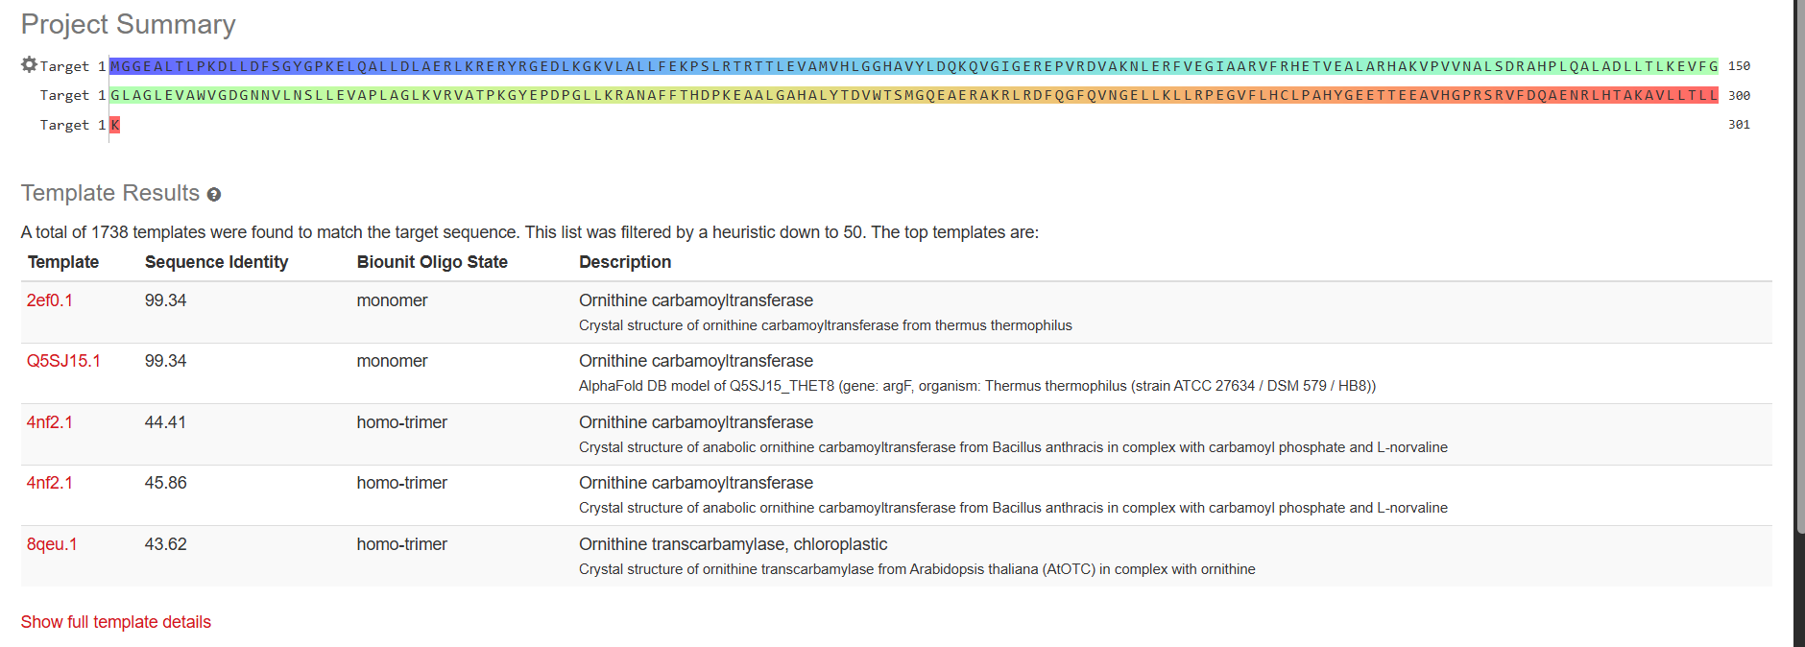
Template (sections)
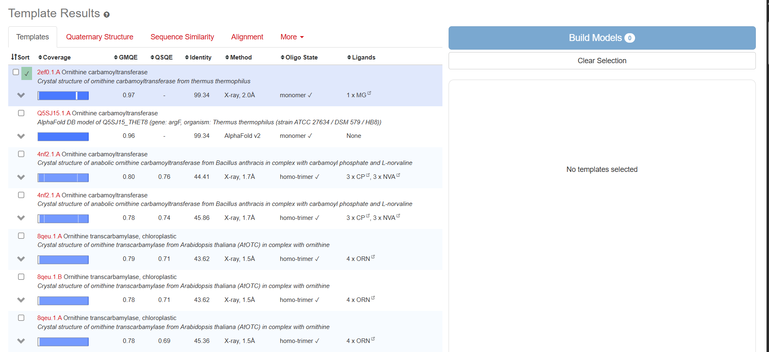
Final model with 3d structure
