Name: Akshat Bhargava
Roll no – BEAD22563
BI-4
1. Ligand Selection – Aspirin
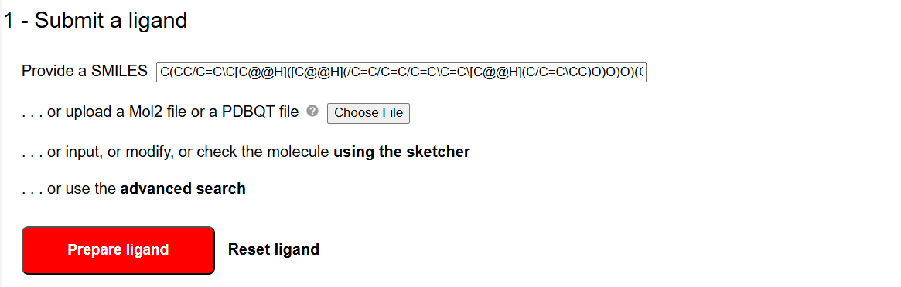
2. Target Protein Search – 5hie
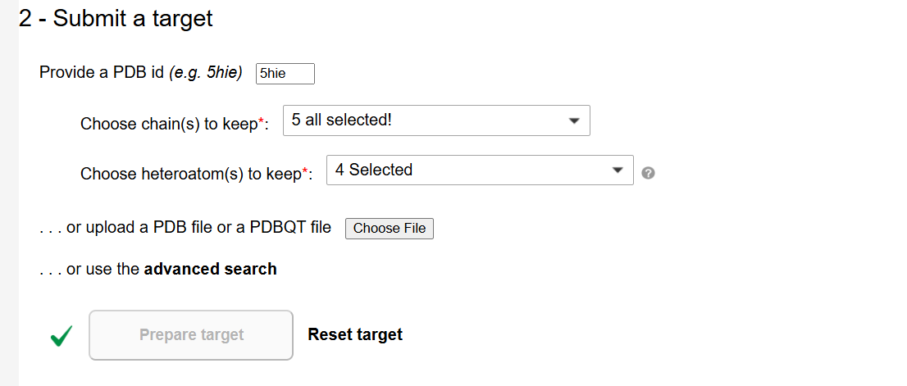
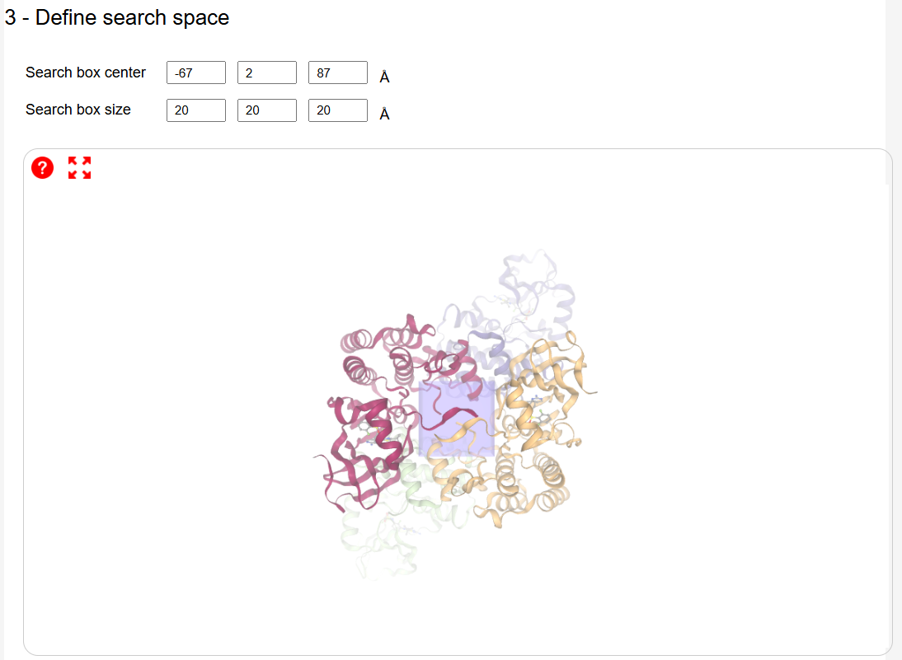
3. Docking Parameters Setup
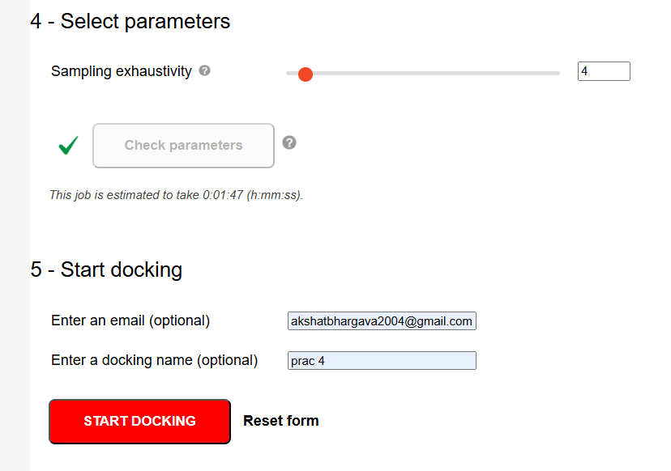
4. Docking Results Summary
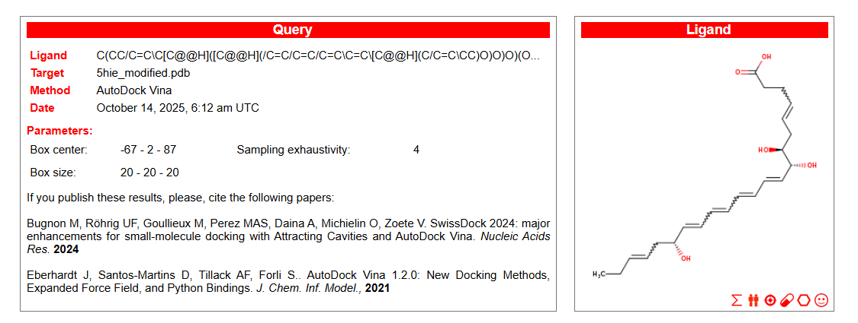
5. Best Docking Pose Visualization 