Name: Akshat Bhargava
Rollno: BEAD-22563
ML Practical 1
Problem Statement: To use PCA Algorithm for dimensionality reduction. You have a dataset that includes measurements for different variables on wine (alcohol, ash, magnesium, and so on). Apply PCA algorithm & transform this data so that most variations in the measurements of the variables are captured by a small number of principal components so that it is easier to distinguish between red and white wine by inspecting these principal components
Code & Output –
1. Import required libraries and dataset. Clean Dataset.
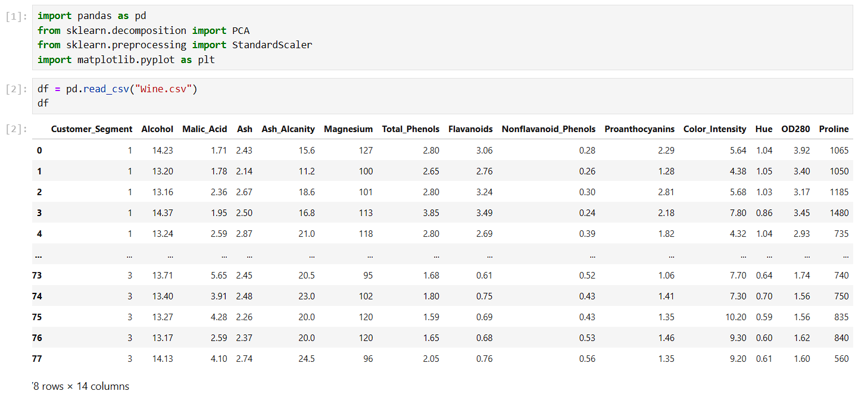
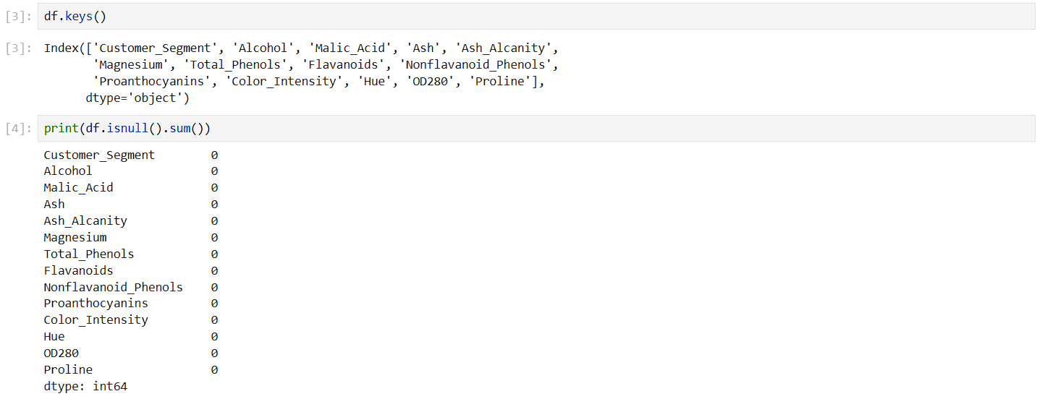

2. Split features and standardize features.
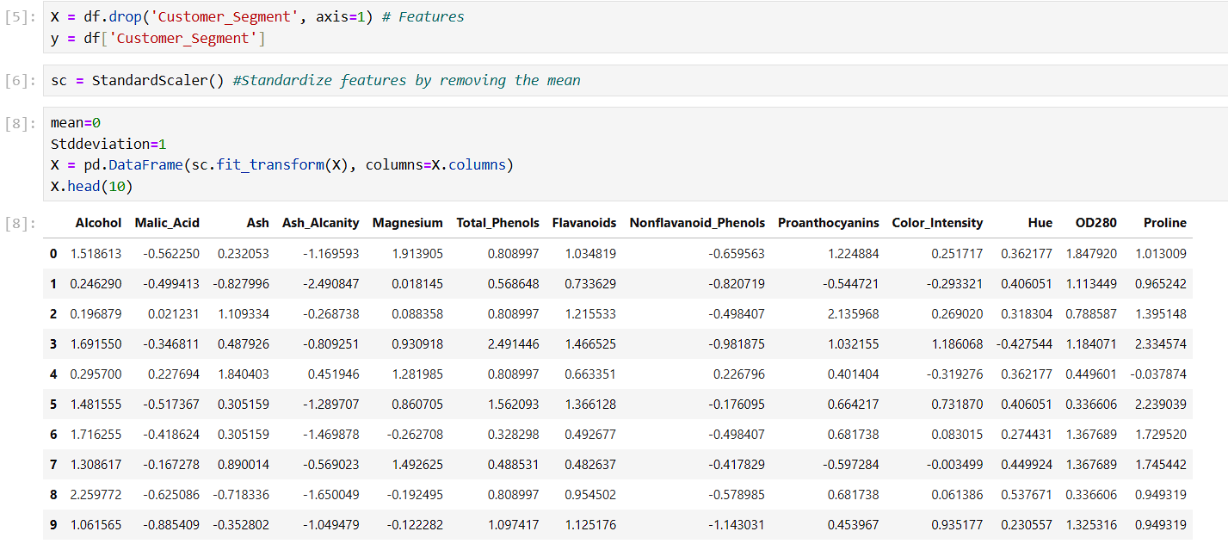
3. Apply PCA and plot explained variance.
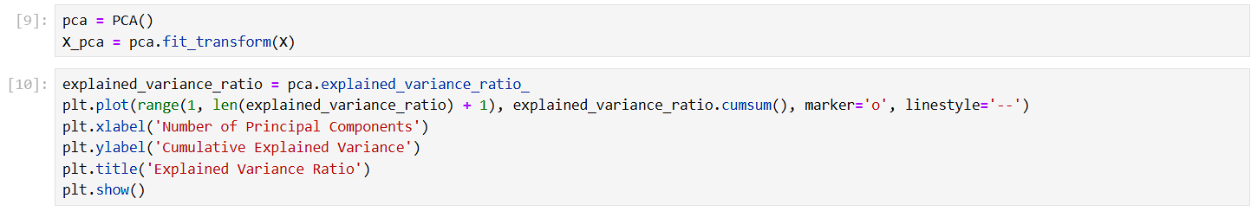
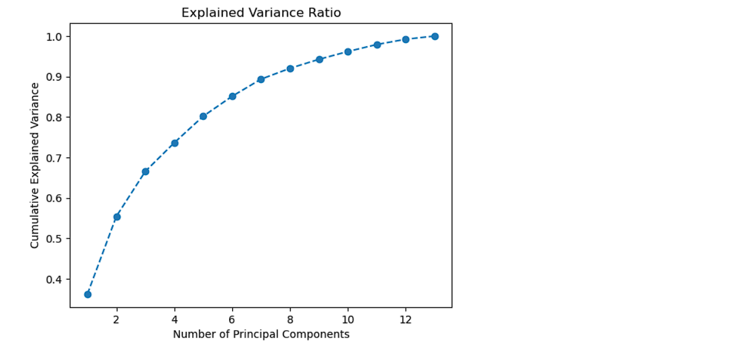

4. Reduce Dimensions and Visualize the transformed Data.
