Name: Akshat Bhargava
Rollno: BEAD-22563
ML Practical 2
Problem Statement: Predict the price of the Uber ride from a given pickup point to the agreed drop-off location. Perform following tasks:
1. Pre-process the dataset.
2. Identify outliers.
3. Check the correlation.
4. Implement linear regression and ridge, Lasso regression models.
5. Evaluate the models and compare their respective scores like R2, RMSE, etc.
Dataset link: https://www.kaggle.com/datasets/yasserh/uber-fares-dataset
Code & Output –
1. Data Loading, Preprocessing & Train-Test Split
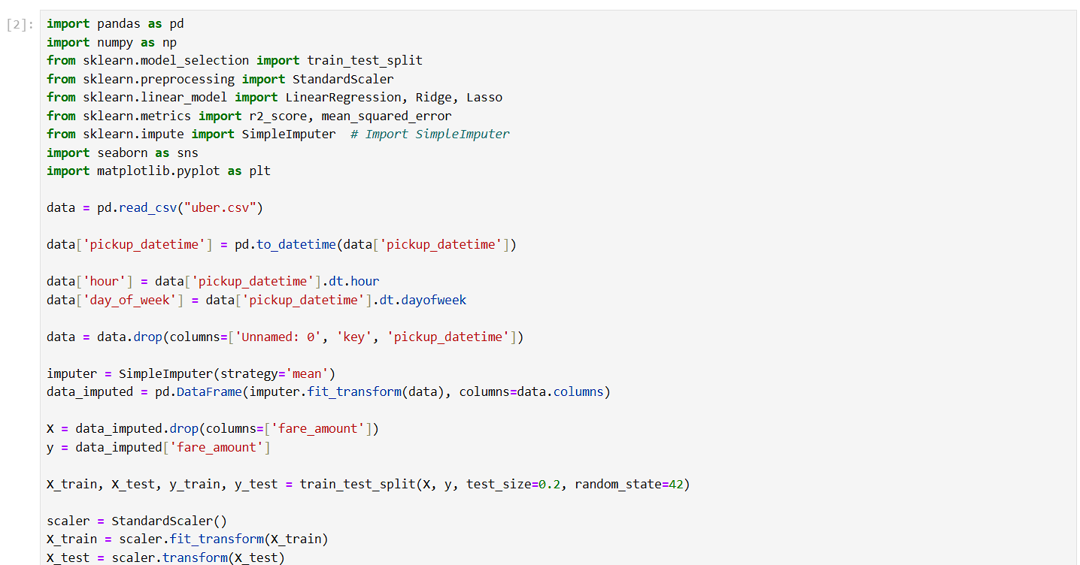
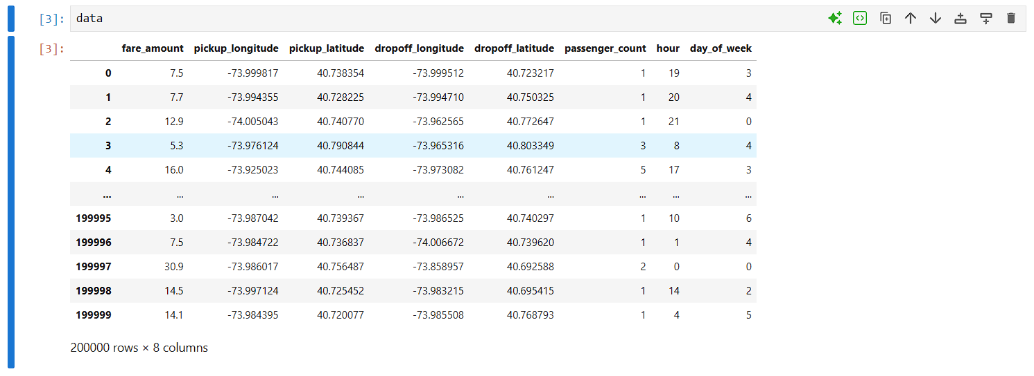
2. Outlier Detection (Boxplot of Fare Amount)
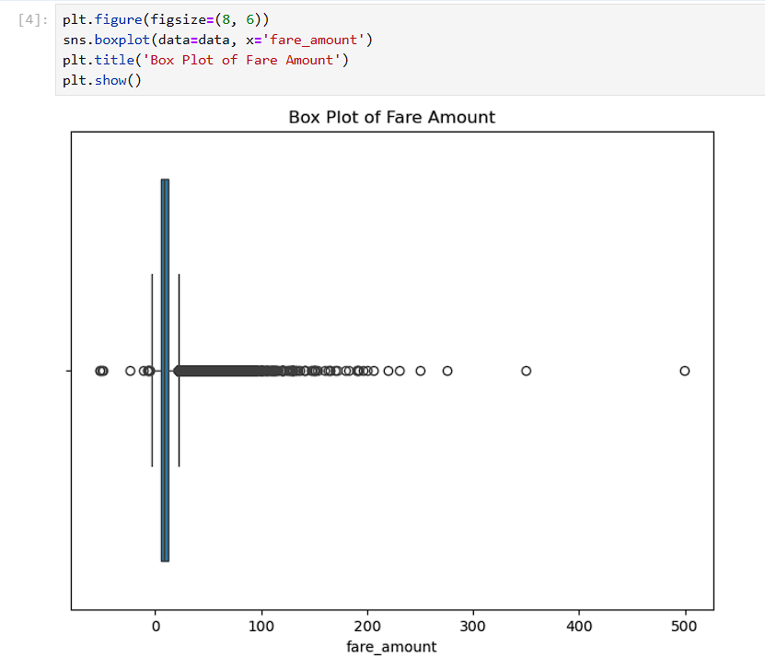
3. Correlation Analysis
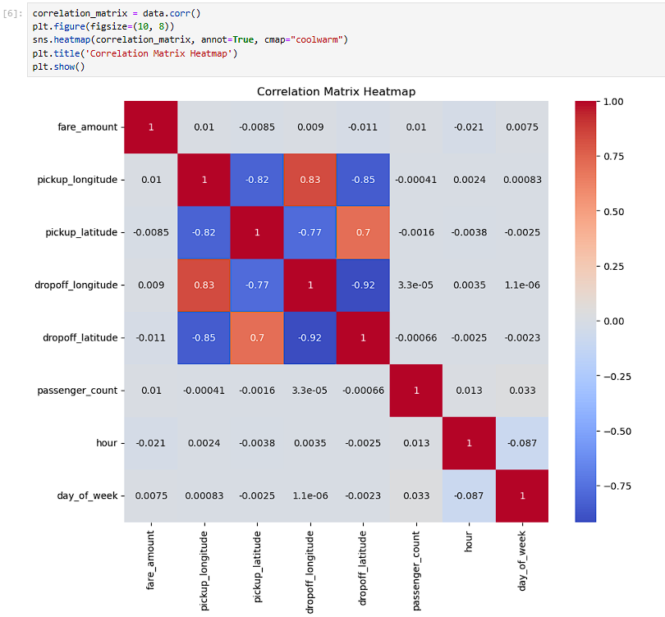
4. Model Implementation & Evaluation
