Name – Akshat Bhargava
Roll No – BEAD22563
ML – 4
Problem Statement - Implement K-Means clustering on Iris.csv dataset. Determine the number of clusters using the elbow method. Dataset Link: https://www.kaggle.com/datasets/uciml/iris
1. Load Dataset and Preprocess:
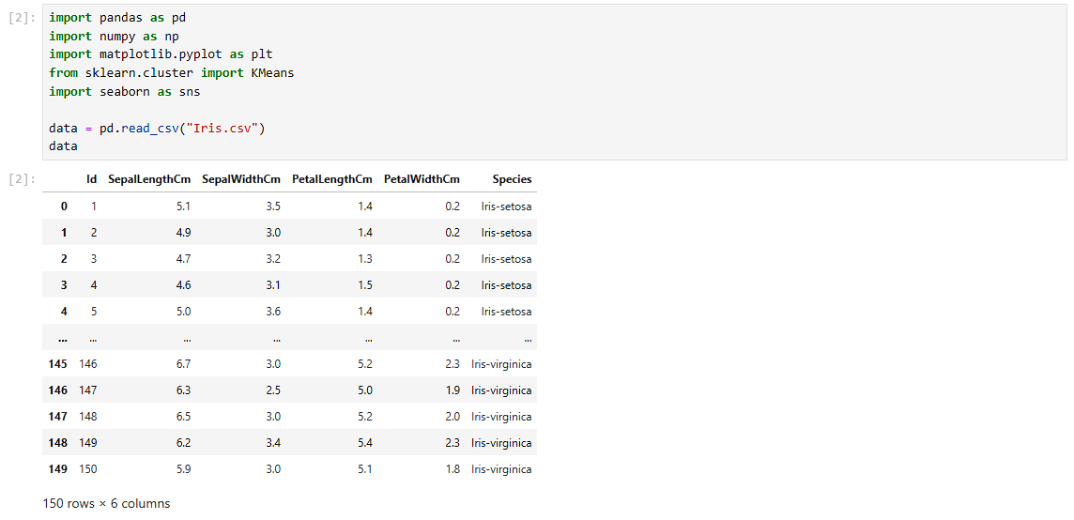
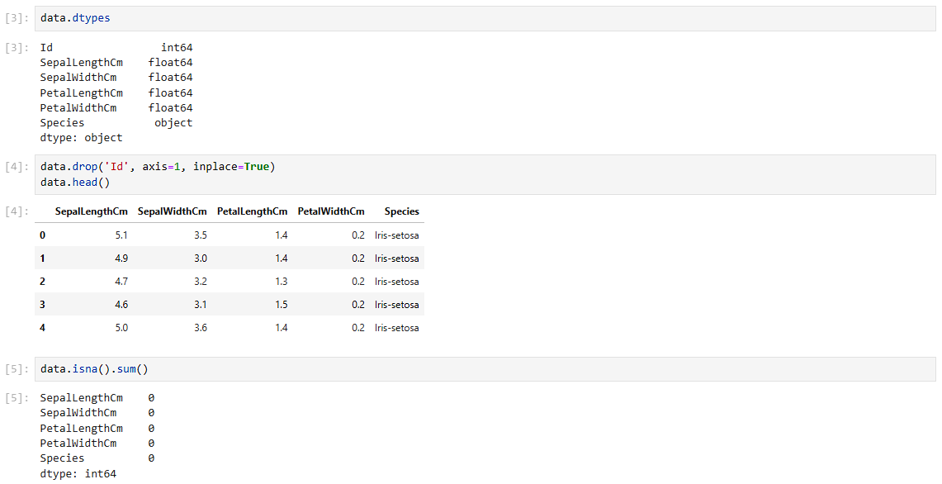

2. Data Exploration and Visualization
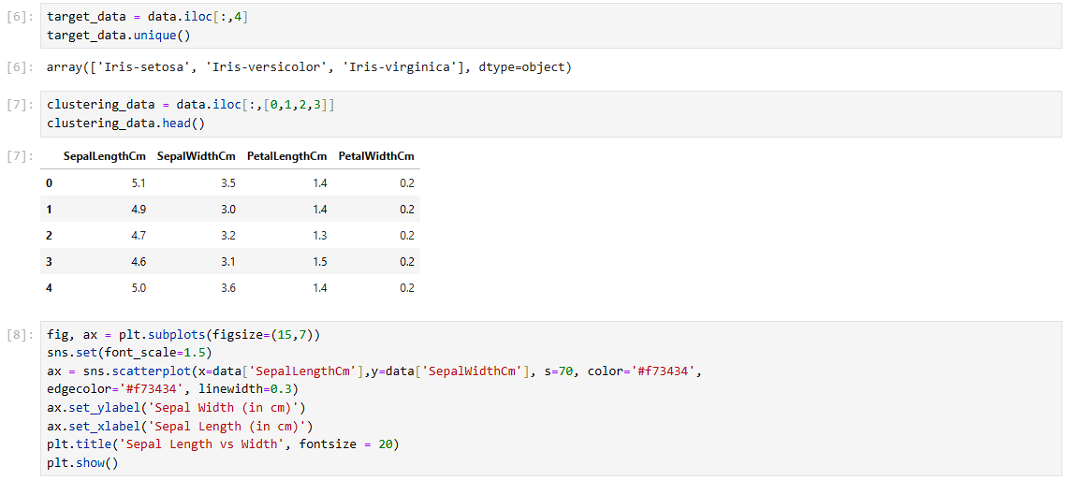
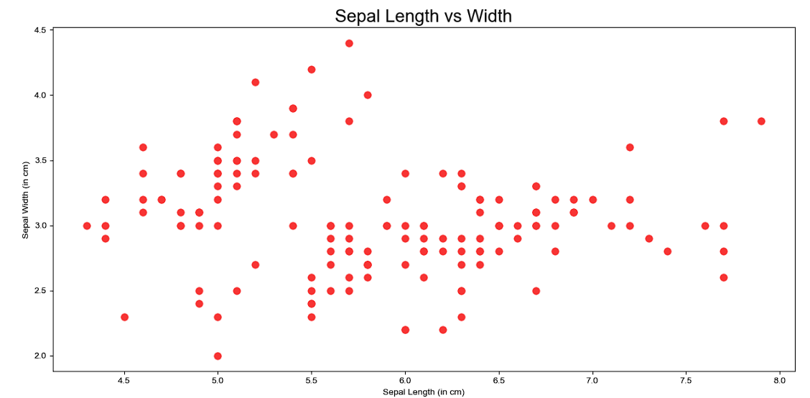
3. Optimal Clusters (Elbow Method)
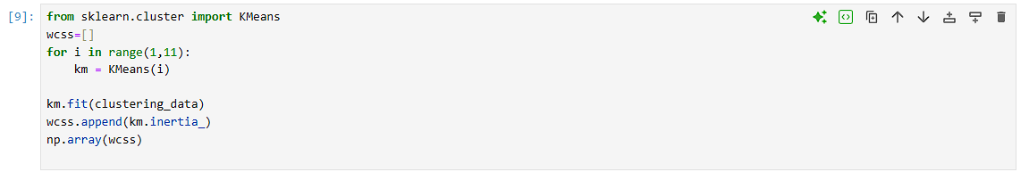

4. Apply K-Means
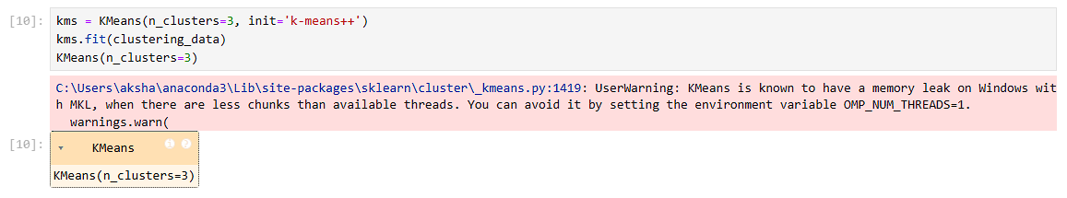
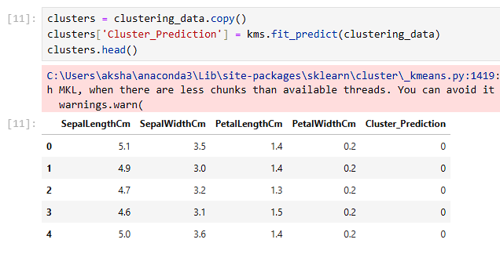
5. Cluster Visualization
