Name: Akshat Bhargava
Rollno: BEAD-22563
ML Practical 5

Problem Statement: Implement Random Forest Classifier model to predict the safety of the car.
Dataset link: https://www.kaggle.com/datasets/elikplim/car-evaluation-data-set

1. Load Dataset and Preprocess:
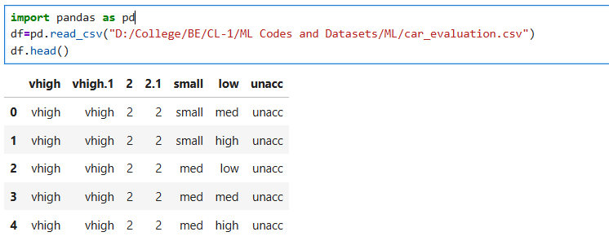
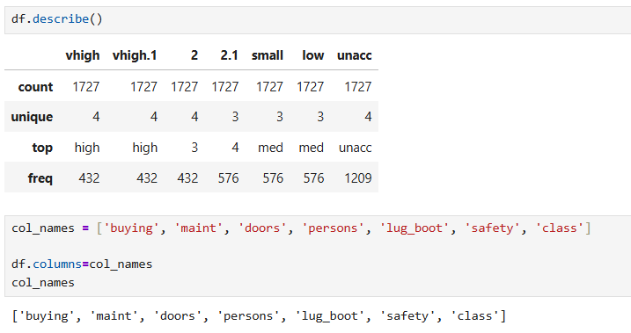
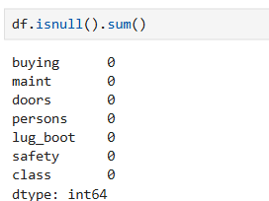
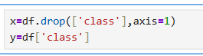

2. Split Dataset into Features and Target, Data Encoding
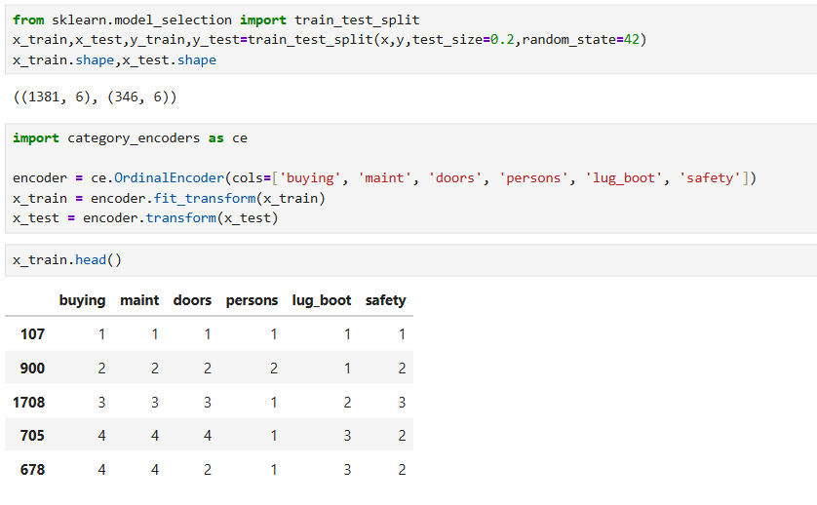

3. Train Random Forest Classifier
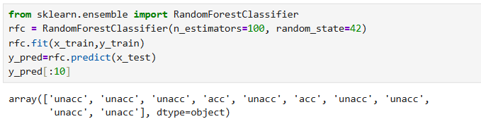

4. Model Evaluation
