WEEK 3 PROJECT REPORT
Advanced Data Analysis and Visualization in Logistics
Dataset: DataCo Supply Chain Dataset
Analysis period: January 2015 – January 2018
Prepared as a Week 3 data analysis submission

1. Introduction
This report presents exploratory data analysis (EDA) and visualization of the DataCo Supply Chain dataset. The objective is to understand delivery performance, delivery duration, monthly order trends, regional sales, and relationships among selected logistics and financial variables.

2. Dataset and Scope
The cleaned item-level dataset contains 180,519 records and 52 columns. It includes delivery information, order dates, shipping modes, sales, discounts, quantities, profit-related fields, and regional information. A separate order-level file contains 65,752 unique orders. The monthly order chart uses unique Order Id values; most other summaries shown here use item-level records.
The dataset does not contain a dedicated shipping-cost column. Therefore, this report does not claim to measure transportation cost. Financial analysis is limited to available sales and profit-related fields.

3. Methodology
- Loaded the cleaned CSV file using pandas.
- Converted the order-date field to datetime for monthly aggregation.
- Summarized delivery status and actual delivery duration.
- Compared delivery duration across shipping modes.
- Counted unique orders by month.
- Summed sales by Order Region.
- Calculated correlations among selected numerical variables.
- Used a scatter plot to inspect sales against actual delivery duration.

4. Descriptive Analysis
Measure | Result | Meaning
Dataset size | 180,519 × 52 | Item-level cleaned dataset
Average actual delivery time | 3.50 days | Mean delivery duration
Median actual delivery time | 3 days | Middle observed value
Delivery-time range | 0–6 days | Minimum to maximum
Average sales per record | 203.77 | Mean Sales value; currency not specified
Total sales | 36,784,735.01 | Sum of Sales across item records
Average Order Profit Per Order field | 21.97 | Average field value per item record; not shipping cost
Total item quantity | 384,079 | Sum of Order Item Quantity
Average item quantity | 2.13 | Mean quantity per item record
Late delivery risk | 54.83% | Share of item records with Late_delivery_risk = 1

5. Visualization and Interpretation
The following seven figures were supplied for this report. Each is followed by a brief interpretation.

Figure 1. Delivery Status Distribution
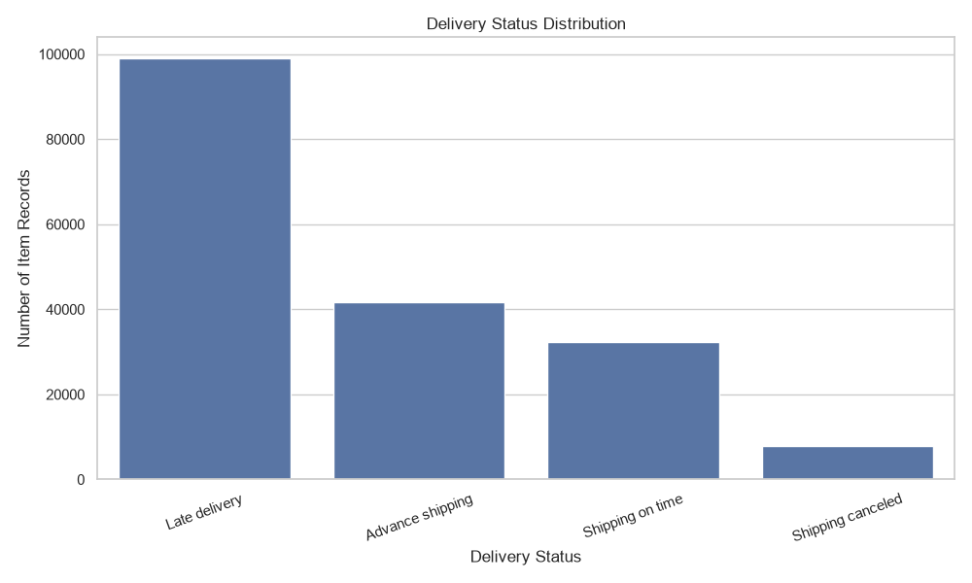
Late delivery is the largest category, with 98,977 item records. Advance shipping accounts for 41,592 records, shipping on time for 32,196, and shipping cancelled for 7,754. This indicates that late delivery is a major operational issue in this dataset. These are item-level records, not unique orders.

Figure 2. Distribution of Actual Delivery Time
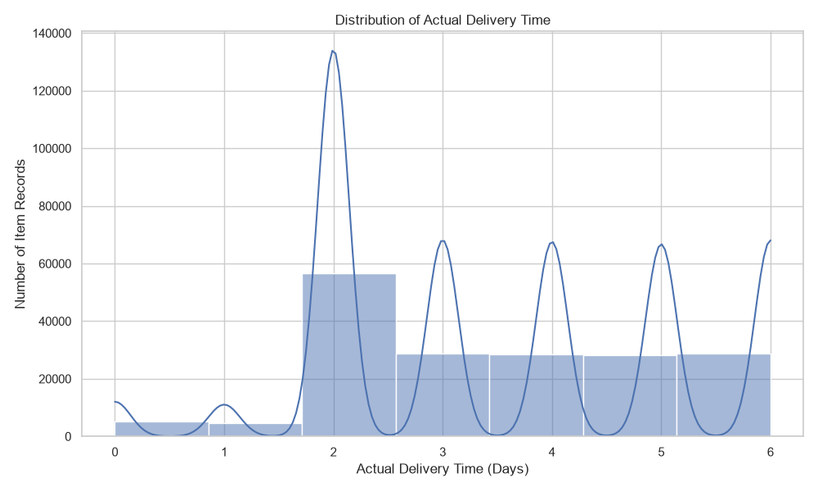
Actual delivery time ranges from 0 to 6 days. The average is approximately 3.50 days and the median is 3 days. The histogram shows a strong concentration around 2 days, with additional records at 3–6 days. Since delivery time is recorded in whole days, the smooth KDE curve appears spiky; the histogram is more useful for interpreting this discrete distribution.

Figure 3. Delivery Time by Shipping Mode
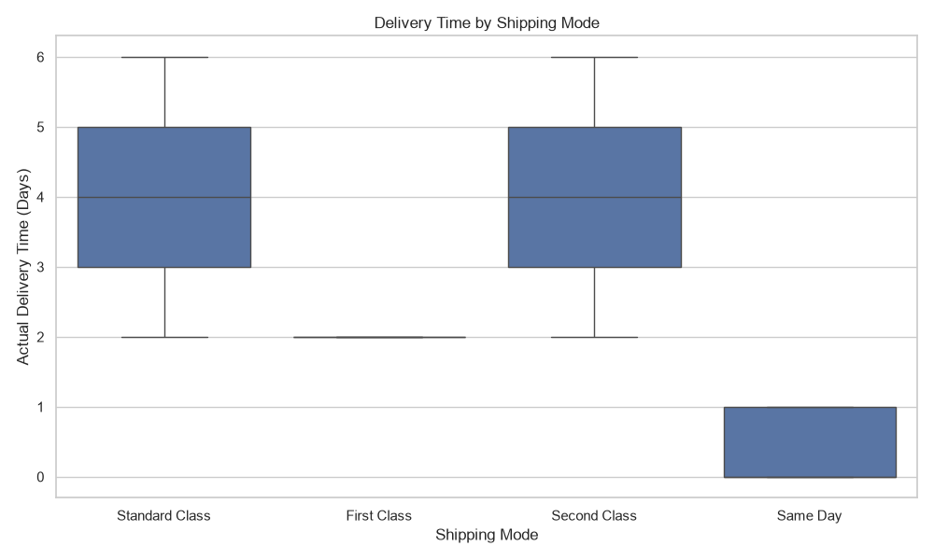
Standard Class and Second Class have medians around 4 days and ranges of approximately 2–6 days. First Class is concentrated at 2 days, while Same Day is concentrated between 0 and 1 day. These patterns reflect the different service speeds associated with the shipping-mode categories in this dataset.

Figure 4. Monthly Order Volume Trend
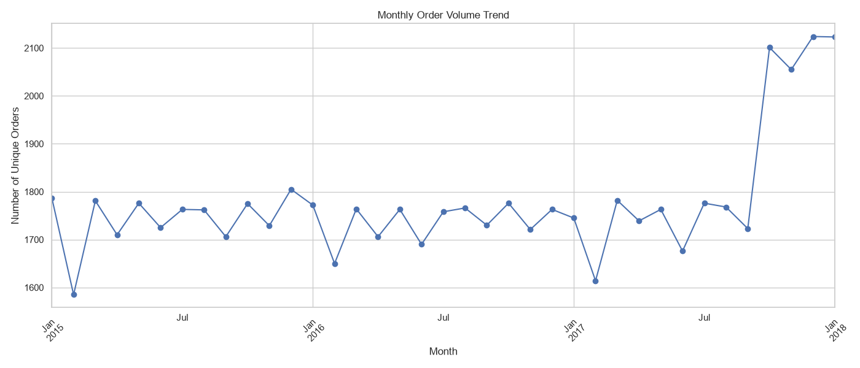
Monthly unique-order volume is fairly steady through much of 2015–2017, generally around 1,600–1,800 orders per month. A clear rise occurs near the end of 2017, reaching roughly 2,100 orders in December 2017 and January 2018. Interpret the final period in the context of the dataset ending in January 2018.

Figure 5. Total Sales by Region
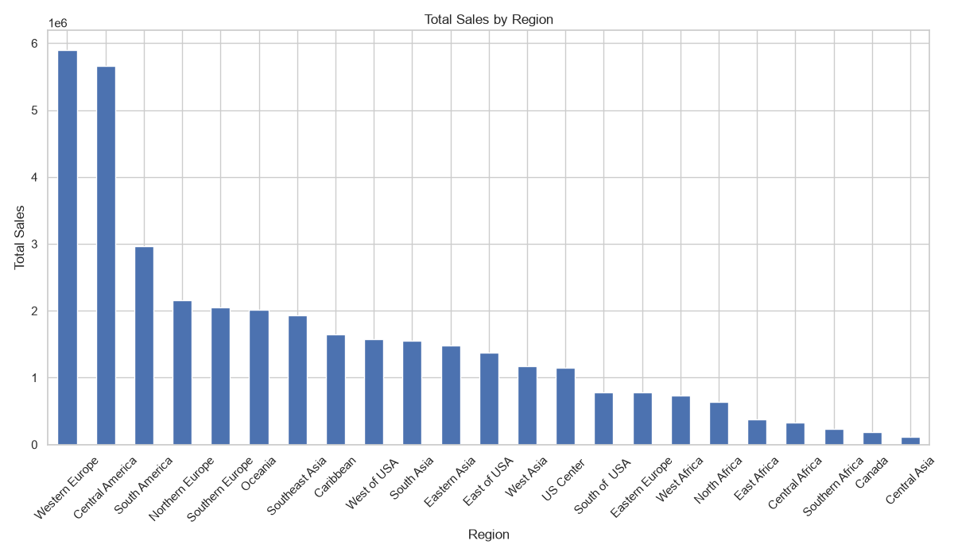
Western Europe and Central America have the highest total sales, followed by South America. Central Asia and Southern Africa are among the lowest. Sales concentration may reflect differences in order volume and product mix; these totals are not measures of regional profit or delivery performance.

Figure 6. Correlation Heatmap of Logistics Variables
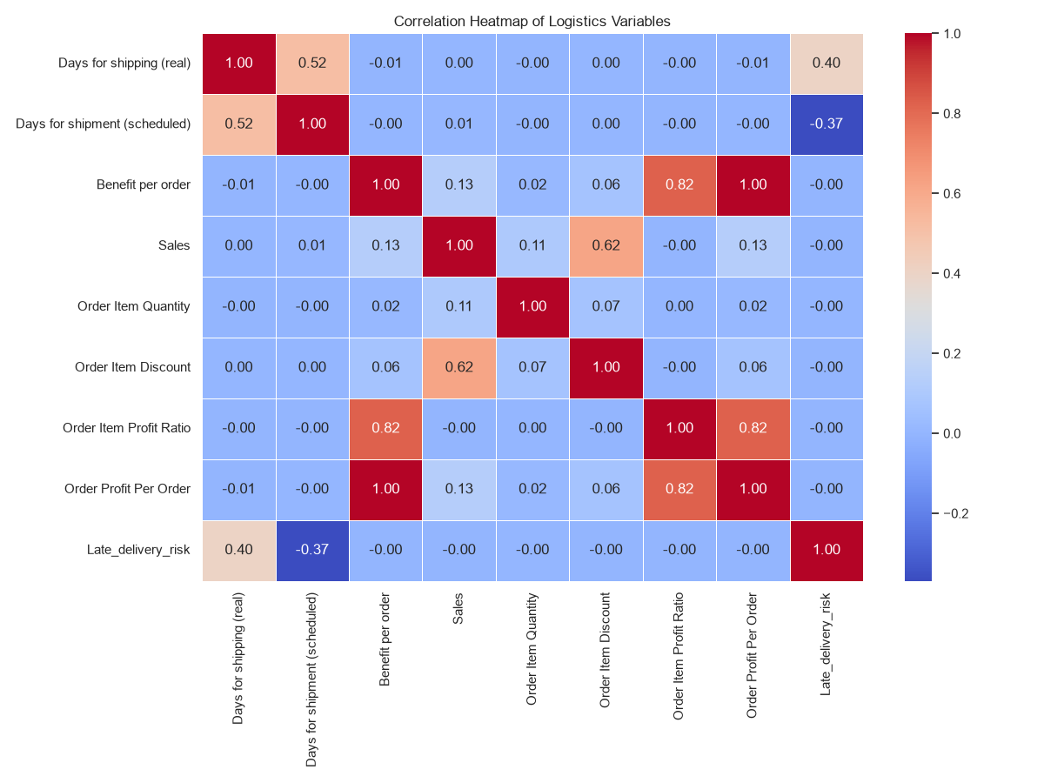
Actual shipping days and scheduled shipping days have a moderate positive correlation (0.52). Late-delivery risk correlates positively with actual shipping days (0.40) and negatively with scheduled shipping days (-0.37). Sales and order-item discount correlate at 0.62. Benefit per order and Order Profit Per Order correlate at 1.00, suggesting the fields may be identical or closely related. Correlation does not prove causation.

Figure 7. Sales vs Actual Delivery Time
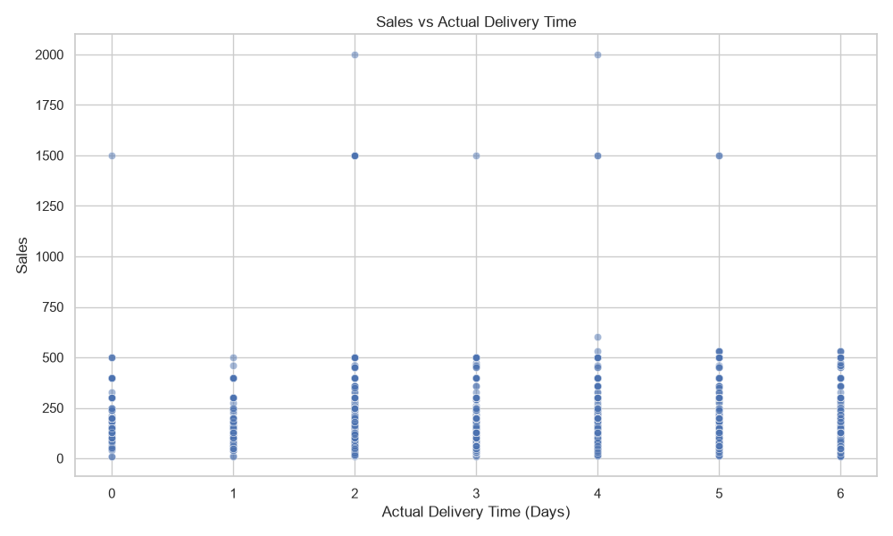
The scatter plot shows sales observations at each delivery duration from 0 to 6 days. Most points are concentrated at lower sales values, with a few high-value records. There is no obvious linear relationship between sales and actual delivery time. The vertical bands occur because delivery duration is recorded in whole days.

6. Overall Findings
- Late delivery is the largest delivery-status category in the item-level data and should be investigated.
- Actual delivery duration averages about 3.50 days, with a median of 3 days and a range of 0–6 days.
- Delivery-time patterns differ across shipping modes; Same Day and First Class show shorter durations than Standard Class and Second Class.
- Monthly unique-order counts remain relatively stable for much of the period, followed by an increase near the end of the dataset.
- Sales are concentrated in Western Europe and Central America.
- The correlation heatmap shows relationships among variables, but correlation alone cannot establish cause and effect.
- The scatter plot does not show a clear linear relationship between sales and actual delivery duration.

7. Recommendations
- Investigate late deliveries by destination, order date, product category, shipping mode, and scheduled delivery expectations.
- Monitor delivery performance separately for each shipping mode and consider the promised service time when comparing them.
- Review demand and fulfilment capacity in high-sales regions, particularly Western Europe and Central America.
- Use monthly order trends to support inventory, staffing, and fulfilment planning.
- Collect a clearly defined shipping-cost field in future datasets to enable direct transportation-cost analysis.
- Verify the definitions of financial fields that show near-perfect correlation before using them for business decisions.
- Use order-level data for order counts and item-level data for product, quantity, and sales analysis.

8. Limitations
- Seven graphs were uploaded. The planned profit-by-shipping-mode graph was not included, so it is not reproduced or interpreted in this report.
- Most delivery-status and financial summaries are based on item-level records rather than unique orders.
- The dataset has no dedicated shipping-cost column.
- The scatter plot is descriptive and cannot establish causation.
- The dataset ends in January 2018; interpret the final monthly values with this coverage in mind.

9. Conclusion
The Week 3 analysis demonstrates how EDA and visualization can reveal patterns in logistics operations. The dataset shows a substantial late-delivery category, different delivery-duration patterns across shipping modes, variation in regional sales, and relationships among selected numerical variables. These findings provide a starting point for deeper investigation of delivery causes, regional operations, and fulfilment planning. Future analysis should use clearly defined order-level measures and include direct shipping-cost data when cost analysis is required.

Appendix: Python Tools
The workflow used pandas for data loading, grouping, and summary calculations, and Matplotlib/Seaborn for visualizations. Date conversion and monthly aggregation were performed in Python.

