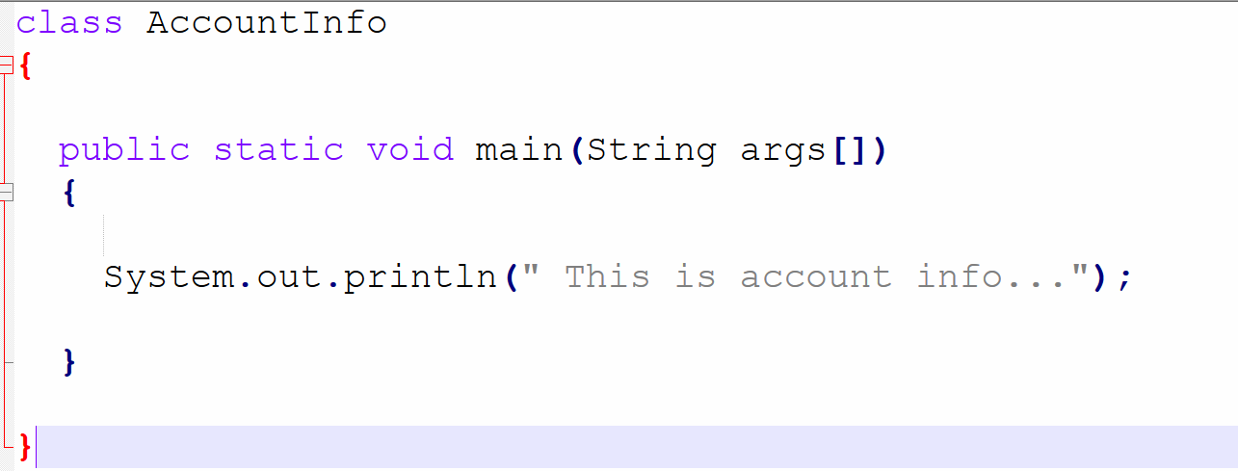

Write a program to add two number.

Why do we need only jre ?

Jar Java Achieve(Bundled/ ZIP)

10 years : data-cleaner.jar
Source Code Compile Jar Created Tested Running in production Env
De-compile Convert the byte code to java code / source

Jdk Develop the java code and compile it.
JRE provide environment for prog execution
JVM execute the program

Local Machine(JDK and JRE) Developed code Compiled Created Jar Testing Production Env(JRE).

Java Identifiers Class , Method, Variable, Constants, Interface etc…
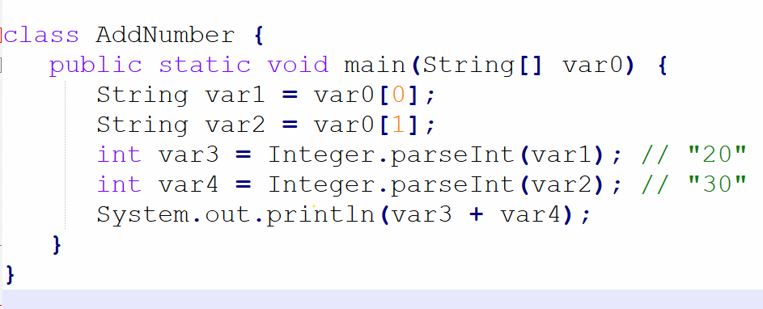

[A-Z][a-z][0-9]
_amount $amount1 myValue
_ and $
amount#
55+ reserved keywords for special purpose

