- Developed the hello world Write a code to perform/do the specific work/Task
- Print HelloWorld
- Add two numbers
- Send email
- Text message
- Send money
- Calculate interest ….
- Compile
- Compiler(javac) - Rules and regulations
- Convert the source code(.java file) into Byte code(.class)
- Execution / Run
- JVM Java Virtual Machine
- Load the class(Byte code) into memory
- While starting JVM will occupy memory from RAM
- 8 GB RAM 1 GB reserved 500 MB HEAP + Stack + MetaSpace + PC +….
- Output

Changed the code re-compile it execute - Time

NEVER DO HARD CODING
Arguments
Program Argument
JVM Argument(Heap Size, Stack Size, GC)

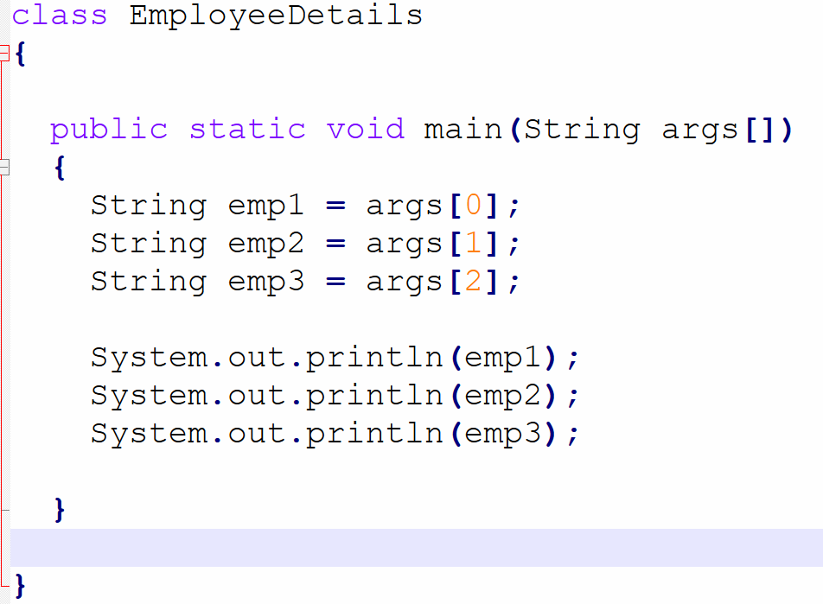

Task :
- Write a program to print order id, product name, placed by, delivery address

ORD11234
IPhone16
Kodewala
“2nd Stage, BTM Layout, Bangalore”

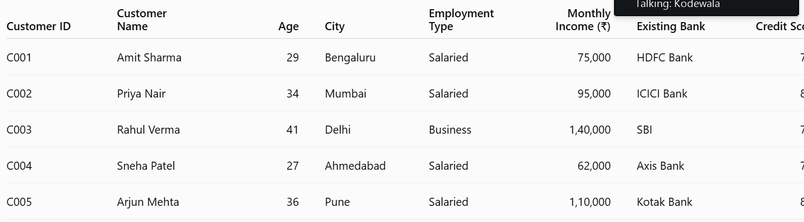

………………. 200 + files

M1.txt

Email to customer
Analyzer Engine

Vega city mall Today’s data.txt
Nexus mall latest data.txt

