BYTE CODE & JVM (Java virtual machine)
{
Source code
}

JVM
Byte code
Machine Code

Compiler

Hello.java Hello.class
JDK
Interpreter Convert code line by line.
JRE
JVM
Compiler Convert code all at once.
Java Is not pure Interpreter/ Compiler, Java is both .
JVM (Interpreter + JIT Compiler)

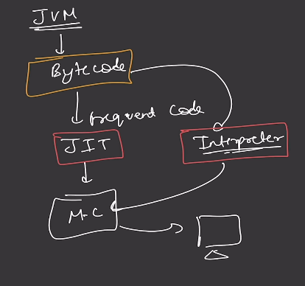
JVM
- Convert Bytecode to machine code (Interpreter + JIT compiler)
- Security (Sand box model)
- Garbage collection

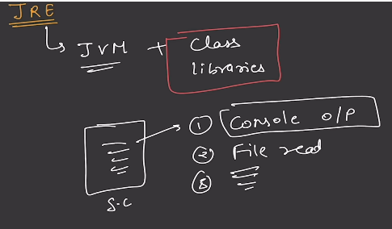
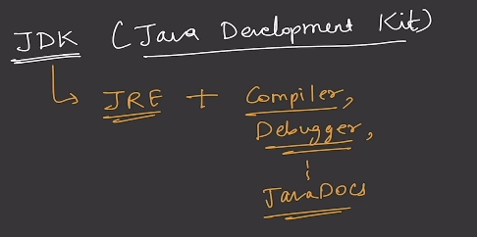
JSE Java Stander Edition (Core)
JEE Java Enterprise Edition (Transaction Jakarta EE)
JME Java Micro Edition (Light Weight edition (early mobile) not use today [Replace Andriod])

STRING java.lang.String (java.lang {auto import})
Character ‘A’ , ’a’ , _ _ _ _ _ _ _ _ _ , ‘1‘ , ‘2’, _ _ _ _ _ _ _ _ _
String Sequence of character. String is non-primitive data type. String Constant Pool (SCP
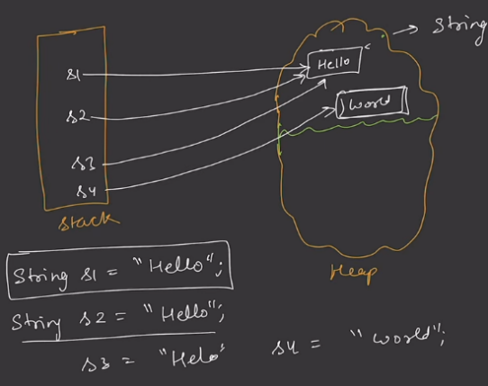
Char [ ] [ ‘a’, ‘k’, ‘s, ‘h, ‘a, ‘t’ ]
String Immutable Class.
String Literal String s = ”Hello”,
Literal new
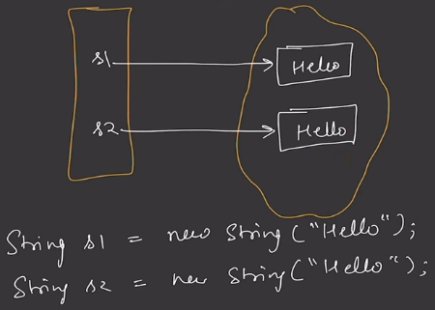
String pool

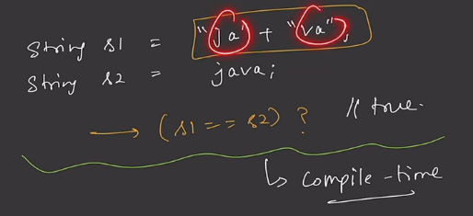
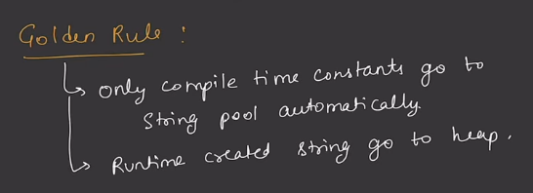
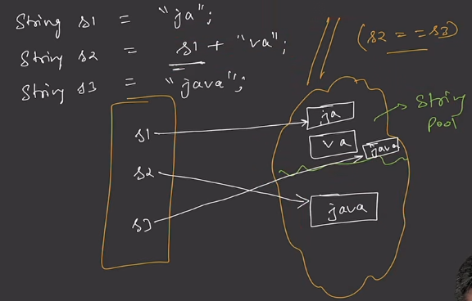
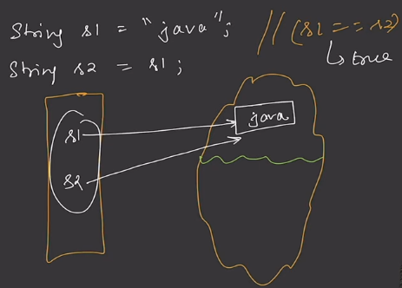

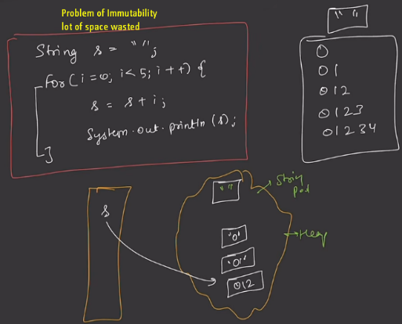
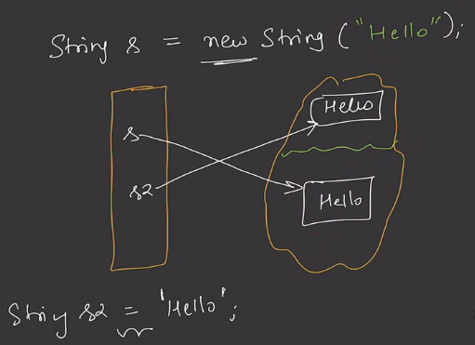
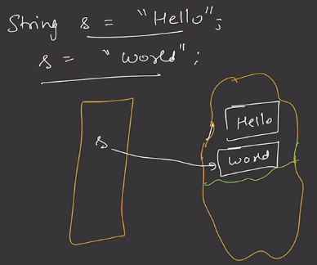
String user1 = "Akshat";
String user2 = new String("Akshat");

System.out.println(user1.equals(user2)); //.equals() Content / Value same?
System.out.println(user1==user2); //= = Reference / Object same ?

* Before:
name ───────► [ "Akshat" ]s
↑
Object
* After:
name ───────► [ "AKSHAT" ]
↑
Object B

When you "change" a String, Java doesn't modify the existing String object. Instead, it creates a new String object.
OOP’s

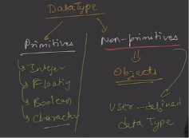
Class And Object

Class Student {
String name;
int age;
int rollNo;
String collage
}

Blueprint of an object

Student s1;
S1 = new Student ( );
Student s1 = new Student ( );
Student s2 = new Student ( );

S1.name = “Akshat”;  S1.age = 26;  S1.rollNo = 121;  S1.collage = “Kodewala”; | S2.name = “Priti”;  S2.age = 16;  S2.rollNo = 151;  S2.collage = “Mrsptu”;

new keyword memory allocation Run time
Dynamic Run time memory allocation
Static Comple time memory allocation

Class Student {  String name;  int age;  int rollNo;  String collage  Void markAttendance ( ) {  }  } | Student s1 = new Student ( );  S1.name = “Akshat”;  S1.age = 26;  S1.rollNo = 121;  S1.collage = “Kodewala”;  S1. markAttendance ( );

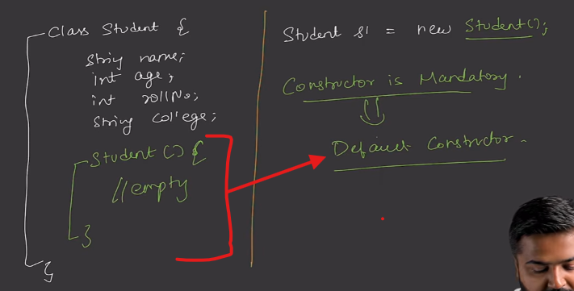
Constructors
Rules of Constructor :-
- Same name as class
- No return Type, not even void.
- Automatically called during object creation.
- Used to initialized an object.
- It can be also be overloaded

Classs Student {  Striing name;  int age;  int rollNo;  String address;  Student ( ) {  name = “Akshat”;  age = 26;  rollNo = 12;  address = “BTM”;  }  }  Student s1 = new Student ( ); | parameterized constructor  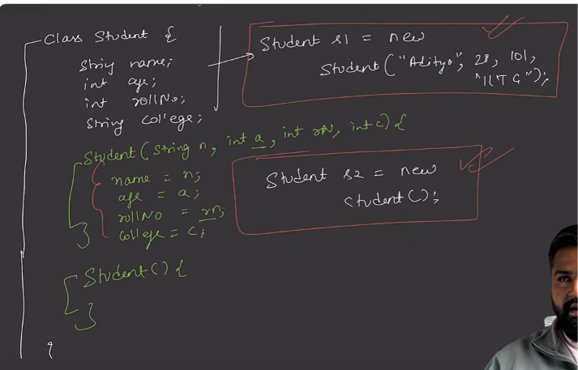
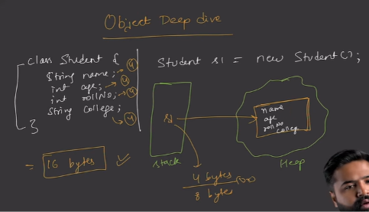
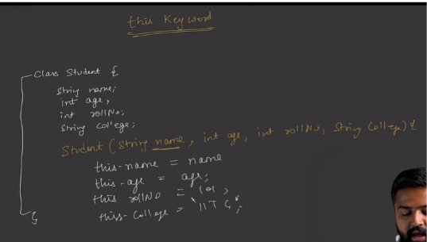
this Keyword
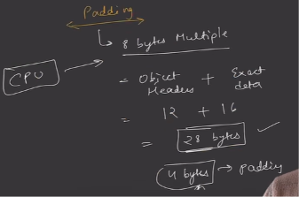
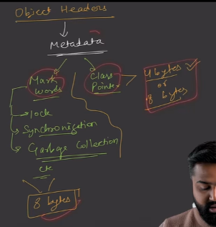
Object size
- Header Size
- Exact Size
- Padding Size
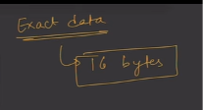

28 byte + 4 byte Padding = 32 byte
Object metadata = 12 byte { Mark Word 8 bytes + Class Pointer 4 bytes}
Object Size = Header Size + Field Sizes + Internal Padding + External Padding (8-byte alignment)

Eg.  Class A {  byte age;  } | Calculate Object Size  metadata 12 byte  extra data 1 byte {because byte 1 byte space leta hai  total 13 byte + 3 byte padding {because multiple of 8byte 13 16 se 3kum hai islye 3padding liye }  Object Size 16 Byte

Java Call by value

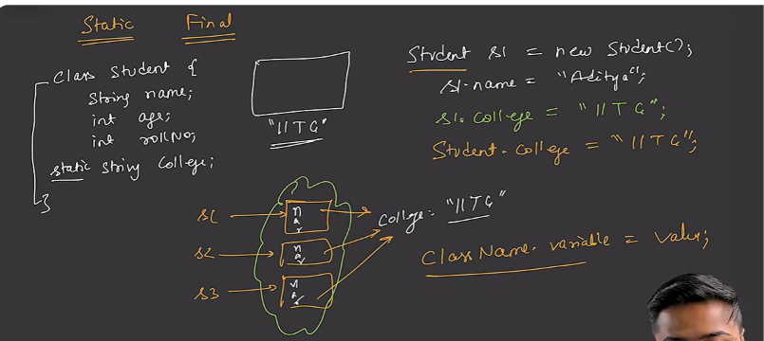
Instance variable

Class variable //Are note store in heap , Store in Method Area (Meta Space)

Encapsulation
- Both data and Behaviour should be together (encapsulation) with in an object
- We should not provide unrestricted access of data

Access Modifiers  Who have access to  - Variable  - Method  - Constructor  - Class | 4 Access modifier in java  - public {Anyone}  - default {same package}  - private {same class}  - protected {package + Inherited class , (child class)

Method | Variable
  Parent | Child | Result
  instance | instance | ✅ Override
  static | static | ✅ Hide
  static | instance | ❌ Compile Error
  instance | static | ❌ Compile Error
  Parent Variable |  | Child Variable | Result
  instance |  | instance | ✅ Hide / Shadow
  static |  | static | ✅ Hide
  static |  | instance | ✅ Hide
  instance |  | static | ✅ Hide

Feature | Fields (Variables) | Methods
Inheritance | ✅ Yes | ✅ Yes
Overriding | ❌ No | ✅ Instance methods only
Hiding | ✅ Yes | ✅ Static methods only
Runtime Polymorphism | ❌ No | ✅ Yes (instance methods)
Compile-time Resolution | ✅ Yes | ✅ Static methods
Runtime Resolution | ❌ No | ✅ Instance methods
Dependent On | Reference Type | Object Type (for overridden methods)
static vs instance mix allowed? | ✅ Yes | ❌ No
@Override allowed? | ❌ No | ✅ Yes

Static Method  ✔ static variables  ✔ ClassName.member  ✘ this.field  ✘ this.method()  ✘ super.field  ✘ super.method() | Instance Method  ✔ this  ✔ super  ✔ instance fields  ✔ instance methods

Kahan Se Access Kar Rahe Ho | Static Variable | Instance Variable | Static Method | Instance Method | this | super
Static Method | ✅ | ❌ Directly | ✅ | ❌ Directly | ❌ | ❌
Instance Method | ✅ | ✅ | ✅ | ✅ | ✅ | ✅
Static Block | ✅ | ❌ | ✅ | ❌ | ❌ | ❌
Constructor | ✅ | ✅ | ✅ | ✅ | ✅ | ✅

Feature | Compile Time | Run Time
Class Loading | ❌ | ✅
Bytecode Generation | ✅ | ❌
Syntax Checking | ✅ | ❌
Type Checking | ✅ | ❌
Method Overloading Resolution | ✅ | ❌
Variable Access Resolution | ✅ | ❌
Static Method Resolution | ✅ | ❌
Object Creation | ❌ | ✅
Constructor Execution | ❌ | ✅
Overridden Method Selection | ❌ | ✅
Dynamic Dispatch | ❌ | ✅
Heap Allocation | ❌ | ✅
Stack Frame Creation | ❌ | ✅

Item | Memory Area
Local Variables | Stack
Method Parameters | Stack
Reference Variables | Stack
Objects | Heap
Arrays | Heap
Instance Variables | Heap (object ke andar)
Static Variables | Method Area
Class Metadata | Method Area
Bytecode | Method Area
String Constant Pool | Method Area (Runtime Constant Pool)
New Thread Stack | Stack
Current Instruction | PC Register
Member | Resolution
Local Variable | Compile Time
Instance Field | Compile Time
Static Field | Compile Time
Static Method | Compile Time
Private Method | Compile Time
Final Method | Compile Time
Overloaded Method | Compile Time
Overridden Method | Run Time
Interface Method Call | Run Time
Abstract Method Call | Run Time

STACK  Local Variables  Method Parameters  References | PC REGISTER  Current Instruction  NATIVE METHOD STACK  JNI / Native Calls | STACK = Method execution  HEAP = Objects  METHOD AREA = Class information + Static data  PC = Current instruction  NATIVE = C/C++ calls
HEAP  Objects  Arrays  Instance Variables | METHOD AREA  Class Metadata  Static Variables  Methods Bytecode  Constant Pool | PC REGISTER  Current Instruction  PC REGISTER  Current Instruction
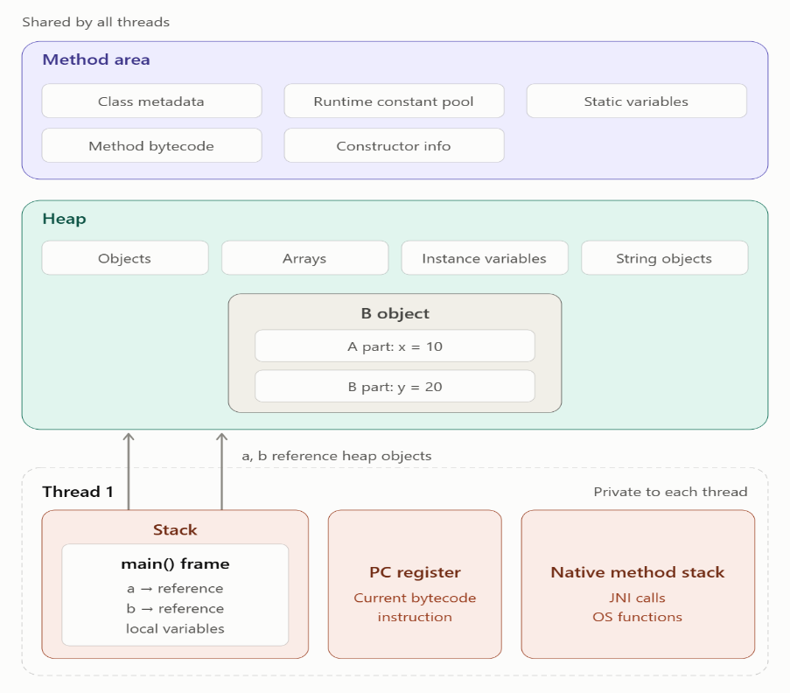
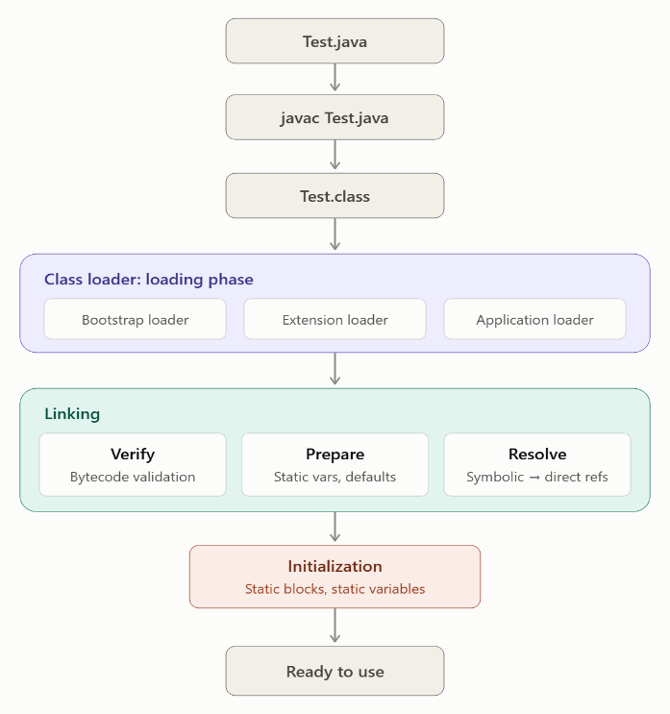
Class Loading Lifecycle OR JVM Memory

3. Downcasting Diagram (✅ Allowed)
Java
User u = new AdminUser(); // Upcasting
AdminUser a = (AdminUser) u; // Downcasting
Plain Text
Step 1

User u
│
▼
+----------------+
| AdminUser Obj |
+----------------+

Step 2

User u ---------┐
│
▼
+----------------+
| AdminUser Obj |
+----------------+
▲
│
AdminUser a ----┘
Both references point to the same object.

1. Upcasting Diagram (✅ Allowed)
Java
User u = new AdminUser();
Plain Text
Reference Type Actual Object
User -----------> AdminUser
(Parent) (Child)

u
│
▼
+----------------+
| AdminUser Obj |
+----------------+
Rule:
Java
Parent p = new Child(); // ✅ Upcasting
Example:
Java
User u = new FinanceUser();
Plain Text
User
│
▼
+------------------+
| FinanceUser Obj |
+------------------+

2. Multi-Level Upcasting (✅ Allowed)
Java
Object obj = new FinanceUser();
Plain Text
Object
│
▼
+------------------+
| FinanceUser Obj |
+------------------+
Inheritance:
Plain Text
Object
↑
User
↑
AdminUser
↑
FinanceUser

Java
AdminUser a = new AdminUser();

User u = a; // ↑ Upcasting

AdminUser a2 = (AdminUser) u; // ↓ Downcasting
Arrow upar = Upcasting
Easy Trick Exam/Interview Ke Liye
Plain Text
Child → Parent ✅ Upcasting
Parent → Child ❌ Directly Not Allowed

Parent → Child Cast ✅ Possible
(Only if object is actually Child)
Yaad rakhne ka shortcut:

Plain Text
UPCASTING

Child Object
↑
│
Parent Reference

DOWNCASTING

Parent Reference
│
▼
Child Reference
Arrow niche = Downcasting ✅

4. Invalid Assignment (❌ Compile Error)
Java
AdminUser a = new User();
Plain Text
AdminUser
│
▼
+------------+
| User Obj |
+------------+
Compiler says:
Plain Text
Type mismatch:
cannot convert from User to AdminUser
Reason:
Plain Text
Every AdminUser is a User ✅

But

Every User is NOT an AdminUser ❌
Example:
Java
User u = new User(); // ordinary user
Compiler cannot guarantee that u is actually an AdminUser.

5. Wrong Downcasting (❌ Runtime Error)
Java
User u = new User();

AdminUser a = (AdminUser) u;
Compile ho jayega, lekin runtime pe crash:
Plain Text
User u
│
▼
+------------+
| User Obj |
+------------+

(AdminUser) u
❌
Output:
Java
Exception in thread "main"
java.lang.ClassCastException
Reason:
Actual object User ka hai, AdminUser ka nahi.

Array
