BYTE CODE & JVM (Java virtual machine)
{
Source code
}

Machine Code
JVM
Byte code

Compiler
Hello.java Hello.class
JDK
Interpreter Convert code line by line.
JRE
JVM
Compiler Convert code all at once.
Java Is not pure Interpreter/ Compiler, Java is both .
JVM (Interpreter + JIT Compiler)

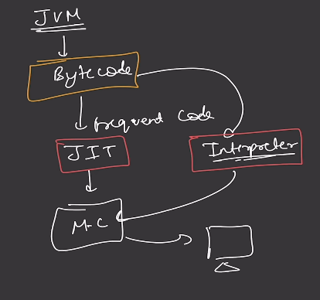
JVM
- Convert Bytecode to machine code (Interpreter + JIT compiler)
- Security (Sand box model)
- Garbage collection

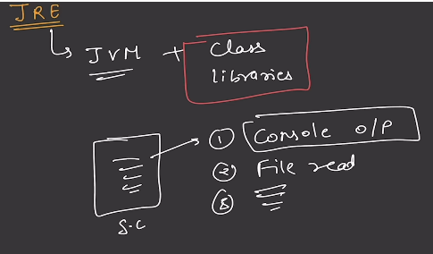
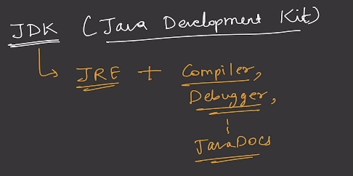
JSE Java Stander Edition (Core)
JEE Java Enterprise Edition (Transaction Jakarta EE)
JME Java Micro Edition (Light Weight edition (early mobile) not use today [Replace Andriod])

STRING java.lang.String (java.lang {auto import})
Character ‘A’ , ’a’ , _ _ _ _ _ _ _ _ _ , ‘1‘ , ‘2’, _ _ _ _ _ _ _ _ _
String Sequence of character. String is non-primitive data type. String Constant Pool (SCP
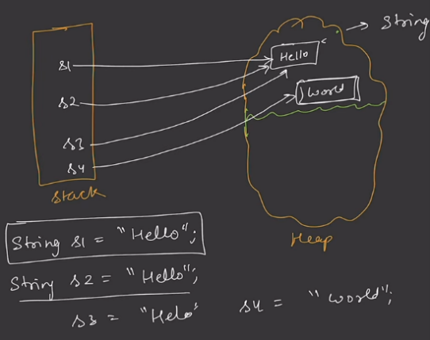
Char [ ] [ ‘a’, ‘k’, ‘s, ‘h, ‘a, ‘t’ ]
String Immutable Class.
String Literal String s = ”Hello”,
Literal new
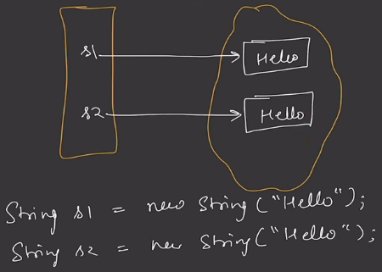
String pool

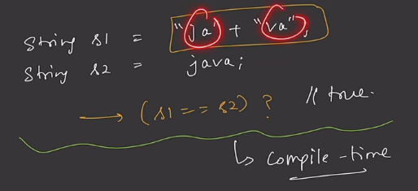
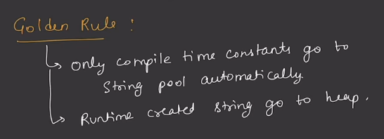
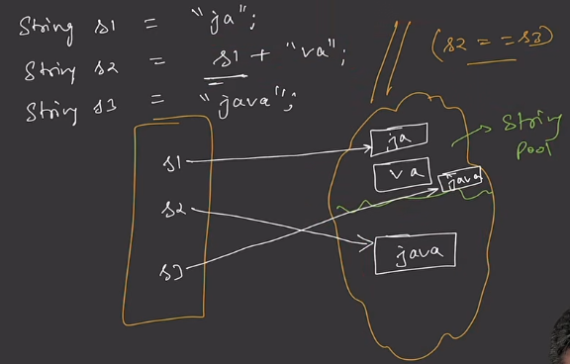
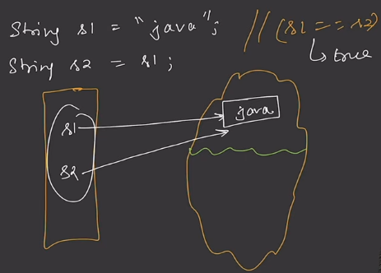

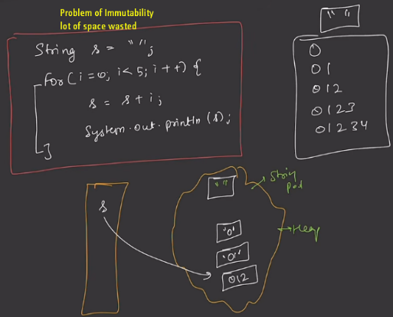
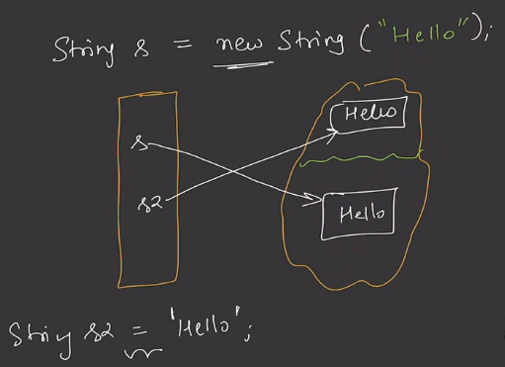
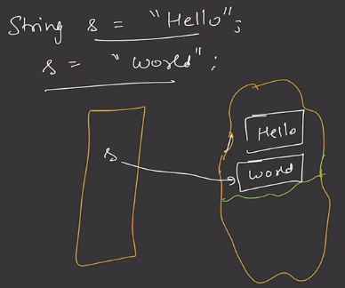
String user1 = "Akshat";
String user2 = new String("Akshat");

System.out.println(user1.equals(user2)); //.equals() Content / Value same?
System.out.println(user1==user2); //= = Reference / Object same ?

* Before:
name ───────► [ "Akshat" ]
↑
Object
* After:
name ───────► [ "AKSHAT" ]
↑
Object B

When you "change" a String, Java doesn't modify the existing String object. Instead, it creates a new String object.

