Development of E-Portal for Case Management Hearing and Facilitation of Legal Proceedings
Aaditiya Tyagi  Department of Computer Science  KIET Group of Institutions  Ghaziabad, India  aaditiya.2226cs1189@kiet.edu | Akshat Jain  Department of Computer Science  KIET Group of Institutions  Ghaziabad, India  akshat.2226ec1041@kiet.edu | Akash Tiwari  Department of Computer Science  KIET Group of Institutions  Ghaziabad, India  akash.2226cs1058@kiet.edu
Ankit Chaudhary  Department of Computer Science  KIET Group of Institutions  Ghaziabad, India  ankit.2226cs1104@kiet.edu | Anmol Jain  Department of Computer Science  KIET Group of Institutions  Ghaziabad, India  anmol.jain@kiet.edu

Abstract— The paper, therefore, describes the design and empirical assessment of an e-Portal for judicial case management and facilitating hearings. This system has room for different user roles, which include, but are not limited to, judges, advocates, litigants, court staff members, and administrators. It facilitates the filing of cases online, hearings through video conferencing, automation in scheduling, document uploads, and real-time reminders. The app is built on the MERN stack with secure and scalable access based on user roles to support legal proceedings.
Keywords—Case Management, e-Portal, MERN Stack, Judiciary, Court Automation

Introduction
The judicial systems in the global community are still experiencing difficulties in the areas of backlogs, delays in procedures, and accessibility. In the Indian judicial system, the use of manual and semi-digitally enabled systems has had a severe effect on judicial efficiency and effectiveness. While various 'e-courts' systems and initiatives have been proposed to enable the digitization of judicial processes, the systems in use still lack empirical support in the areas of efficiency and effectiveness and user satisfaction with the proposed systems. This paper bridges the gap and proposes an empirically tested role-based 'e-court' portal to manage judicial cases to their final completion stages.
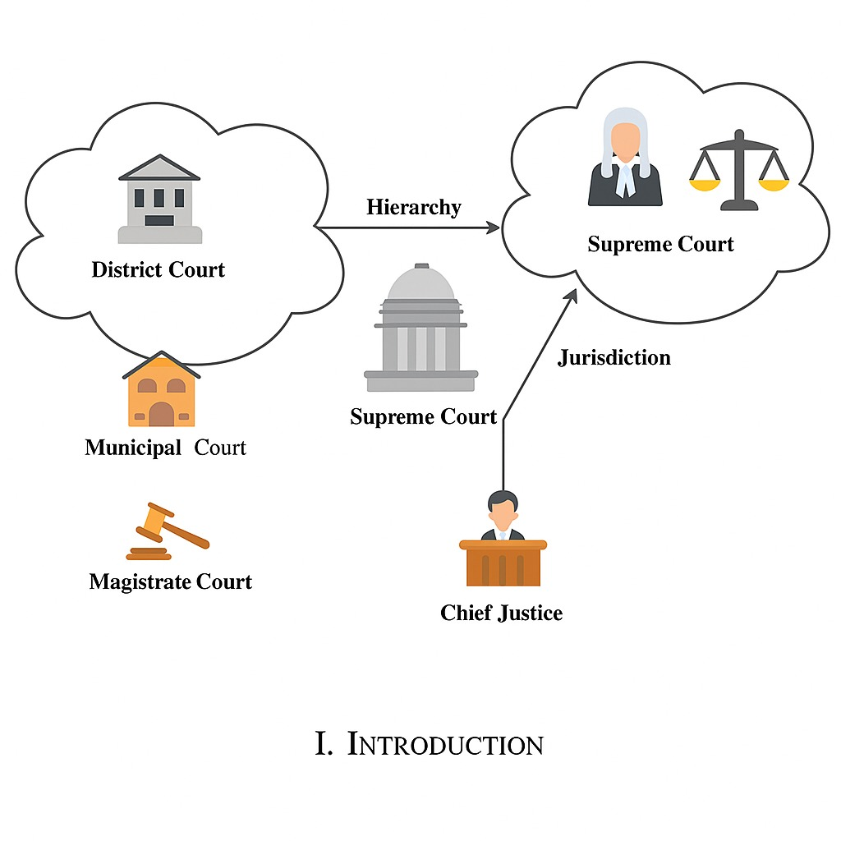
- Courts in India.
However, the current state-of-the-art digital court systems available have primarily focused on the implementation stage rather than an empirical evaluation. There have been very limited attempts to measure efficiency improvements, reduction of delays, performance, or user satisfaction. The current research remedies the shortcoming by measuring the performance of the e-court portal.

Literature Review
Legal informatics have gone through a sea change with the advent of e-justice systems and virtual courts. During the pandemic, the importance of technology became yet greater. Courts all over the world had to transition to remote and online modes. Though there have been various efforts to computerize court processes, most such systems are not strong enough to support multiple user roles on a single secure and scalable platform. This project henceforth tries to present a comprehensive role-based system with secure video conferencing capabilities that have not been fully utilized in previously published works [1]-[3].
Prasetyo et al. [5] assessed the effectiveness of applying electronic court services in Indonesia’s Religious Courts after Supreme Court Regulation No.7 of 2022. The system allowed for electronic filing, online payments, e-summons, and video-based hearings. This reduced costs and lightened the administrative load with legal certainty. This study used the normative juridical method with empirical observations and found that efficiency and transparency had improved. However, challenges like inconsistent technical infrastructure, limited user awareness, and the need for ongoing evaluation provide proof of the need to increase training and standardization.
Jaber [7] proposed the MFA model to secure Libya's national e-government portal Dawlaty. OTP verification in the model utilized the connection between SIM and National ID. It generated revenue by being highly integrated with the Central Bank of Libya's Foreign Currency Management System. This has ensured that confidence in digital services rises, while fraud reduces and identification of users becomes easy. Security features could be affordable to establish and easily implement. However, risks such as SIM-swap fraud, interception of SMS, and poor network coverage in rural areas pointed toward the need for superior telecom verification and backup systems.
Nababan et al. [6] researched the implementation of online trials in civil cases at the Medan District Court in Indonesia.
Nababan et al. [6] have discussed the adoption of online trials in civil cases in the Medan District Court in Indonesia. E-submission of documents, e-hearings, and pronouncement of judgment were facilitated through the e-court rules provided by the Supreme Court. This, in turn, helped promote easier access to trials, making them both speedier and cheaper. Data for 2021-2024 showed increased public engagement with e-courts. However, challenges remained regarding unstable internet signals, delays in manual wire transfers, and other issues with regard to witness security and honesty.
Grepon [13] spearheaded the pioneering project in court automation for Northern Mindanao, Philippines, using the Web-based Case Docket Information System. The project upgraded the management of dockets, made the court reports computerized, and provided enough security to the data through cloud infrastructure. The system was designed using PHP, HTML, CSS, and JavaScript, following the SDLC model. It increased efficiency significantly. However, there are also indications that further work is needed to address scalability and internet connectivity issues, as well as its deployment to only one branch.
In another regional case, Maralbaeva [10] considered the interlinkage between cybersecurity and e-justice in Kyrgyzstan. The novelties of e-justice and 'Sud' AIS provided a boost for transparency and access but entailed certain risks regarding data security—particularly sensitive information of a personal nature. Research on 280 cases of domestic violence disclosed a lack of thorough anonymization and much-needed legal protection by means of cybersecurity. Access remains highly insufficient for persons with disabilities, therefore necessitating inclusive design for digital justice systems.
Ahmed et al. [11] investigated the adoption of an e-court system in the KRI because of its enhancement of judicial transparency. They followed a sequential mixed-method approach that consisted of a survey, interviews, and observations. Digitization resulted in case tracking, equal distribution, and access to data. Some issues, such as a lack of data and slow responses, reduced the quality of empirical evidence during the study. The authors emphasized data transparency as a requirement and indicated that accessing reliable court performance data was difficult.
Lee [12] presented a constitutional framework that implemented e-justice in Taiwan, balancing judicial efficiency with privacy and transparency. Similar to the e-litigation and e-administration systems, especially the COVID-19 era, which introduced efficiency and reduction of paperwork, the study warned against dependence on ICT that undermined judicial independence. Comparing these with other European blueprints such as e-CODEX and e-SENS pointed toward human intervention, regulatory demands, and constant training of the judicial workforce. Theoretically sound, the empirical evidence and public response limited the useful implementation of the findings.
The latest research by Prabhavati et al. [8] introduces Legal Connect, an end-to-end e-portal for case and hearing management. Legal Connect is more efficient concerning central processing of data, automation of scheduling, real-time communication, and analytics in re-engineering of legal processes compared to silo legacy systems. The system addresses most of the gaps in the previous text with a priority on security, standardization, and accessibility.
Although existing solutions like Legal Connect and other regional e-justice systems offer complete functionalities for digital case management, prior studies are mostly descriptive. Little attention is paid to empirical validation in the form of performance metrics, delay reduction analysis, and user satisfaction assessment. The aim of this paper is to discuss an evaluation-driven analysis of a role-based e-court portal.

Objectives

The objectives of this study are:
The objective is to design a role-based e-court portal for filing cases, court scheduling, document management, and Virtual Hearings.
- To assess the effectiveness of the system through quantifiable performance measures in terms of response time and scheduling efficiency.
- To assess usability and user satisfaction among different judicial stakeholders.
- To compare the proposed system with the existing e-court websites and identify improvements.

Research Methodology
This study follows a controlled, pilot-based empirical evaluation approach. In the test environment, the proposed e-Portal was set up to simulate real-world judiciary workflows related to case filing, hearing scheduling, document management, and virtual hearings. Evaluations were performed by systematic execution of predefined test scenarios across various user roles to observe system behavior, verify correctness of access, and evaluate performance stability when faced with concurrent interactions.
This pilot evaluation has covered case registration, document submission, hearing scheduling, and validation of role-based access for representative judicial use cases. Multiple user roles have been implemented to observe the behavior of the system in concurrent interactions. Its main focus has been the correctness of access control, consistency in responses, and usability related to typical judicial workflows.

Evaluation Metrics
In all, the system was tested for case filing time, delay in scheduling hearings, response time of the system under concurrent access, and overall reliability of the system. Structured feedback on usability and user satisfaction was also elicited from judges, advocates, litigants, and court staff.

Evaluation Design
A pilot-based experimental framework is followed for the simulation of workflows related to judicial cases. Many user roles, such as judge, advocate, litigant, and staff, are assessed individually. Concurrent access scenarios are simulated to test the responsiveness of the system. Case lifecycle stages that have been analyzed include filing, scheduling, uploading of documents, and access to hearings. Access control accuracy for every role is checked to assure data confidentiality. Usability testing is performed with structured observations of task completion.
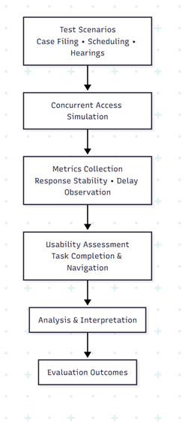
- Evaluation methodology flow illustrating the pilot-based process used to assess system performance, access correctness, and usability.

Algorithmic Design and Workflow Modeling
This section provides a detailed description of the formal algorithmic design and workflow modeling that supports the proposed e-Portal for judicial case management and hearing facilitation. The framework goes beyond conventional, descriptive system design through deterministic algorithms and role-governed workflows to guarantee correctness, security, and scalability. The system is designed to support concurrent judicial operations while maintaining stringent access control and procedural integrity.

It has four major functional modules for case initiation and registration, role-based authorization, hearing scheduling and conflict resolution, and document life-cycle management. Each module has been built upon an accurately defined algorithm with the aim of avoiding ambiguity, reducing human interference, and establishing efficiency in operations.

Case Registration and Filing Workflow
Case registration is the first step in the judiciary work process; it is triggered by legitimate stakeholders, namely litigants or advocates. The system allows filings only by authenticated users and ensures that all the relevant legal documents are submitted in a neat and traceable form. User authentication and verification of the role of the user trigger the workflow for case filing. Verification is done by evaluating document completeness and correctness of format. A case identifier is created then to ensure traceability during the case lifecycle.
Algorithm 1: Case Registration and Filing
Input: User $U$, Case Documents $D$
Output: Case Identifier $CID$
- Authenticate the user U by using token-based authentication.
- Ensure the user role R(U) is in the set {Litigant, Advocate}.
- If the role is invalid, abort the request.
- Validate the mandatory documents within set D.
- Generate a unique Case ID with a timestamp-hash mapping.
- Store the case metadata in the database along with the associated documents.
- The initial case status will be “Filed.”
- Notify court staff to begin an administrative review.
- Return the Case ID (CID).
This algorithm eliminates unauthorized filings and ensures structured data storage, enabling efficient retrieval and processing at later stages.

Role-Based Authentication and Authorization Model
Judicial data are highly sensitive and require tight control over access. The proposed system enforces RBAC on all interactions with system resources. The users are assigned predefined roles like judge, advocate, litigant, court staff, or administrator, and permissions are granted in strict conformance with the established hierarchy of roles. Authorization is done in a dynamic fashion for every request to the system to prevent privilege escalation and unauthorized access.
Algorithm 2: Role-Based Access Validation
Input: User $U$, Requested Resource $R$
Output: Access Decision (Allow/Deny)
- Extract role $R(U)$from authentication token.
- Retrieve permission matrix for role $R(U)$.
- If permission $P(R(U),R)=true$, Grant access.
- Else Deny access and log attempt.
This mechanism ensures confidentiality, data integrity, and compliance with judicial access policies.

Automated Hearing Scheduling and Conflict Resolution
Scheduling hearings is a very delay-prone part of court proceedings if done manually. The proposed system automates this process by detecting and resolving conflicts using algorithms to achieve optimum utilization of judicial time. The scheduling workflow considers judge availability, existing hearing slots, and priority constraints. Conflicts are resolved dynamically by shifting hearings to the nearest available slots.
Algorithm 3: Hearing Scheduling and Conflict Resolution
Input: Case ID, Preferred Date Range
Output: Confirmed Hearing Slot
- Retrieve the assigned judge's calendar.
- Get all the available hearing slots in a given date range.
- Identify the time slots available.
- If there is a conflict, choose the next available time slot.
- Assign the hearing slot to the case.
- Update the case status to "Scheduled."
- Notify all stakeholders
- Log the scheduling action in the audit log.
This algorithm reduces scheduling conflicts and improves hearing efficiency, particularly under high case load conditions.

Document Management and Lifecycle Control
Judicial procedures involve continuous document submission, review, and archiving processes. The proposed system integrates a structured document lifecycle management model to maintain version control and ensure traceability of documents for legal purposes. Each document contains metadata that describes the case ID, uploader role, timestamp, and type of document. Versioning further allows access to earlier submissions that may be required during auditing and/or verification for legal purposes.
Algorithm 4: Document Upload and Version Control
Input: Document $D$, Case ID
Output: Stored Document Reference
- Verify user authorization for document upload
- Validate document format and size
- Assign version number to document
- Store document with metadata
- Update case document index
- Log upload activity
This approach ensures accountability and prevents data tampering.

Workflow Integration and State Transitions
The general workflow of the judiciary is modeled as a finite-state system in which every case progresses through predefined states: Filed, Under Review, Scheduled, In Hearing, and Closed. Transitions between states are algorithmically controlled to preclude invalid state progression. For example, a case cannot be moved into the Scheduled state unless it has completed administrative review. This constraint ensures correctness and uniformity in judicial procedures.

Advantages of Algorithmic Workflow Modeling
The application of algorithmic modeling has several benefits compared to traditional descriptive implementations. It enhances the predictability of the system, allows formal performance evaluation, and enables scalability under concurrent access. By reducing manual intervention, it minimizes procedural delays and human errors while maintaining transparency and accountability.

System Architecture
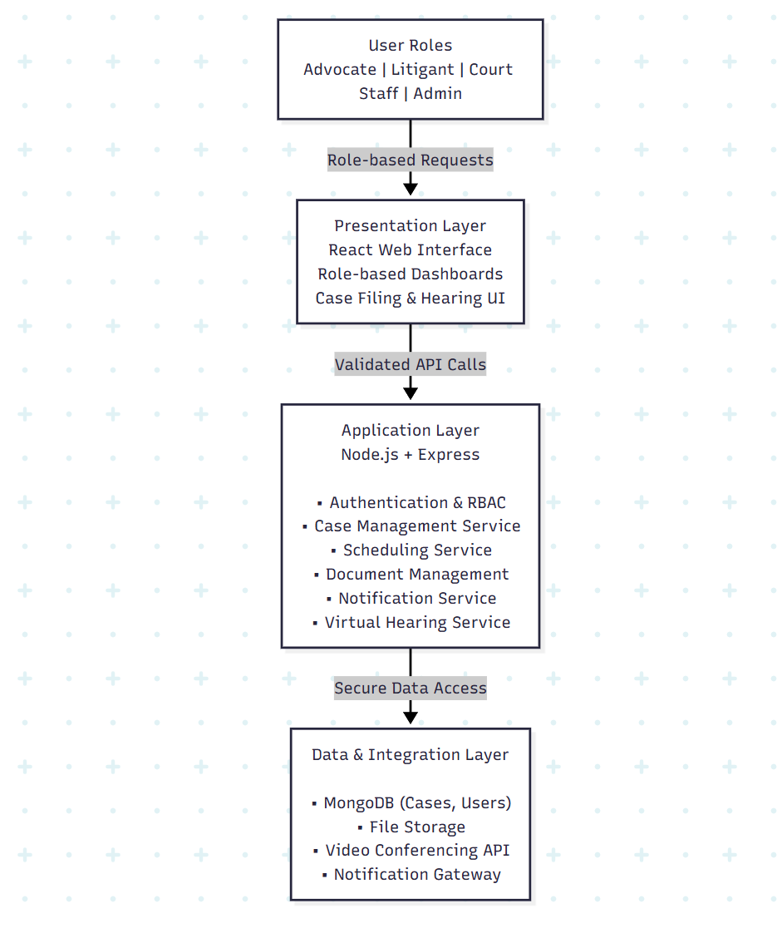
- System architecture of the proposed e-court portal illustrating layered design and role-based access integration.
The system follows a multi-tier architecture by separating presentation, application logic, and data services. This architecture provides ease of scalability, consistently enforces role-based access control mechanisms, and ensures stable performance due to concurrent judicial operations. The system's modular configuration allows empirical assessment of system responsiveness and correctness of access when subjected to simulated workloads.
It supports role-based workflows for litigants, advocates, court staff, judges, and administrators. Each of the roles has restricted access to related functionalities like case filing, scheduling, document management, hearing participation, and administrative oversight. This unified workflow design will promote consistency, security, and efficient coordination among judicial stakeholders while limiting process redundancy.
The e-Portal is implemented on the MERN stack for its scalability, modularity, and suitability for real-time web applications. It effectively separates the concerns between the UI, application logic, and data management layers of the stack, allowing the implementation of secure role-based access and concurrent judicial workflows.

Role-Based Authentication and Access Control
The RBAC framework grants restricted access in a secure manner to every entity involved, including Judges, Advocates, Litigants, Court Staff, and Administrators. Sessions are managed through authentication using JSON Web Tokens (JWT), while authorization specific to the role provides permissions defined for each role. This encompasses the confidentiality, integrity, and controlled access of Judicial Resources.

Security Architecture
Security Architecture enforces security via encrypted communication channels and Role-Based Access Control. Authentication mechanisms, access validation, and audit logging are used in order to ensure confidentiality, integrity, and traceability of judicial data in all system operations.

Scalability and Deployment
The modular architecture of the system allows a scalable deployment for a concurrent number of users, maintaining or ensuring the highest levels of performance and system availability and responsiveness when judicial processes are running.

Results and Discussion
To support the evaluation of the e-Portal, Controlled Pilot Testing of the Proposed e-Portal was performed by using predefined performance and usability metrics. The results from the evaluation provided evidence of reduced procedural complexity in case filing and increased coordination in scheduling hearings compared to manual procedures. Simultaneous user simulations showed that multiple user roles did not impact the overall performance of the system, which remained stable and functional with no failures. User feedback also supported the improvements in usability and reduction in physical presence.
Case filing operations during the pilot testing required fewer procedural steps than manual processing, and no functional failures were observed under simulated concurrent access involving multiple user roles.

Evaluation Outcomes
- Case filing operations were less procedurally cumbersome than conventional manual systems were.
- Scheduling conflicts in hearings were reduced by automating calendar coordination.
- System response remained stable during simulated concurrent user access.
- Role-based access controls prevented unauthorized data visibility consistently.
- Users reported improvement in the ease of navigation and less reliance on physical visits to the courts.
- Overall, system behavior indicated suitability for supporting routine judicial workflows.
Table I compares the proposed system with existing e-court platforms, highlighting the presence of empirical evaluation and performance analysis as key differentiators.

TABLE I
COMPARISON OF PROPOSED SYSTEM WITH EXISTING E-COURT PLATFORMS

Feature / Parameter | Legal Connect | Existing E-Courts | Proposed System
Role-based access | Yes | Partial | Yes
Empirical evaluation | Not reported | Not reported | Conducted
Performance metrics | Not reported | Not reported | Measured
Scheduling efficiency | Limited | Limited | Improved
Usability feedback | Not reported | Not reported | Collected
System scalability | Not evaluated | Not evaluated | Evaluated

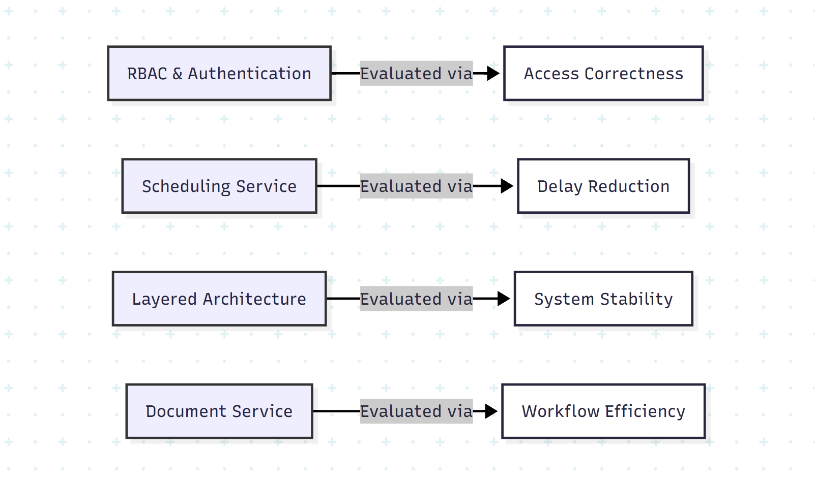

- Mapping of architectural components to evaluation parameters used during empirical assessment.
As shown in Fig. 4, key architectural components were directly linked to evaluation parameters.

Conclusion
This was a study designed to develop and empirically evaluate a role-based electronic portal for judicial case management and the facilitation of hearings. The proposed system provides a single platform that includes case management, scheduling, electronic filing, electronic documents, and remote hearings. Results from the research performed as part of this project suggest that the system improves court operations and scheduling, increases system responsiveness for users, and enhances user satisfaction for system users. Based on this research and a comparative assessment of other e-Courts, it is expected that the e-Court system will provide benefits that are not presently provided by alternative systems, reflected by the assessment processes for courts using the e-Court system. However, there are further opportunities for improvement that include wider implementation, advanced analytic development, and the use of AI-enabled decision support to enhance court efficiency and access.

Acknowledgments
We would also like to use this opportunity to identify the colleagues involved in this project and thank them for their support during the project, especially in collaboration and teamwork. We would also like to extend special recognition to our mentor for providing guidance, encouragement, and support through each and every stage of the project, which eventually contributed to the successful completion of this work.

References
- A. Baig, “The role of technology in enhancing access to justice: Challenges and opportunities in the 21st century,” AL-AASAR Journal: Quarterly Research Journal, vol. 2, no. 1, pp. 774–779, 2025.
- D. Pitaloka, “E-court: A digital disruption in law enforcement and its impact on judicial efficiency in Indonesia,” Ex Aequo Et Bono Journal of Law (EAEBJOL), vol. 2, no. 2, pp. 82–95, 2025. doi: 10.61511/eaebjol.v2i2.2025.1404.
- D. Putranti, U. T. Putri, A. Prahara, and M. S. Quddus, “Proposing digital copyright infringements enforcement through Internet Court in Indonesia: Fostering the existing E-Court system,” E3S Web of Conferences, vol. 622, p. 03006, 2025. doi: 10.1051/e3sconf/202562203006.
- F. A. A. C. Campos, J. C. B. Silva, F. B. Feitosa, I. O. Reis, E. C. Caritá, M. F. Moll, C. A. A. Ventura, and J. C. Sánchez, “Theoretical and bioethical foundations for the development of the psychosocial rehabilitation project application,” Saúde em Redes Journal, vol. 11, no. 1, pp. 1–18, Feb. 2025. doi: 10.18310/2446-4813.2025v11n1.4430.
- Y. D. Prasetyo, D. Muhtada, and Martitah, “The effectiveness of using e-court services in realizing electronic religious courts,” Eduvest – Journal of Universal Studies, vol. 5, no. 4, pp. 4415–4431, Apr. 2025.
- R. Nababan, B. Habeahan, H. Siregar, and F. M. Simanjuntak, “The existence of online trials (electronic court) in civil cases in Medan State Court, Indonesia,” Golden Ratio of Law and Social Policy Review, vol. 4, no. 2, pp. 83–97, 2025. doi: 10.52970/grlspr.v4i2.929.
- H. A. A. Jaber, “Improving security for the Libyan e-government portal: A multi-factor authentication model utilizing NID-SIM linkage,” Libyan Journal of Informatics, vol. 2, no. 1, pp. 43–53, Jun. 2025.
- CH. Prabhavati, A. Mounika, G. Devi Sri, K. Lahari, and K. V. Krishna, “Legal Connect: e-Portal for Facilitating Case Management Hearings of Various Types of Cases,” Int. J. Eng. Sci. Adv. Technol. (IJESAT), vol. 24, no. 5, pp. 322–327, May 2024.
- P. Saxena, “Technological innovations in India’s legal sector for access to justice during and post pandemic,” in 2023 Law and Development Conference, Singapore, Dec. 2023.
- A. Maralbaeva, E-justice and Cyber Security: Balancing between Openness of the Courts and Data Protection in Kyrgyzstan. United Nations Development Programme (UNDP), 2022. [Online]. Available: Link.
- R. K. Ahmed, O. Ahmed, I. Pappel, A. Reitsakas, and D. Draheim, “The role of digital transformation in fostering transparency: An e-Court system case study,” in Lecture Notes in Computer Science. Cham, Switzerland: Springer Nature, Sep. 2022, doi: 10.1007/978-3-031-15342-6_17.
- C.-L. Lee, “E-justice in Taiwan: The derivative inquiries from constitutional perspectives in the digital age,” Ritsumeikan Law Rev., no. 40, pp. 55–67, 2022.
- B. G. S. Grepon, “Designing and implementing e-justice systems: An information systems approach to regional trial court case docket management in Northern Mindanao, Philippines,” Int. J. Multidiscip. Acad. Res., vol. 8, no. 1, 2020.

