**Create SignIn and Signup Page layout using Handlebars**

Index.js

var express = require('express');

var router = express.Router();

/* GET home page. */

router.get('/', function(req, res, next) {

  res.render('index', { title: 'Node Tutorial' });

});

router.post('/', function(req, res){

    var body = req.body;

    var res_body = {

        first_name: body.first_name,

        last_name: body.last_name,

        email: body.email

    };

    res.render('welcome', res_body);

});

module.exports = router;

User.js

var express = require('express');

var router = express.Router();

/* GET users listing. */

router.get('/', function(req, res, next) {

  res.send('respond with a resource');

});

module.exports = router;

App.js

var express = require('express');

var path = require('path');

var favicon = require('serve-favicon');

var logger = require('morgan');

var cookieParser = require('cookie-parser');

var bodyParser = require('body-parser');

var index = require('./routes/index');

var users = require('./routes/users');

var app = express();

// view engine setup

app.set('views', path.join(__dirname, 'views'));

app.set('view engine', 'hbs');

// uncomment after placing your favicon in /public

//app.use(favicon(path.join(__dirname, 'public', 'favicon.ico')));

app.use(logger('dev'));

app.use(bodyParser.json());

app.use(bodyParser.urlencoded({ extended: false }));

app.use(cookieParser());

app.use(express.static(path.join(__dirname, 'public')));

app.use('/', index);

app.use('/users', users);

// catch 404 and forward to error handler

app.use(function(req, res, next) {

  var err = new Error('Not Found');

  err.status = 404;

  next(err);

});

// error handler

app.use(function(err, req, res, next) {

  // set locals, only providing error in development

  res.locals.message = err.message;

  res.locals.error = req.app.get('env') === 'development' ? err : {};

  // render the error page

  res.status(err.status || 500);

  res.render('error');

});

module.exports = app;

error.hbs

<h1>{{message}}</h1>

<h2>{{error.status}}</h2>

<pre>{{error.stack}}</pre>

index.hbs

<div style="background-color:rgba(58, 28, 230, 0.7);" class="jumbotron">

    <div class="container">

        <h1>Welcome to Handlebars Academy</h1>

        <p>This is signup or signin page designed using handlebars</p>

    </div>

</div>

<div class="container">

    <div class="row">

        <div class="col-xs-12 col-sm-12 col-md-12 col-lg-12">

            <form action="/" method="post" role="form" enctype="application/x-www-form-urlencoded">

                <legend>Enter Registration Information Here</legend>

                <div class="form-group">

                    <label for="first_name">First Name</label>

                    <input type="text" class="form-control" name="first_name" id="first_name" placeholder="First Name">

                </div>

                <div class="form-group">

                    <label for="last_name">Last Name</label>

                    <input type="text" class="form-control" name="last_name" id="first_name" placeholder="Last Name">

                </div>

                <div class="form-group">

                    <label for="email">Email Address</label>

                    <input type="text" class="form-control" name="email" id="email" placeholder="Email Address">

                </div>

                <div class="form-group">

                    <label for="pw">Password</label>

                    <input type="password" class="form-control" name="pw" id="pw">

                </div>

                <div class="form-group">

                    <label for="pw_confirm">Confirm Password</label>

                    <input type="password" class="form-control" name="pw_confirm" id="pw_confirm">

                </div>

                <button type="submit" class="btn btn-primary">Submit</button>

            </form>

        </div>

    </div>

</div>

layout.hbs

<!DOCTYPE html>

<html>

  <head>

    <title>{{title}}</title>

      <script

              src="https://code.jquery.com/jquery-3.2.1.js"

              integrity="sha256-DZAnKJ/6XZ9si04Hgrsxu/8s717jcIzLy3oi35EouyE="

              crossorigin="anonymous"></script>

      <!-- Latest compiled and minified CSS & JS -->

      <link rel="stylesheet" media="screen"

            href="https://maxcdn.bootstrapcdn.com/bootstrap/3.3.7/css/bootstrap.min.css">

      <script src="https://maxcdn.bootstrapcdn.com/bootstrap/3.3.7/js/bootstrap.min.js"></script>

      <link rel='stylesheet' href='/stylesheets/style.css' />

  </head>

  <body>

    {{{body}}}

  </body>

</html>

Welcome.hbs

<div style="background-color:rgb(205, 245, 29);" class="jumbotron">

    <div class="container">

        <h1>Hello {{first_name}} {{last_name}}!</h1>

        <p>You are registered with an email address of {{email}}</p>

        <p>Well done!</p>

    </div>

</div>

**Output:-**

SignUp/SignIn Page

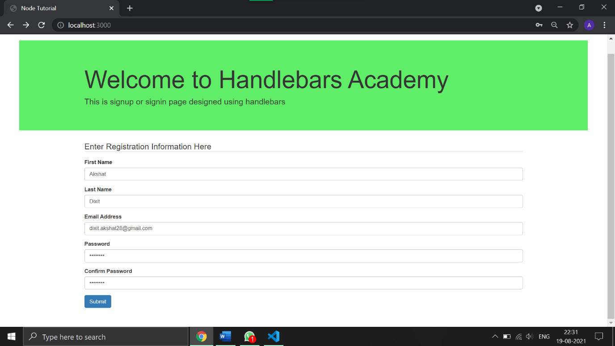

Registration Page

