1. Explain the difference between frontend, backend, and full-stack development with suitable real-world examples.
Answer:
The frontend is the part of a website that we can see and use directly. It includes the layout, buttons, colors, and text on the screen. For example, when we open Amazon, the product images, search bar, and “Add to Cart” button are all part of the frontend.
The backend works behind the scenes. It handles things like login, storing data, and sending information to the frontend. For example, when you log in to Instagram, the backend checks if your username and password are correct.
A full-stack developer works on both frontend and backend. For example, a developer who builds a restaurant booking site designs the web pages (frontend) and also creates the system that saves bookings in a database (backend).
2. Create a simple diagram showing how the client-server model works in web architecture.
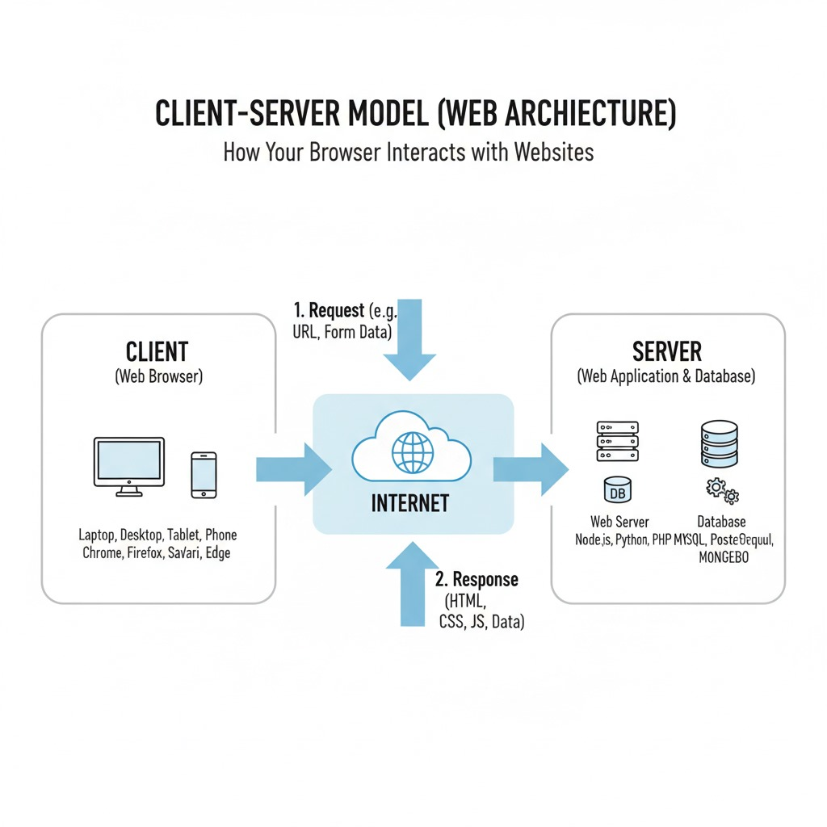

3. Describe how a browser requests and displays a web page from a web server.
Answer:
When we type a website address in a browser, the browser sends a request to the web server. The server finds the page and sends it back to the browser. The browser then reads the HTML, CSS, and JavaScript and shows the complete page to the user. Images, styles, and scripts are also loaded during this process.

4. Identify and list the tools required to set up a web development environment. Explain the purpose of each.
Answer:
Tool | Purpose
VS Code | Used to write and edit code for websites.
Web Browser | To open and test the website (like Chrome or Firefox).
Node.js | Helps run JavaScript on the computer and manage packages.
Git & GitHub | Used for saving and tracking changes in code.
Live Server Extension | To preview web pages instantly while coding.

5. Explain what a web server is and give examples of commonly used servers.
Answer:
A web server is a computer program that stores website files and sends them to users when they open a website. It handles requests from browsers and gives the right response.
Examples: Apache, Nginx, Microsoft IIS, and Node.js (with Express).

6. Define the roles of a frontend developer, backend developer, and database administrator in a project.
Answer:
- Frontend Developer: Designs how the website looks and makes it easy to use. Works with HTML, CSS, and JavaScript.
- Backend Developer: Builds the system behind the website, handles user data, and connects the website to the database.
- Database Administrator (DBA): Manages and secures the database, makes backups, and ensures everything runs smoothly.

7. Install VS Code and configure it for HTML, CSS, and JavaScript development. Take a screenshot of the setup.
Answer:
Steps I followed:
- Installed VS Code on my computer.
- Added extensions like Live Server and Prettier.
- Created files named index.html, style.css, and script.js.
- Opened them in VS Code and ran using Live Server.

8. Explain the difference between static and dynamic websites. Provide an example of each.
Answer:
Type | Description | Example
Static Website | Same content for every visitor. It doesn’t change. | A personal portfolio website.
Dynamic Website | Changes based on user or database. | Facebook or YouTube.
A static site is simple and doesn’t use a database, while a dynamic one shows updated information each time.

9. Research and list five web browsers. Explain how rendering engines differ between them.
Answer:
Browser | Rendering Engine | Notes
Google Chrome | Blink | Fast and widely used.
Mozilla Firefox | Gecko | Focuses on privacy and open source.
Safari | WebKit | Works best on Apple devices.
Microsoft Edge | Blink | Based on Chromium, good for Windows.
Opera | Blink | Has built-in VPN and ad-blocker.
Rendering engines are the parts of browsers that display web pages. Different browsers use different engines, so pages might look slightly different.

10.Draw a labeled diagram showing the basic web architecture flow — client, server, database, and APIs.
