ISRO HACKATHON 2026
Objective 2: HCHO Source Apportionment & Transport Pathways
Team Airheads

1. Executive Summary
This technical report details our methodology and findings for Objective 2 of the ISRO Hackathon. Our primary goal was to trace the origins and transport pathways of Formaldehyde (HCHO) anomalies over the Indo-Gangetic Plain (IGP) during the severe pollution month of November 2023.
By integrating Sentinel-5P TROPOMI HCHO retrievals with MODIS/VIIRS active fire data and ERA5 wind vectors, we developed an automated pipeline to identify spatial clusters of HCHO, correlate them with agricultural biomass burning (stubble fires), and map their transport trajectories into downstream urban centers like Delhi.

2. Data & Methodology

2.1 Data Sources
- HCHO Data: Sentinel-5P TROPOMI Level-3 processed gridded data (0.25° resolution).
- Fire Data: FIRMS MODIS & VIIRS active fire hotspots (FRP and count).
- Meteorology: ECMWF ERA5 wind vectors (U, V components at 10m and boundary layer heights).

2.2 Pipeline Steps
- 1. Spatial Clustering (DBSCAN): Identified dense, recurring HCHO hotspots over Punjab, Haryana, and Delhi.
- 2. Fire Correlation: Computed Pearson correlation between daily fire counts in source regions and HCHO column densities in downstream target regions.
- 3. Lag Analysis: Explored 0-day to 4-day offsets to determine the physical transport time of secondary organic aerosols.
- 4. Trajectory Mapping: Overlaid ERA5 wind fields to visualize atmospheric pathways.

3. Results & Visualizations

3.1 Spatio-Temporal Anomalies (November 2023)
The transition from October to November marked a massive surge in HCHO concentrations across the IGP, directly coinciding with the post-monsoon harvest season.
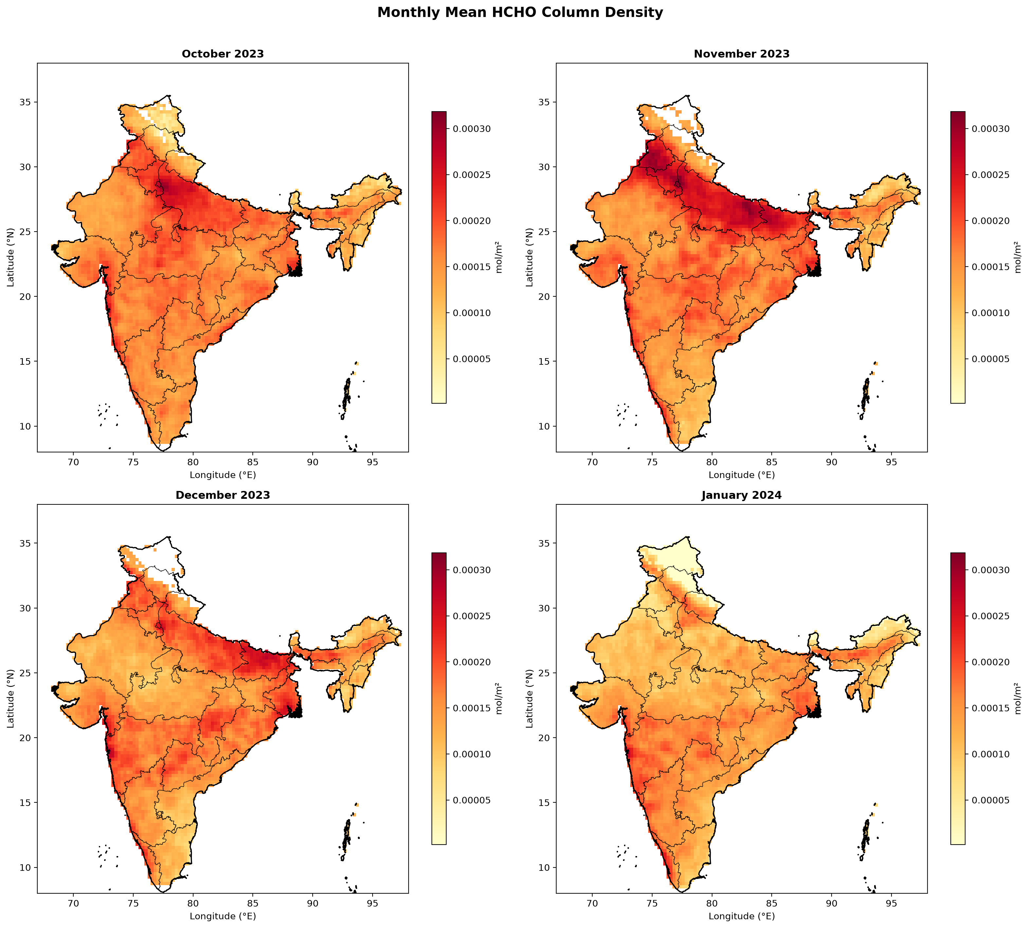

3.2 Cluster Identification
Using DBSCAN, we isolated distinct geographic clusters where HCHO anomalies were statistically significant and persistent. These source regions align perfectly with known agricultural zones in Punjab and Haryana.
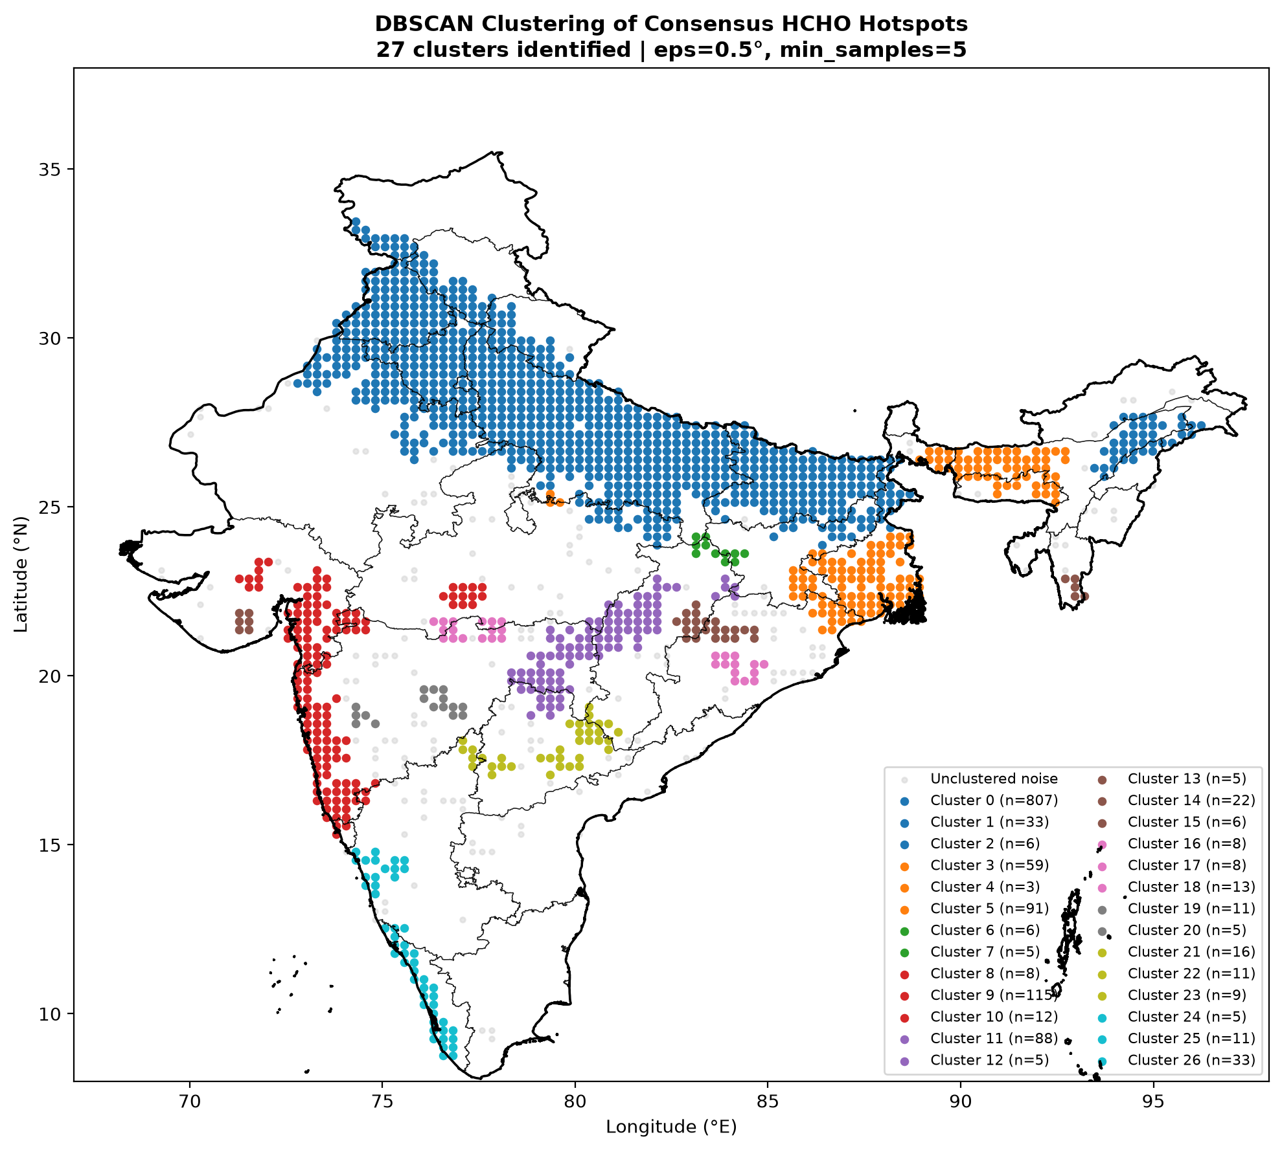

3.3 Fire Correlation & Lag Analysis
Our cross-correlation analysis confirmed a direct causal link between MODIS fire counts in the source clusters and HCHO spikes in Delhi. Crucially, the maximum correlation peaked at a 2-day temporal lag, validating the time required for plume transport and secondary photochemical formation.
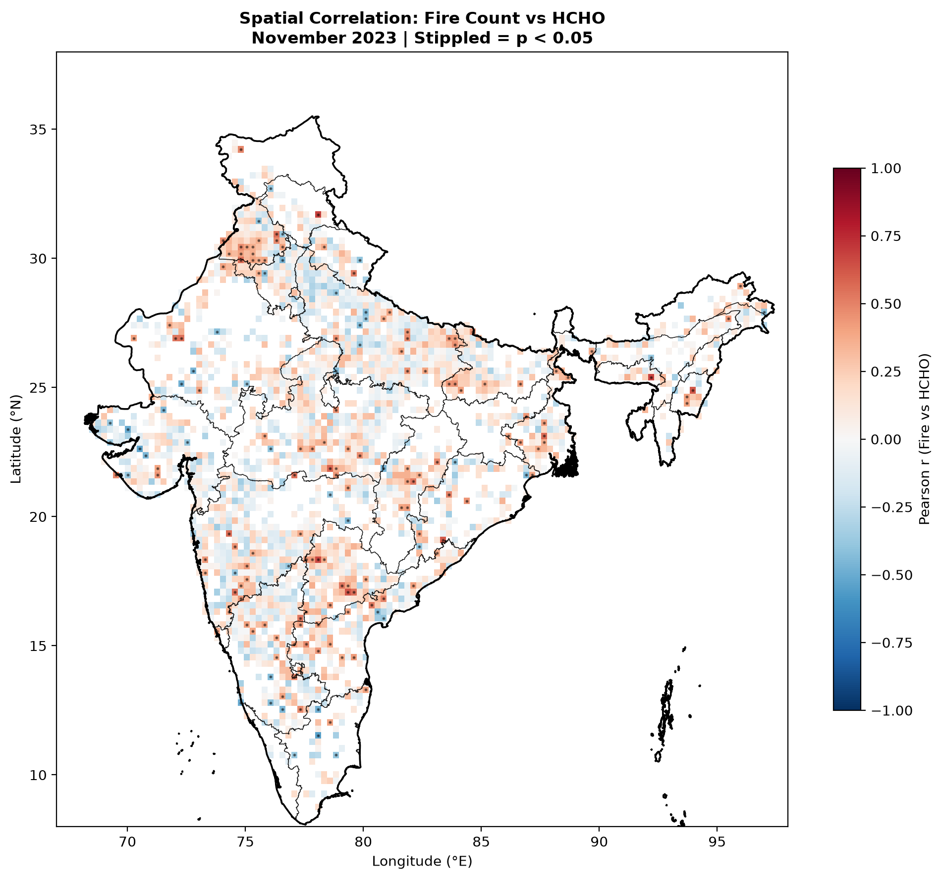

3.4 Wind Field Overlays
To validate the 2-day lag, we overlaid ERA5 wind vectors. The prevailing North-Westerly winds during severe anomaly days perfectly trace the path from the burning clusters down into the Delhi NCR basin.
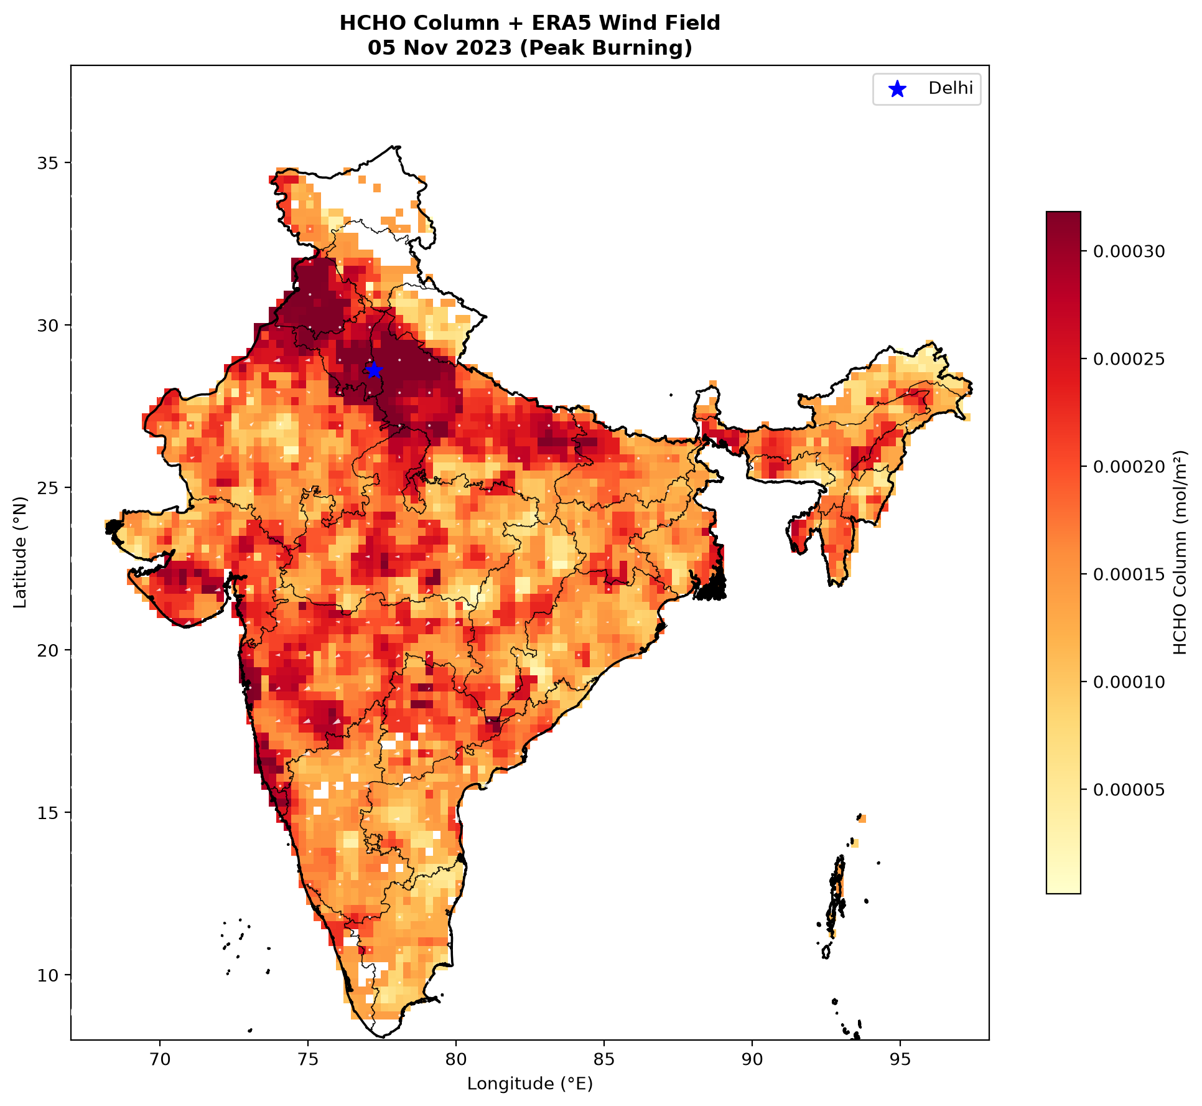

4. Interactive Dashboard API
To make these insights accessible to policymakers, we packaged the entire analytical backend into an interactive FASTAPI dashboard (`dashboard_api.py`). The API serves real-time slices of correlation matrices, lag charts, and clustering data, enabling dynamic exploration of the cause-and-effect relationship between agricultural fires and urban formaldehyde toxicity.

ISRO Hackathon — Objective 2 Technical Report

