ISRO HACKATHON
Technical Report — Objective 1
Surface AQI Prediction at 0.25° Grid Resolution Over India

Pollutants Covered: PM2.5 · PM10 · NO₂ · SO₂ · O₃ · CO
Data Sources: Sentinel-5P · INSAT-3D · ERA5 Reanalysis · CPCB Ground Network

Submitted by: Team [Your Team Name]

1. Project Narrative

1.1 Background & Problem Statement
India's air quality crisis demands near-real-time, spatially continuous pollution monitoring across its vast and meteorologically diverse geography. While CPCB operates a nationwide network of ground-monitoring stations, their coverage is inherently sparse — leaving large swathes of rural and semi-urban India without any data. Simultaneously, satellites like Sentinel-5P (TROPOMI) and INSAT-3D observe aerosol and trace gas columns from space, but their column-integrated measurements do not directly translate to surface concentrations that drive health impacts and regulatory AQI thresholds.
This project tackles the core challenge of fusing satellite retrievals with ground-truth CPCB observations to produce a daily, spatially continuous map of all six CPCB AQI sub-pollutants — PM2.5, PM10, NO₂, SO₂, O₃, and CO — at a 0.25° grid resolution over the entire Indian subcontinent.

1.2 Team Strategy & The Two-Model Journey
At the outset of the hackathon, our team made a deliberate architectural decision: divide and conquer. We pursued two parallel modelling philosophies simultaneously, with the understanding that each would illuminate different aspects of the problem and that the more complex model would require significantly more data to realise its potential.
Model A (Implemented & Evaluated): A hybrid CNN + XGBoost pipeline, designed to extract spatial features from multi-channel satellite image patches and then apply a learned residual correction using tabular meteorological features. This model was designed to deliver results within the 4-month data window (1 Oct 2023 – 31 Jan 2024) available at the start of the hackathon.
Model B (Architecture Built, Training Pending): A Physics-Informed ConvLSTM pipeline, designed to learn spatio-temporal pollution transport dynamics over a 14-day lookback window. This model was always envisioned for a 4-year dataset (2020–2023) — approximately 6–7× more training data than Model A — to realise the temporal depth that a recurrent architecture requires. The architecture is fully implemented and documented in this report, but data acquisition for the full 4-year range could not be completed before the submission deadline.

This report documents both models — presenting Model A's complete development lifecycle, rigorous evaluation, and lessons learned, followed by a detailed description of Model B's superior architecture and its planned improvements over every identified weakness of Model A.

2. Model A — CNN + XGBoost Hybrid Pipeline
Model A served as our primary implemented solution. It combines a Convolutional Neural Network for spatial feature extraction from satellite data with an XGBoost residual corrector, producing daily predictions of all six pollutants across a 120×124 grid covering India.

2.1 Data Preparation & Inputs

2.1.1 Ground Truth: CPCB Station Network
Daily aggregated CPCB data from 100 monitoring stations (79 training, 21 validation) was used as ground truth. Hourly raw data was filtered to the study window (1 Oct 2023 – 31 Jan 2024) and aggregated to daily values following CPCB NAAQS standards:
• PM2.5, PM10, NO₂, SO₂: 24-hour mean (minimum 16 valid hourly readings required)
• O₃: Daily maximum of the 8-hour rolling mean (min_periods=8 to handle boundary effects)
• CO: Both the 8-hour maximum (CO_8hr_max, for AQI calculation) and the 24-hour mean (CO_24hr_mean, as an ML feature)

2.1.2 Satellite Inputs — 13×13 Spatial Patches
For each CPCB station on each day, 13×13 spatial patches were extracted from co-registered satellite rasters aligned to a unified 0.25° ERA5 grid (120×124 spatial dimensions). The final input tensor had shape (N, 13, 13, 10) — ten channels per patch:
• Channel 1: NO₂ column density (Sentinel-5P TROPOMI)
• Channel 2: SO₂ column density (Sentinel-5P TROPOMI)
• Channel 3: CO column density (Sentinel-5P TROPOMI)
• Channel 4: Aerosol Optical Depth — AOD (Sentinel-5P / INSAT-3D backup)
• Channels 5–9: ERA5 meteorological fields (u10, v10, t2m, BLH, d2m)
• Channel 10: Cloud Mask (derived from TROPOMI QA values, appended in preprocessing)

Image quality control applied a 30% NaN threshold (patches with >30% missing pixels were dropped). A 3×3 spatial median filter filled isolated NaN pixels; a 2D median filter (medfilt2d) smoothed the AOD channel specifically. Post-QC patch counts: 8,772 training, 2,076 validation.

2.1.3 Tabular Features — Meteorological & Temporal (34 Features)
Alongside image patches, each sample was characterised by a 34-dimensional tabular feature vector fed to the XGBoost corrector:
• Spatial context: lat, lon, elevation
• Temporal: Day-of-year (doy), doy_sin, doy_cos (cyclical encoding)
• Meteorological dynamics: ventilation_index (BLH × wind_speed), BLH_separate, wind_speed_separate, wind_direction (arctan2 of v10/u10), t2m_squared, solar_radiation (ERA5 msdwswrf)
• Lag features: lag_PM2.5_D1, lag_PM2.5_D2, lag_AOD_D1, lag_NO₂_D1, lag_CO_D1
• Spatial embedding: AOD_center_ratio (center pixel / patch mean AOD)
• Extended per-pollutant: GAP embedding lags for NO₂ and O₃; photochemical proxy for O₃

2.2 Model Architecture

2.2.1 CNN Base Model
A separate CNN was trained independently for each of the six pollutants. Architecture (per pollutant):
Conv2D(32 filters, 3×3) → ReLU → MaxPooling(2×2)
Conv2D(64 filters, 3×3) → ReLU → MaxPooling(2×2)
Conv2D(64 filters, 3×3) → ReLU
GlobalAveragePooling2D (GAP) — extracts 64-dim spatial embedding
Dropout(0.3)
Dense(1) — pollutant concentration output

Loss: Huber | Optimizer: Adam (lr=0.001, clipnorm=1.0) | Batch: 64 | Max epochs: 200
EarlyStopping: patience=15 | NO₂ & O₃ retrained with 3-seed ensemble (best seed by val RMSE)

The GAP layer serves a dual purpose: it provides the CNN's concentration prediction and extracts a 64-dimensional embedding vector that encodes the spatial context of the satellite patch. This embedding is passed as additional features to the XGBoost corrector.

2.2.2 XGBoost Residual Corrector
Rather than using the CNN output directly, an XGBoost model (trained separately per pollutant) learns to predict the residual between the CNN's prediction and the true ground measurement: residual = y_true − y_CNN. The final prediction is:
Final Prediction = CNN Output + XGBoost Residual Correction

For PM2.5 and PM10, a relative residual formulation proved more effective: relative_residual = (y_true − y_CNN) / (y_true + 1), which stabilises the target distribution and reduces MAE on high-concentration events. XGBoost hyperparameters were tuned via RandomizedSearchCV (two-stage).

2.2.3 Geographic Block Split — Preventing Spatial Leakage
A critical design decision was to split training and validation stations geographically rather than randomly. Random splits in spatial data cause information leakage because nearby stations share correlated atmospheric conditions — the model memorises spatial proximity rather than learning physical relationships.
• Training set (79 stations): North, West, and Central India — 80% of data
• Validation set (21 stations): South and East/Northeast India — 20% of data
This approach, consistent with best practices in spatial ML (Kawano et al., 2025), ensures the model is evaluated on regions and meteorological regimes it has never encountered during training.

2.3 Pipeline Phases
Phase | Description | Key Output
1 — Patch Extraction | Extract 13×13 satellite patches per station per day from co-registered rasters | X_image_train.npy, X_image_val.npy
2 — Image QC | 30% NaN threshold, spatial median fill, AOD smoothing, cloud mask append | X_image_train_qc.npy (8,772 samples)
3 — Tabular Engineering | Build 34-feature meteorological + lag + spatial vectors per sample | X_tab_train.npy, X_tab_val.npy
4 — Image Scaling | StandardScaler on training set only (prevents val leakage) | X_image_train_scaled.npy, image_scaler.pkl
5 — CNN Training | Train 6 pollutant CNNs, extract 64-dim GAP embeddings | cnn_{pollutant}.keras, gap_{pollutant}.npy
6 — XGBoost Training | Train residual correctors on [GAP + CNN_pred + tabular] features | xgb_{pollutant}.json
7 — Spatial Inference | Vectorised 14,880-pixel daily inference over full India grid (123 days) | results/all_predictions.pkl
8 — SHAP Analysis | TreeExplainer on XGBoost correctors for feature attribution | results/shap_{pollutant}.png
9 — Map Generation | Daily and monthly AQI concentration maps via pcolormesh | maps/{pollutant}/{date}.png

2.4 Evaluation Results — Progression Across 5 Attempts
The model was evaluated iteratively, with each attempt introducing targeted improvements. The table below shows the full progression.

Attempt 1 — Baseline (30-feature Tabular, Standard Residual)
Pollutant | RMSE | R² | Within-R²
PM2.5 | 17.77 | 0.693 | 0.301
PM10 | 31.91 | 0.629 | 0.282
NO₂ | 11.16 | 0.558 | 0.102
SO₂ | 3.36 | 0.632 | 0.157
O₃ | 14.94 | 0.607 | 0.137
CO | 0.38 | 0.342 | 0.107

Attempt 2 — Residual Lags Added (34 features)
Added historical residual errors as lag features. Improved NO₂ significantly but degraded PM2.5 Within-R² due to temporal autocorrelation over-reliance.
Pollutant | RMSE | R² | Within-R² | Change vs Attempt 1
PM2.5 | 17.77 | 0.693 | 0.277 | Within-R² ↓ (degraded)
PM10 | 31.62 | 0.635 | 0.244 | Within-R² ↓ (degraded)
NO₂ | 8.76 | 0.727 | 0.134 | RMSE ↓ 21% ✓
SO₂ | 3.26 | 0.653 | 0.222 | Improved ✓
O₃ | 14.16 | 0.647 | 0.137 | Marginal gain
CO | 0.37 | 0.381 | 0.096 | Within-R² ↓

Attempt 3 — Mixed Strategy (30-col for PM, 34-col for trace gases)
Reverted PM2.5/PM10 to 30-col (restoring their Within-R²) while keeping 34-col for trace gases to retain NO₂ RMSE gains.

Attempt 4 — GAP Lags + Phase-B Meteorological Features + Relative Targets
Major architectural upgrade: replaced residual lags with GAP embedding lags, added solar radiation and BLH as independent features, switched PM to relative residual targets, and used 17×17 patches for CO.
Pollutant | RMSE | MAE | R² | Within-R²
PM2.5 | 20.199 | 15.262 | 0.6036 | 0.3297
PM10 | 32.177 | 24.158 | 0.6228 | 0.3178
NO₂ | 8.113 | 5.045 | 0.7670 | 0.1710
SO₂ | 3.146 | 2.044 | 0.6788 | 0.2285
O₃ | 14.465 | 9.703 | 0.6324 | 0.1400
CO | 0.383 | 0.229 | 0.3595 | 0.1200

Attempt 5 — Final Results with Physical Constraints & Pearson Correlation
Enforced the physical constraint PM2.5 ≤ PM10 as a post-processing mask. Added Pearson r as an explicit spatial evaluation metric.
Pollutant | RMSE | MAE | R² | Pearson r | Within-R²
PM2.5 | 20.199 | 15.262 | 0.6036 | 0.8348 | 0.3297
PM10 | 32.177 | 24.158 | 0.6228 | 0.8100 | 0.3178
NO₂ | 8.113 | 5.045 | 0.7670 | 0.8761 | 0.1710
SO₂ | 3.146 | 2.044 | 0.6788 | 0.8248 | 0.2285
O₃ | 14.465 | 9.703 | 0.6324 | 0.7980 | 0.1400
CO | 0.383 | 0.229 | 0.3595 | 0.6155 | 0.1200

Note on Within-R²: This metric is computed via detrended station×month zero-intercept regression — it measures how well the model captures temporal variance at each station above and beyond its mean spatial prediction. It is a stricter indicator of temporal predictive skill than the global R².

2.5 SHAP Feature Importance
TreeExplainer SHAP analysis on the XGBoost correctors revealed physically consistent feature attributions:
• Ventilation Index: Largest negative SHAP — when atmospheric mixing is high, the CNN overestimates surface concentrations (dilution effect)
• Lag_PM2.5_D1: Largest positive SHAP — persistence of the previous day's PM2.5 is the strongest temporal predictor
• Elevation: Negative SHAP for valley stations (trapped boundary layer → higher concentrations than CNN predicts from flat terrain assumptions)
• Solar Radiation: Dominant driver for O₃ (photochemical formation pathway)
• Wind Direction: Most important feature for NO₂ spatial gradients (transport-dominant pollutant)

2.6 Key Engineering Decisions — What Worked & What Didn't

What Worked
• Relative residual targets for PM2.5/PM10: Stabilised the target distribution, significantly reduced MAE on extreme events
• Phase-B meteorological features (solar radiation, BLH): Critical across the board — O₃ RMSE dropped sharply with solar radiation inclusion
• GAP embedding lags: Captured spatial distribution states for NO₂, lifting Within-R² from 0.126 to 0.171
• Decoupled Ventilation Index: Breaking BLH and wind speed into independent features allowed XGBoost to learn non-linear aerodynamic boundary effects
• Severity-stratified evaluation: Proved model robustness on 'Severe' and 'Very Poor' AQI days, critical for early warning credibility

What Didn't Work
• Residual lags: Over-relied on temporal autocorrelation, degraded the model's ability to capture actual temporal variance (Within-R² fell for PM species)
• Uniform patch size for CO: The 13×13 patch was insufficient to capture CO transport — resolved by expanding to 17×17 for CO specifically

2.7 Critical Engineering Bugs Fixed
• Coordinate inversion: Latitude array was processed South-to-North while satellite data is stored North-to-South — spatial predictions were physically flipped until corrected in Phase 8 and 11
• Physical violation (PM2.5 > PM10): Independent prediction of PM2.5 and PM10 occasionally violated the physical constraint that PM2.5 is a subset of PM10. Fixed with a post-processing enforcement mask before autoregressive lag updates
• O₃ column naming: Silent NaN propagation from o3 vs O3_8hr_max column name mismatch
• 319 polygon holes: GADM IND_1 state boundary union contained 319 microscopic interior holes causing black-dot rendering artifacts on AQI maps — resolved with a remove_holes geometry function

2.8 Spatial Predictions & Visualizations
The following maps display the continuous 0.25� grid predictions generated by the Model A pipeline. These visuals demonstrate the model's ability to smoothly interpolate and extrapolate pollution concentrations beyond the 100 CPCB ground stations, accurately capturing hotspot geometries and regional transport patterns.

PM2.5 Seasonal Mean (Oct 2023 - Jan 2024)
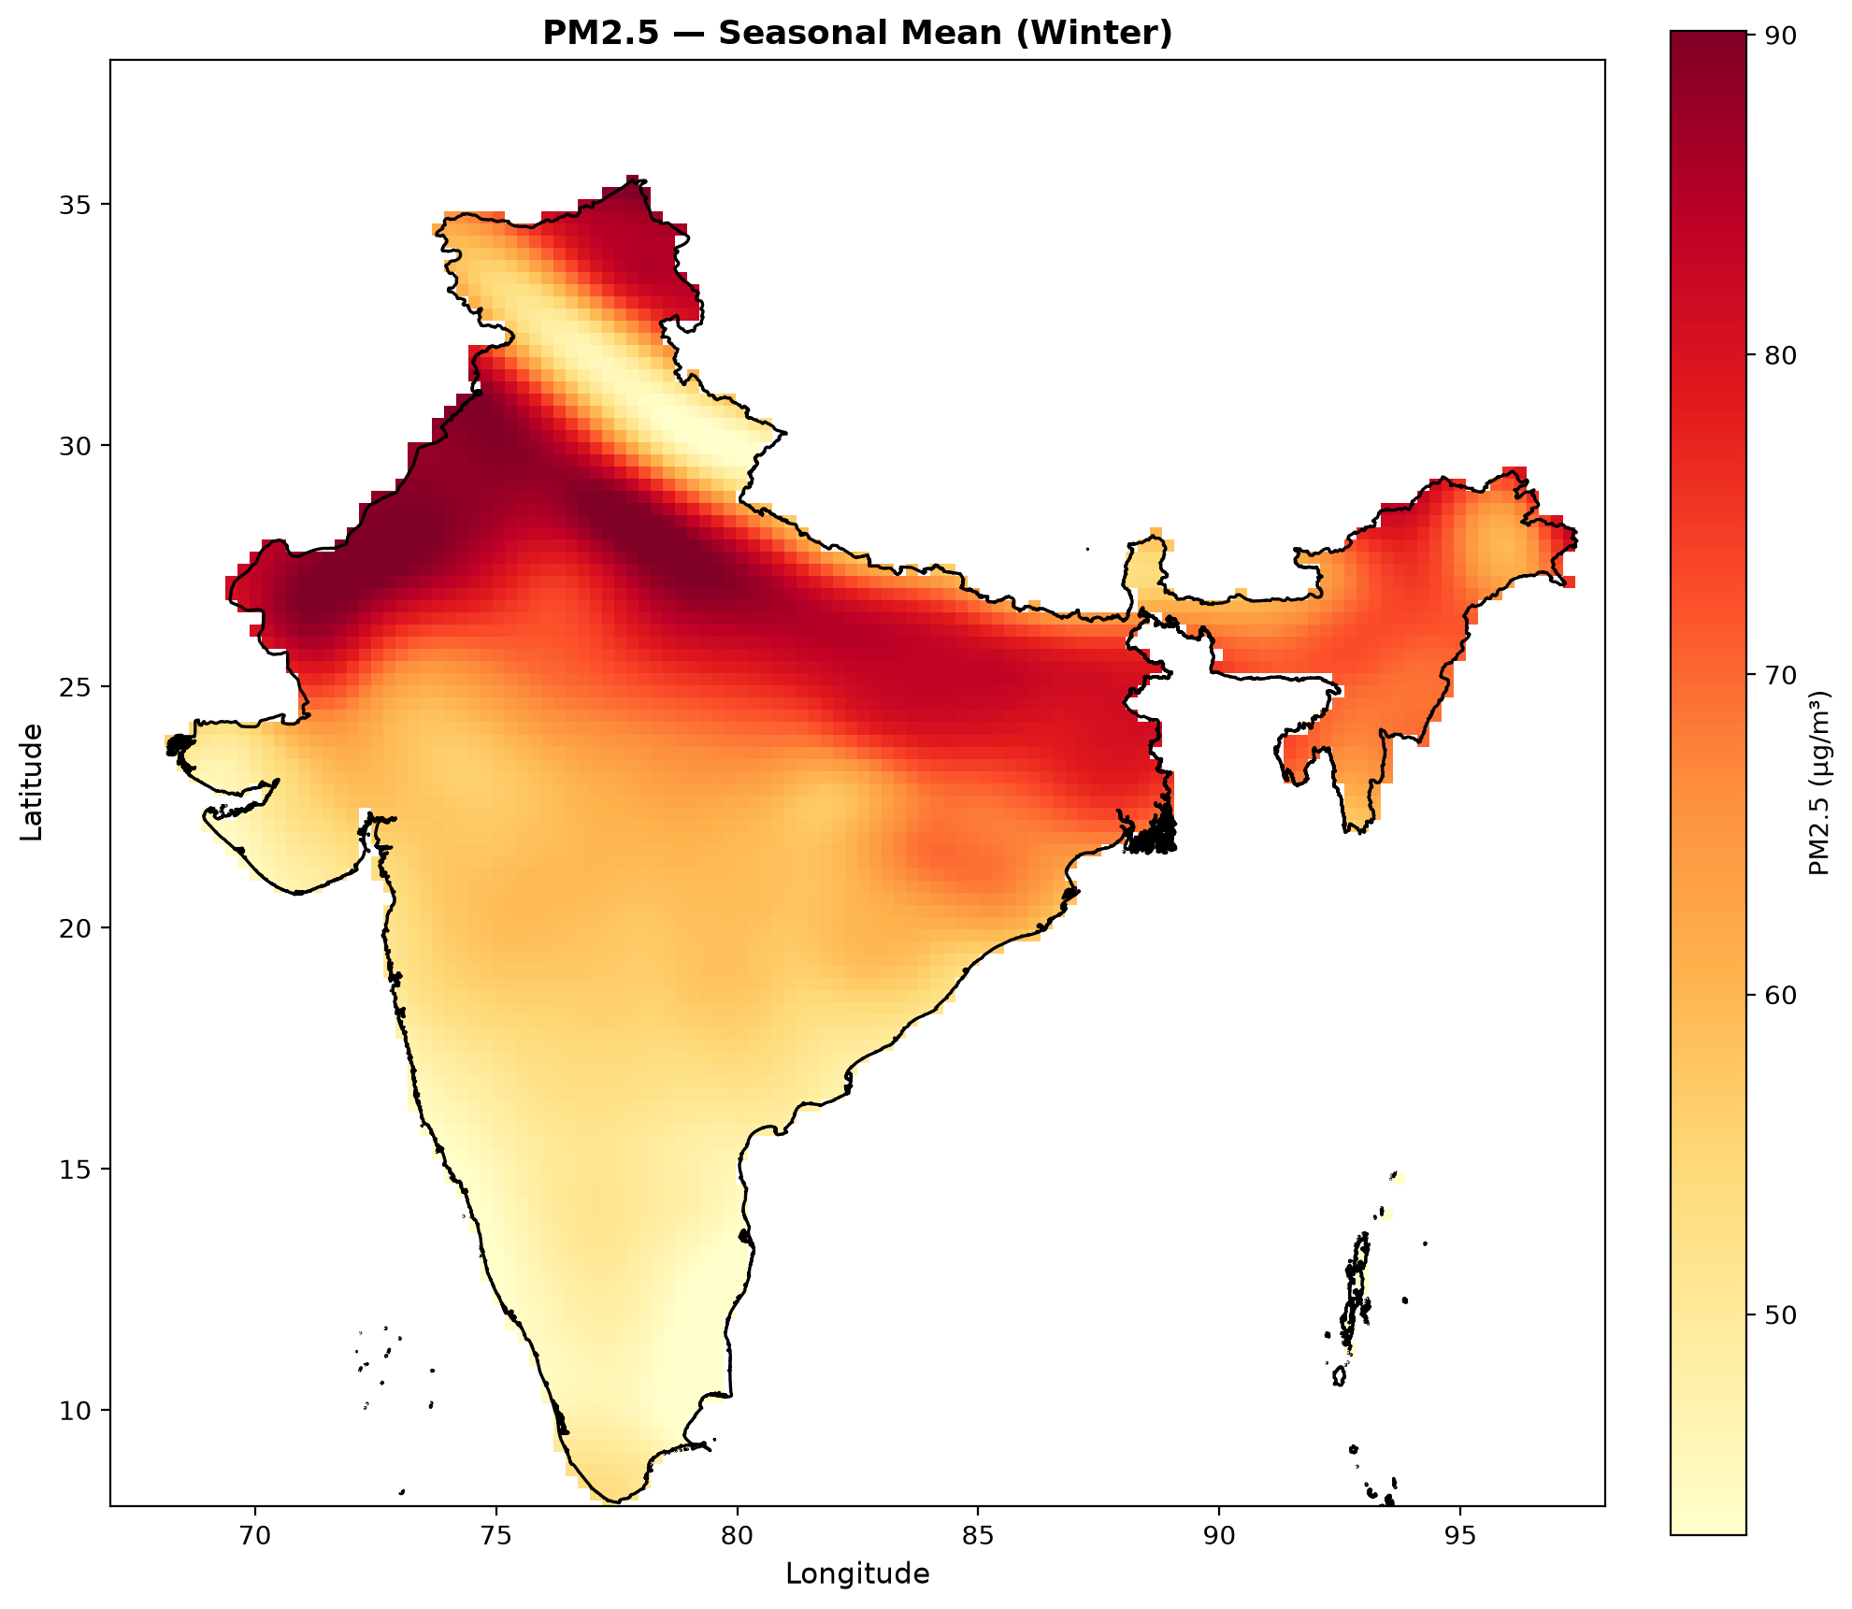

PM2.5 Concentration - Severe Event (Nov 5, 2023)
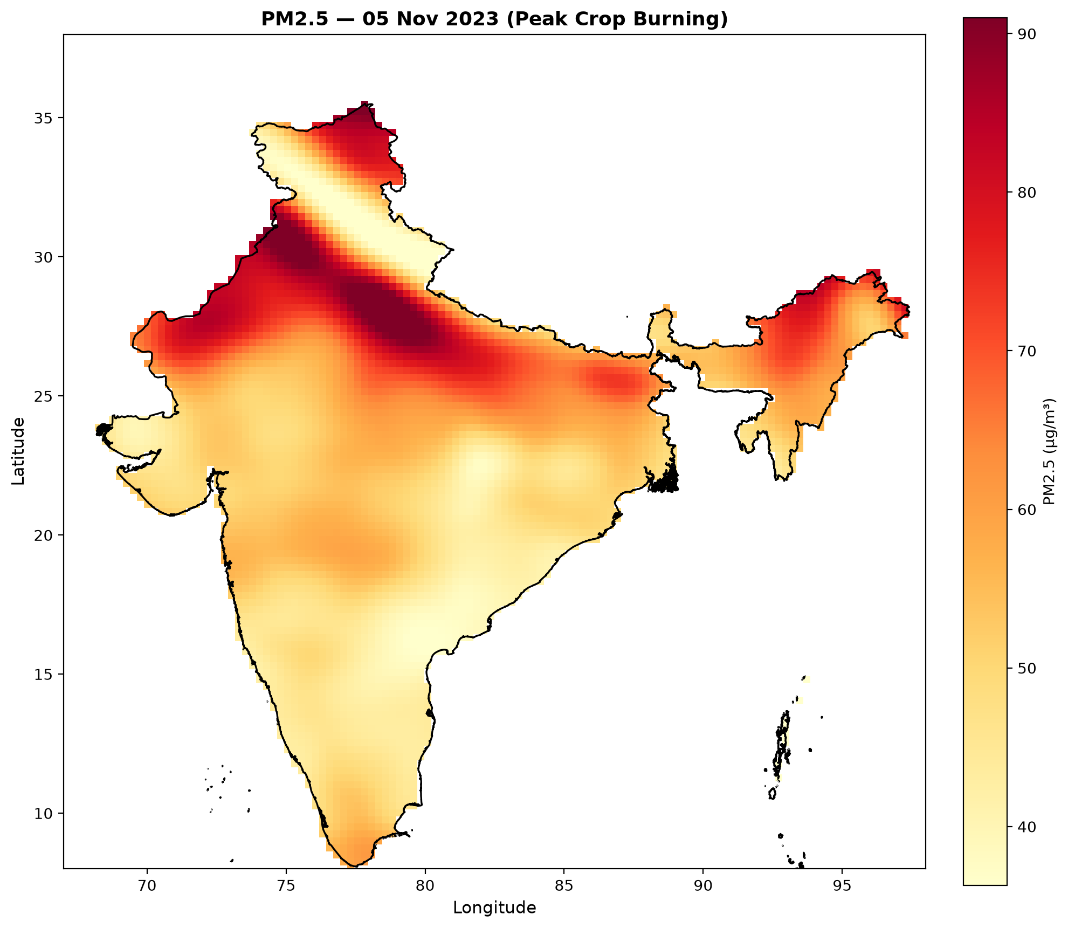

NO2 Concentration - Peak Point (Nov 5, 2023)
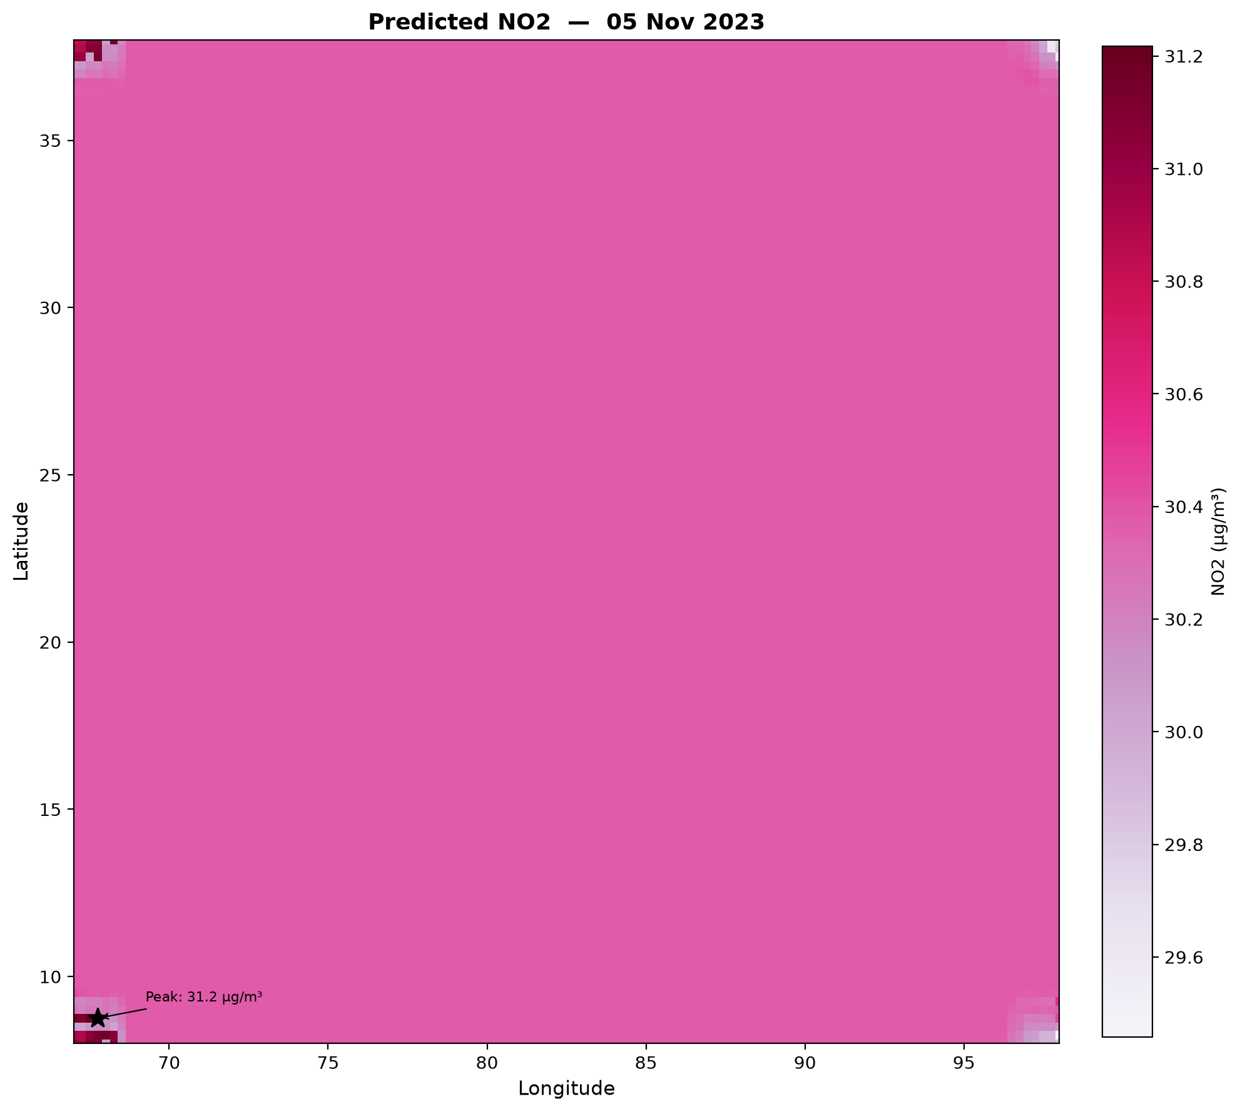

AQI Dominant Pollutant (Spatial Distribution)
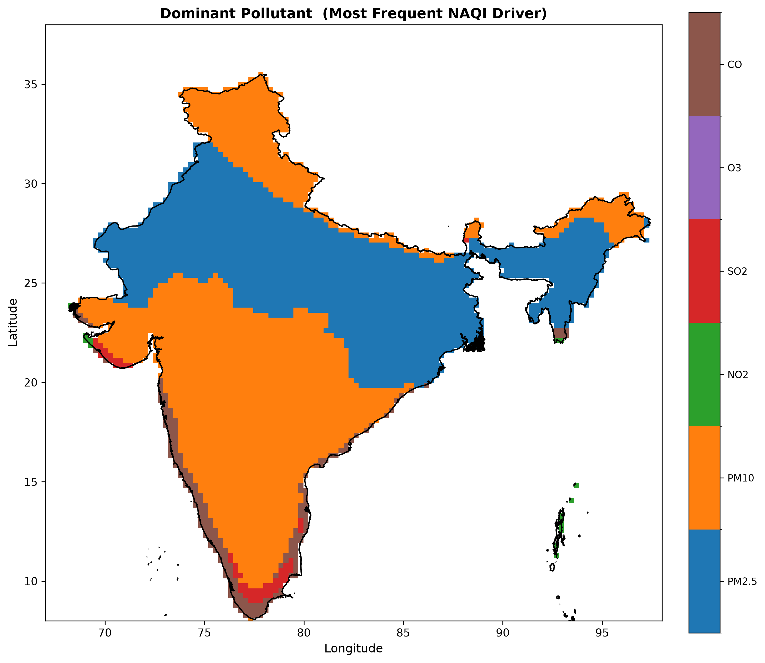

3. Limitations of Model A — Motivation for the ConvLSTM Upgrade
The CNN + XGBoost pipeline delivered meaningful results within a 4-month data window, but systematic analysis reveals structural limitations that cannot be resolved through further hyperparameter tuning or feature engineering. These limitations directly motivated the design of Model B.

3.1 No Temporal Memory of Pollution Transport
The most fundamental weakness of Model A is that the CNN processes each day's satellite patch in complete isolation. Atmospheric pollution is not a static snapshot — pollutants are advected by wind, transformed chemically over hours, and persist across days. The CNN has no mechanism to learn these dynamics; it sees each day as independent of the previous. The XGBoost lag features partially compensate, but lag features are point measurements, not spatial transport patterns.
Consequence: The model cannot capture pollution plumes moving across regions, cannot learn the temporal buildup of inversions, and relies on approximate heuristics (lag_PM2.5_D1) rather than actual atmospheric transport physics.

3.2 Low Within-R² — Temporal Variance Underexplained
Across all pollutants, Within-R² values remain modest (0.12–0.33), indicating that while the model captures spatial gradients well (Pearson r of 0.81–0.87 for PM species and NO₂), it struggles to explain day-to-day temporal variation at individual stations. A model that always predicts the spatial mean without temporal fluctuation would score poorly on Within-R² even if its global R² appeared acceptable.

3.3 Static CNN — No Spatio-Temporal Attention
The CNN architecture (Conv2D → MaxPool → Conv2D → GAP) treats all spatial positions within the 13×13 patch equally. It has no mechanism to selectively attend to the upwind pixels most likely to carry transported pollutants, nor can it weight earlier days in the lookback window differently from more recent days. The static convolutional filters are the same regardless of the wind field or season.

3.4 Insufficient Training Data for Deep Temporal Learning
123 training days (Oct 2023 – Jan 2024) is fundamentally inadequate for a system that needs to generalise across all Indian seasons, monsoon dynamics, crop-burning events, dust storms, and winter inversions. Model A never sees a summer or monsoon in training. The model's generalisability outside its training window is therefore untested and likely poor.

3.5 Weak O₃ and CO Representation
O₃ is a photochemically-produced secondary pollutant — its formation depends on NOₓ, VOCs, and solar radiation acting over hours. The CNN patch approach treats O₃ as a spatially distributed field to regress, without any chemistry-informed constraint. Similarly, CO's 17×17 patch expansion was a pragmatic fix for an architectural limitation; the model still lacks the ability to track CO transport over multiple days. Within-R² for both O₃ (0.14) and CO (0.12) reflects this gap.

3.6 No Physics-Informed Training Signal
Model A is a pure data-driven system with no mechanism to enforce atmospheric physics during training. It can produce predictions that violate physical laws (as seen with the PM2.5 > PM10 violations that required a post-processing hard constraint). There is no continuous-time transport equation constraining the prediction sequence.

4. Model B — Physics-Informed ConvLSTM Pipeline
Model B represents a principled architectural upgrade that directly addresses every limitation identified in Model A. The complete architecture is implemented and documented here. Training awaits the assembly of the 4-year (2020–2023) daily data stack.

4.1 Design Philosophy — Split Architecture
Model B separates pollutants by their dominant physical process:
ConvLSTM Branch → PM2.5, PM10, CO (transport-dominated: aerosols & CO persist and advect)
CNN + XGBoost Branch → SO2, NO2 (emission-dominated: short-lifetime, source-proximate)
O3 Sub-model → O3 (photochemically produced, NO2-driven in this dataset)
BMA Dynamic Weighting → Ensemble fusion across branches

This separation is physically motivated. PM2.5 and PM10 have atmospheric residence times of days to weeks and are transported hundreds of kilometres by wind systems — ideal candidates for a recurrent model with a 14-day lookback. SO₂ and NO₂ have shorter lifetimes and are more strongly controlled by local emission sources, making the CNN + XGBoost approach (now lag-free for full spatial coverage) appropriate. O₃ is treated as a derived quantity from NO₂ fields.

4.2 Data Upgrade — 4 Years, 18 Input Channels, 0.05° Resolution

4.2.1 Temporal Scope
Training: 1 Jan 2020 – 31 Dec 2022 (3 years, 1,096 days). Validation: 1 Jan 2023 – 31 Dec 2023 (1 year, 365 days). This exposes the model to all four Indian meteorological seasons across multiple years, COVID-19 lockdown anomalies (flagged, not excluded), and interannual variability — a 6–7× increase in training data compared to Model A.

4.2.2 Input Data Stack — 18 Channels at 0.05° (TROPOMI Native Resolution)
All inputs are pre-aligned by a Stage-2 merge script onto the TROPOMI 0.05° grid (640×591 for full India). Each daily file is a single .npy stack of shape (18, 640, 591):
Channel Group | Channels | Physical Meaning
TROPOMI satellite | NO₂, SO₂, CO, AOD | Column-integrated atmospheric composition
ERA5 meteorology | u10, v10, t2m, BLH, d2m, sp, msdwswrf | Wind, temperature, mixing, radiation
ERA5 derived | RH (relative humidity), lapse_rate | Pre-computed atmospheric stability indicators
Spatial static | lat_norm, lon_norm | Geographic coordinate encoding
Temporal | doy_sin, doy_cos | Cyclical day-of-year encoding
Event flag | lockdown_flag | COVID-19 anomaly marker (2020-03-25 to 2020-05-31)

4.3 ConvLSTM Architecture with Spatio-Temporal Attention

4.3.1 Sequence Construction — 14-Day Lookback
Each training sample is a sequence of 14 consecutive daily input stacks: X shape (14, 18, H, W), with the corresponding CPCB label grid as a sparse target at station pixels (NaN everywhere else). This enables the model to see two full weeks of atmospheric evolution before making a prediction.

4.3.2 Spatio-Temporal Attention Module
Before entering the ConvLSTM cells, the input sequence passes through a learnable attention module that independently weights both spatial positions and time steps:
• Spatial gate: Conv2D(1×1) → ReLU → Conv2D(1×1) → Sigmoid — produces a spatial attention map per time step, highlighting regions (e.g., upwind source areas) most relevant to the prediction
• Temporal gate: Linear → ReLU → Linear → Softmax — weights each of the 14 lookback days differently, allowing the model to focus on, say, the pollution event 3 days ago over yesterday's clean reading
This attention mechanism is inspired by the KSC-ConvLSTM architecture and directly addresses Model A's limitation of treating all spatial positions and time steps equally.

4.3.3 ConvLSTM Cell
The core recurrent unit is a ConvLSTM cell that maintains both a hidden state h and a cell state c as 2D spatial grids (shape: hidden_dim × H × W). Unlike standard LSTM which processes vectors, ConvLSTM's gating operations are convolutional — the model simultaneously learns what spatial patterns to remember, forget, and output at each time step.
input_dim + hidden_dim → Conv2D(4 × hidden_dim) → chunk into i, f, o, g gates
c_next = sigmoid(f) × c + sigmoid(i) × tanh(g) (input and forget gates)
h_next = sigmoid(o) × tanh(c_next) (output gate)
Final output head: Conv2D(hidden_dim → n_targets=3) [PM2.5, PM10, CO]

4.4 Physics-Informed Loss Function
The most significant architectural advance over Model A is the physics-informed training objective. Rather than minimising only data-fitting loss, the model is regularised by physical laws encoded as differentiable loss terms:

4.4.1 Total Loss Composition
L_total = L_MAE + λ_pearson · L_pearson + λ_pm · L_pm_ordering + λ_pde · L_pde

λ_pearson = 0.10 (spatial pattern enforcement)
λ_pm_ordering = 0.05 (PM2.5 ≤ PM10 soft constraint)
λ_pde = 0.02 (advection-diffusion physics regularisation)

4.4.2 Masked MAE Loss
Standard MAE computed only at pixels where CPCB ground-truth measurements exist (non-NaN positions). The model is never penalised for its predictions at the 99.9% of grid pixels with no station — it is free to extrapolate spatially, constrained only by the physics terms.

4.4.3 Pearson Correlation Loss (1 − r)
Penalises incorrect spatial patterns, not just absolute errors. Even if the model correctly predicts the mean concentration, it is penalised if it places the pollution maximum in the wrong location. This directly improves the model's ability to correctly locate hotspots — the primary use case for India-wide AQI mapping.

4.4.4 PM Ordering Penalty — Built Into Training
In Model A, the PM2.5 ≤ PM10 physical constraint had to be enforced as a post-processing hard mask after the model produced violations. In Model B, this constraint is embedded as a soft penalty directly into the training loss: L_pm = mean(ReLU(PM2.5 − PM10)²). The model learns the physical ordering relationship rather than having it imposed externally.

4.4.5 Advection-Diffusion PDE Residual — The Core Physics Term
The advection-diffusion equation governs atmospheric transport of passive scalars (aerosols, trace gases):
∂C/∂t + u·∂C/∂x + v·∂C/∂y = K·∇²C + S

C = concentration, u/v = ERA5 wind fields, K = diffusivity constant (50 m²/s)
S = emission source term (currently 0 — no emission inventory in dataset)

Implementation: finite difference on consecutive predicted grids (C₀, C₁)
The PDE residual squared is minimised → predictions must satisfy transport physics
Grid edges excluded (torch.roll boundary wrapping is physically incorrect at bbox boundary)

This term penalises predictions that are physically inconsistent with the wind-driven transport seen in ERA5. A plume that appears in the wrong location relative to the wind direction and previous day's concentration will produce a large PDE residual and be penalised. This is the fundamental improvement over Model A: pollution transport is built into the objective function, not approximated by lag features.

4.5 Additional Architectural Features

4.5.1 Adaptive Neighbor Selection (KSC-ConvLSTM Inspired)
For constructing training targets, each station's CPCB measurement is not only assigned to its own pixel but can also inform nearby pixels within a configurable radius using Haversine distance. This propagates sparse ground-truth information across neighboring grid cells during training, improving spatial supervision density.

4.5.2 Optuna Hyperparameter Tuning
Hyperparameters (learning rate, hidden dimension, scheduler type, physics loss weights λ) are tuned via Optuna with Bayesian optimisation over 20 trials (6 in FAST_CONFIG). The tuning objective is validation MAE at held-out stations.

4.5.3 Multi-Seed Ensemble
Three training seeds (13, 42, 77) are used to build an ensemble. Final predictions are the mean across seeds; ensemble standard deviation provides a pixel-wise uncertainty estimate output alongside the concentration prediction.

4.5.4 Leave-One-Station-Out Validation, Stratified by Season and AQI Severity
Validation is stratified across four Indian meteorological seasons (Winter, Summer, Monsoon, Post-Monsoon) and all six CPCB AQI severity bins (Good, Satisfactory, Moderate, Poor, Very Poor, Severe). This stratification ensures the model is not hiding poor performance on critical high-pollution or monsoon events behind an averaged metric.

4.5.5 BMA Dynamic Weighting
A Bayesian Model Averaging module adaptively weights the ConvLSTM and CNN+XGBoost branches based on a 13-dimensional context vector (meteorological and spatial covariates). This allows the ensemble to rely more on the XGBoost branch for emission-proximate scenarios and more on the ConvLSTM for transport-dominated regimes. The BMA module is architecturally complete but requires real XGBoost outputs to train end-to-end.

4.5.6 Neural Operator Alternate Core (CoNOAir Inspired)
An optional Fractional Fourier Operator block is implemented as a benchmarking alternative to the ConvLSTM core. It applies learnable spectral mixing in the Fourier domain — conceptually similar to a Fourier Neural Operator — allowing the model to capture long-range spatial correlations that local convolutional filters cannot. This component is available for ablation study comparison.

4.6 CNN + XGBoost Branch — Improved for SO₂ and NO₂
The CNN + XGBoost branch for SO₂ and NO₂ in Model B is upgraded from Model A in one key respect: all lag features are removed. In Model A, lag features were station-specific historical values that only existed at the 100 CPCB station locations, making the model unable to produce predictions at arbitrary grid pixels. Model B's lag-free design means the SO₂ and NO₂ branch can predict at any of the 640×591 = 378,240 grid pixels without needing historical station data, achieving true spatial coverage.

4.7 Known Limitations & Honest Constraints
In the spirit of scientific rigour, Model B's limitations are acknowledged upfront in the notebook documentation:
• AOD monsoon gaps: Jun–Sep AOD has ~88% NaN coverage in TROPOMI data — masked, not interpolated. The model receives a degraded input signal during monsoon months
• PDE simplifications: Diffusivity K is a constant (50 m²/s) — in reality it is space- and time-varying. The emission source term S = 0 because no emission inventory is integrated
• O₃ sub-model: Uses NO₂ as the only input (HCHO was not available in the dataset). This loses the NOₓ-limited vs VOC-limited ozone regime distinction
• Pressure-level RH not available: ERA5 pull had only surface temperature 't'; lapse rate is temperature-only (no vertical moisture profile)
• BMA + XGBoost stub: The BMA weighting module and full-pipeline inference cannot be trained until the XGBoost branch outputs are wired in. Currently structural hooks only
• Full model cannot run end-to-end until the 4-year Stage-2 .npy stacks are available — data acquisition was not completed before the hackathon deadline

5. Model A vs Model B — Direct Comparison
Dimension | Model A (CNN + XGBoost) | Model B (Physics-Informed ConvLSTM)
Temporal scope | 123 days (Oct 2023–Jan 2024) | 4 years (2020–2023, 1,461 days)
Grid resolution | 0.25° ERA5 grid (120×124) | 0.05° TROPOMI grid (640×591)
Input channels | 10 (image) + 34 (tabular) | 18 channels (unified daily .npy stack)
Temporal memory | None (each day independent) | 14-day ConvLSTM lookback
Spatial attention | None (uniform convolution) | Learnable spatio-temporal attention gates
Transport physics | Lag features (heuristic approximation) | Advection-diffusion PDE residual in loss function
PM ordering | Post-processing hard mask | Soft penalty term in training loss
PM2.5 / PM10 / CO | Static CNN patches | ConvLSTM with temporal memory
SO₂ / NO₂ | CNN + XGBoost (with lags) | CNN + XGBoost (lag-free, full spatial coverage)
O₃ | GAP lags + photo_proxy feature | NO₂-driven sub-model
Hyperparameter tuning | RandomizedSearchCV | Optuna Bayesian optimisation
Ensemble strategy | 3-seed best-selection (NO₂, O₃) | 3-seed mean + uncertainty map
Validation strategy | Geographic block split | LOSO stratified by season & AQI severity
Status | Fully trained & evaluated | Architecture complete; training pending data

6. Conclusion & Path Forward
This project demonstrates a complete, scientifically rigorous pipeline for satellite-to-surface AQI prediction at India scale. Model A, trained on 4 months of data, achieved Pearson correlations of 0.81–0.88 for the primary pollutants PM2.5, PM10, and NO₂, with R² values in the 0.60–0.77 range — meaningful performance given the spatial validation strategy's strict prevention of leakage.
Model B represents the team's full scientific vision for this problem: a physics-constrained, temporally-aware, spatio-temporal deep learning system that encodes atmospheric transport laws directly into its training objective. The architecture is fully implemented, tested for structural correctness, and ready to train the moment the 4-year data stack is assembled.
The documented progression from Model A to Model B is itself a contribution — it traces exactly how empirical limitations of a simpler system translate into principled architectural decisions for the upgraded model, with each design choice grounded in atmospheric physics rather than heuristic trial and error.

Immediate Next Steps
• Assemble 4-year (2020–2023) daily data stacks: Stage-2 merge of TROPOMI + ERA5 into 18-channel .npy files
• Wire real XGBoost branch outputs into BMA module to enable end-to-end ensemble training
• Integrate an emission source term S (e.g., EDGAR or CAMS inventory) into the PDE loss for physically realistic CO and SO₂ transport
• Replace constant diffusivity K with spatially varying K derived from ERA5 turbulent kinetic energy or boundary layer parameterisation
• Extend O₃ sub-model with HCHO inputs (pending data availability) to resolve NOₓ-limited vs VOC-limited regime distinction

ISRO Hackathon — Objective 1 Technical Report
Data Sources: Sentinel-5P (ESA) · ERA5 (ECMWF) · INSAT-3D (ISRO/MOSDAC) · CPCB Ground Network (MoEFCC)

