QuizGenius CI CD Pipeline Report
Jenkins Docker SonarQube and Trivy
Project: CI CD Pipeline using Jenkins Docker SonarQube and Trivy
Repository: AkshatKunder DevOps LabCA
Branch: feature sonarqube trivy pipeline
Prepared: 23 October 2026

Project Overview
This report documents the QuizGenius continuous integration and continuous delivery pipeline. The pipeline checks source code, installs dependencies, runs automated tests, evaluates code quality, builds a container image, scans the exact image with Trivy, and deploys the application only after the mandatory gates succeed.

Pipeline Design
Stage | Purpose
Declarative Checkout SCM | Checks out the configured Git branch before the pipeline stages run.
Build | Installs the Python project dependencies.
Unit Tests | Runs the application unit test suite.
Integration Tests | Runs the end to end integration tests.
SonarQube Analysis | Submits source analysis to SonarQube.
SonarQube Quality Gate | Stops the pipeline when the SonarQube gate does not pass.
Docker Build | Builds the deployable image without cached layers.
Trivy Security Scan | Scans the built image for HIGH and CRITICAL vulnerabilities.
Deploy | Starts the application container after all required checks succeed.

Security and Verification Results
The Docker image uses the supported official python:3.11-alpine3.24 base image. The package installation command uses retry and timeout settings so transient download failures remain visible rather than being ignored. The certifi dependency was updated from version 2026.7.22 to 2026.10.19, the version identified as fixed by the reported Trivy finding.
Verification | Result
Python tests | 24 passed
Docker build | Passed using --pull and --no-cache
Dependency validation | certifi 2026.10.19 installed; pip check reported no broken requirements
Fresh Trivy scan | 0 HIGH and 0 CRITICAL findings
Trivy gate | Exited with status 0 using --scanners vuln --severity HIGH,CRITICAL --exit-code 1
Application smoke test | Gunicorn started and the root endpoint returned HTTP 302 to the login flow

Pipeline Control Flow
Deployment is placed after the testing, quality, image build, and Trivy stages. Consequently, a failed test, SonarQube quality gate, Docker build, or Trivy security gate prevents the Deploy stage from running. The Trivy configuration retains the HIGH and CRITICAL severity filter and a nonzero exit code for real findings.

Evidence Screenshots
The following screenshots provide evidence of the Jenkins stages, SonarQube result, container deployment, Trivy artifact, and QuizGenius application workflow. Jenkins build #24 is historical pipeline evidence; a new Jenkins build should be run after pushing the current certifi update to verify the current remote commit.

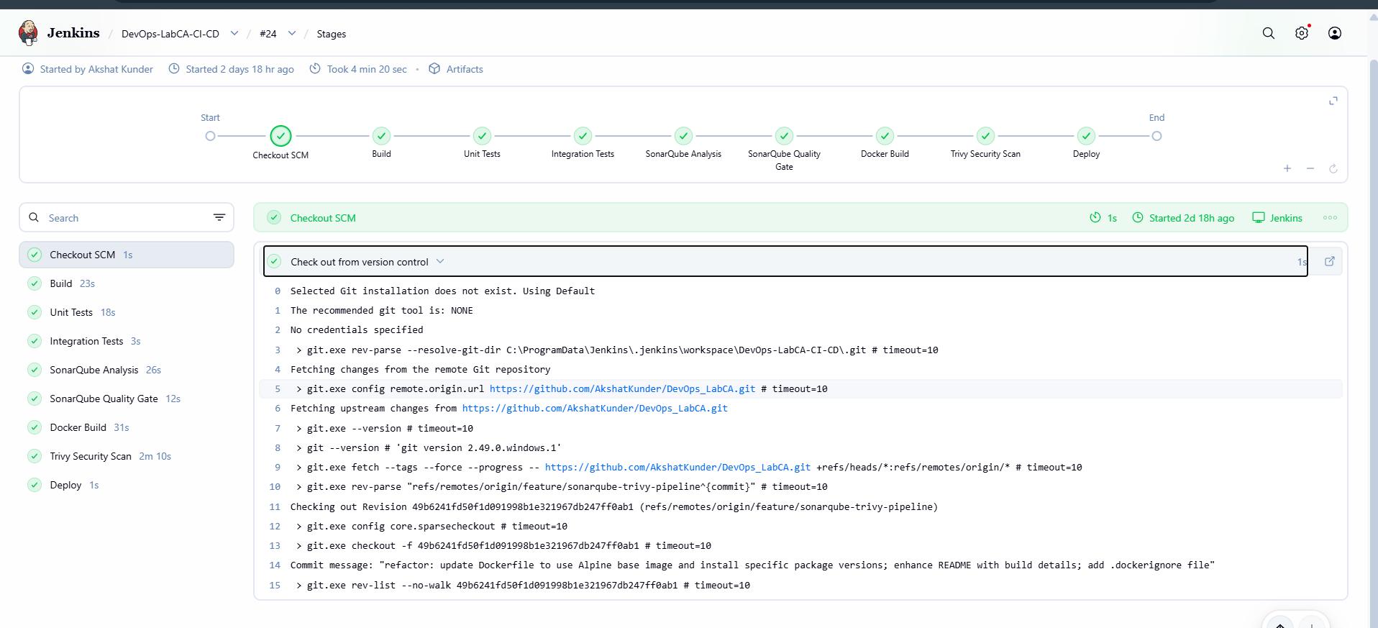
Figure 1. Jenkins build #24 Stage View showing all nine pipeline stages completed successfully.

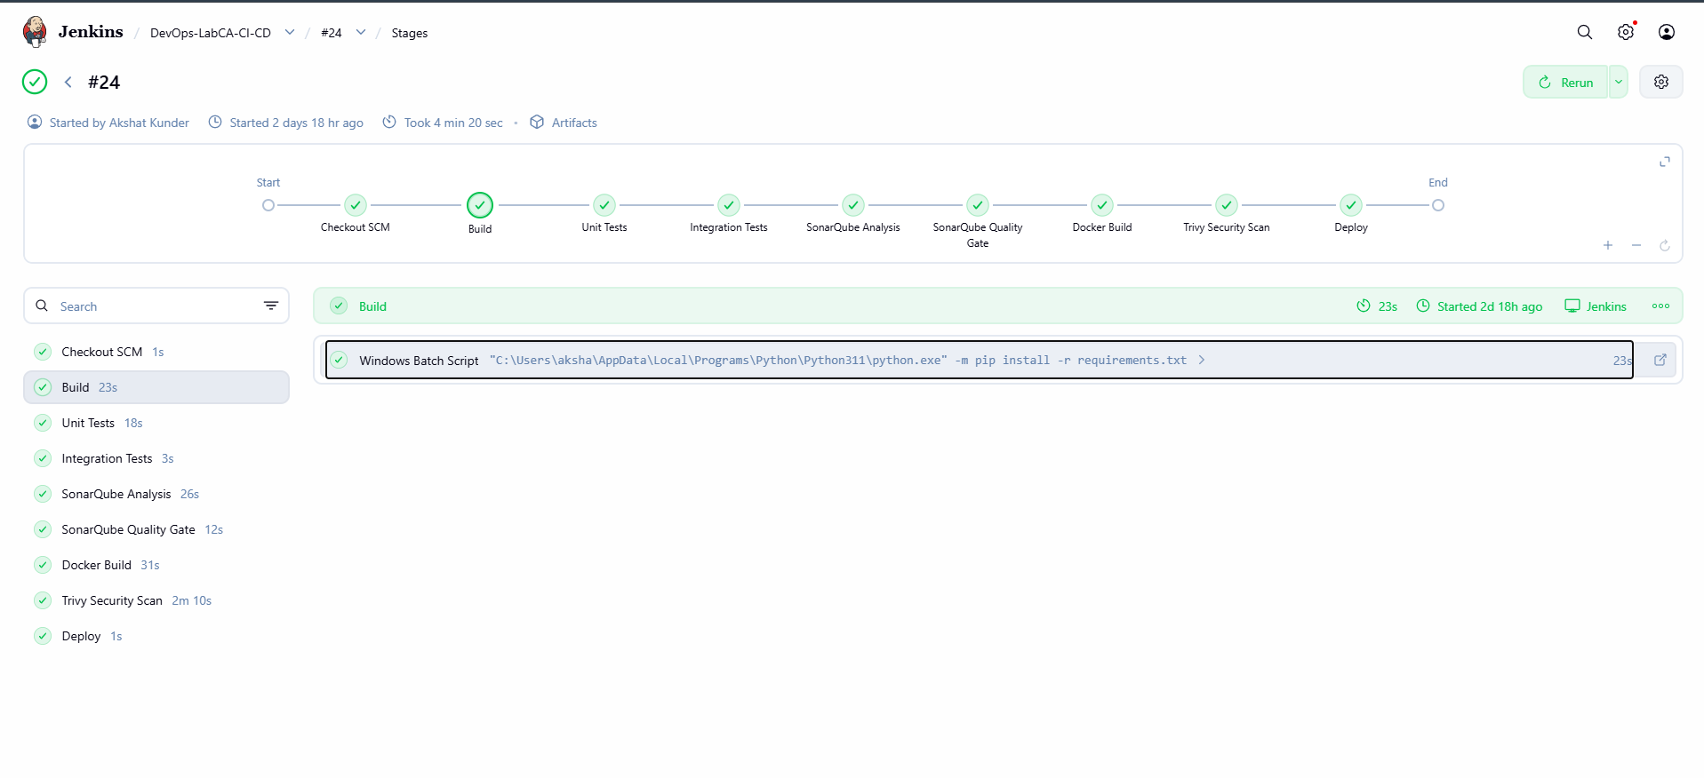
Figure 2. Jenkins Build stage installing the project dependencies.

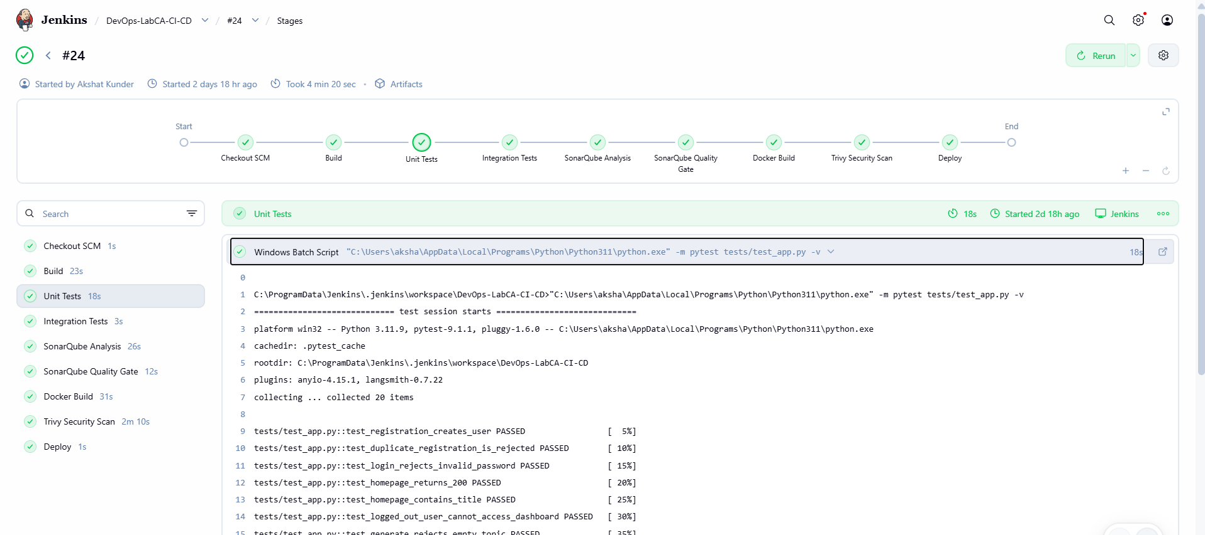
Figure 3. Jenkins Unit Tests stage showing successful pytest execution.

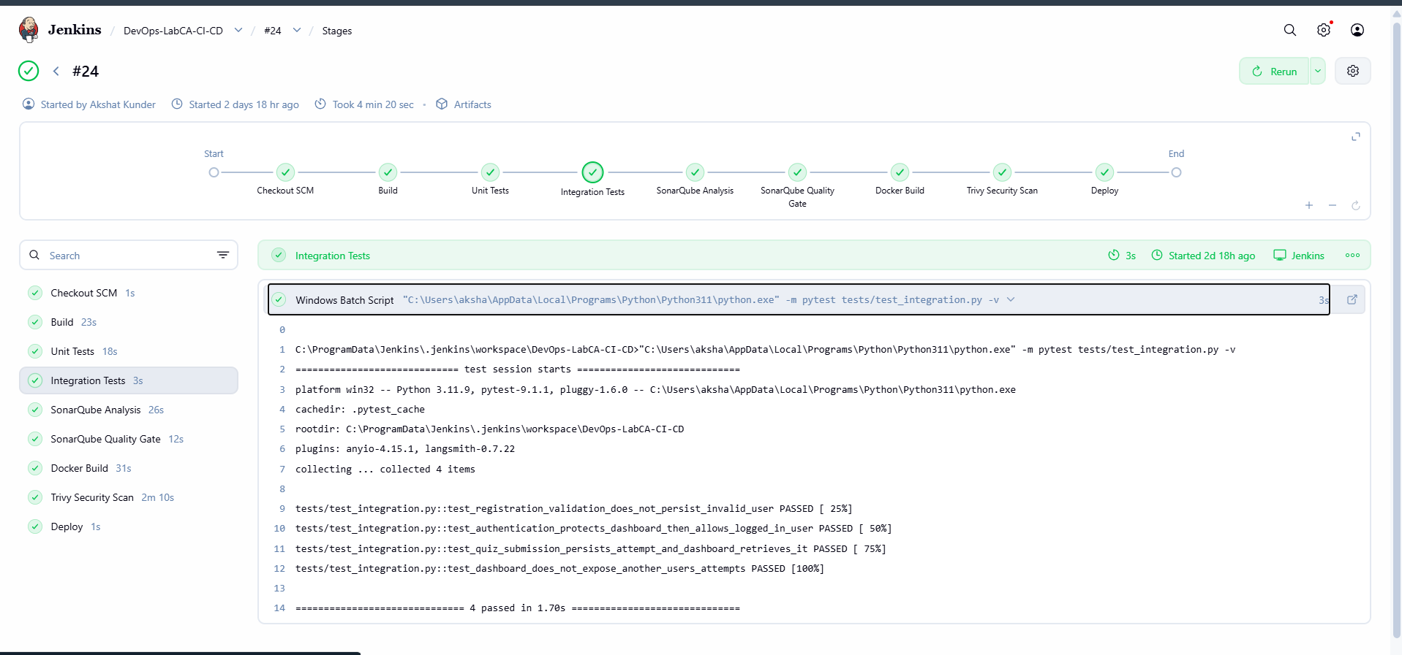
Figure 4. Jenkins Integration Tests stage showing successful integration tests.

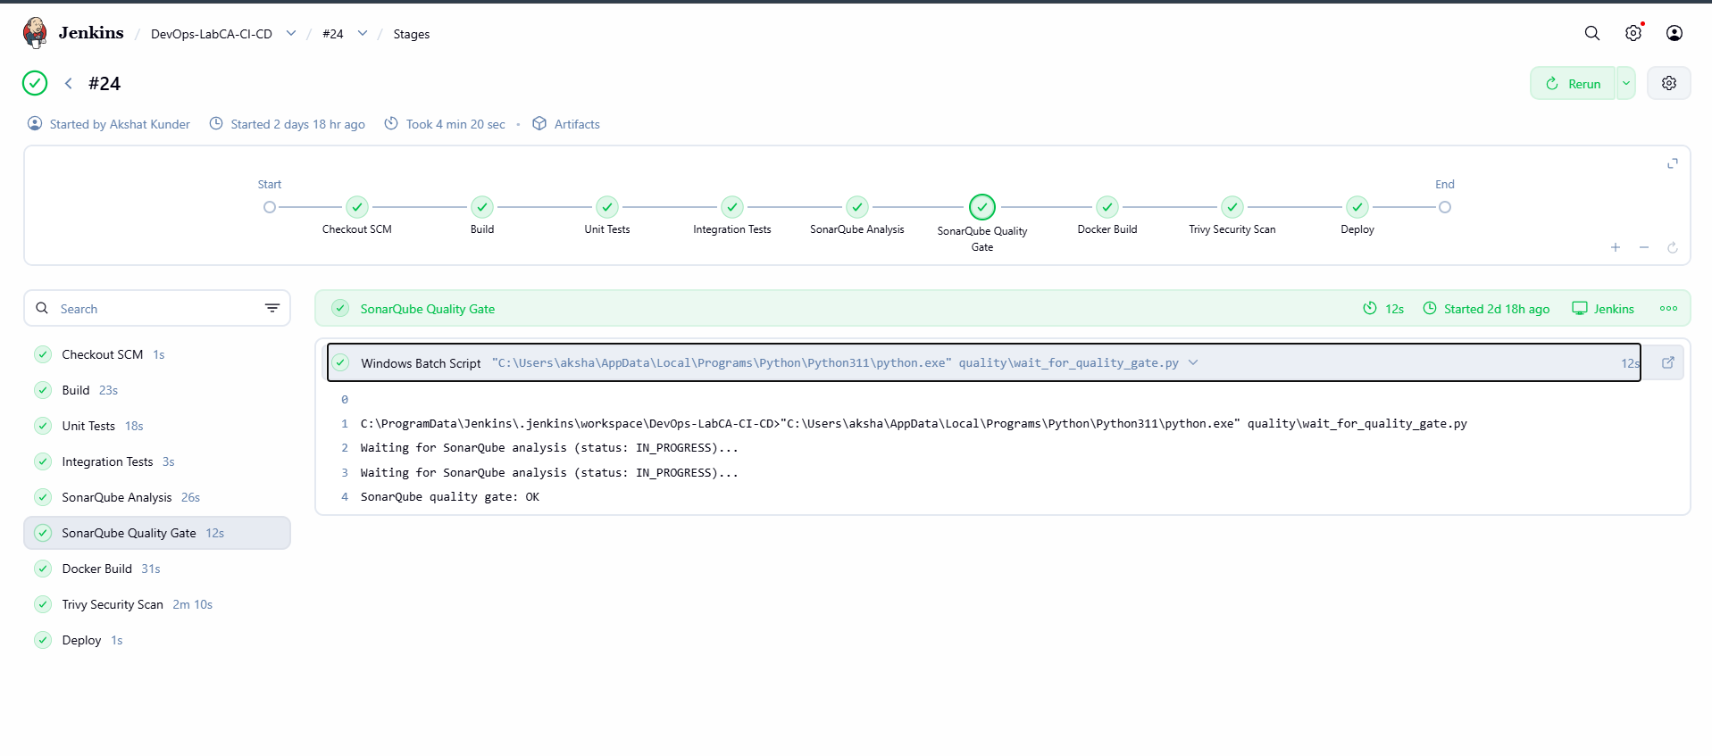
Figure 5. Jenkins SonarQube Quality Gate stage reporting an OK result.

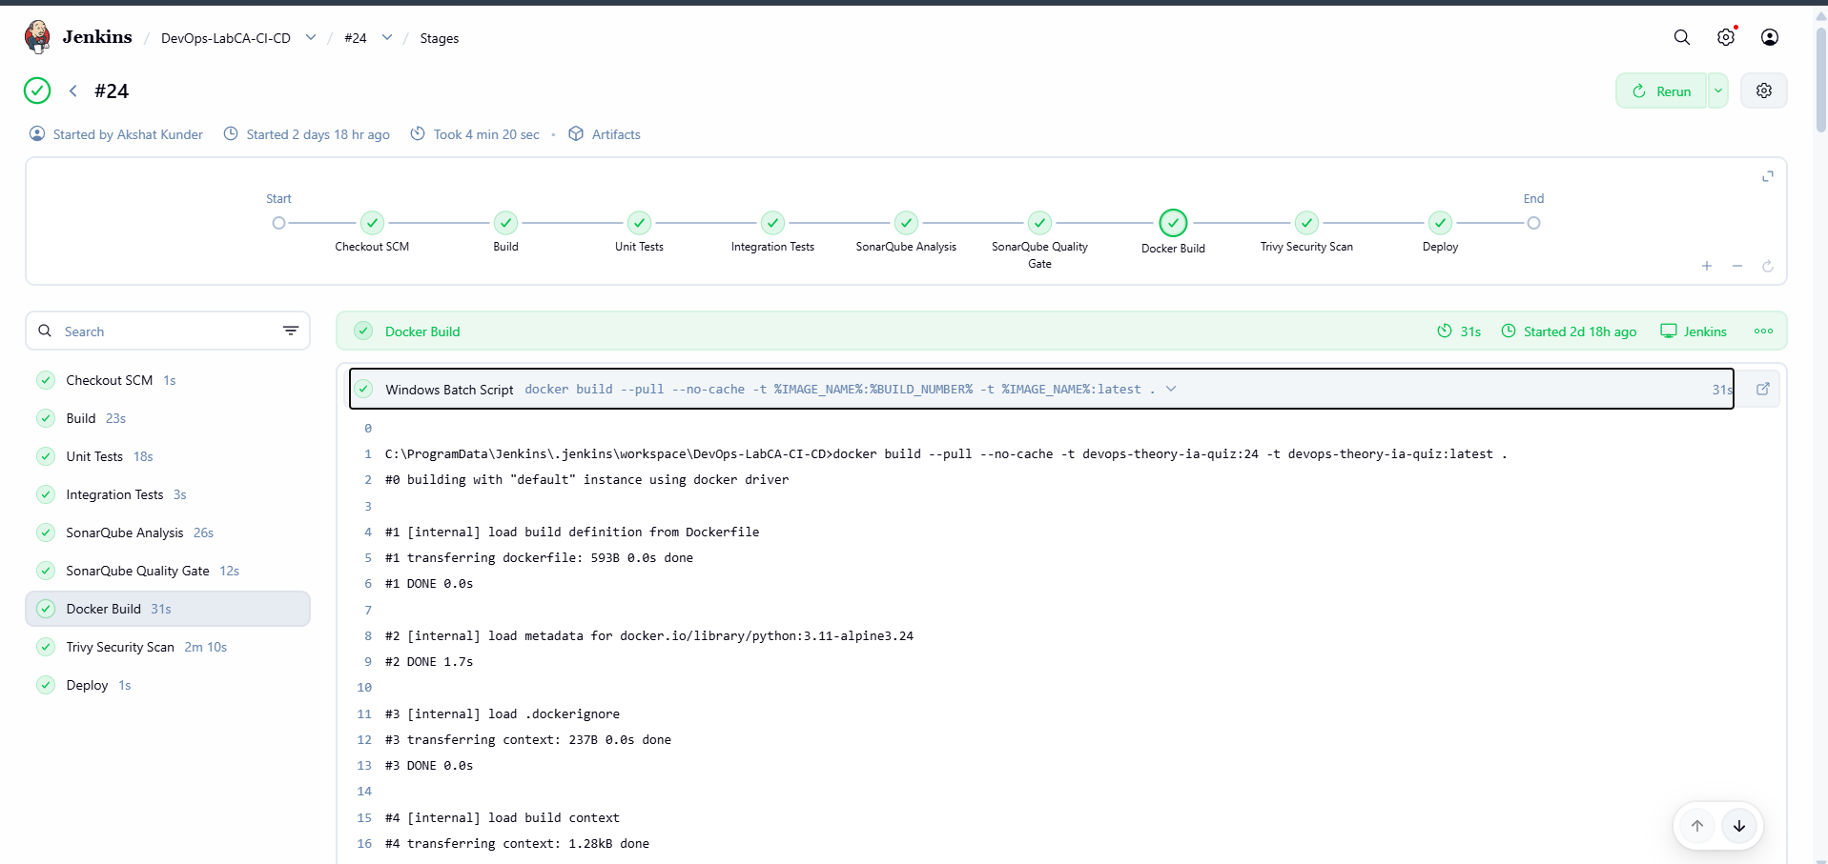
Figure 6. Jenkins Docker Build stage using the Python 3.11 Alpine image.

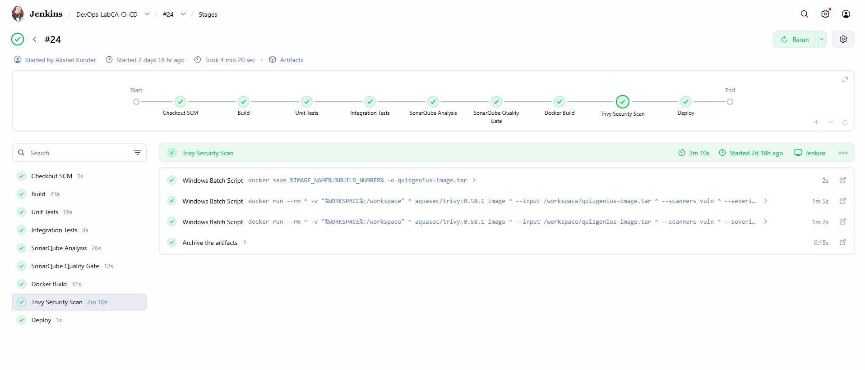
Figure 7. Jenkins Trivy Security Scan stage in the successful pipeline build.

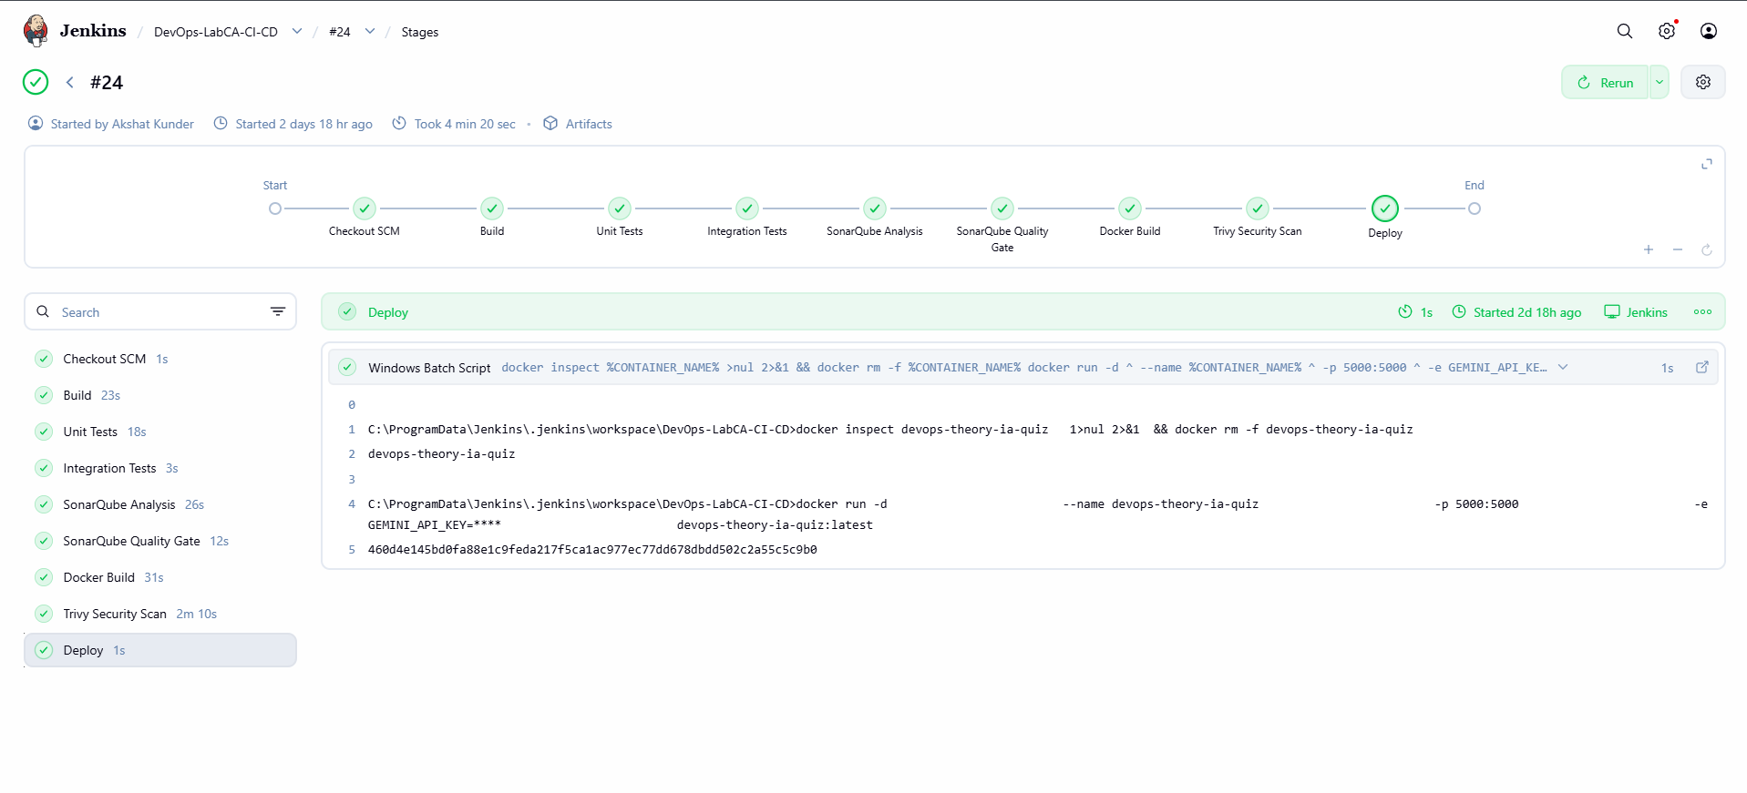
Figure 8. Jenkins Deploy stage starting the QuizGenius container.

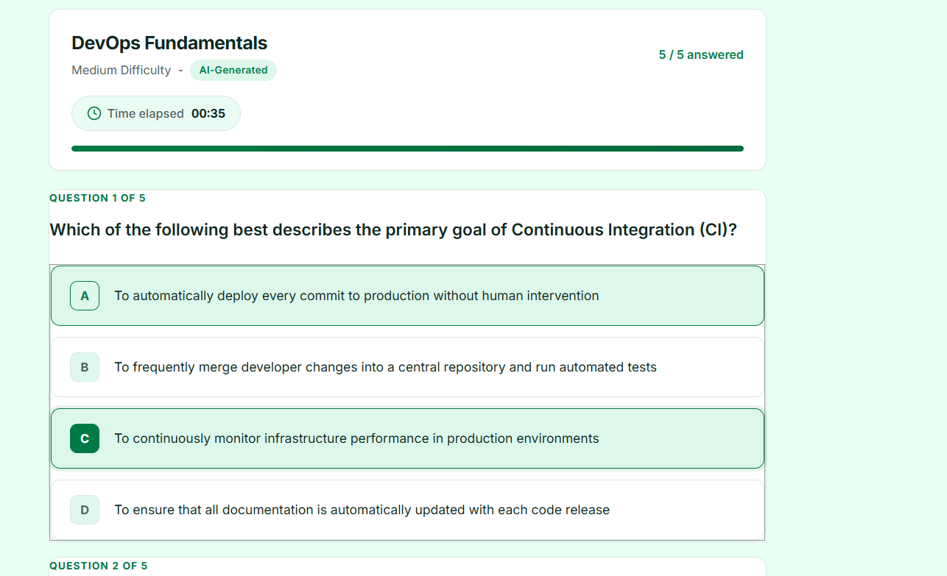
Figure 9. QuizGenius quiz attempt interface after application deployment.

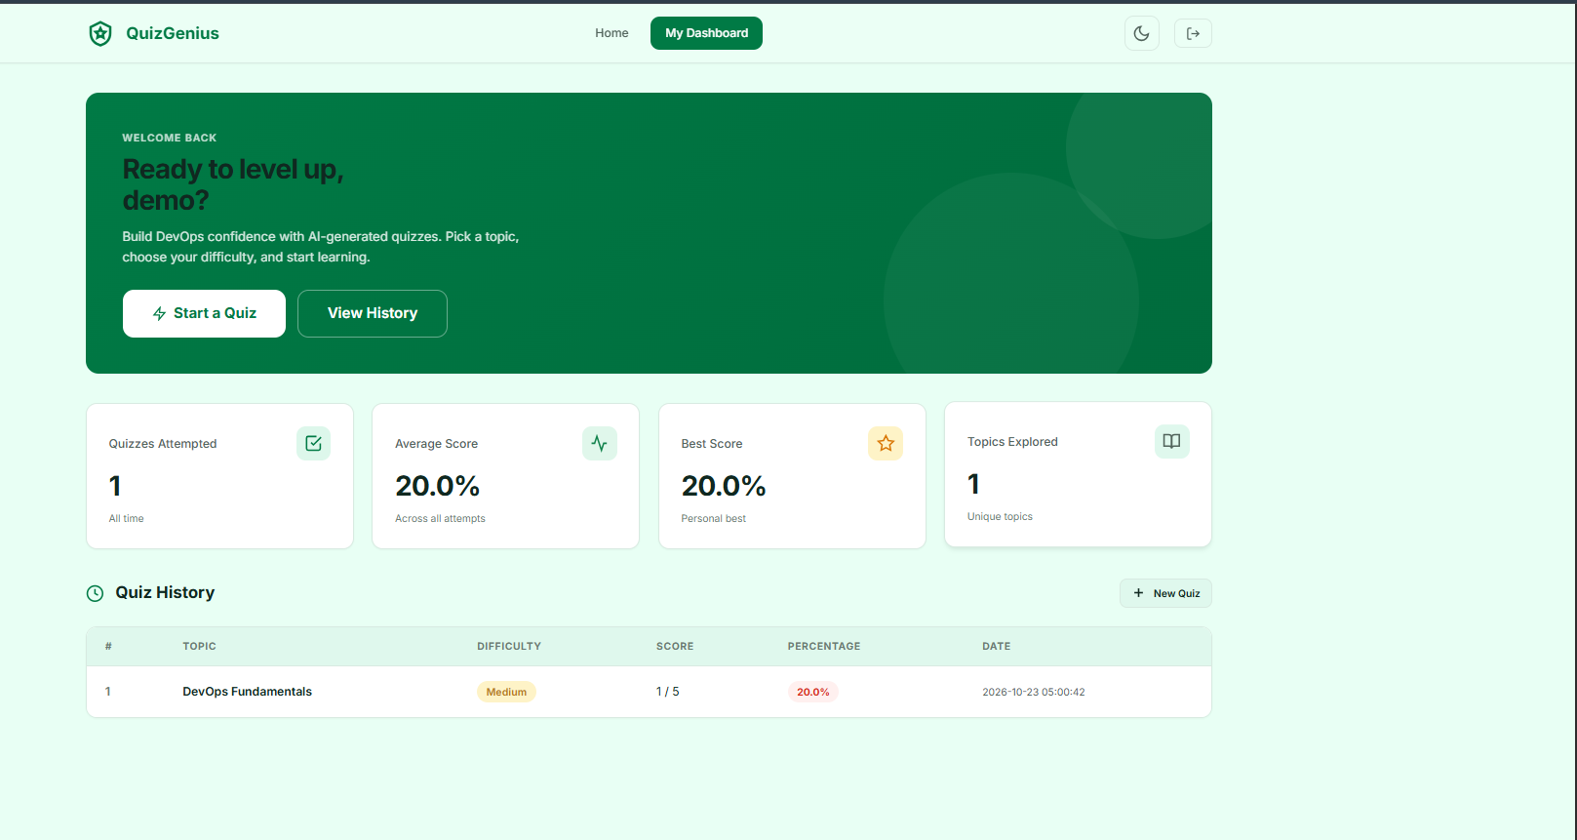
Figure 10. QuizGenius dashboard showing quiz history and user statistics.

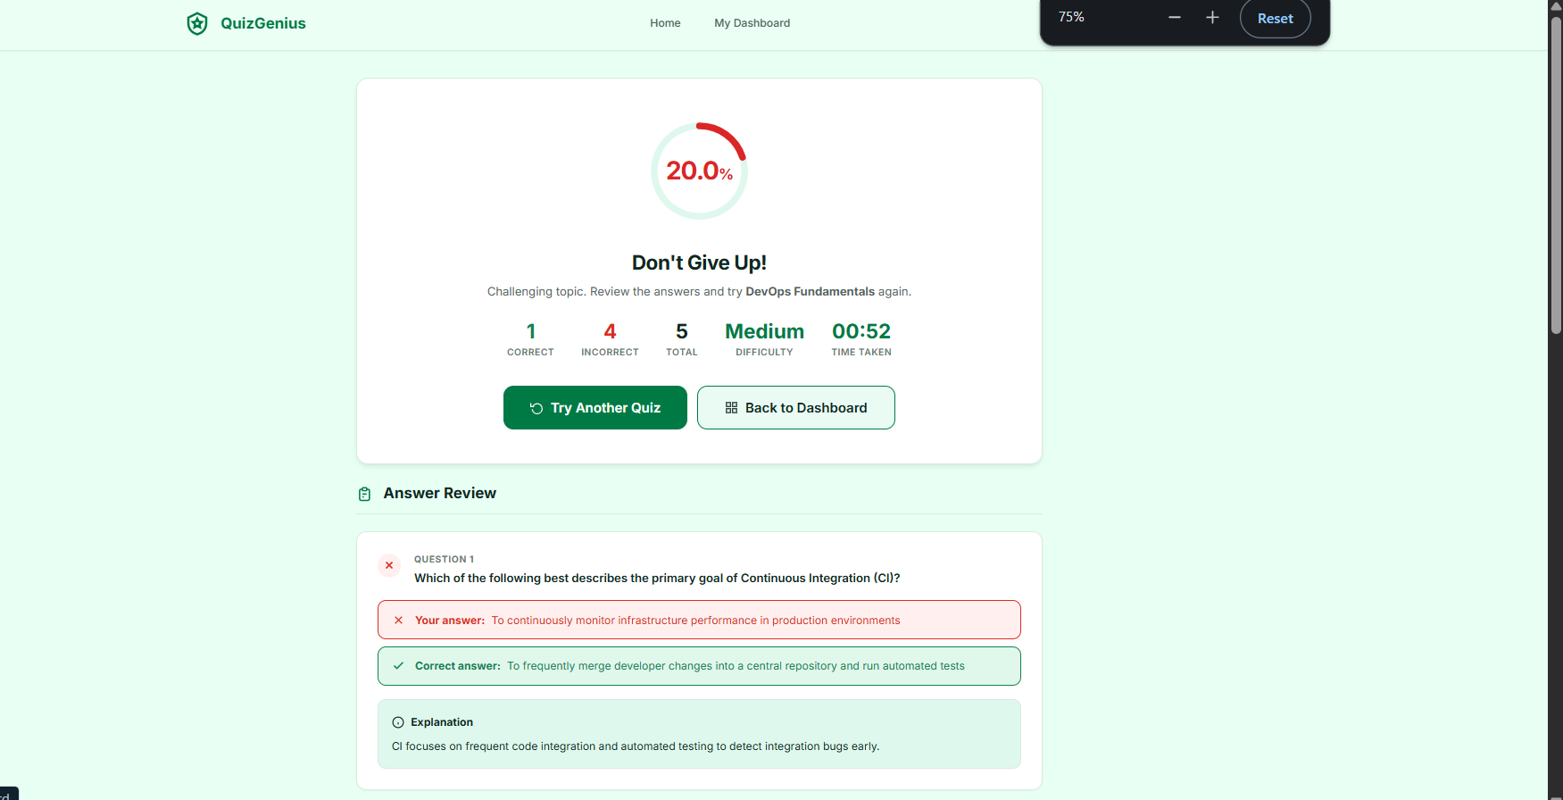
Figure 11. QuizGenius result and answer review screen.

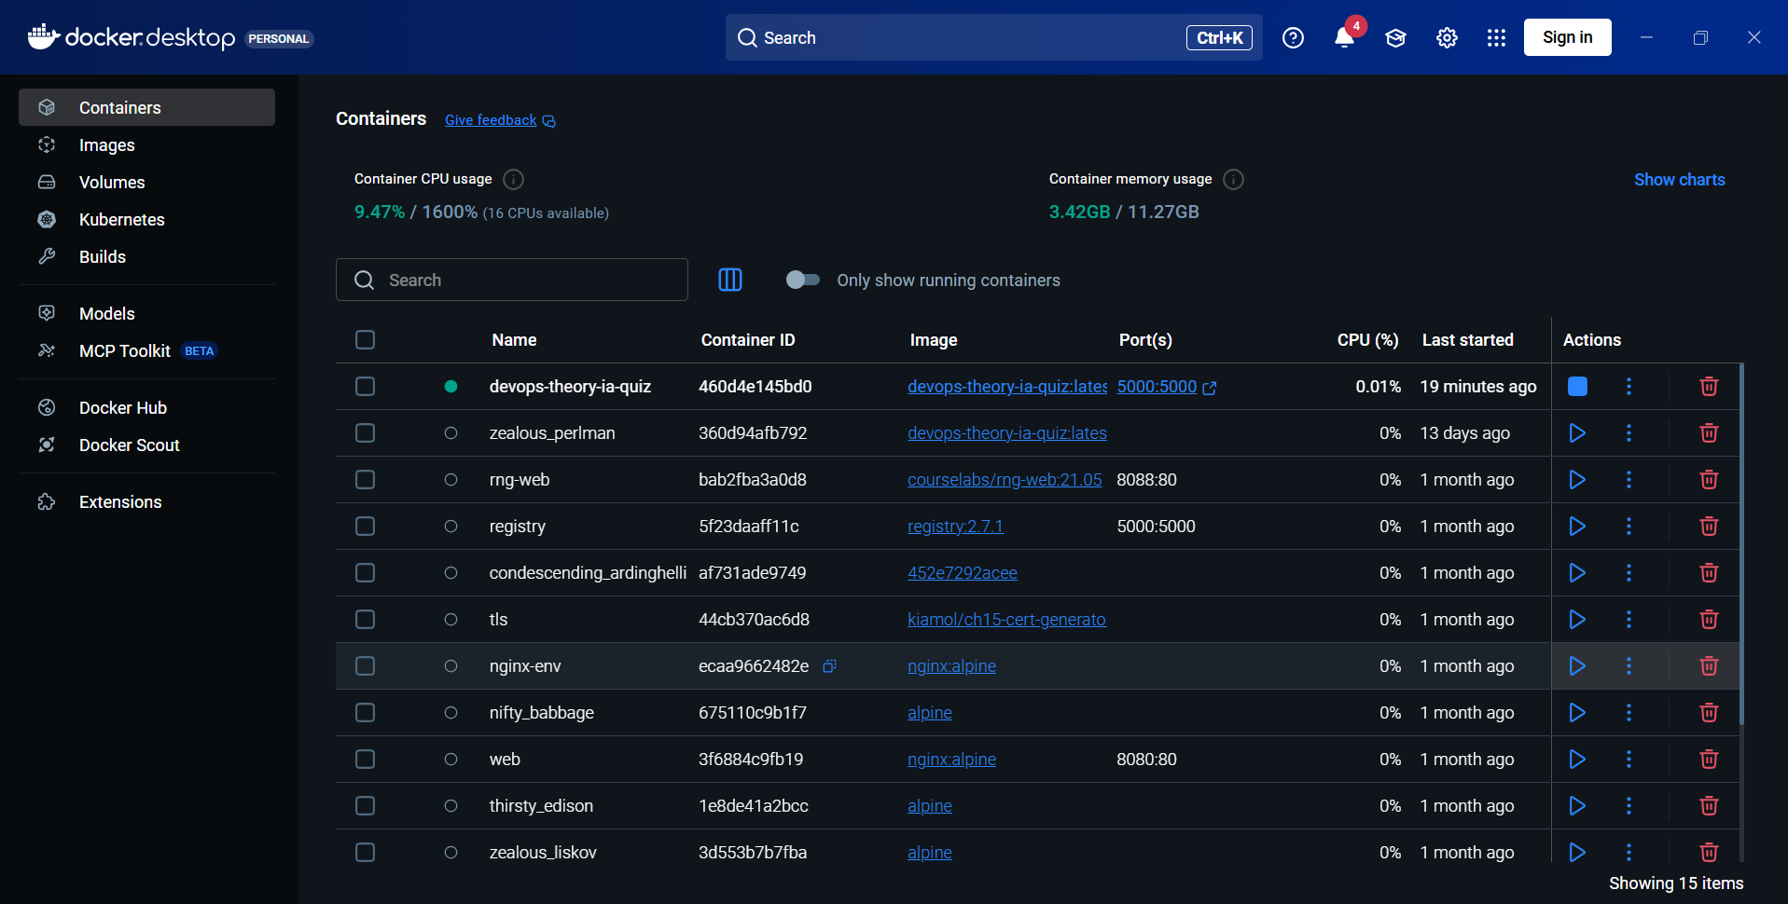
Figure 12. Docker Desktop showing the deployed devops-theory-ia-quiz container running on port 5000.

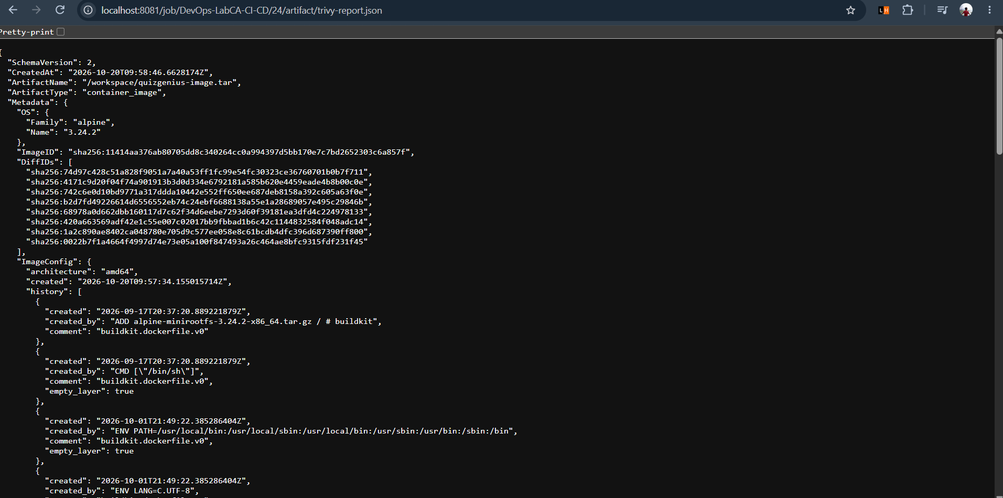
Figure 13. Archived Jenkins Trivy JSON report artifact identifying the Alpine image metadata.

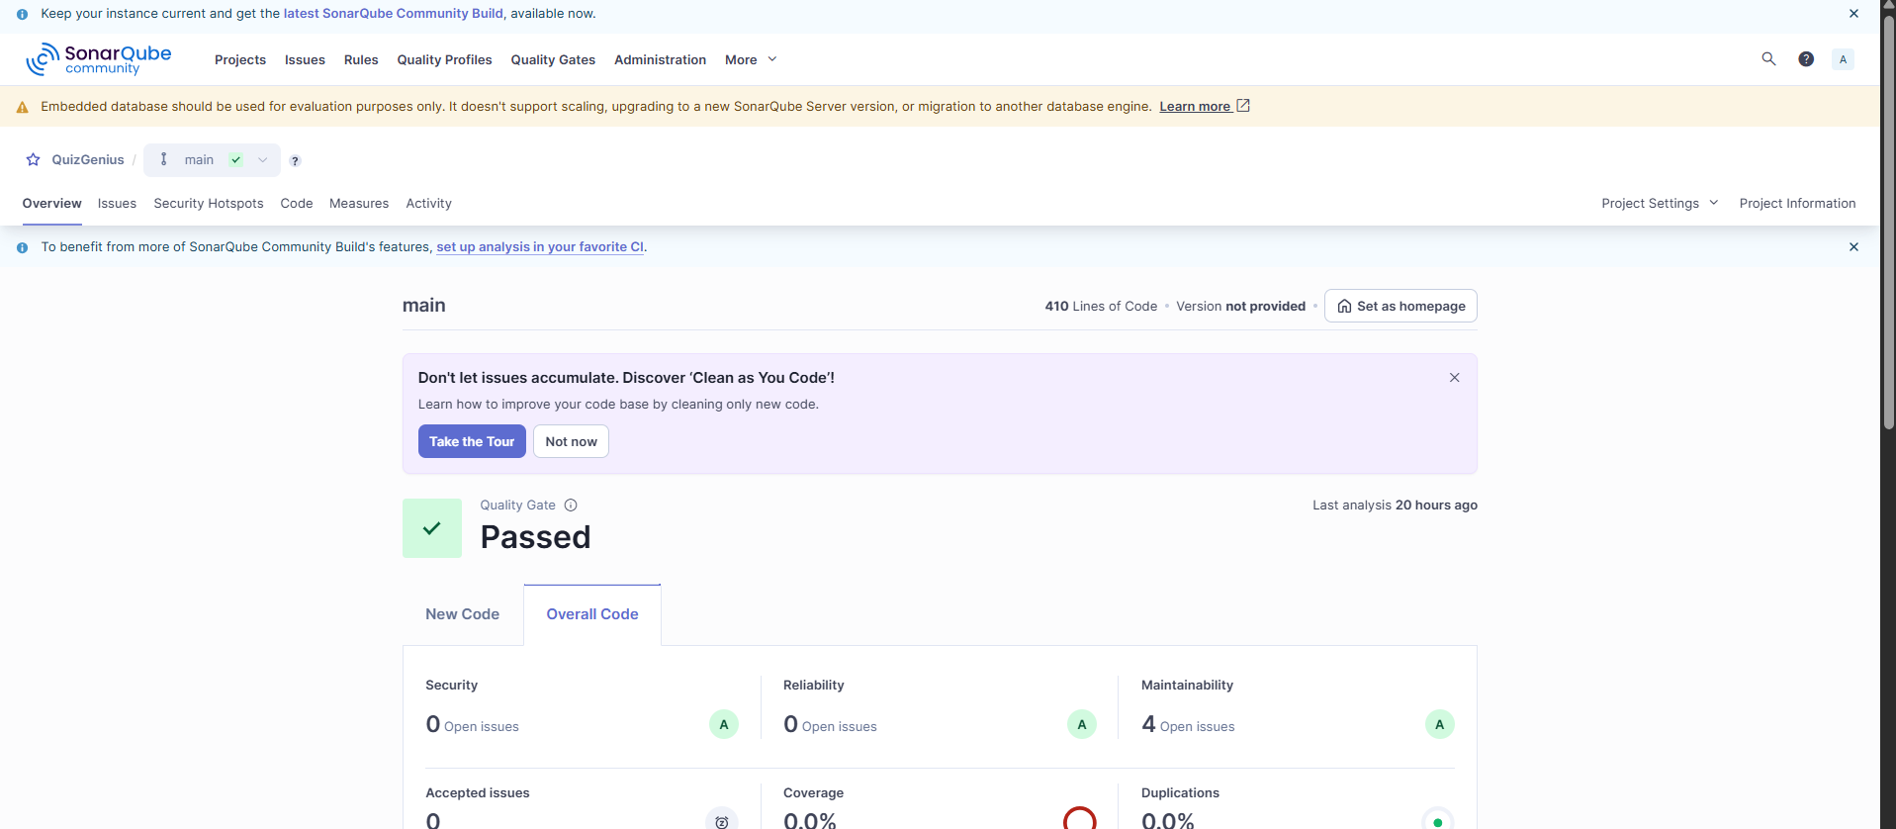
Figure 14. SonarQube project dashboard showing the quality gate passed.

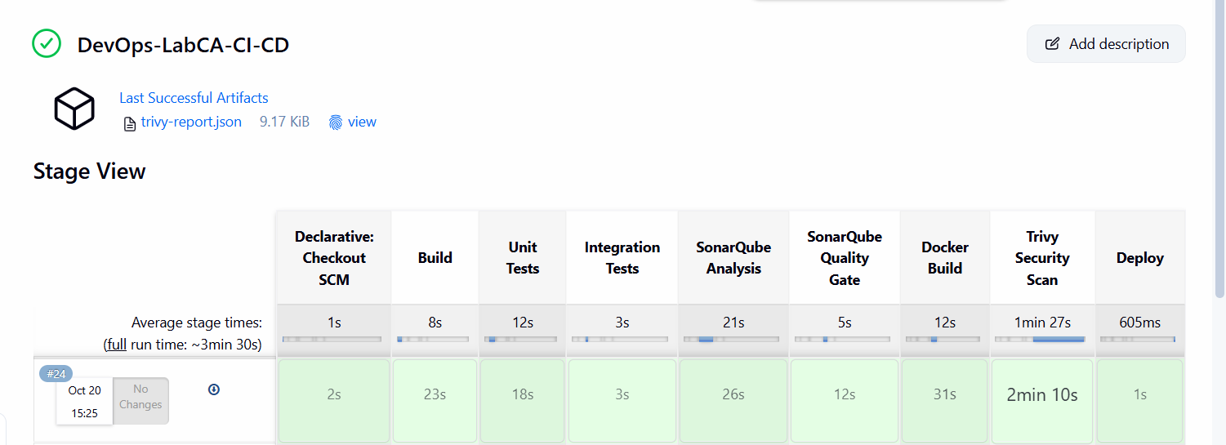
Figure 15. Classic Jenkins Stage View for build #24 with all nine stages visible.

Conclusion
The project demonstrates a gated CI CD workflow in which code quality, automated tests, container security, and deployment are connected in one Jenkins pipeline. The attached evidence shows the required nine Stage View entries, a passed SonarQube quality gate, a successful Trivy stage, and a running QuizGenius container. Before final submission, the certifi update should be committed and pushed, then a new Jenkins build should be captured to provide the latest Stage View evidence.

