Linux Homework Tasks
Akshat Kushwaha
DevOps — Linux Fundamentals
3 September 2026
────────────────────────────────────────────────────────────

Setup
Everything below was done on my own Ubuntu machine.
akshat@AK-work:~$ hostnamectl
Static hostname: AK-work
Icon name: computer-laptop
Chassis: laptop
Machine ID: 77bf962e465241da80b2f928003cfdc1
Boot ID: edb5d589e9cf4ab3af5c5949c36bbae5
Operating System: Ubuntu 22.04.5 LTS
Kernel: Linux 6.8.0-110-generic
Architecture: x86-64
Hardware Vendor: HP
Hardware Model: OMEN by HP Gaming Laptop 16-xd0xxx
akshat@AK-work:~$ df -T /
Filesystem Type 1K-blocks Used Available Use% Mounted on
/dev/nvme0n1p4 ext4 147163036 124942956 14671768 90% /
Root filesystem is ext4 on an NVMe partition, and my user is UID 1000. That matters for a couple of the link tests later.
────────────────────────────────────────────────────────────

Task 1: Soft Link & Hard Link

The difference
The thing that finally made this click for me is that a filename is not the file. The actual file is the inode — the data plus its metadata. A directory is just a table mapping names to inode numbers.
So a hard link is nothing more than a second row in that table pointing at the same inode. There is no original and no copy. Both names are equally real, and the kernel keeps a count of how many names point at the inode. Delete one name, the count drops by one. The data is only freed when the count hits zero.
A soft link (symlink) is a completely different animal. It is its own file, with its own inode, and the "contents" of that file are just a string — the path of the thing it points at. The kernel follows that string every time you touch the link. If whatever the string names goes away, the link is still sitting there, it just points at nothing.
 | Hard link | Soft link (symlink)
What it actually is | Another name for the same inode | A separate file containing a path string
Inode | Shared with the target | Its own
Command | ln target link | ln -s target link
Across filesystems | Not possible | Fine
Point at a directory | Not allowed | Fine
Target gets deleted | Still works | Breaks (dangling)
Type in ls -l | -, looks like any file | l, shows link -> target
Size shown | The file's size | Number of characters in the target path
Link count column | Goes up with each link | Target's count unchanged
Permissions | Same inode, so identical | Always lrwxrwxrwx; the target's perms are what apply

Commands
ln target link # hard link
ln -s target link # soft link
ln -sf target link # replace an existing link
ln -sfn target dir # -n so it doesn't get created *inside* an existing symlinked dir
ln -sr target link # make the symlink relative instead of absolute
For looking at them:
ls -li # -i shows inode numbers, which is how you prove a hard link
stat file # inode + link count in one place
readlink link # the raw string stored in the symlink
readlink -f link # follow it all the way to the real file
find . -xtype l # broken symlinks
find . -samefile f # every hard link to the same inode

Practice
Starting clean:
akshat@AK-work:~$ mkdir -p ~/linkdemo && cd ~/linkdemo
akshat@AK-work:~/linkdemo$ echo "Hello DevOps" > original.txt
akshat@AK-work:~/linkdemo$ ls -li
total 4
5112884 -rw-rw-r-- 1 akshat akshat 13 Sep 3 15:44 original.txt
One file, inode 5112884, link count 1. Now both kinds of link:
akshat@AK-work:~/linkdemo$ ln original.txt hardlink.txt
akshat@AK-work:~/linkdemo$ ln -s original.txt softlink.txt
akshat@AK-work:~/linkdemo$ ls -li
total 8
5112884 -rw-rw-r-- 2 akshat akshat 13 Sep 3 15:44 hardlink.txt
5112884 -rw-rw-r-- 2 akshat akshat 13 Sep 3 15:44 original.txt
5112888 lrwxrwxrwx 1 akshat akshat 12 Sep 3 15:44 softlink.txt -> original.txt
This one listing shows basically everything:
- original.txt and hardlink.txt both say 5112884 and both say 2. Same inode, two names, count went from 1 to 2.
- softlink.txt has its own inode 5112888, type l, count 1.
- The symlink's size is 12. original.txt is 12 characters. That is not a coincidence, that string is the file.
stat says the same thing more explicitly:
akshat@AK-work:~/linkdemo$ stat original.txt
File: original.txt
Size: 13 Blocks: 8 IO Block: 4096 regular file
Device: 10304h/66308d Inode: 5112884 Links: 2
Access: (0664/-rw-rw-r--) Uid: ( 1000/ akshat) Gid: ( 1000/ akshat)
Access: 2026-09-03 15:44:08.153970203 +0530
Modify: 2026-09-03 15:44:08.153970203 +0530
Change: 2026-09-03 15:44:08.159970474 +0530
Birth: 2026-09-03 15:44:08.153970203 +0530
Small thing I noticed: Change is later than Modify. I never touched the contents, but adding the hard link changed the inode's metadata (the link count), and ctime tracks that.
akshat@AK-work:~/linkdemo$ readlink softlink.txt
original.txt
akshat@AK-work:~/linkdemo$ readlink -f softlink.txt
/home/akshat/linkdemo/original.txt
akshat@AK-work:~/linkdemo$ find . -samefile original.txt
./original.txt
./hardlink.txt
Writing through one name shows up in the others, because there is only one file:
akshat@AK-work:~/linkdemo$ echo "Added via hard link" >> hardlink.txt
akshat@AK-work:~/linkdemo$ cat original.txt
Hello DevOps
Added via hard link
akshat@AK-work:~/linkdemo$ cat softlink.txt
Hello DevOps
Added via hard link

Deleting the target
This is the part worth remembering, and it is where the two stop looking alike.
akshat@AK-work:~/linkdemo$ rm original.txt
akshat@AK-work:~/linkdemo$ cat hardlink.txt
Hello DevOps
Added via hard link
akshat@AK-work:~/linkdemo$ cat softlink.txt
cat: softlink.txt: No such file or directory
The hard link still has the data. The symlink is pointing at a name that no longer exists, so it fails, and the error is about softlink.txt even though the missing thing is original.txt, which is a bit confusing the first time you see it.
akshat@AK-work:~/linkdemo$ ls -li
total 4
5112884 -rw-rw-r-- 1 akshat akshat 33 Sep 3 15:44 hardlink.txt
5112888 lrwxrwxrwx 1 akshat akshat 12 Sep 3 15:44 softlink.txt -> original.txt
akshat@AK-work:~/linkdemo$ find . -xtype l
./softlink.txt
Link count on the surviving file dropped back to 1. In a colour terminal the dead symlink shows up in flashing red, which is a useful tell.

The two things you cannot do with a hard link
Tried both, mostly to see the actual error messages.
Cross-filesystem — /dev/shm is tmpfs so it is definitely a different filesystem from my home:
akshat@AK-work:~/linkdemo$ ln hardlink.txt /dev/shm/test.txt
ln: failed to create hard link '/dev/shm/test.txt' => 'hardlink.txt': Invalid cross-device link
Makes sense once you know a directory entry stores an inode number. That number means nothing on a different filesystem. A symlink stores a path, which is why the same thing works fine:
akshat@AK-work:~/linkdemo$ ln -s ~/linkdemo/hardlink.txt /dev/shm/test.txt
akshat@AK-work:~/linkdemo$ ls -l /dev/shm/test.txt
lrwxrwxrwx 1 akshat akshat 34 Sep 3 15:44 /dev/shm/test.txt -> /home/akshat/linkdemo/hardlink.txt
And directories:
akshat@AK-work:~/linkdemo$ ln ~/linkdemo ~/dirlink
ln: /home/akshat/linkdemo: hard link not allowed for directory
Even with sudo. The reason is that it would let you build loops in the directory tree, and then anything that walks the tree (find, du, fsck) can go round forever.

Cleaning up
akshat@AK-work:~/linkdemo$ rm softlink.txt # removes the link only
akshat@AK-work:~/linkdemo$ unlink hardlink.txt # unlink works too
akshat@AK-work:~/linkdemo$ rm /dev/shm/test.txt
akshat@AK-work:~/linkdemo$ cd ~ && rmdir linkdemo
One trap worth writing down: if linkdir is a symlink to a directory, rm linkdir removes the link, but rm linkdir/ with the trailing slash does not do what you want. Tab completion adds that slash for you, so it is easy to hit by accident.

Interview prep
Notes to myself, since this comes up constantly.
Difference in one line?
Hard link = another name for the same inode. Soft link = a small file holding the path of another file, resolved when you access it.
Why can't a hard link cross filesystems?
Directory entries store inode numbers, and inode numbers are only unique within one filesystem. Symlinks store a path string, so they don't care.
Why can't you hard link a directory?
It would allow cycles in the tree, which breaks tree traversal and makes the link counting for . and .. unsound. The kernel refuses it outright.
Delete the original — what happens?
Hard link keeps working, data survives until the link count is zero. Soft link goes dangling.
Why is a symlink's size 12 or 31 or whatever?
That is the length of the path it stores. Its content is the path.
How do you prove two files are hard links?
ls -li and compare inode numbers, or stat both, or find . -samefile x. Same inode on the same device means the same file.
Where does this actually come up at work?
- systemctl enable literally just creates a symlink under /etc/systemd/system/*.wants/.
- /etc/nginx/sites-enabled/* are symlinks into sites-available.
- /etc/alternatives is how Ubuntu switches java/python versions.
- Deploys: ln -sfn /opt/app/releases/v2 /opt/app/current flips the live version in one step, and rolling back is the same command pointing at the old release.
- rsync --link-dest and cp -al use hard links so daily snapshots share unchanged files instead of duplicating them.
Does a hard link use extra disk space?
No, that is the whole point. One copy of the data, several names. Only the directory entry costs anything.
Relative or absolute symlink?
Relative (ln -sr) survives the tree being moved or mounted somewhere else, which matters in containers and when you mount a broken system under /mnt to fix it. Absolute is easier to read but breaks on relocation.
────────────────────────────────────────────────────────────

Task 2: adduser vs useradd

The difference
Both exist on Ubuntu and they are not two versions of the same thing. Easiest way to see it:
akshat@AK-work:~$ which adduser useradd
/usr/sbin/adduser
/usr/sbin/useradd
akshat@AK-work:~$ file /usr/sbin/adduser /usr/sbin/useradd
/usr/sbin/adduser: Perl script text executable
/usr/sbin/useradd: ELF 64-bit LSB pie executable, x86-64, version 1 (SYSV), dynamically linked, interpreter /lib64/ld-linux-x86-64.so.2, BuildID[sha1]=009a7493ec62a93a5f688198d1b34667cccb1a7b, for GNU/Linux 3.2.0, stripped
useradd is a compiled binary. adduser is a Perl script, and if you read it, it shells out to useradd. Different packages too:
akshat@AK-work:~$ dpkg -S /usr/sbin/adduser /usr/sbin/useradd
adduser: /usr/sbin/adduser
passwd: /usr/sbin/useradd
So useradd is the low-level tool from shadow, and adduser is Debian's friendly wrapper around it. You can just read the wrapper, which is 1150 lines of Perl:
akshat@AK-work:~$ head -4 /usr/sbin/adduser
#!/usr/bin/perl
# adduser: a utility to add users to the system
# addgroup: a utility to add groups to the system
akshat@AK-work:~$ wc -l /usr/sbin/adduser
1150 /usr/sbin/adduser
And the different default shells the table below mentions are not folklore, they are literally two different config files:
akshat@AK-work:~$ grep -E "^(DHOME|DSHELL|SHELL)" /etc/adduser.conf /etc/default/useradd
/etc/adduser.conf:DSHELL=/bin/bash
/etc/adduser.conf:DHOME=/home
/etc/default/useradd:SHELL=/bin/sh
 | useradd | adduser
What it is | Compiled binary from the passwd/shadow package | Perl script that wraps useradd
Where it exists | Every distro | Debian/Ubuntu. On RHEL, adduser is just a symlink to useradd
Interactive | No, does exactly what the flags say | Yes, prompts for password and details
Home directory | Not created unless you pass -m | Always created
/etc/skel dotfiles | Only with -m | Copied automatically
Password | Left locked, needs a separate passwd | Prompts and sets it
Default shell | /bin/sh, from /etc/default/useradd | /bin/bash, from /etc/adduser.conf
Matching group | Created by default (suppress with -N) | Same, plus any EXTRA_GROUPS from its config
Config it reads | /etc/default/useradd, /etc/login.defs | /etc/adduser.conf
Good for | Scripts, Dockerfiles, Ansible, cloud-init | A human adding a real account by hand

Which one to use on Ubuntu
For adding a normal user by hand on Ubuntu, `adduser` is the one to reach for. It is what the Debian and Ubuntu docs point you at, and the reason is simply that it finishes the job. Home directory, skel files, a usable shell, matching group, password set — all in one command. Bare useradd on Ubuntu leaves you with an account that has no home, no password and /bin/sh, and then you spend ten minutes wondering why the login is broken. I ran both below so the difference is on the page rather than taken on trust.
The flip side is that `useradd` is the right one in automation. Three reasons:
- It exists everywhere. RHEL, Amazon Linux, SUSE, and busybox on Alpine all have useradd. A playbook or Dockerfile written against it runs anywhere; one written against adduser doesn't.
- It never prompts, so there is no interactive stdin to fight with in a script or an image build.
- Every attribute is explicit in the flags, so the result is reproducible instead of depending on whatever is in /etc/adduser.conf on that box.
Short version: person at a keyboard → `adduser`. Script → `useradd` with explicit flags.
Ansible's user module, for what it's worth, drives useradd underneath.

Creating the test user
I did this in a throwaway ubuntu:22.04 container rather than on the laptop itself. Same distribution, same adduser and useradd binaries from the same packages, but nothing left behind on my own machine when I am finished — creating and deleting real accounts on a working machine to prove a point is a bad habit to get into.
akshat@AK-work:~$ docker run -d --name usertest ubuntu:22.04 sleep 400
akshat@AK-work:~$ docker exec usertest bash -c 'cat /etc/os-release | head -2; which adduser useradd'
PRETTY_NAME="Ubuntu 22.04.5 LTS"
NAME="Ubuntu"
/usr/sbin/adduser
/usr/sbin/useradd
Same 22.04.5 as the host, so the defaults are the ones that matter.
adduser is the recommended command, and it is interactive:
root@usertest:/# adduser devops_test
Adding user `devops_test' ...
Adding new group `devops_test' (1000) ...
Adding new user `devops_test' (1000) with group `devops_test' ...
Creating home directory `/home/devops_test' ...
Copying files from `/etc/skel' ...
New password:
Retype new password:
passwd: password updated successfully
Changing the user information for devops_test
Enter the new value, or press ENTER for the default
Full Name []: DevOps Test User
Room Number []:
Work Phone []:
Home Phone []:
Other []:
Is the information correct? [Y/n] Y
Five distinct jobs in that one command: it made the group, made the user, created the home directory, copied /etc/skel into it, and set a password. The GECOS prompts at the end are all optional — Enter skips them.
Checking what it actually built:
root@usertest:/# id devops_test
uid=1000(devops_test) gid=1000(devops_test) groups=1000(devops_test)
root@usertest:/# getent passwd devops_test
devops_test:x:1000:1000:DevOps Test User,,,:/home/devops_test:/bin/bash
root@usertest:/# ls -la /home/devops_test
total 20
drwxr-x--- 2 devops_test devops_test 4096 Sep 3 11:16 .
drwxr-xr-x 1 root root 4096 Sep 3 11:16 ..
-rw-r--r-- 1 devops_test devops_test 220 Sep 3 11:16 .bash_logout
-rw-r--r-- 1 devops_test devops_test 3771 Sep 3 11:16 .bashrc
-rw-r--r-- 1 devops_test devops_test 807 Sep 3 11:16 .profile
root@usertest:/# passwd -S devops_test
devops_test P 09/03/2026 0 99999 7 -1
root@usertest:/# getent group devops_test
devops_test:x:1000:
Four things to read out of that:
- The shell is `/bin/bash`.
- The home directory mode is `drwxr-x---`, i.e. 0750 — group-readable, not world-readable.
- The three dotfiles came straight from /etc/skel.
- passwd -S reports `P`, meaning a usable password is set.
None of those are accidents. They come from /etc/adduser.conf:
root@usertest:/# grep -E "^(DSHELL|DHOME|DIR_MODE)" /etc/adduser.conf
DSHELL=/bin/bash
DHOME=/home
DIR_MODE=0750
And logging in works:
root@usertest:/# su - devops_test -c "pwd; whoami; echo \$SHELL"
/home/devops_test
devops_test
/bin/bash
Landed in the right home directory, as the right user, with the right shell.
If the account needed admin rights:
root@usertest:/# usermod -aG sudo devops_test
root@usertest:/# id devops_test
uid=1000(devops_test) gid=1000(devops_test) groups=1000(devops_test),27(sudo)
The -a is not optional. usermod -G sudo devops_test without it would replace the user's supplementary groups rather than add to them, which is a genuinely nasty way to lock someone out of things.

What plain useradd does instead
The contrast is the whole point of this task, so the same thing with no flags at all:
root@usertest:/# useradd useradd_test
root@usertest:/# getent passwd useradd_test
useradd_test:x:1001:1001::/home/useradd_test:/bin/sh
root@usertest:/# ls -ld /home/useradd_test
ls: cannot access '/home/useradd_test': No such file or directory
root@usertest:/# passwd -S useradd_test
useradd_test L 09/03/2026 0 99999 7 -1
Three problems in one command, and they line up exactly with the config files:
- The passwd entry claims a home at /home/useradd_test that was never created. useradd only creates it with -m.
- The shell is `/bin/sh`, which is dash on Ubuntu — no history, no tab completion, no prompt customisation. That comes from /etc/default/useradd:
root@usertest:/# grep -E "^SHELL" /etc/default/useradd
SHELL=/bin/sh
- The password status is `L`, locked. The account cannot log in at all.
The consequence is visible immediately:
root@usertest:/# su - useradd_test -c "pwd; whoami"
su: warning: cannot change directory to /home/useradd_test: No such file or directory
/
useradd_test
The user exists, but they are dumped in / with a warning, on a dash shell, with a locked password. That is the account you get from bare useradd on Ubuntu, and it is exactly why adduser is the one to reach for when adding a person by hand.
The useradd form that actually works, which is what belongs in a script or a Dockerfile:
useradd -m -d /home/devops_test -s /bin/bash -c "DevOps Test User" devops_test
passwd devops_test
-m create the home directory and copy skel, -d where it goes, -s login shell, -c the comment/GECOS field.
That automation argument is not hypothetical — the multi-stage Dockerfile in Assignment 6 uses exactly this pattern:
RUN adduser -D -u 10001 appuser
and docker exec hello-multistage id returns uid=10001(appuser) gid=10001(appuser). That is busybox's adduser inside Alpine rather than Debian's Perl one, and -D means "no password". Same principle: explicit flags, no prompts, reproducible every build.

Cleanup
root@usertest:/# deluser --remove-home devops_test
/usr/sbin/deluser: In order to use the --remove-home, --remove-all-files, and --backup features,
you need to install the `perl' package. To accomplish that, run
apt-get install perl.
Worth knowing: deluser is a Perl script, and the ubuntu:22.04 base image is stripped down far enough that Perl is not installed. adduser itself works because it degrades gracefully; --remove-home does not. After apt-get install -y perl:
root@usertest:/# deluser --remove-home devops_test
Looking for files to backup/remove ...
Removing files ...
Removing user `devops_test' ...
Warning: group `devops_test' has no more members.
Done.
root@usertest:/# userdel -r useradd_test
userdel: useradd_test mail spool (/var/mail/useradd_test) not found
userdel: useradd_test home directory (/home/useradd_test) not found
root@usertest:/# getent passwd devops_test useradd_test; echo "exit status: $?"
exit status: 2
root@usertest:/# ls /home
userdel -r complained about the missing home directory and mail spool, which tracks with useradd never having created either. Empty output from getent and exit status 2 means neither account exists any more, and /home is empty.
Then the container itself goes away:
akshat@AK-work:~$ docker rm -f usertest
usertest
────────────────────────────────────────────────────────────

Task 3: journalctl

What it is for
On anything running systemd, which is Ubuntu since 16.04, there is a daemon called systemd-journald that collects log data from more or less everywhere:
- the kernel ring buffer, the same stuff dmesg shows
- early boot and initrd, before any normal logging exists
- stdout and stderr of every service systemd starts, so an application that just prints to the console still gets logged properly
- the classic syslog socket
- structured messages sent through the journal API, and anything piped through systemd-cat
- audit records
It writes all of that into an indexed binary format, and every single entry carries structured metadata: which unit produced it, PID, UID, which boot, the executable path, priority, timestamps. journalctl is the tool for reading it back. You need it because the journal files are binary, so cat and grep are no help.
The practical reason to like it over digging through /var/log: you can filter on that metadata instead of grepping one enormous merged text file. "Errors only, from this service, since an hour ago" is one command rather than a pipeline of greps. Rotation and size limits are handled for you. And the metadata is recorded by journald, not written by the application, so a program cannot lie about which unit it was or what its PID was.
One thing that caught me out: if /var/log/journal/ doesn't exist, the journal lives in /run and is wiped on every reboot, so journalctl -b -1 gives you nothing. Making it persistent:
sudo mkdir -p /var/log/journal
sudo systemd-tmpfiles --create --prefix /var/log/journal
sudo systemctl restart systemd-journald
Mine was already persistent:
akshat@AK-work:~$ journalctl --disk-usage
Archived and active journals take up 3.9G in the file system.
3.9G is a lot — this machine has months of boots retained. That is what --vacuum-time and --vacuum-size in the housekeeping section below are for.

Reading logs
The basics:
journalctl # everything, oldest first, in a pager
journalctl -e # jump to the newest
journalctl -r # newest first
journalctl -n 50 # last 50 entries
journalctl -f # follow live, like tail -f
journalctl --no-pager # plain output for scripts and redirection
By unit, which is what I use 90% of the time:
journalctl -u docker.service
journalctl -u docker -u containerd # several units, interleaved by time
journalctl -u docker -f
journalctl -u docker --since today
By boot:
journalctl -b # this boot only
journalctl -b -1 # the previous boot, for working out why it rebooted
journalctl --list-boots
journalctl -k # kernel only, same as dmesg
akshat@AK-work:~$ journalctl --list-boots | tail -5
-4 1de81363723742a9aeb7abb3bfbdc004 Wed 2026-04-15 19:03:59 IST—Wed 2026-04-15 13:35:40 IST
-3 c45e0c0dcae64475a9bd80fe51eb8ce8 Sat 2026-04-25 23:30:52 IST—Sat 2026-04-25 18:08:26 IST
-2 2810c961fc064f08a963edc3caf7a3be Sat 2026-04-25 18:15:30 IST—Sun 2026-04-26 12:22:13 IST
-1 00ede7a4f99e4ad5b22a519a8a5a816c Thu 2026-09-03 14:50:22 IST—Thu 2026-09-03 15:23:53 IST
0 edb5d589e9cf4ab3af5c5949c36bbae5 Thu 2026-09-03 15:24:57 IST—Thu 2026-09-03 15:45:22 IST
Piped through tail because there are 41 boots on this machine. Boot 0 is always the current one, and the ID edb5d589... matches what hostnamectl printed at the top.
A detail worth noticing: on a couple of rows the "last entry" is earlier than the "first entry" (-4 and -3). That is not corruption — it is the clock being corrected by NTP part-way through the boot, so entries written before the correction carry a later timestamp than ones written after it.
By priority. These are the syslog levels, 0 emerg through 7 debug:
akshat@AK-work:~$ journalctl -p err -b --no-pager | tail -6
Sep 03 15:29:21 AK-work wpa_supplicant[906]: bgscan simple: Failed to enable signal strength monitoring
Sep 03 15:29:39 AK-work wpa_supplicant[906]: bgscan simple: Failed to enable signal strength monitoring
Sep 03 15:34:46 AK-work systemd[1]: Failed to start Process error reports when automatic reporting is enabled.
Sep 03 15:43:44 AK-work sudo[24822]: pam_unix(sudo:auth): conversation failed
Sep 03 15:43:44 AK-work sudo[24822]: pam_unix(sudo:auth): auth could not identify password for [akshat]
Sep 03 15:43:44 AK-work sudo[24822]: akshat : a password is required ; PWD=/home/akshat/Downloads/DevOps ; USER=root ; COMMAND=/usr/bin/true
The wpa_supplicant and apport lines are ordinary laptop noise. The three sudo lines at the end are me running sudo -n true from a non-interactive shell to check whether passwordless sudo was configured — it is not, so PAM refused. That is a good illustration of the point: journald records the security-relevant metadata itself (PWD, USER, COMMAND), so the log tells you exactly what was attempted and from where, and the process being logged has no say in it.
journalctl -p err -b is the first thing I'd run on a machine that is misbehaving, because it cuts thousands of lines down to a handful.
By time:
journalctl --since "2026-09-02 20:00:00" --until "2026-09-02 21:00:00"
journalctl --since yesterday
journalctl --since "1 hour ago"
journalctl --since "-15min" -p err
By other metadata, which is the part that has no equivalent in plain text logs:
journalctl _PID=1893
journalctl _UID=1000
journalctl /usr/sbin/sshd # by executable path
journalctl _COMM=sshd
journalctl -t sudo # by syslog tag
journalctl --user -u myapp # user units rather than system ones
journalctl -F _SYSTEMD_UNIT # list every unit that has ever logged
Output formats:
journalctl -u docker -o short-iso # ISO-8601 timestamps
journalctl -u docker -o verbose # every metadata field
journalctl -u docker -o json-pretty # structured, for shipping to Loki/ELK
journalctl -u docker -o cat # message text only
journalctl -xe # -x adds catalog explanations, -e jumps to the end
Housekeeping:
journalctl --disk-usage
sudo journalctl --vacuum-time=7d
sudo journalctl --vacuum-size=500M
journalctl --verify

Checking logs for a specific service
The obvious choice would have been ssh, but this machine has no openssh-server installed:
akshat@AK-work:~$ systemctl status ssh --no-pager
Unit ssh.service could not be found.
So I used docker.service instead, which is running here and is more relevant to the rest of the module anyway.
akshat@AK-work:~$ systemctl status docker --no-pager
● docker.service - Docker Application Container Engine
Loaded: loaded (/lib/systemd/system/docker.service; enabled; vendor preset: enabled)
Active: active (running) since Thu 2026-09-03 15:26:02 IST; 19min ago
TriggeredBy: ● docker.socket
Docs: https://docs.docker.com
Main PID: 6929 (dockerd)
Tasks: 18
Memory: 94.6M
CPU: 530ms
CGroup: /system.slice/docker.service
└─6929 /usr/bin/dockerd -H fd:// --containerd=/run/containerd/containerd.sock
Sep 03 15:26:02 AK-work dockerd[6929]: time="2026-09-03T15:26:02.511848564+05:30" level=info msg="Loading containers: done."
Sep 03 15:26:02 AK-work dockerd[6929]: time="2026-09-03T15:26:02.537467864+05:30" level=info msg="Docker daemon" commit="28.2.2-0ubuntu1~22.04.1" containerd-snapshotter=false storage-driver=overlay2 version=28.2.2
Sep 03 15:26:02 AK-work dockerd[6929]: time="2026-09-03T15:26:02.571258276+05:30" level=info msg="Daemon has completed initialization"
Sep 03 15:26:02 AK-work dockerd[6929]: time="2026-09-03T15:26:02.571294674+05:30" level=info msg="API listen on /run/docker.sock"
Sep 03 15:26:02 AK-work systemd[1]: Started Docker Application Container Engine.
Three useful things in that one screen: Loaded: shows the unit file path and that it is enabled (starts at boot); Active: gives the state and how long it has held it; Main PID and CGroup show the actual processes, and TriggeredBy shows it is socket-activated. Then the last ten log lines are appended for free — that is systemctl status reading the journal for you.
The last full stop/start cycle, which is what you would look at after a restart:
akshat@AK-work:~$ journalctl -u docker.service --since today --no-pager
Sep 03 15:22:23 AK-work systemd[1]: Stopping Docker Application Container Engine...
Sep 03 15:22:23 AK-work dockerd[2276]: time="2026-09-03T15:22:23.654537085+05:30" level=info msg="Processing signal 'terminated'"
Sep 03 15:22:23 AK-work dockerd[2276]: time="2026-09-03T15:22:23.660820337+05:30" level=info msg="Daemon shutdown complete"
...
Sep 03 15:26:02 AK-work systemd[1]: Starting Docker Application Container Engine...
Sep 03 15:26:02 AK-work dockerd[6929]: time="2026-09-03T15:26:02.511848564+05:30" level=info msg="Loading containers: done."
Sep 03 15:26:02 AK-work dockerd[6929]: time="2026-09-03T15:26:02.571294674+05:30" level=info msg="API listen on /run/docker.sock"
Sep 03 15:26:02 AK-work systemd[1]: Started Docker Application Container Engine.
You can read the whole cycle in order, and the PID changes from 2276 to 6929 — the shutdown lines are tagged dockerd[2276], the startup lines dockerd[6929]. Processing signal 'terminated' is SIGTERM, systemd asking it to stop politely rather than killing it.
Filtering to just this service's errors for today:
akshat@AK-work:~$ journalctl -u docker.service -p err --since today --no-pager
-- No entries --
Nothing, which is the answer you want.
Searching within one service, using -g:
akshat@AK-work:~$ journalctl -u docker.service -g "Daemon has completed" --since today --no-pager
Sep 03 20:19:54 AK-work dockerd[2276]: time="2026-09-03T20:19:54.394651398+05:30" level=info msg="Daemon has completed initialization"
-- Boot edb5d589e9cf4ab3af5c5949c36bbae5 --
Sep 03 15:26:02 AK-work dockerd[6929]: time="2026-09-03T15:26:02.571258276+05:30" level=info msg="Daemon has completed initialization"
Two hits, one per boot, and journalctl inserts a -- Boot <id> -- separator so you can see the reboot between them. Handy: "how many times has this daemon actually come up today" is a one-liner.
Full metadata for one entry, which shows how much is attached to a single log line:
akshat@AK-work:~$ journalctl -u docker.service -n 1 -o verbose --no-pager
Thu 2026-09-03 15:26:02.571475 IST [s=b64e8a94fcea492ab058673ba2294d62;i=f5b3;b=edb5d589e9cf4ab3af5c5949c36bbae5;m=3faca2e;t=65a9128dca8dc;x=5fa9c0408a991e28]
PRIORITY=6
SYSLOG_FACILITY=3
_TRANSPORT=journal
_MACHINE_ID=77bf962e465241da80b2f928003cfdc1
_HOSTNAME=AK-work
SYSLOG_IDENTIFIER=systemd
_PID=1
_UID=0
_GID=0
_COMM=systemd
_EXE=/usr/lib/systemd/systemd
_CMDLINE=/sbin/init splash
_CAP_EFFECTIVE=1ffffffffff
_SYSTEMD_UNIT=init.scope
CODE_FILE=src/core/job.c
CODE_LINE=713
CODE_FUNC=job_emit_done_message
JOB_TYPE=start
JOB_RESULT=done
UNIT=docker.service
_BOOT_ID=edb5d589e9cf4ab3af5c5949c36bbae5
INVOCATION_ID=3dda61c806f8462193a246a62cb6129c
MESSAGE=Started Docker Application Container Engine.
Worth pulling apart, because it explains why the journal is more than a text log:
- _SYSTEMD_UNIT=init.scope but UNIT=docker.service. The line was emitted by PID 1, and it is about docker.service. Fields with a leading underscore are trusted — journald attaches them from the sending process's credentials and the sender cannot forge them. Fields without are supplied by the sender.
- CODE_FILE, CODE_LINE, CODE_FUNC point at the exact line of systemd's own source that produced the message.
- INVOCATION_ID is unique to this particular start of the unit, so you can isolate one run even across many restarts.
- _CAP_EFFECTIVE=1ffffffffff is the full capability set, i.e. it really was root.
Following it live in one terminal while doing something in another. Here I ran journalctl -u docker.service -f, then in a second terminal docker run --rm alpine:3.20 echo "hello from a container":
akshat@AK-work:~$ journalctl -u docker.service -f
Sep 03 15:26:02 AK-work dockerd[6929]: time="2026-09-03T15:26:02.566957744+05:30" level=info msg="Completed buildkit initialization"
Sep 03 15:26:02 AK-work dockerd[6929]: time="2026-09-03T15:26:02.571258276+05:30" level=info msg="Daemon has completed initialization"
Sep 03 15:26:02 AK-work dockerd[6929]: time="2026-09-03T15:26:02.571294674+05:30" level=info msg="API listen on /run/docker.sock"
Sep 03 15:26:02 AK-work systemd[1]: Started Docker Application Container Engine.
^C
-f prints the tail and then blocks waiting for more. Nothing new arrived, which surprised me until I thought about it: a container's own stdout goes to Docker's logging driver, not to journald, so you read it with docker logs, not journalctl. journalctl -u docker.service only shows you the daemon's lifecycle. Good thing to have got wrong once.
Two more filters I tried, neither tied to a unit:
akshat@AK-work:~$ journalctl -t sudo -n 5 --no-pager
Sep 03 15:21:43 AK-work sudo[10648]: pam_unix(sudo:auth): conversation failed
Sep 03 15:21:43 AK-work sudo[10648]: pam_unix(sudo:auth): auth could not identify password for [akshat]
-- Boot edb5d589e9cf4ab3af5c5949c36bbae5 --
Sep 03 15:43:44 AK-work sudo[24822]: pam_unix(sudo:auth): conversation failed
Sep 03 15:43:44 AK-work sudo[24822]: pam_unix(sudo:auth): auth could not identify password for [akshat]
Sep 03 15:43:44 AK-work sudo[24822]: akshat : a password is required ; PWD=/home/akshat/Downloads/DevOps ; USER=root ; COMMAND=/usr/bin/true
akshat@AK-work:~$ journalctl -F _SYSTEMD_UNIT | head -12
whoopsie.service
snap.docker.nvidia-container-toolkit.service
me.proton.vpn.split_tunneling.service
apport-autoreport.service
secureboot-db.service
accounts-daemon.service
networkd-dispatcher.service
acpid.service
thermald.service
cron.service
snapd.apparmor.service
apparmor.service
-F lists every distinct value a field has ever taken. journalctl -F _SYSTEMD_UNIT is the fastest way to find out what a unit is actually called before you filter on it.

The routine I'll use when something won't start
systemctl status <service> # summary plus the last few lines
journalctl -xeu <service> # the detail, with explanations, at the end
journalctl -u <service> -b -p err # errors from this boot only
systemctl cat <service> # read the unit file that produced all this
journalctl -xeu name.service is the one to memorise. It answers "why did this fail" more often than anything else.
────────────────────────────────────────────────────────────

Task 4: Linux Command Cheat Sheet
Went through the sheet and practised the commands. Writing them out grouped by what they are for, since that is how I actually remember them, with notes on the ones that bit me.

Files and navigation
Command | What it does | Usage
pwd | Where am I | pwd
ls | List contents | ls -lah
cd | Change directory | cd /var/log, cd .., cd - for previous, cd alone for home
tree | Show the hierarchy | tree -L 2
mkdir | Make a directory | mkdir -p a/b/c creates parents too
rmdir | Remove an empty directory | rmdir olddir
touch | Create empty file, or bump its timestamp | touch file.txt
cp | Copy | cp -r src/ dst/, cp -a to preserve everything
mv | Move or rename, same command | mv old.txt new.txt
rm | Delete | rm file, rm -rf dir/
ln | Links | ln -s target link, ln target link
stat | Inode, timestamps, link count | stat file
file | What a file actually is | file /usr/sbin/adduser
basename / dirname | Split a path | basename /a/b/c.txt gives c.txt
realpath | Resolve to a real absolute path | realpath ./link

rm -rf has no undo and no confirmation. Habit worth building: run the ls first with the same path, and only then change ls to rm -rf.

Reading and editing
Command | What it does | Usage
cat | Print a file | cat file
tac | Print it backwards | tac file
less | Page through it, / searches, q quits | less /var/log/syslog
head | First lines | head -20 file
tail | Last lines | tail -50 file, tail -f app.log to follow
nano | Simple editor | nano file, Ctrl+O saves, Ctrl+X exits
vim | The other editor | vim file, i to type, Esc, :wq to save, :q! to bail out
wc | Count lines/words/bytes | wc -l file
diff | Compare two files | diff -u old new

less over cat for anything big. cat on a large log just floods the terminal.

Searching
Command | What it does | Usage
grep | Find text | grep -rin "error" /var/log
find | Find files by attributes | find /var -name "*.log" -mtime -1 -size +10M
locate | Fast name lookup from an index | sudo updatedb && locate nginx.conf
which / whereis | Where is this binary | which python3
xargs | Feed stdin in as arguments | `find . -name "*.tmp" -print0 \ | xargs -0 rm`

grep -r is recursive, -i ignores case, -n gives line numbers, -v inverts. find is picky about argument order: path first, then the tests.

Permissions
Command | What it does | Usage
chmod | Change permissions | chmod 644 file, chmod +x script.sh, chmod -R 750 dir/
chown | Change owner and group | sudo chown user:group file, -R for recursive
chgrp | Change group only | sudo chgrp devs file
umask | Default mask for new files | umask 022
getfacl / setfacl | Per-user ACLs when groups aren't enough | setfacl -m u:alice:rw file

The numbers are just r=4, w=2, x=1 added up, per owner/group/other. 755 is rwxr-xr-x, 644 is rw-r--r--, 600 is owner-only. SSH private keys have to be 600 or ssh refuses to use them.

Users and groups
Command | What it does | Usage
whoami / id | Who am I / full UID, GID, groups | id akshat
adduser | Add a user, interactive | sudo adduser devops_test
useradd | Add a user, scriptable | sudo useradd -m -s /bin/bash bob
passwd | Set or check a password | sudo passwd bob, passwd -S bob
usermod | Modify an account | sudo usermod -aG sudo bob
deluser / userdel | Remove a user | sudo deluser --remove-home bob
groupadd / groupdel | Add or remove a group | sudo groupadd devs
groups | What groups is someone in | groups bob
su | Become another user | su - bob, the dash gives a full login shell
sudo | Run one command as root | sudo systemctl restart nginx, sudo -i for a root shell
visudo | Edit sudoers safely, it syntax-checks | sudo visudo
last / w / who | Login history, who is on right now | last -10

Files behind all of this: /etc/passwd for accounts, /etc/shadow for password hashes, /etc/group, /etc/sudoers.
Never edit /etc/sudoers with a normal editor. A syntax error there and sudo stops working entirely, which locks you out of fixing it. visudo validates before saving.

Processes
Command | What it does | Usage
ps | Snapshot of processes | ps aux, `ps -ef \ | grep nginx`
top / htop | Live monitor | top, q quits
kill | Signal by PID | kill 1234, kill -9 1234 as a last resort
pkill / killall | Signal by name | pkill -f "python app.py"
pgrep | Find PIDs by name | pgrep -a sshd
jobs / fg / bg | Job control in the shell | jobs, fg %1
nohup | Survive logout | nohup ./run.sh &
nice / renice | Priority | nice -n 10 ./batch.sh
lsof | What has this file or port open | sudo lsof -i :8080
strace | Trace syscalls when nothing else explains it | strace -p 1234

kill sends SIGTERM, which asks nicely and lets the process clean up. kill -9 is SIGKILL and cannot be caught, so buffers don't flush and temp files don't get removed. Try plain kill first.

System info
Command | What it does | Usage
uname | Kernel info | uname -a
hostnamectl | Hostname, OS, kernel, virtualisation | hostnamectl
lsb_release | Distro version | lsb_release -a, or cat /etc/os-release
uptime | How long up, load average | uptime
free | Memory | free -h
vmstat / iostat | CPU, memory, IO stats | vmstat 1 5
lscpu / lsblk / lsusb / lspci | CPU / disks / USB / PCI | lsblk -f
timedatectl | Time and timezone | timedatectl set-timezone Asia/Kolkata
env / export | Environment variables | export PATH=$PATH:/opt/bin
history | What I ran before | `history \ | grep ssh, !123` reruns line 123

Load average from uptime is three numbers: 1, 5 and 15 minute averages. Compare against your core count, not against 1.0.

Disk
Command | What it does | Usage
df | Free space per filesystem | df -hT
du | Space used by directories | du -sh *, `du -h --max-depth=1 /var \ | sort -h`
mount / umount | Attach or detach a filesystem | sudo mount /dev/sdb1 /mnt
fdisk / parted | Partitions | sudo fdisk -l
mkfs | Make a filesystem | sudo mkfs.ext4 /dev/sdb1
fsck | Check and repair | sudo fsck /dev/sdb1, unmounted only
blkid | UUIDs of block devices | sudo blkid

"Disk full" that df shows but du cannot explain usually means a deleted file still held open by a process. sudo lsof +L1 finds it, and restarting that process frees the space.
Use UUIDs in /etc/fstab, not /dev/sdb1. Device names can move between boots; UUIDs don't.

Networking
Command | What it does | Usage
ip | Addresses, links, routes | ip a, ip r, ip link set eth0 up
ping | Is it reachable | ping -c 4 8.8.8.8
curl | HTTP client | curl -I https://example.com, curl -fsSL url -o file
wget | Download | wget https://example.com/file.tar.gz
ss | Open sockets and ports | ss -tulpn
dig / nslookup | DNS | dig +short example.com
traceroute / mtr | Path to a host | mtr 8.8.8.8
ssh | Remote login | ssh -i key.pem ubuntu@1.2.3.4
scp | Copy over SSH | scp file.txt user@host:/tmp/
rsync | Sync efficiently, resumable | rsync -avz --progress src/ user@host:/dst/
ufw | Firewall | sudo ufw allow 22/tcp && sudo ufw enable
nc | Is this port open | nc -zv host 443

ss -tulpn is the one to know: TCP, UDP, listening, with the process name and the port number. netstat does the same thing but is deprecated and not installed by default on 22.04.
Allow port 22 before running sudo ufw enable on a remote box. Otherwise the firewall comes up, drops your session, and you have locked yourself out.

Packages
Command | What it does | Usage
apt update | Refresh the package index | sudo apt update
apt upgrade | Upgrade what's installed | sudo apt upgrade -y
apt install | Install | sudo apt install -y nginx
apt remove / purge | Remove / remove with config files | sudo apt purge nginx
apt search / show | Find or inspect a package | apt show nginx
apt list --installed | What's installed | `apt list --installed \ | grep nginx`
dpkg | Low-level .deb handling | sudo dpkg -i pkg.deb, dpkg -l
apt autoremove | Drop orphaned dependencies | sudo apt autoremove

update and upgrade are not the same. update only refreshes the list of what is available; upgrade actually installs. You need update first or you are upgrading from stale information. RHEL uses dnf/yum and rpm for the same jobs.

Archives
Command | What it does | Usage
tar | Create and extract archives | tar -czvf backup.tar.gz dir/, tar -xzvf backup.tar.gz -C /dst
gzip / gunzip | Compress one file | gzip file, gunzip file.gz
zip / unzip | ZIP | zip -r out.zip dir/, unzip out.zip

tar flags: c create, x extract, t list, z gzip, j bzip2, v verbose, f the filename. czf to make one, xzf to open one, tzf to look inside without extracting.

Services
Command | What it does | Usage
systemctl status | State and recent logs | systemctl status nginx
systemctl start/stop/restart | Control it | sudo systemctl restart nginx
systemctl reload | Reread config without dropping connections | sudo systemctl reload nginx
systemctl enable/disable | Start at boot or not | sudo systemctl enable --now nginx
systemctl is-active | Scriptable check | systemctl is-active nginx
systemctl list-units --failed | What is broken right now | systemctl list-units --failed
systemctl daemon-reload | Reload unit files after editing one | sudo systemctl daemon-reload
journalctl | The logs, see Task 3 | journalctl -u nginx -f

enable and start are separate things. start runs it now, enable makes it come back after a reboot. enable --now does both, and forgetting the difference is why a service can be running fine but vanish after a restart.
After editing a unit file you have to daemon-reload before restart, or systemd keeps using the old version.

Text processing
Command | What it does | Usage
`\ | ` | Pipe output into the next command | `ps aux \ | grep nginx`
> / >> | Redirect, overwrite or append | cmd > out.txt 2>&1
sort / uniq | Sort, then count duplicates | `sort file \ | uniq -c \ | sort -rn`
cut | Pull out columns | cut -d: -f1 /etc/passwd
awk | Field-aware processing | awk -F: '{print $1, $7}' /etc/passwd
sed | Find and replace in a stream | sed -i 's/old/new/g' file
tr | Swap or delete characters | tr 'a-z' 'A-Z' < file
tee | Write to a file and to the screen | `cmd \ | tee -a log.txt`

uniq only collapses adjacent duplicates, so it is nearly always sort | uniq -c. And sed -i edits in place with no backup unless you give it a suffix like sed -i.bak.

Shortcuts
Keys | Effect
Ctrl+C | Kill the running command
Ctrl+Z | Suspend it, fg to bring it back
Ctrl+D | End of input, or log out
Ctrl+L | Clear the screen
Ctrl+R | Search backwards through history
Ctrl+A / Ctrl+E | Start / end of the line
Ctrl+U / Ctrl+K | Delete to start / end of the line
Tab | Autocomplete
!! | Last command again, sudo !! is the classic
man cmd | The manual, and cmd --help for the short version

Ctrl+R is the biggest time saver of the lot. Start typing any part of an old command and it finds it.
────────────────────────────────────────────────────────────

Screenshots
The machine everything was run on | 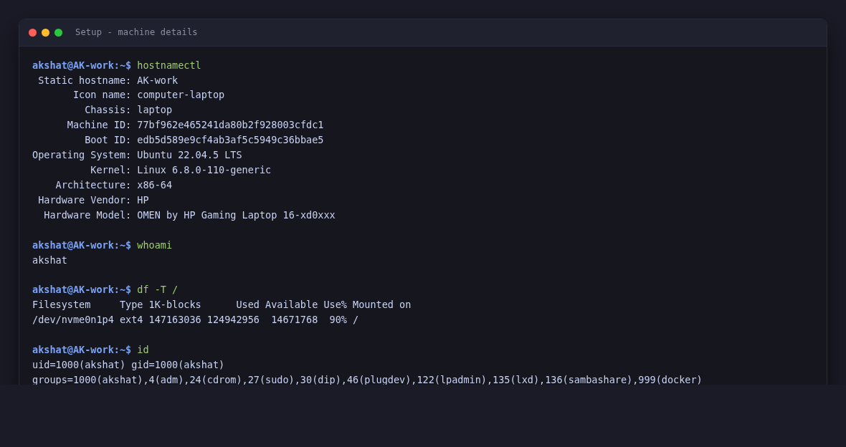
Task 1 — hard links vs soft links, start to finish | 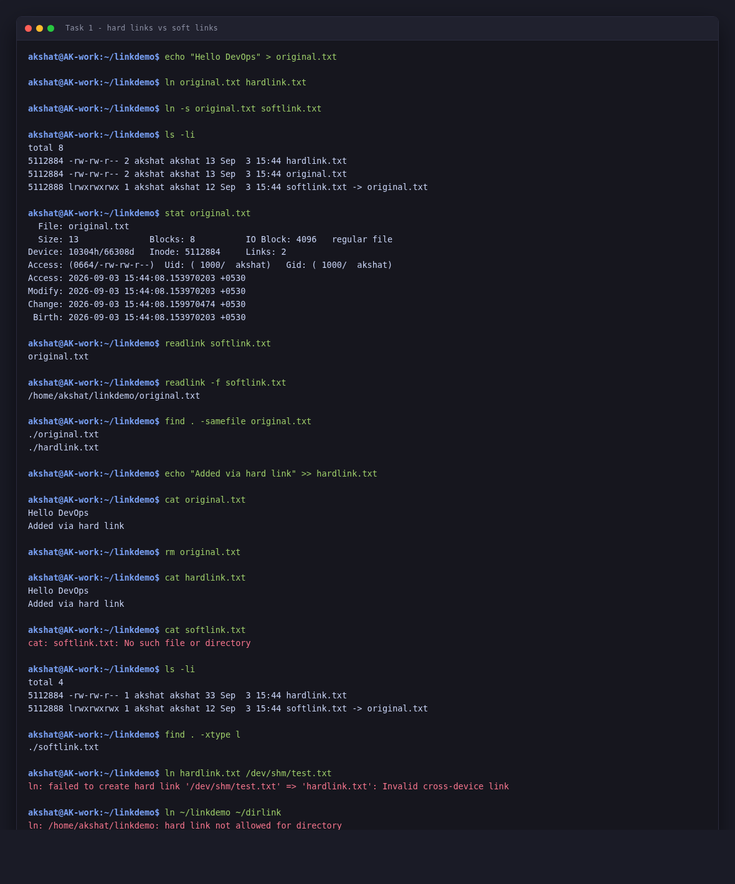
Task 2 — what adduser and useradd actually are | 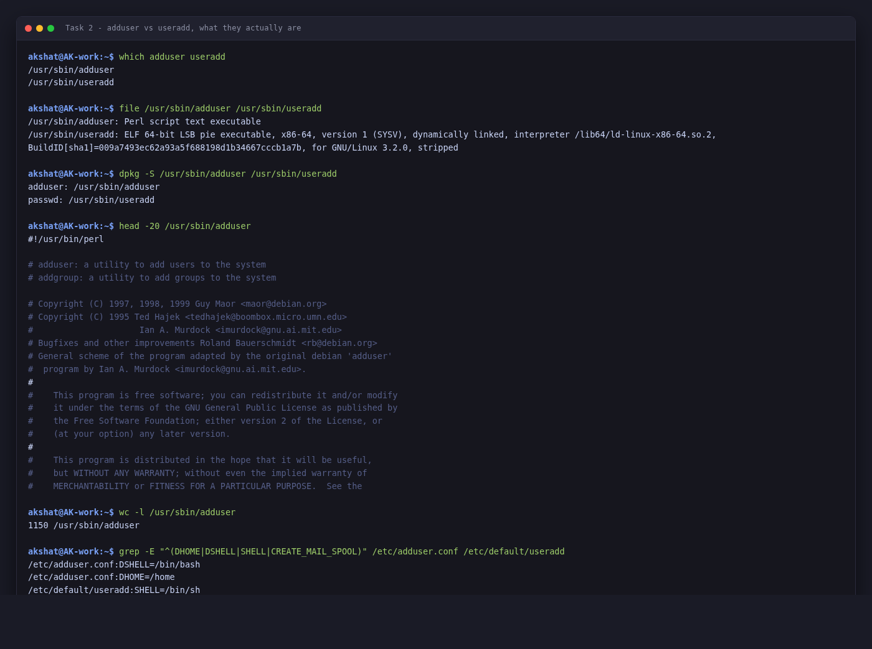
Task 2 — adduser, start to finish | 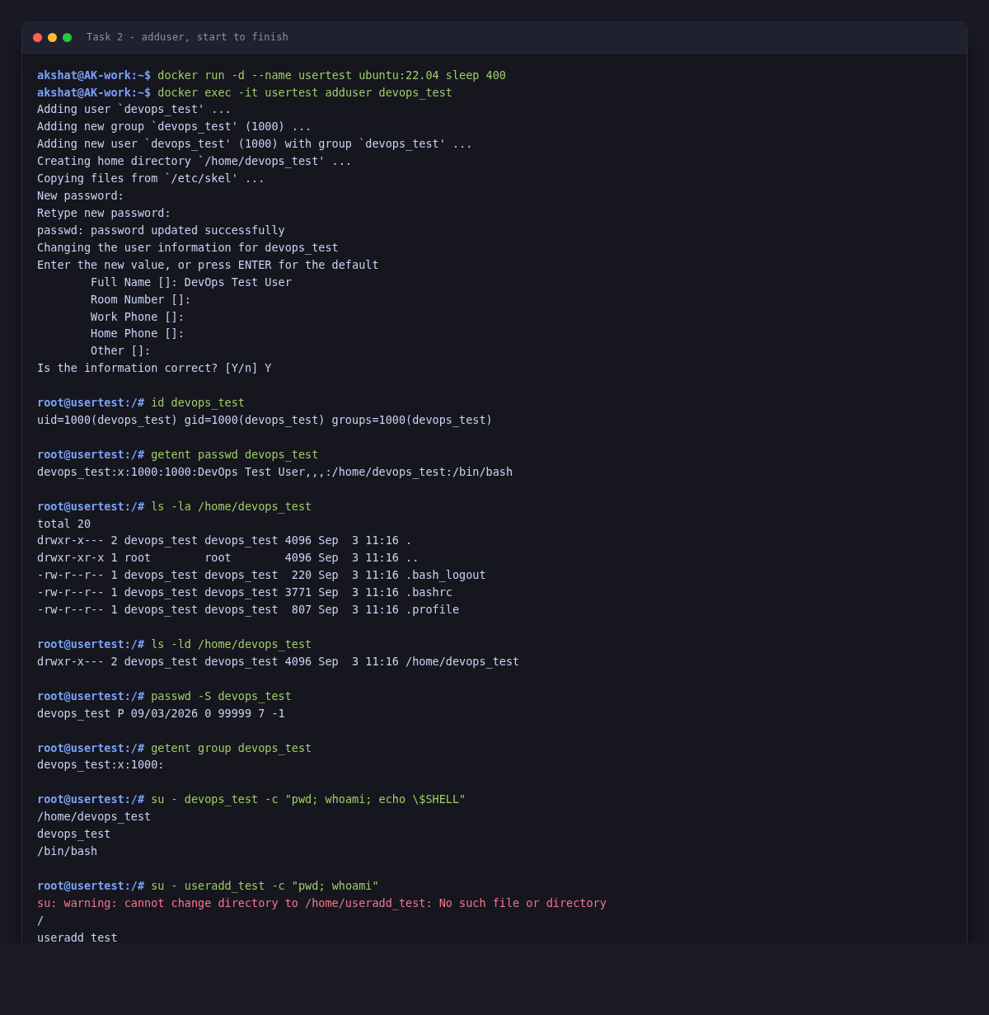
Task 2 — plain useradd, and the cleanup | 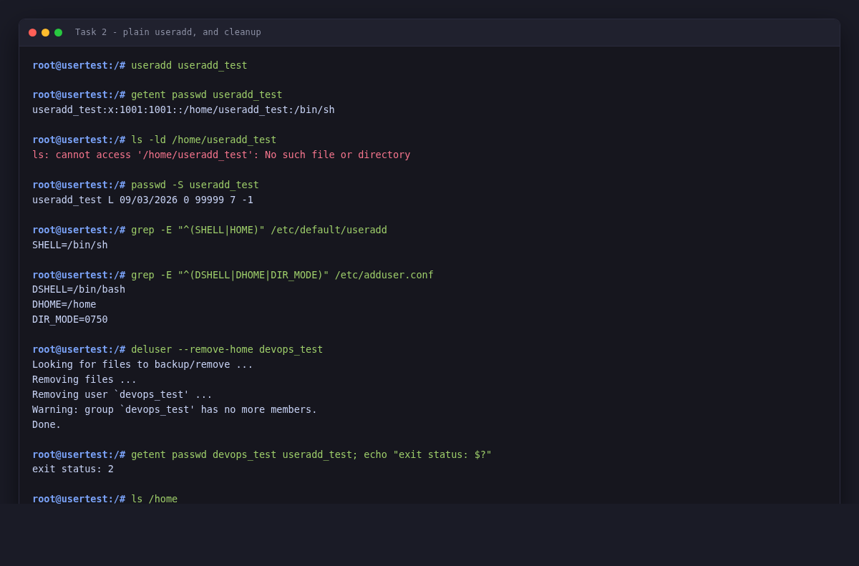
Task 3 — journalctl for a specific service | 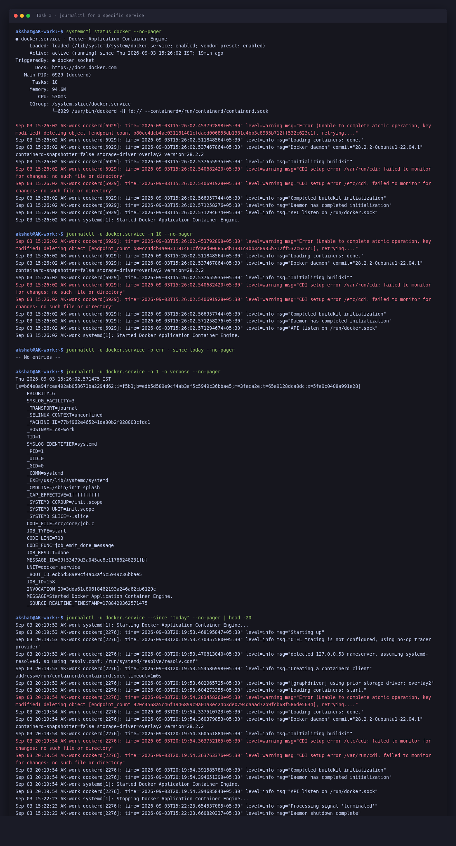
Task 3 — journalctl filters and metadata | 



