**HOW TO OPEN AND CLOSE PULL REQUEST.**

**OPENING A PULL REQUEST**

Follow these steps to open a pull request.

* Open the repository on GitHub where you want to create a pull request

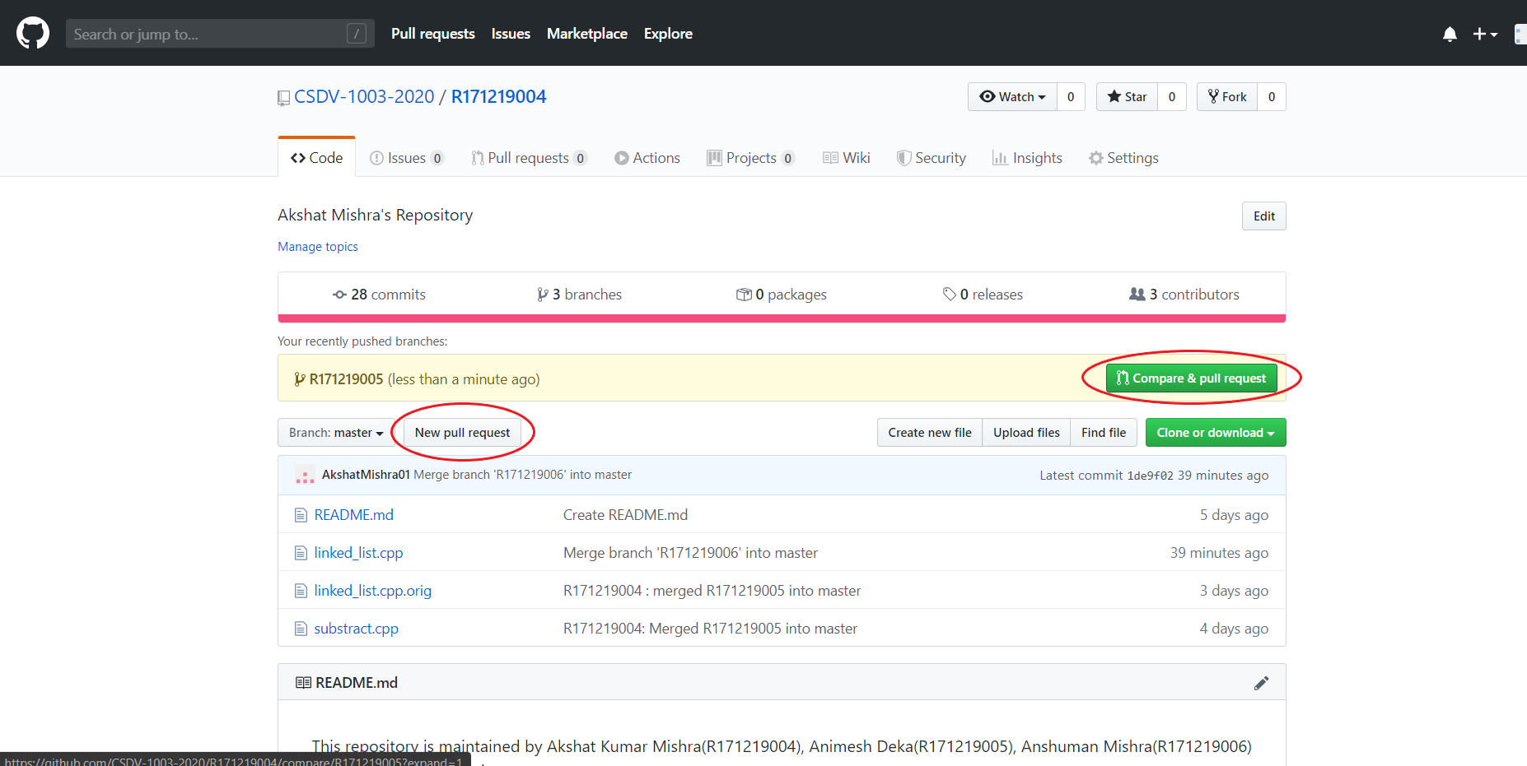

* Click on the New pull request button or on the Compare & pull request button (encircled in red). A new screen will appear like the one below.

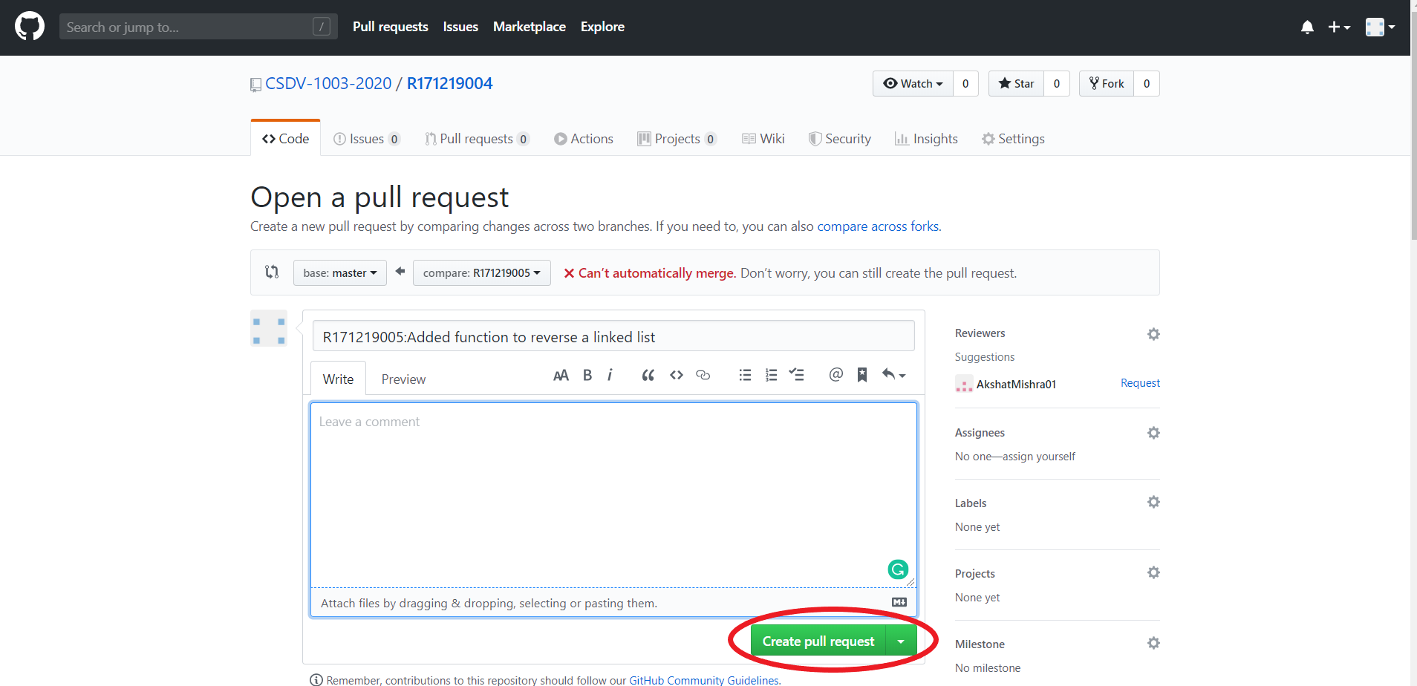

* Finally click on the Create pull request button (encircled in red). This will successfully create a pull request.

**CLOSING A PULL REQUEST**

There are two cases to close a pull request i.e., closing the pull request when there are no merge conflicts and closing the pull request when there are merge conflicts.

CASE 1: NO MERGE CONFLICTS: AUTOMATIC MERGING

Follow these steps to close a pull request with no merge conflict.

* Open your GitHub repository and go to the pull request section.

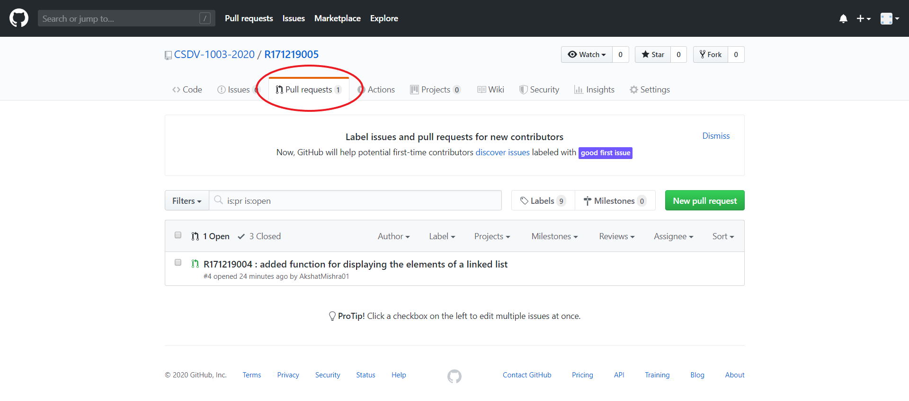

* Select the pull request you want to close.

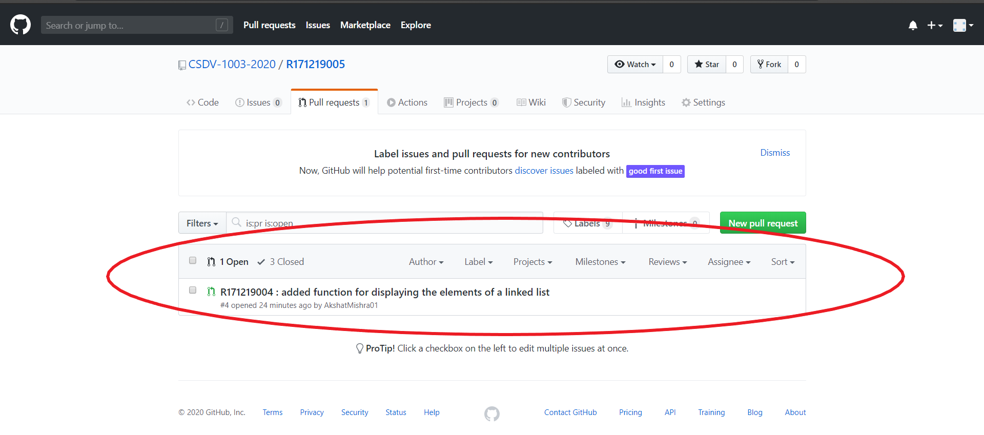

* Now you will have two option one is to close the pull request without merging (using the Close pull request button) and the other is to close the pull request by merging the branches (using the Merge pull request button)

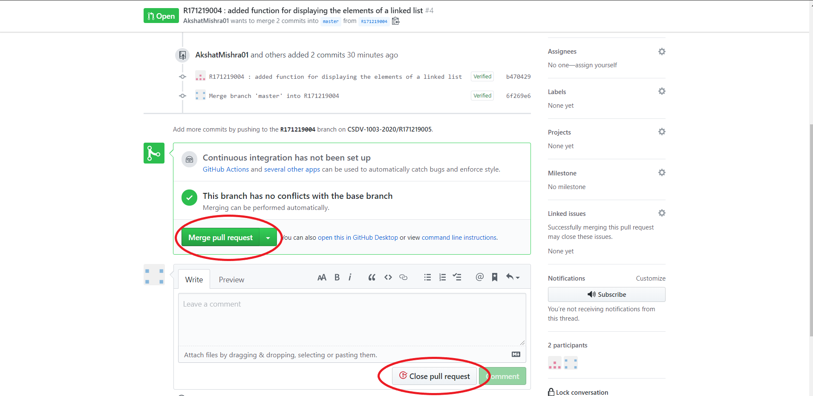

* Once clicked it will close the pull request.

CASE 2: MERGE CONFLICT: RESOLVING & CLOSING

Follow these steps to close a pull request with merge conflict.

* Repeat the first two steps that you did in case 1.
* The following screen will appear. Then, click on the Resolve conflicts button.

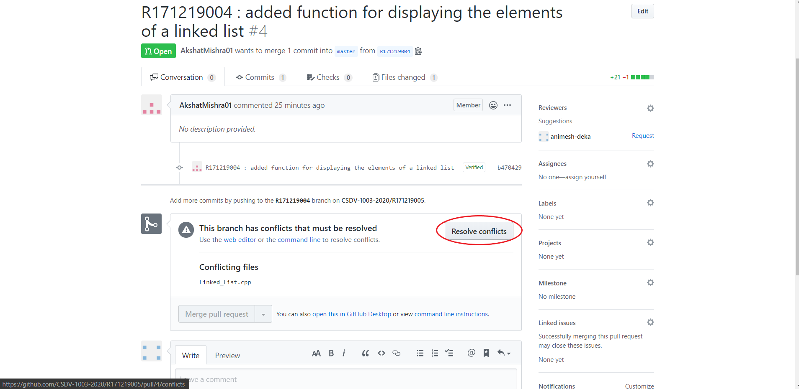

* The following screen will appear. Resolve your conflicts here.

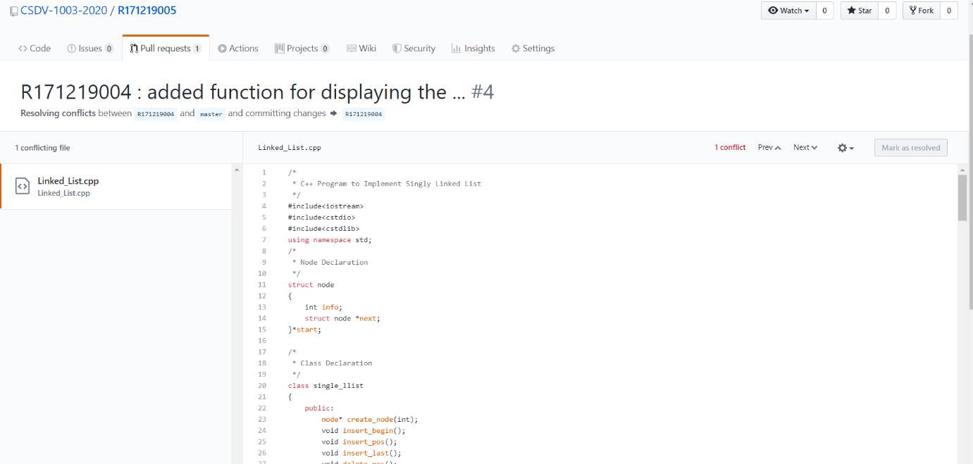

* After resolving the conflicts, you will notice that the Mark as resolved button which was previously disabled has now been enabled. Click on it.

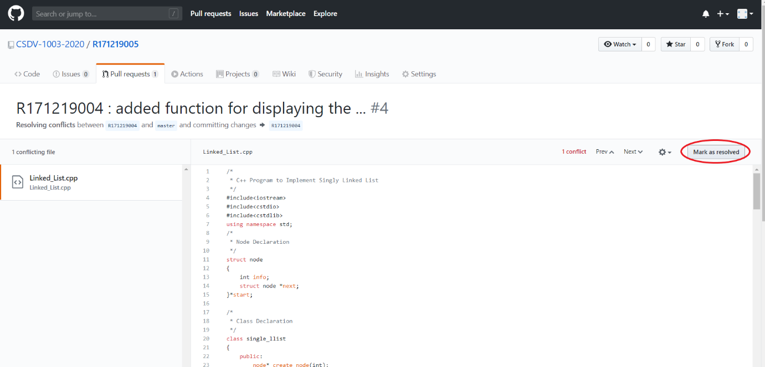

* Now you will notice that a new button named Commit merge has appeared. Click on it.

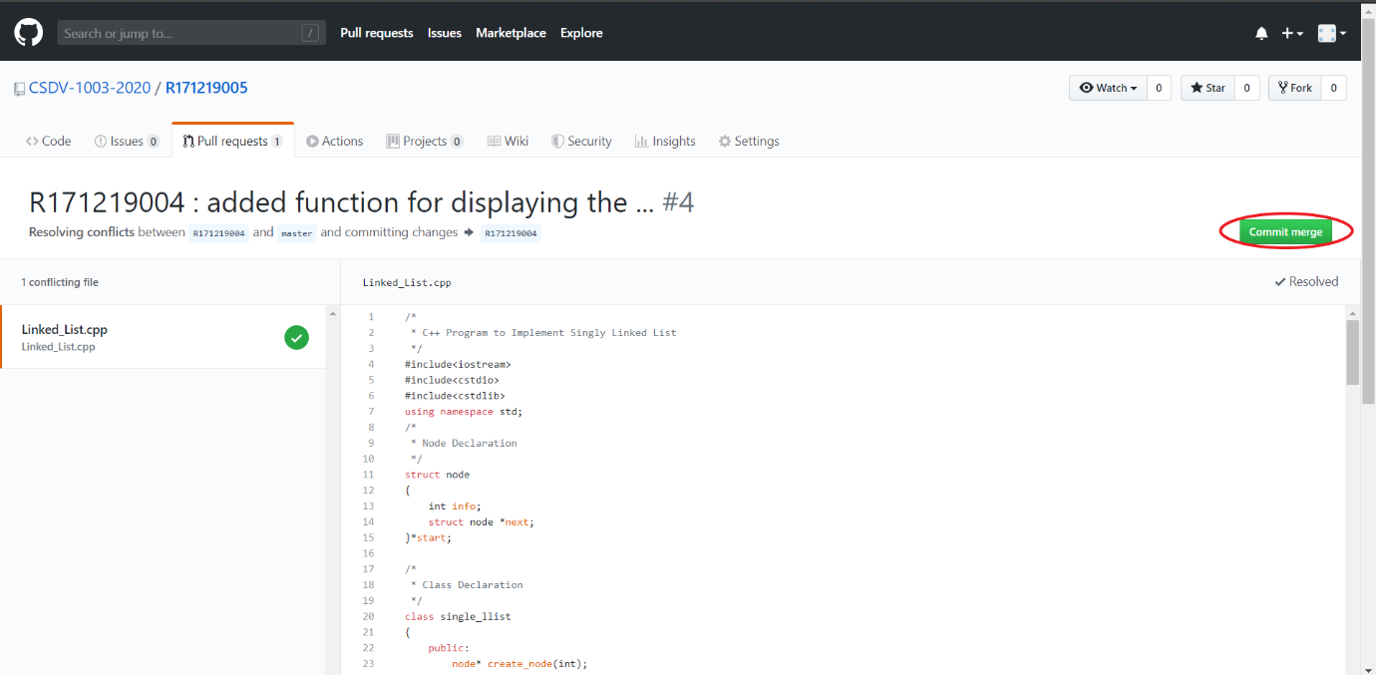

* Now the following screen will appear. Click on the Merge pull request button.

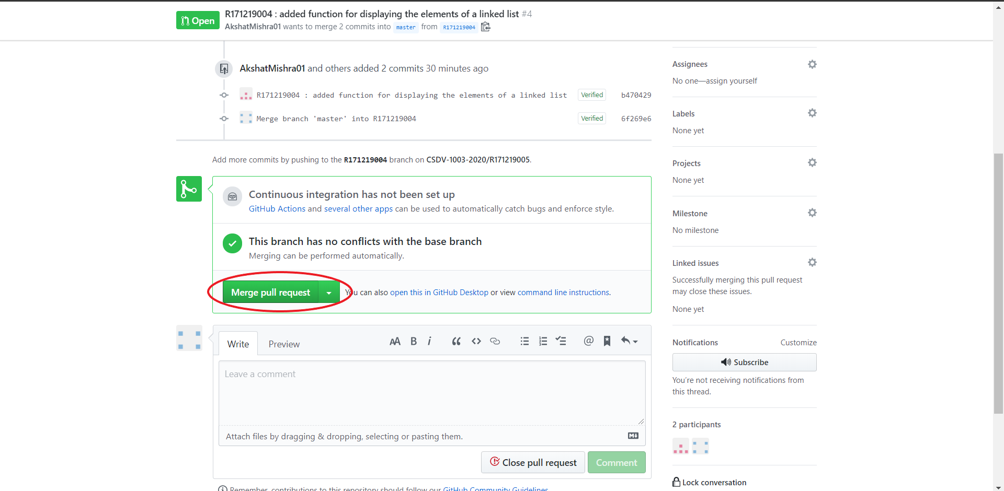

* Click on the Confirm merge button to successfully close the pull request.

