**HOW TO OPEN AND CLOSE PULL REQUESTS!!**

**OPENING A PULL REQUEST**

Opening a pull request is a simple task, you just need to follow these simple instructions:

* Open your Repository on GitHub

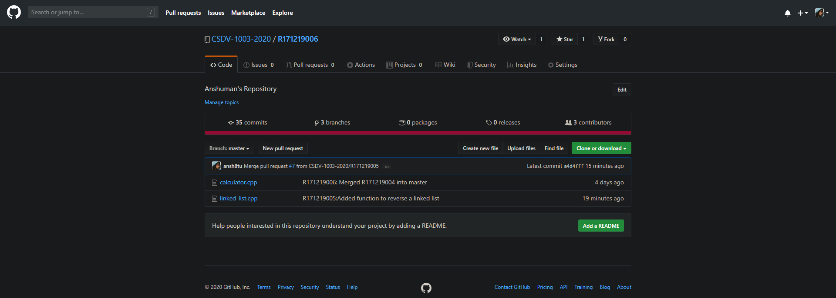

* Then, Click on New Pull request option shown on the centre of your screen. After that a new screen will appear like this which will show the ability to merge the branches with/without conflicts.

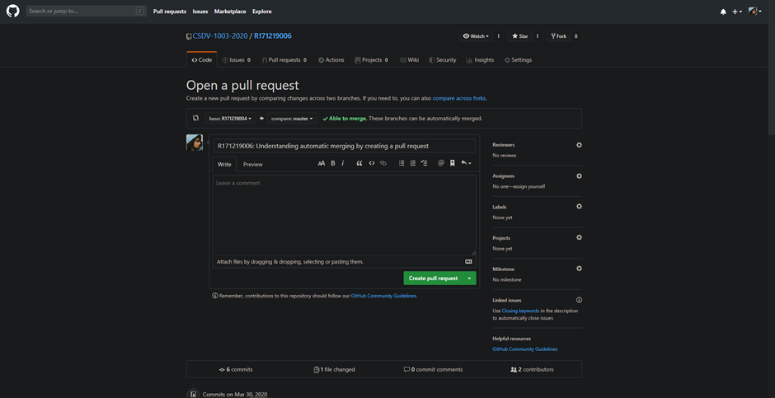

* Then, simply click on the Create pull request button that is present at the bottom part of the screen in green box. Once you click it you are done with creating a pull request.

**CLOSING A PULL REQUEST**

Closing the pull request, basically has two subcases i.e. closing the pull request when there are no merge conflicts and closing a pull request when there are merge conflicts in the branches;

*CASE 1: NO MERGE CONFLICTS: AUTOMATIC MERGING*

Closing a pull request in case of automatic merging is an easy task, all you need to do is to follow these basic steps:

* Open your Repository on GitHub, and then go under the pull requests sections to check the number of pull requests,

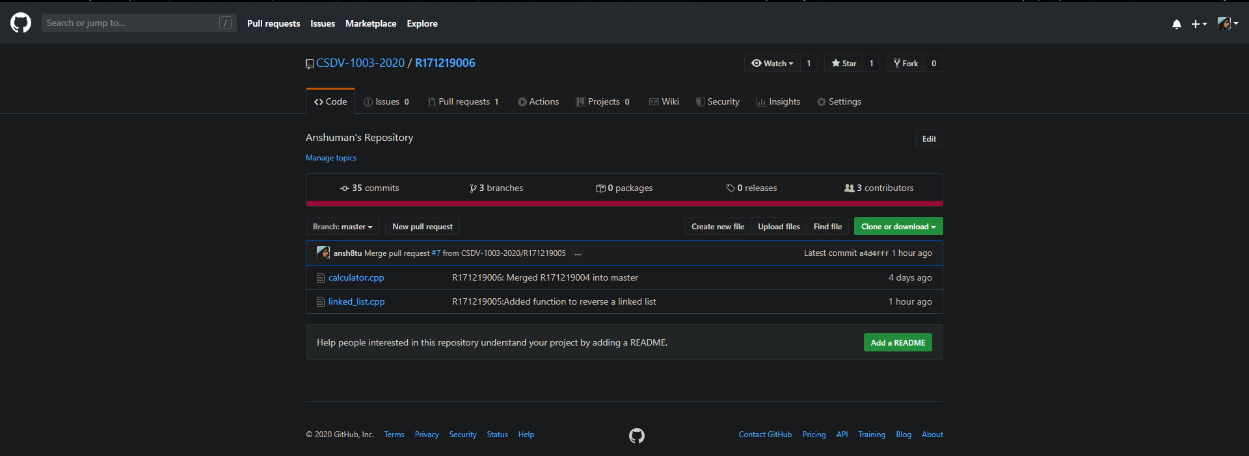

* Once you click on that option then a new screen will appear, then click on any of pull requests which you want to close,

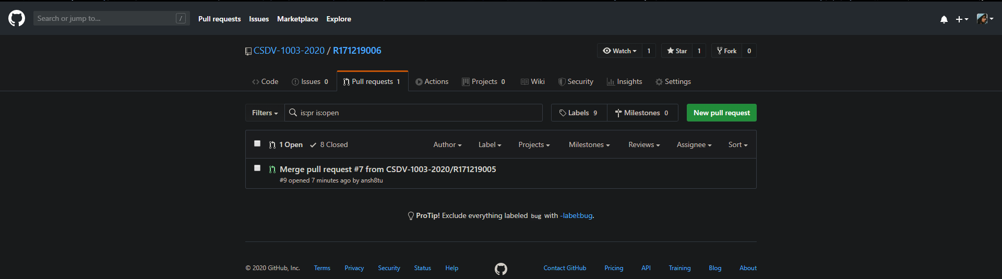

* Then you will have two options one is that you can directly close the pull request without merging(present at the bottom) and the other option is that you can merge the changes(present at the centre in green), the later one will automatically close the pull request,

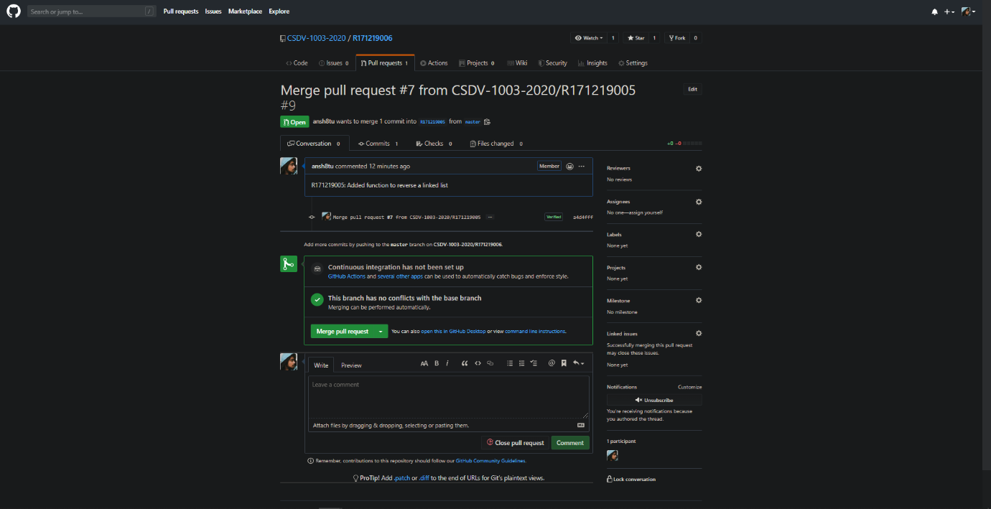

* Once you click on close the pull request, the pull request will be closed.

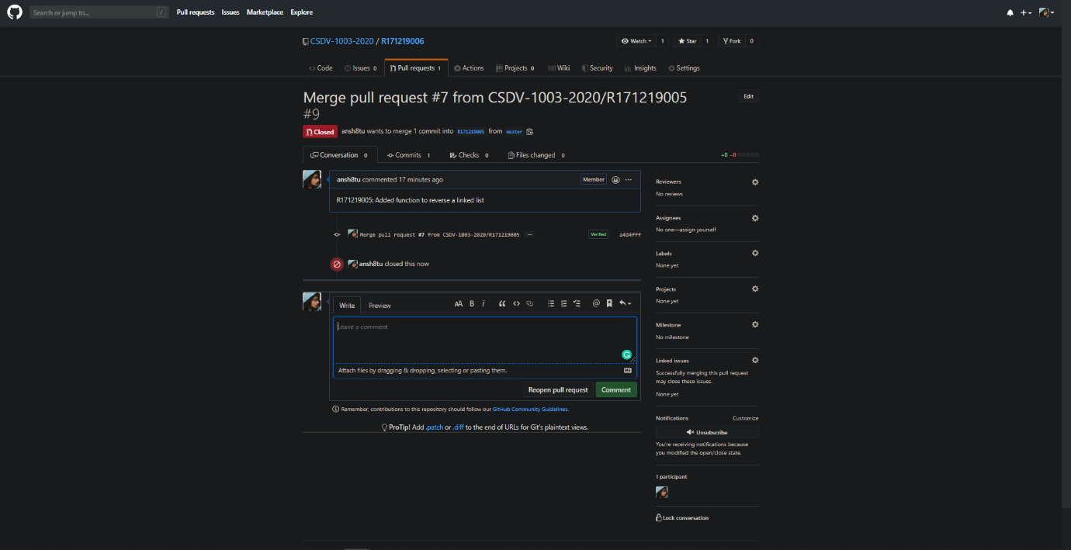

*CASE2: MERGE CONFLICTS CASE- RESOLVING AND CLOSING*

Closing a pull request in case of merge conflicts can be somewhat complicated but following these steps will surely help in closing the same:

* Repeat the first two steps that you did in the case of auto merging and closing, after that this screen will appear,

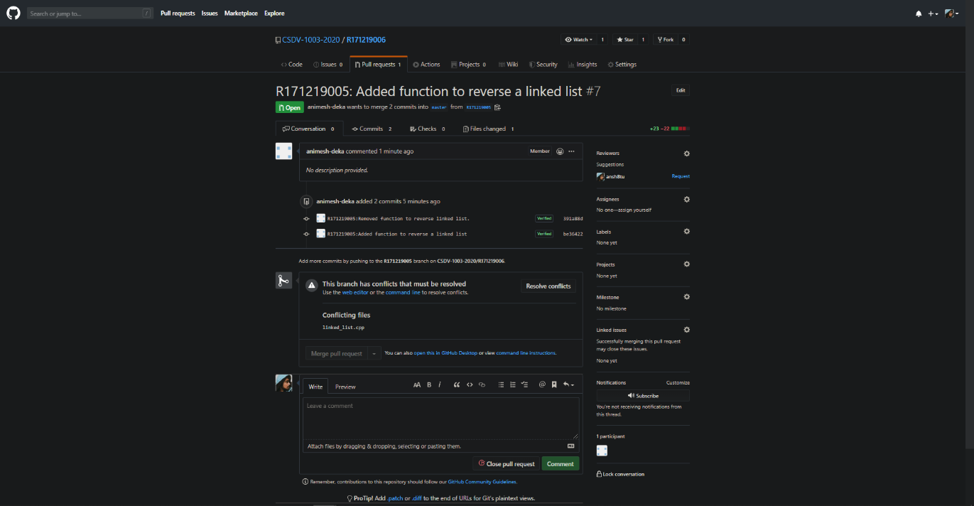

* Now if you don’t want to merge then simply close the pull requests but if you want to merge and then close the pull request then click on Resolve conflicts option that you see in the middle of the screen. After clicking on it you’ll reach the file which has conflicts that need to be resolved,

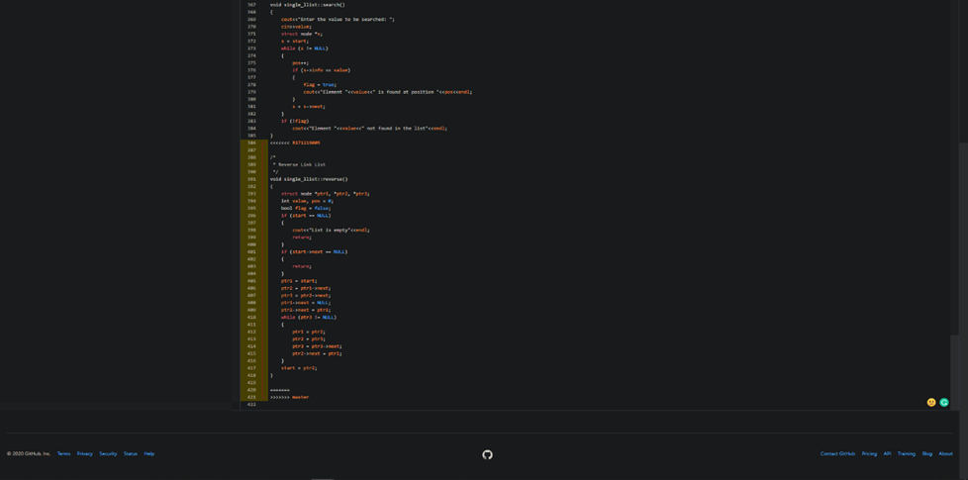

* Once you resolve the conflicts then the screen will look like this,

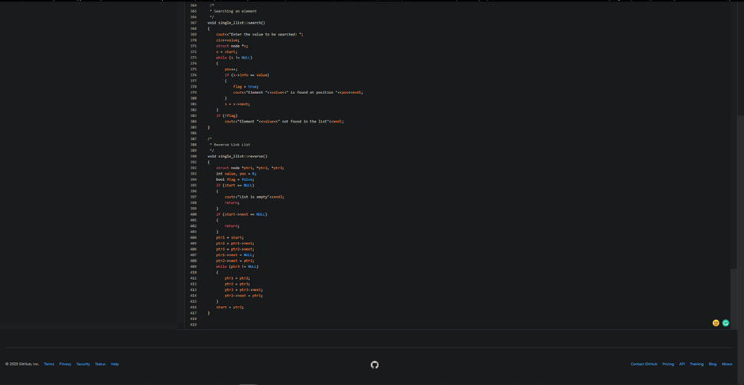

* Then scroll up and click on mark as resolved button present on the upper right side of the screen,

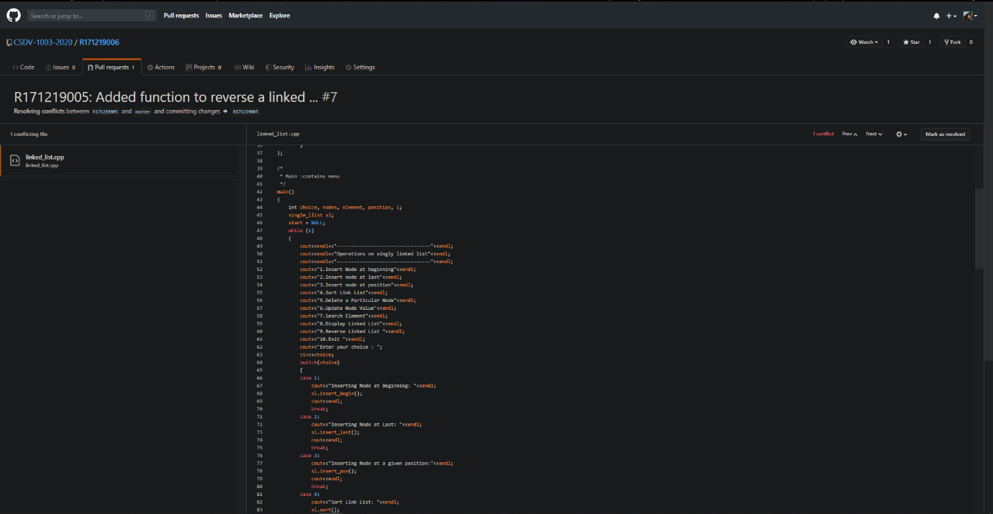

* Once you click on the same a new button will appear just above mark as resolved button in green named as commit merge, click on the commit merge button,

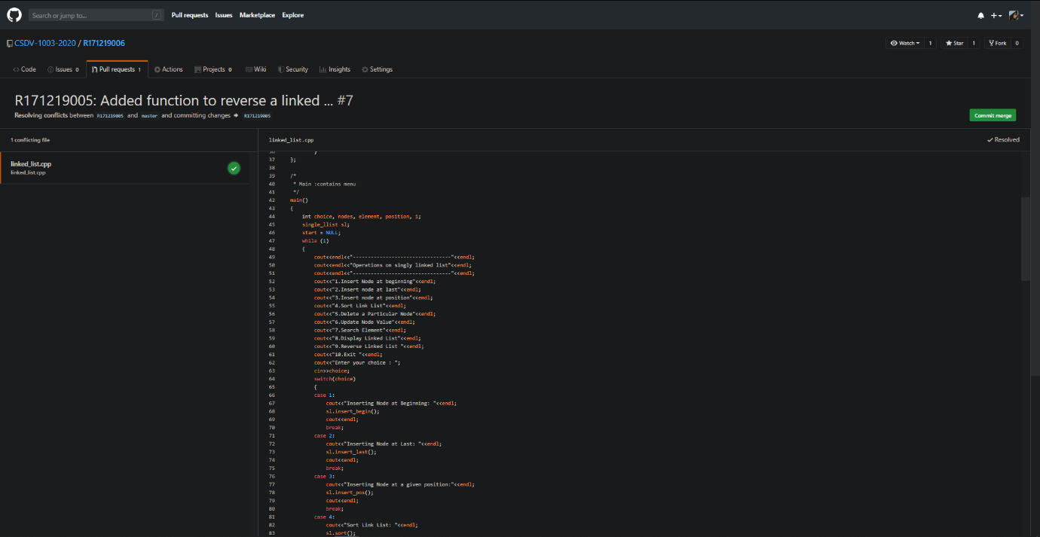

* Once you click commit merge button then a new screen will appear, on this screen click on merge pull request present in green in the centre of screen,

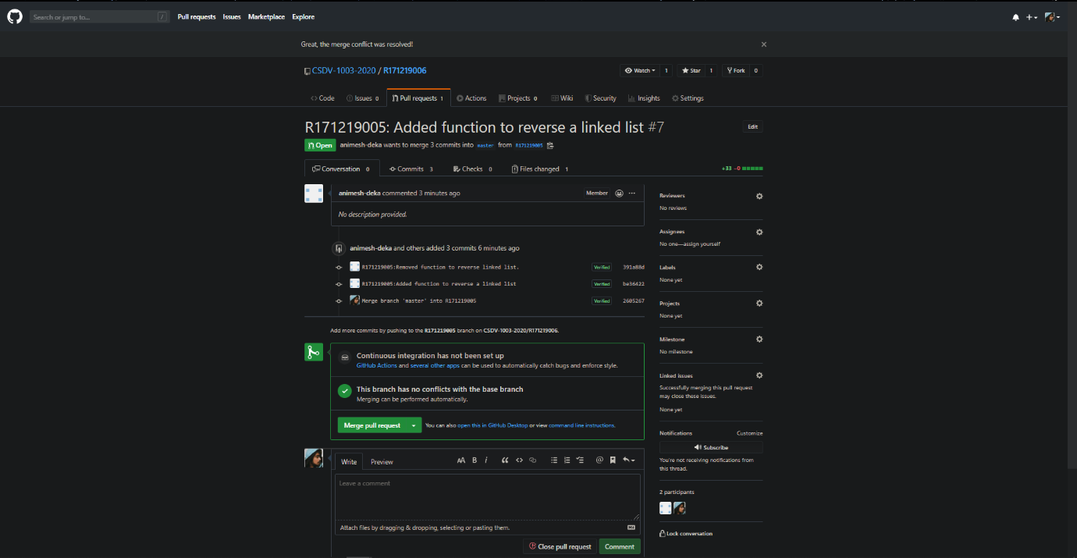

* Now click on commit merge button present in the centre of screen in green colour,

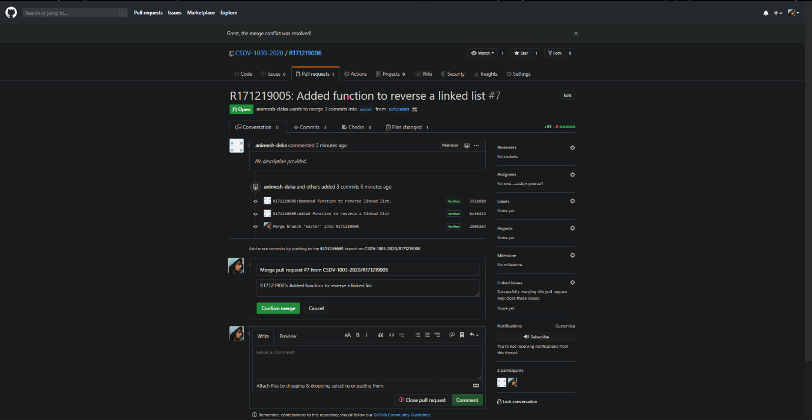

* Once you click on the same then your pull request is successfully merged and committed.

