Mid Evaluation report

1. What till now?
2. 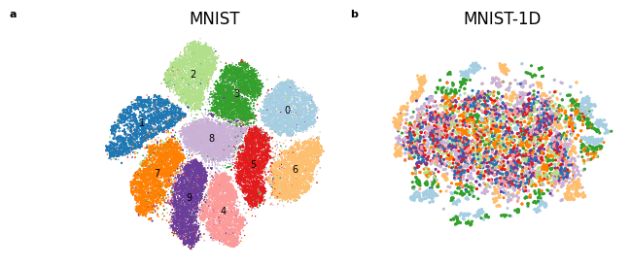Comparing the original mnist and mnist1d using t-SNE.
3. Finding the lottery ticket (a more efficient subnetwork, extracted from original network) and the comparing the accuracies with varying sparsity.

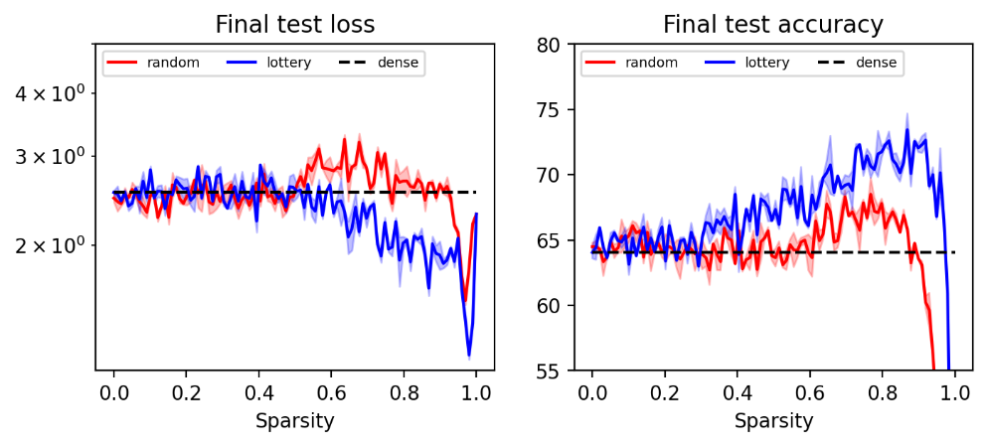

1. How spatially shuffling the dataset effect the accuracy? (LT==Lottery ticket, baseline == original structure of mnist1d dataset.)

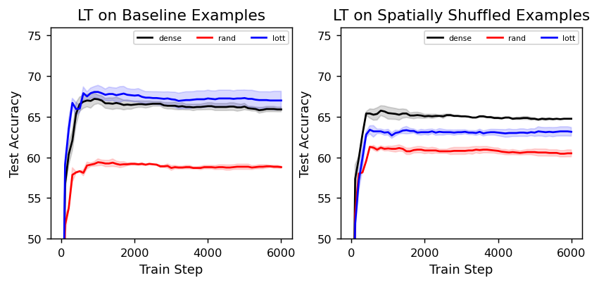

1. 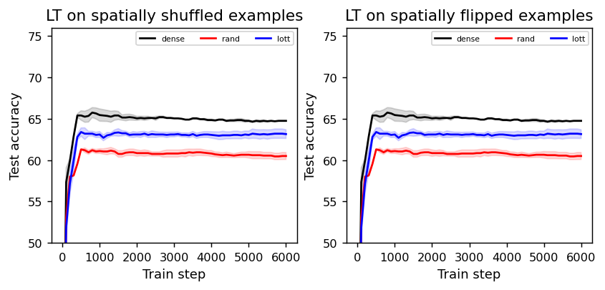Spatially shuffled vs spatially flipping the dataset.
2. 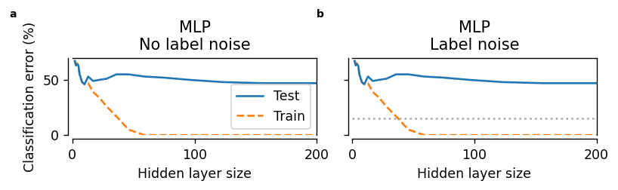Deep Double Descent phenomenon, (here they look quite similar, but the difference may occur when increase the noise level in testing.)
3. 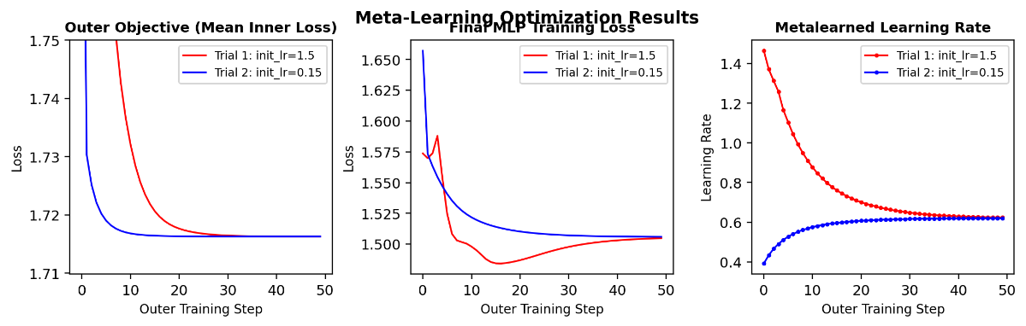Meta-learning: learning rate by considering two learning rates with significant difference and checking whether they converge.
4. 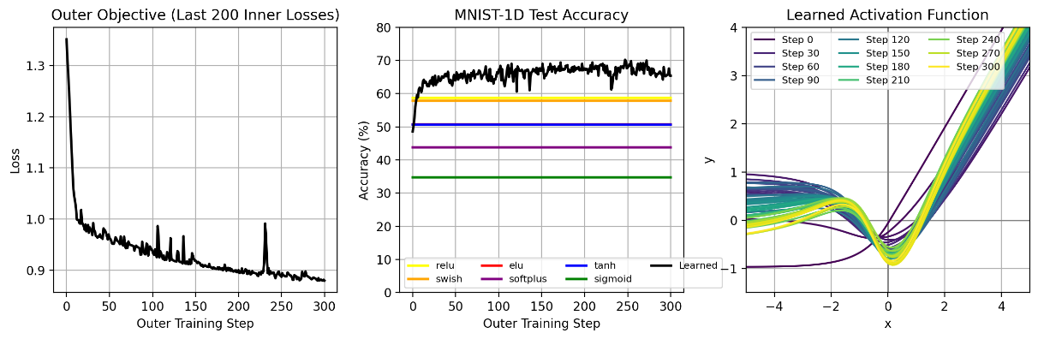Meta-learning: activation function
5. Self Assessment

I was able to learn the concept used in the paper but not in depth. There are many experiments in the paper involved and still some of them are left to do, although I have given like 3-4 hours every day (at least) and was still working on this during Diwali, I thought that I would be able to complete all the experiments in the paper but “nothing goes as planned in this accursed world”. I tried understanding the basic terms too used in the paper and I got a little help from one deep learning project I am doing from PaAC. I didn’t feel like it’s all everything new.

1. Challenges:
2. Faced challenge migratorily in understanding the codes
3. On Meta learning topic, (I really want to learn more about meta learning), as it uses some other paper discussion.
4. Problem with runtime on colab, anyone of the process from above mentioned topic took more the 2 hours just because I was not on gpu and had to perform the same testing like 2-3 time as it was getting disconnected or other problem with colab, literally took my 6 hours (approx.)
5. When I try to make difference in the code most of the time, I ended up in either low accuracy, or syntax error or any other error.
6. For second phase:

Will try learn pytorch as code by other uses pytorch. I am thinking about completing the experiments then doing ablation study, ablation study sounds like fun but will require a good machine for that level of ablation study, maybe I can setup the machine on ‘paramganga’ then It would be easy, And will try to the learn the concepts in little detail or depth along with meta learning.