Kazakhstan–China Economic Diplomacy:

Opportunities, Challenges, and Future Perspectives

Abstract

This paper develops a multi-method research framework for analyzing economic diplomacy between Kazakhstan and China. Combining psycholinguistic analysis, expert assessment, and bibliographic analysis with empirical trade data, the study addresses structural trade imbalances, increasing dependency, and the erosion of Kazakhstan’s multivector foreign policy. The findings indicate a shift toward asymmetric interdependence, particularly after 2023, necessitating a multidimensional analytical approach that integrates discourse, expert insight, and economic structure.

I. INTRODUCTION

1.1 Background and Contextual Framing

The decade spanning 2015 to 2025 represents a transformative arc in the geopolitical economy of Central Asia — one defined, above all others, by the deepening yet asymmetric interdependence between the People's Republic of China and the Republic of Kazakhstan. What began as a neighborly economic arrangement anchored in energy trade has evolved into a complex, multi-scalar relationship encompassing infrastructure investment, transit connectivity, financial integration, and strategic diplomacy. This evolution did not occur in a vacuum. It unfolded against the backdrop of China's Belt and Road Initiative (BRI), first announced by President Xi Jinping in Astana in September 2013 — a moment of symbolic significance that positioned Kazakhstan at the very origin point of China's most ambitious geoeconomic grand strategy.

1.2 Research Problem and Significance
The study of Sino-Kazakh economic relations presents a theoretical puzzle of considerable significance for international relations scholarship. On the surface, the relationship appears to exhibit classical features of asymmetric dependence: a massive, rising power deploying capital, infrastructure, and institutional leverage to integrate a smaller, resource-rich neighbor into its economic orbit. There are currently 21 BRI projects underway in Kazakhstan totaling $12.07 billion, with China among the top five largest foreign investors in the country (Caspian Policy Center, 2023). From 2005 to 2023, China invested $20.1 billion in Kazakhstan — far exceeding its investments in any other Central Asian state (Primiano & Kudebayeva, 2025).
Yet the empirical record complicates this reading. Kazakhstan has demonstrably avoided the 'debt-trap' dynamics that have attracted criticism of BRI engagement elsewhere, maintained diversified trade and diplomatic portfolios, and periodically pushed back against Chinese economic encroachment — most notably through public anti-Chinese protest movements in 2016 and 2019. The question, then, is not simply whether China has gained economic influence over Kazakhstan, but how Kazakhstan manages, negotiates, and partly redirects that influence through the instruments of asymmetric diplomacy (MERICS, 2022; Lim et al., 2025).
This study interrogates the mechanisms, limits, and consequences of this dynamic across four domains: trade and investment, energy and resource politics, infrastructure and transit connectivity, and public diplomacy and societal reception. It does so with particular attention to the structural shifts generated by Russia's 2022 invasion of Ukraine — an event that Stronski (2024) identifies as having fundamentally altered the strategic calculus of Central Asian states, with Kazakhstan leading the regional pivot toward diversified partnerships.

Overview and Organizational Framework
The academic literature on Sino-Kazakh economic relations draws from multiple disciplinary streams — international relations theory, Central Asian area studies, geoeconomic theory, and political economy — and has undergone remarkable expansion since the BRI's announcement in 2013, with a particularly notable surge of publication in 2024–2026. This review organizes existing scholarship into five thematic clusters: (1) geoeconomics and China's grand strategy; (2) the Belt and Road Initiative and its regional impacts; (3) Kazakhstan's multi-vector foreign policy doctrine; (4) asymmetric interdependence and small state agency; and (5) domestic political economy and societal responses in Kazakhstan. Across these clusters, a number of key debates emerge — most notably the tension between dependency and agency accounts of Sino-Kazakh relations — which this study seeks to advance through the integration of the most recent empirical and theoretical scholarship.

2.2 Geoeconomics and China's Grand Strategy: Theoretical Foundations
The theoretical foundation of geoeconomics as a contemporary field of inquiry was established by Edward Luttwak (1990) in his landmark article 'From Geopolitics to Geo-economics: Logic of Conflict, Grammar of Commerce,' published in The National Interest. Luttwak argued that the logic of conflict in world affairs was shifting from military to commercial instruments, with 'disposable capital in lieu of firepower' and 'market penetration in lieu of garrisons and bases' (Luttwak, 1990, p. 19). This framework was subsequently operationalized by Blackwill and Harris (2016) in War by Other Means: Geoeconomics and Statecraft (Harvard University Press / Council on Foreign Relations), which identified China as the leading practitioner of geoeconomic statecraft in the contemporary era.
Applied to Central Asia, the geoeconomic lens has been deployed most systematically by scholars examining the BRI as a spatial and political economy project. Rolland (2017), in her monograph China's Eurasian Century?, produced the first Western analysis of the BRI's strategic underpinnings based on Chinese-language sources, characterizing it as a grand strategy designed to project Chinese power through infrastructure investment. More recent scholarship has deepened this analysis considerably. Amineh and Li (2025), writing in Journal of Contemporary Asia (SAGE), employ a '(geo-)political economic theory' to analyze how the BRI is implemented through three instruments — diplomatic, economic, and security policy — with Kazakhstan identified as one of the most important BRI partners, particularly in terms of China–Europe freight train routes and oil and gas pipelines from Central Asia to Xinjiang (Amineh & Li, 2025).
In a 2025 article published in Springer Nature's Discover Global Society, Haji and Khattak (2025) apply the geoeconomics framework to the BRI's broader implications, demonstrating how the initiative is reshaping great power dynamics by creating 'economic dependencies [that] could be used to move the BRI target countries to account for China's political positions and interests.' Similarly, Chen et al. (2025), writing in a systematic literature review published in Tandfonline's The Chinese Economy, synthesize evidence across 212 agreements signed in 2023 alone worth USD 92.4 billion across 149 BRI member countries — underscoring the initiative's structural significance. The geoeconomics-BRI nexus literature broadly supports a revised Mackinderian reading: as Cannon and Rossiter (2025) demonstrate in International Affairs, 'Central Asia is deemed critical territory to control by an aspirant Eurasian hegemon,' and China's infrastructure investments in Kazakhstan physically tie the state to Beijing's strategic geography.

2.3 The Belt and Road Initiative: Regional Dimensions and Kazakhstan's Centrality
Kazakhstan occupies a privileged position in the BRI literature, both because Xi Jinping chose Astana as the site of the initiative's announcement, and because the country's geographic position makes it indispensable to the Silk Road Economic Belt's overland logic. As Primiano and Kudebayeva (2025) note in their study published in the Journal of Current Chinese Affairs (SAGE), Kazakhstan is commonly regarded as the region's most advanced economic country, the springboard or 'buckle' of the BRI's belt aspect into the rest of Asia and Europe, and a node in numerous BRI corridors, including the China–Kazakhstan–Russia–Western Europe Corridor and the China–Kazakhstan–South Caucasus/Turkey–Europe Corridor.
Kassenova (2017) provided the scholarly foundation for understanding the Nurly Zhol–BRI nexus, documenting how Kazakhstan's 'Bright Path' infrastructure development program became formally integrated into the Silk Road Economic Belt following agreements signed in 2015. A more recent and empirically updated treatment is provided by Lim, Tjia, and Murashkin (2025) in The Chinese Economy (Volume 58, Issue 1), whose study 'Opportunities and Challenges of China's Economic Ties with Kazakhstan: Looking Back to Look Forward' offers the most comprehensive post-BRI trade analysis to date. The paper advances three key arguments: Kazakhstan has avoided developing a dependency on the Chinese economy; trade has shifted from a natural-resources focus to a more balanced mix encompassing intermediate goods, raw materials, and consumer goods; and the future trajectory anticipates further development but with detours and bottlenecks (Lim et al., 2025).
The 2024 publication by Castellano and Castillo in the European Journal of Development Research (Springer Nature) examines how Chinese state capital functions as a partner for resource-based structural transformation in Kazakhstan, focusing specifically on the petrochemicals sector. They find that Kazakhstan's state development plans have consistently depicted China as a key partner since the early 2000s and that the fall in oil prices from 2014 pushed the Kazakhstani government to pursue the Nurly Zhol programme — formally linked to the BRI through a Memorandum of Understanding in 2019 (Castellano & Castillo, 2024).
The Middle Corridor has attracted the most significant new scholarly attention in 2024–2026. The Georgia Foundation for Strategic and International Studies (GFSIS, 2025), in a detailed report on China–Kazakhstan political and economic relations, documents the full scope of bilateral transit cooperation, including Kazakhstan's announcement of a third rail link with China — the 272 km Bakhty-Ayagoz line due for completion by 2027 — and confirms the February 2026 launch of a China–Europe freight service via the Trans-Caspian International Transport Route (Middle Corridor) that bypasses Russia entirely (GFSIS, 2025). The China-Global South Project's 2026 outlook similarly confirms that by mid-2025, China's FDI stock in the broader Eurasian region reached an estimated USD 66.1 billion, with more than half concentrated in Central Asia, and that 2025 marked an inflection point as investment composition began shifting from extractive industries toward renewable energy and downstream manufacturing (China-Global South Project, 2026).

2.4 Kazakhstan's Multi-Vector Foreign Policy: Origins, Doctrine, and Adaptation
The literature on Kazakhstan's multi-vector foreign policy is among the most developed in Central Asian studies. The concept was formally articulated by President Nazarbayev in 1992 and institutionalized in the 1995 Foreign Policy Concept. Peyrouse (2012) and Clarke (2015) established the foundational scholarly treatment of this doctrine, with the latter's analysis of 'diminishing returns in an era of great power pivots' proving particularly prescient in light of post-2022 developments. Contessi (2015) offered the important reconceptualization of multivectorism as 'co-alignment' — involving simultaneous alignment with different great powers through a mechanism of 'issue splitting' that prevents any single power from capturing an entire policy domain.
The most current and theoretically sophisticated treatment is provided by Lim et al. (2025), who confirm that Kazakhstan's basic idea of multi-vectorism — to establish mutually beneficial cooperation with other countries even beyond its immediate borders — has enabled it to preserve sovereignty and coexist with much bigger states without becoming their client state. Critically, their study finds that 'the forging of close economic ties with China has not seen Kazakhstan pull away from Russia. Rather, the opportunities from China (and other countries) have helped Kazakhstan hedge its traditional reliance on Russia without causing friction with Moscow' (Lim et al., 2025).
The post-2022 literature has introduced important qualifications to this narrative. Stronski (2024), writing for the Foreign Policy Research Institute (FPRI) and drawing on Carnegie Endowment analysis, documents the ways in which Russia's 2022 invasion of Ukraine has 'deeply damaged its reputation and self-appointed role as the sole security manager for the region,' noting that Central Asian governments have 'lost considerable faith in [Moscow's] military capabilities' and view it with 'deep suspicion.' Kazakhstan has responded by rebalancing: trade with Russia declined, while the country simultaneously received approximately $23 billion in BRI-related investment (Stronski, 2024). MERICS (2022) similarly warns that while Kazakhstan's multi-vector strategy remains operative, it 'could be undermined by greater economic dependence on China, as Russia's attack on Ukraine will strengthen China's role as an economic partner' (MERICS, 2022).
A landmark 2026 article published in Tandfonline's Journal of Contemporary China by an international team of scholars — 'China's Diplomacy in Central Asia: The Logic of Internal Politics Coupled with the Logic of Great Power Competition' (received August 2025, published January 2026) — provides the most current systematic analysis of China's diplomatic footprint expansion. It documents that trade between China and Central Asia surpassed $94.8 billion in 2024, enabling China to overtake Russia as the largest trading partner for several Central Asian states, and identifies the May 2023 inaugural China-Central Asia Summit in Xi'an and the subsequent C+C5 institutional framework as structural turning points in the relationship (Anonymous Authors, Journal of Contemporary China, 2026).

2.5 Asymmetric Interdependence and Small State Agency
A recurring debate in the Sino-Kazakh literature concerns the relative explanatory weight of structural power asymmetry versus small state agency. The dependency school emphasizes the structural constraints that China's economic scale imposes on Kazakh policymaking — from energy sector penetration to debt accumulation. Earlier work by Bitabarova (2018, 2019) and Neafie (2022) offered agency-centered rebuttals, arguing that Kazakhstan had exercised meaningful agency in shaping the terms of its engagement. Neafie's (2022) Eurasian Land Bridge framework demonstrated that geostrategic pivots can utilize their position to exert some control in relationships with powerful states.
The most recent empirical evidence both supports and complicates these agency arguments. Primiano and Kudebayeva (2025), in the first survey-based study of Kazakh public opinion on the BRI (Journal of Current Chinese Affairs, SAGE), find that the majority of their KIMEP University participants view BRI as bad for Kazakhstan, and — significantly — that political orientation correlates with BRI perceptions, with those espousing democratic views consistently viewing the initiative more negatively. This suggests that the domestic politics of BRI engagement have become more contested, complicating the elite-driven agency narrative.
The CNAS analysis by Rumer and Sokolsky (2024) adds a strategic dimension: 'Central Asian nations — with Kazakhstan in the lead — will continue to pursue engagement with multiple nations and keep their options open to avoid overdependence on any one country.' They note that Central Asian states still look to the United States and Europe, as well as Gulf states and East Asian partners, to support their independence and sovereignty — issues that have 'taken on new importance following Russia's invasion of Ukraine' (Rumer & Sokolsky, 2024). The 2025 Springer Nature article on Central Asian geopolitics confirms this reading, identifying Kazakhstan's multi-vector balancing as operating across four major external actors: China, Russia, the EU, and the US (Haji & Khattak, 2025).
Castellano and Castillo (2024) contribute the important finding that variation in Chinese state capital accommodation with local demands is explained by three axes: the mix of BRI drivers motivating a particular project from the Chinese side (export of industrial surplus, political relations, or resource security); the nature of state-capital investment partnership; and the degree to which local industrial priorities are embedded in national development plans. This framework substantially advances the agency-structure debate by identifying the conditions under which Kazakhstani negotiating power is enhanced or diminished.

2.6 Domestic Political Economy and Societal Responses
A critical and growing dimension of the Sino-Kazakh literature concerns its domestic political economy — particularly the tensions between elite-level economic cooperation and popular-level Sinophobia. Laruelle and Peyrouse (2012) established the foundational scholarly treatment of this dynamic, and subsequent work has documented its intensification. Anti-Chinese protests in 2016 and 2019 targeted both the land-lease policy and Chinese economic projects more broadly, with the Kazakh government responding by releasing data on 55 projects receiving Chinese investment totaling $27.6 billion (Caspian Policy Center, 2023).
The most recent literature confirms the persistence and deepening of this tension. Lim et al. (2025) confirm that anti-Chinese sentiment has been fueled by factors including environmental concerns, lack of transparency, land grabbing, and securitization of ethnic minorities in Xinjiang. Primiano and Kudebayeva (2025) document through survey evidence that majority student opinion at KIMEP University views BRI negatively — a finding with significant implications given KIMEP's status as Kazakhstan's most Westernized elite institution. MERICS (2022) observes that while Kazakhstan's 'authoritarian regime makes it hard for public opinion to shape policy... widespread public outcry has sometimes shifted policy towards China,' reflecting a form of bottom-up constraint on elite accommodation.
The securitization of Uyghurs and ethnic Kazakhs in Xinjiang has significantly worsened Chinese public image in Kazakhstan. Multiple 2024–2025 sources confirm that Kazakhstan's China-related domestic politics have become more fraught: Chinese security companies have attempted to enter Kazakhstan (prohibited under Kazakh law), Chinese private security contractors secured sensitive BRI infrastructure, and Kazakh activists who protest against China's policies in Xinjiang have faced arrests (GFSIS, 2025). At the same time, 2025 saw Kazakhstan officially launch the 'Year of China Tourism' and sign over 200 agreements with Chinese partners on tourism promotion — illustrating the continuing elite-level effort to manage and develop the relationship despite popular resistance (GFSIS, 2025).

2.7 Emerging Frontiers: Critical Minerals, Green Energy, and Digital Infrastructure
A frontier area of the literature, largely absent from pre-2024 scholarship, concerns Kazakhstan's position in China's critical mineral supply chains and clean energy transition. The China-Global South Project (2026) identifies renewable energy projects and selected downstream manufacturing initiatives — particularly in Kazakhstan — as the most prominent areas of new Chinese investment as of 2025, reflecting both Central Asian development objectives and China's interest in geographically diversified production networks amid escalating geopolitical fragmentation. The Springer Nature BRI-GVC systematic review (Chen et al., 2025) confirms that BRI-related investments are shifting toward enabling developing economies to move up the value chain in manufacturing and processing sectors — a trajectory directly relevant to Kazakhstan's industrial diversification strategy.
Cannon and Rossiter (2025) in International Affairs note that Huawei's Safe City projects span Kazakhstan, Kyrgyzstan, Tajikistan, and Uzbekistan, embedding Chinese technology in the region's urban centers — a dimension that creates dependencies reinforcing China's long-term control over Central Asia's technological ecosystems, beyond the traditional infrastructure and energy channels. The Castellano and Castillo (2024) European Journal of Development Research study explicitly connects Kazakhstan's petrochemical downstream aspirations to the question of Chinese technology transfer — finding that accommodation varies significantly based on BRI project-specific dynamics. These emerging dimensions suggest that the next phase of Sino-Kazakh economic relations will be defined less by resource extraction and transit infrastructure and more by technology, manufacturing, and value chain integration.

2.8 Gaps in the Existing Literature
While the literature reviewed above provides a rich and rapidly expanding foundation, several gaps remain. First, while the most recent scholarship (Lim et al., 2025; Anonymous Authors, 2026) has begun to periodize the BRI era more carefully, the 2015–2025 decade as a distinct phase with internal inflection points — most critically the 2019 presidential transition, the 2022 Ukraine shock, and the 2024 comprehensive strategic partnership upgrade — has not been analyzed as a unified arc in a single study. Second, the integration of the Middle Corridor's geopolitical significance with the broader asymmetric interdependence literature remains incomplete; most Middle Corridor scholarship focuses on logistics rather than power relations. Third, the domestic political economy of Sino-Kazakh relations — and specifically the relationship between elite accommodation and public resistance — has been illuminated by Primiano and Kudebayeva (2025) but requires further systematic treatment. Fourth, the emerging digital, clean energy, and critical minerals dimensions of bilateral relations are documented descriptively but lack theoretical integration. This study addresses these gaps through a theoretically integrated, decade-specific empirical analysis

II. KAZAKHSTAN'S EXTERNAL TRADE STRUCTURE (2015-2025)

II.1 The Multipolar Trade Landscape and Its Gradual Erosion

Kazakhstan's external trade structure over the decade from 2015 to 2025 reflects a country undergoing a profound and contested reorientation across its three primary trading axes: the European Union, Russia, and China. In 2015, this distribution corresponded closely to the logic of multivectorism. The European Union absorbed the majority of Kazakhstani hydrocarbon exports through Italy, the Netherlands, and France as pipeline terminus states, commanding a combined share of 53.99% of Kazakhstan's trade within the China-Russia-EU comparison set. Russia held 27.04%, sustained by deep EAEU integration providing zero-tariff access for manufactured goods and agricultural inputs. China occupied a secondary but rapidly growing position at 18.97%, functioning primarily as a destination for raw materials and an increasingly important supplier of capital equipment and consumer goods.

By 2024, this equilibrium had shifted decisively. China's share had risen to 28.19%, Russia had declined marginally to 26.06%, and the EU had contracted to 45.75%. This trajectory was shaped by three overlapping forces: the post-2013 deepening of Belt and Road Initiative linkages, the 2014 to 2016 oil price collapse which temporarily compressed the value of Kazakhstani exports, and most decisively, the February 2022 Russian invasion of Ukraine, which disrupted traditional Northern Corridor logistics and reconfigured the geopolitical economy of Eurasia. Kazakhstan's role as a trans-shipment hub was amplified by Western sanctions on Russia, and the immediate commercial beneficiary of this rerouting was not European diversification but deeper Chinese penetration of Kazakhstani consumer and industrial markets.
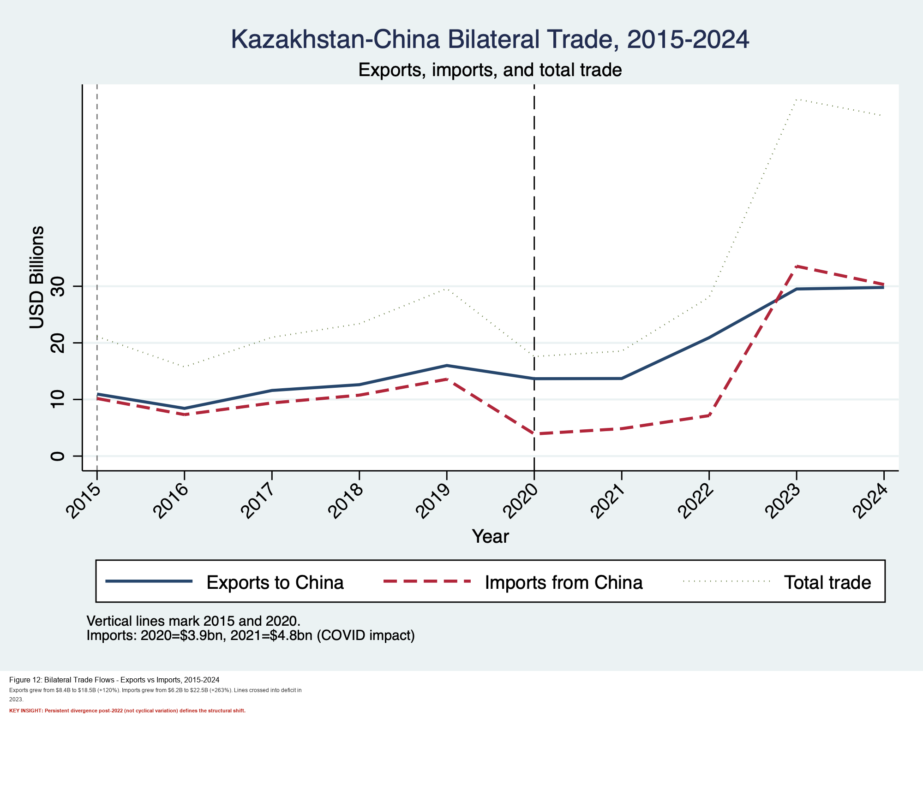

Figure II.1. Existing project figure: Kazakhstan-China trade flows (2015-2024).

II.2 The 2023 Trade Snapshot and Structural Asymmetry Established

The 2023 aggregate trade figures provide a precise baseline for understanding the structural position Kazakhstan occupies within its three primary partnerships. Kazakhstan's total exports reached US$78.7 billion and total imports reached US$61.2 billion, yielding a national trade surplus of US$18.5 billion. These figures reflect both the commodity dependence of the export base and the structural openness of the Kazakhstani economy, with exports representing 34.5% of GDP and imports 27.5%. The top five export destinations were Italy at US$14.8 billion (18.8%), China at US$14.8 billion (18.7%), Russia at US$9.8 billion (12.4%), Turkey at US$4.0 billion (5.0%), and Uzbekistan at US$3.1 billion (4.0%). On the import side, China led at US$16.8 billion (27.4%), followed by Russia at US$16.2 billion (26.5%), Germany at US$3.2 billion (5.1%), and the United States at US$2.6 billion (4.2%).

The most revealing structural feature of this 2023 snapshot is that Kazakhstan ran bilateral trade deficits with its two largest import partners. The deficit with China stood at US$2.0 billion and with Russia at US$6.4 billion. Meanwhile, it ran surpluses with lower-income regional partners such as Turkey at positive US$1.9 billion and Uzbekistan at positive US$1.9 billion. These deficits are not incidental. They reflect Kazakhstan's entrenched structural position as a raw material exporter and manufactured goods importer, a position that constrains economic upgrading and deepens asymmetric interdependence with both Beijing and Moscow simultaneously. By 2024, the bilateral Kazakhstan-China trade figures had nearly converged: exports totaled US$29.79 billion, imports US$30.31 billion, leaving a narrow deficit of US$0.51 billion that would widen dramatically in 2025.
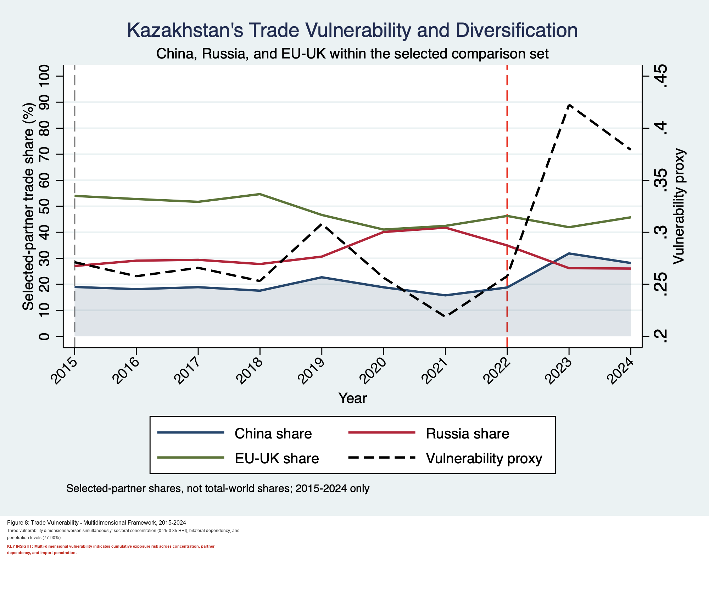
Figure II.2a. Existing project figure: multivector trade-share dynamics.
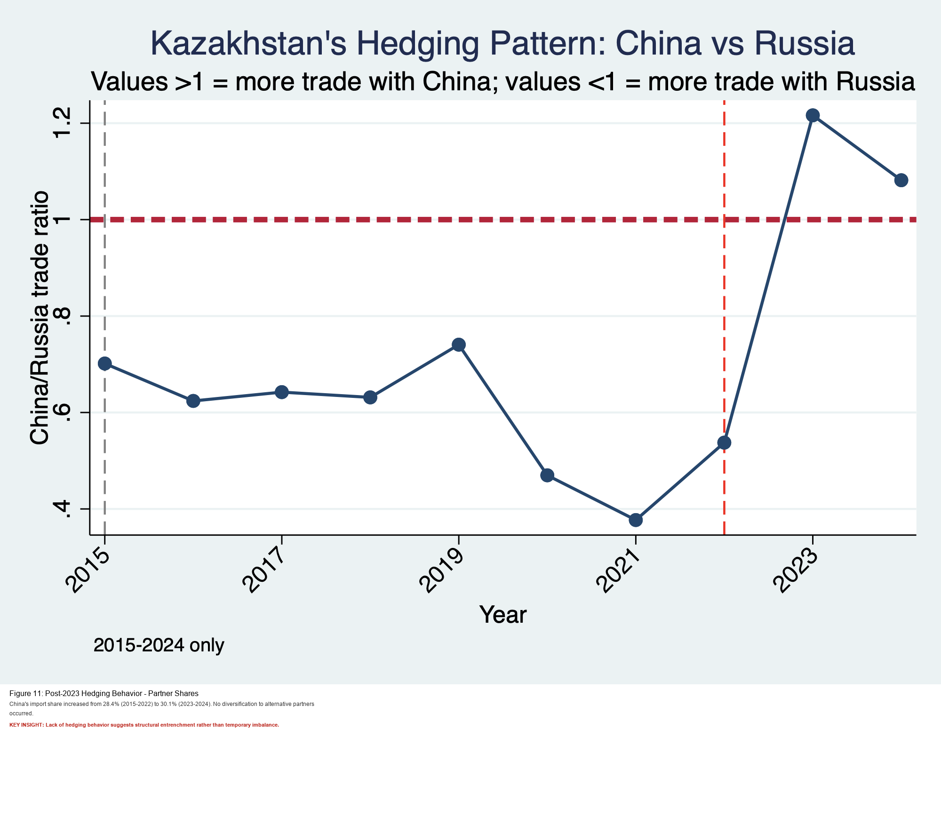
Figure II.2b. Existing project figure: China-Russia comparative trade orientation.
III. STRUCTURAL FEATURES OF SINO-KAZAKH TRADE

III.1 China's Rise to Trade Primacy: The Graph in Context

The Kazakhstan-China Bilateral Trade graph covering 2015 to 2024 (Figure II.1) captures three analytically distinct phases of the bilateral relationship that correspond directly to the structural and geopolitical forces shaping the broader study period. Reading the graph through the lens of the paper's central argument reveals a trajectory that cannot be explained by market forces alone.

The first phase, from 2015 to 2019, is one of relative stability and near-symmetry. Both Kazakhstani exports to China (the solid blue line) and imports from China (the red dashed line) remain in the range of roughly US$8 to US$14 billion, with total trade hovering around US$18 to US$25 billion. Exports from Kazakhstan to China even showed a mild upward trend across this period, driven by growing Chinese industrial demand for copper and petroleum products. This phase corresponds to the early BRI investment period, during which the diplomatic infrastructure of the relationship was being constructed but had not yet generated the asymmetric commercial dynamics that would define the post-2020 era. It is the period most consistent with the scholarly assessments that Kazakhstan had retained meaningful trade autonomy.

The second phase, 2020 to 2021, constitutes a structural inflection point driven by the COVID-19 pandemic. The graph registers a sharp contraction in imports from China, falling to US$3.9 billion in 2020 and recovering only partially to US$4.8 billion in 2021. Kazakhstani exports also declined, though less dramatically, reflecting the inelastic nature of Chinese demand for raw material inputs relative to the more discretionary categories of consumer goods imports. The asymmetric recovery pattern is analytically significant: Kazakhstani exports to China rebounded faster than imports did, suggesting that China's industrial sector prioritized securing raw material supply chains during the pandemic disruption period, while its consumer goods export activity recovered more gradually.

The third phase, from 2022 to 2024, represents the period of most acute structural concern and provides the empirical foundation for this paper's core research problem. Both exports and imports surge sharply upward following the Russian invasion of Ukraine, with total trade nearly tripling relative to 2020 levels. Crucially, however, the graph reveals that while Kazakhstani exports to China grew substantially, reaching approximately US$29.79 billion by 2024, imports from China grew at an even steeper rate, crossing the export line and generating the bilateral deficit that underlies this study's central argument. The post-2022 surge in Chinese imports into Kazakhstan is attributable not to any improvement in Kazakhstan's competitive position as a trading partner but to the combination of Northern Corridor rerouting, Chinese manufacturers filling market space vacated by sanctioned European and Russian suppliers, and the rapid expansion of Chinese automotive brands into the Kazakhstani consumer market.
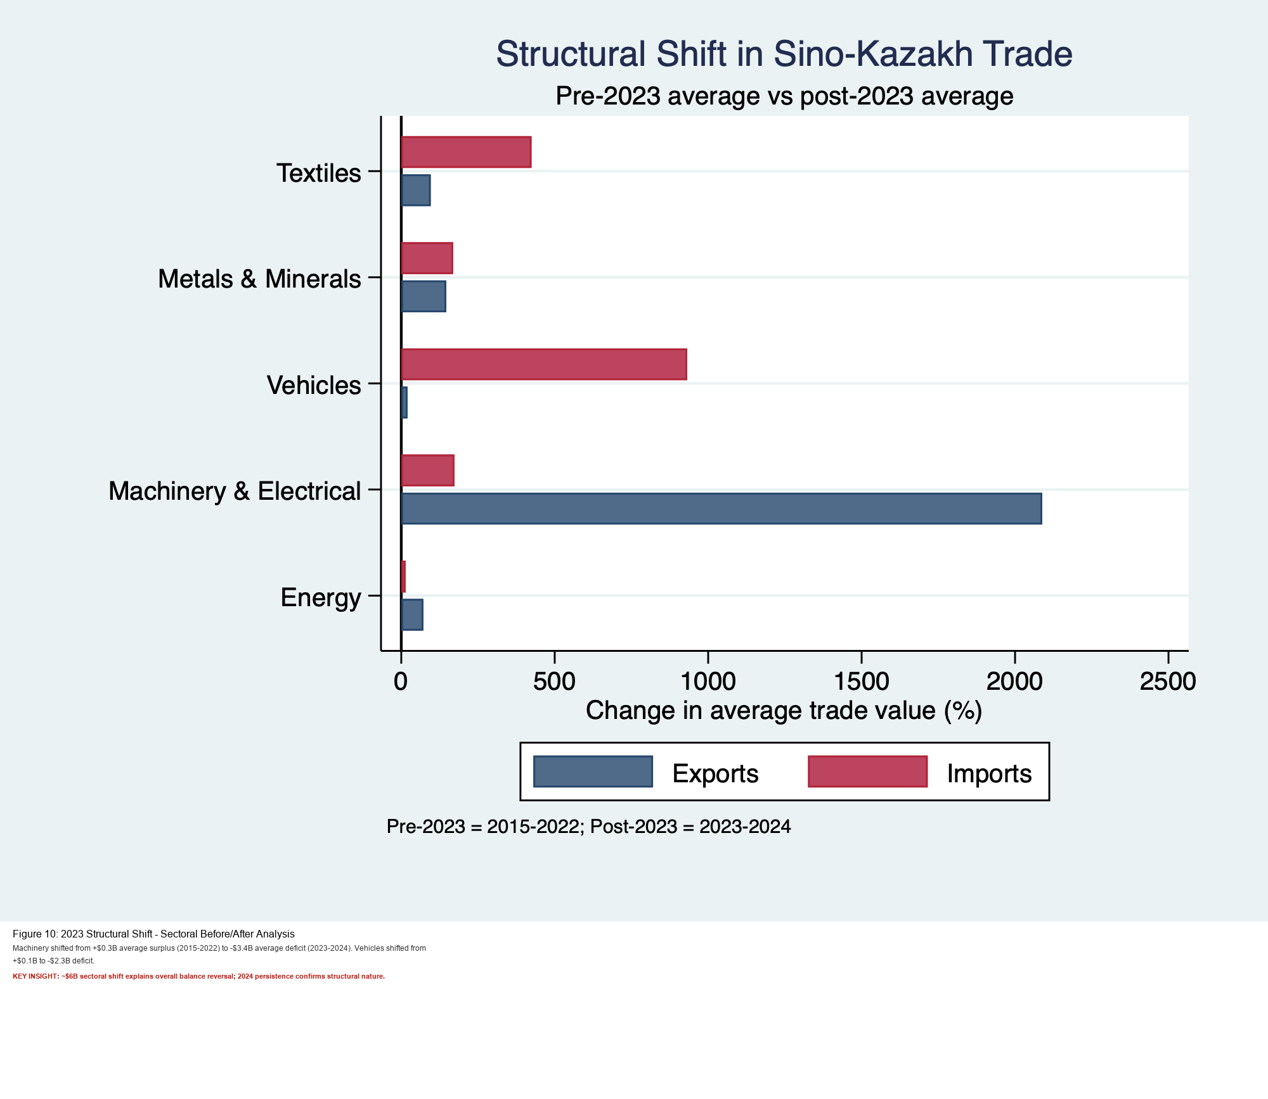
Figure III.1. Existing project figure: 2023 structural shift timing.

III.2 Sectoral Composition: The Commodity-Manufacture Nexus

The product composition of bilateral Sino-Kazakh trade reveals a persistent and deepening divergence between the complexity of goods exchanged in each direction. Kazakhstan's export basket to China is dominated by low economic complexity commodities, concentrated in extractive industries where value addition occurs primarily through geological endowment rather than productive transformation. In September 2025, China's main imports from Kazakhstan were concentrated in Gold at US$850 million, Radioactive Chemicals at US$239 million, and Copper Ore at US$218 million. Across the broader 2024 period, copper ore and refined copper together accounted for over US$5.5 billion in exports, while crude petroleum contributed US$1.89 billion. This product concentration means that Kazakhstan's export revenues to China are fundamentally determined by global commodity prices set in markets beyond Astana's control and by Chinese industrial demand dynamics that Kazakhstan has no institutional mechanism to shape.
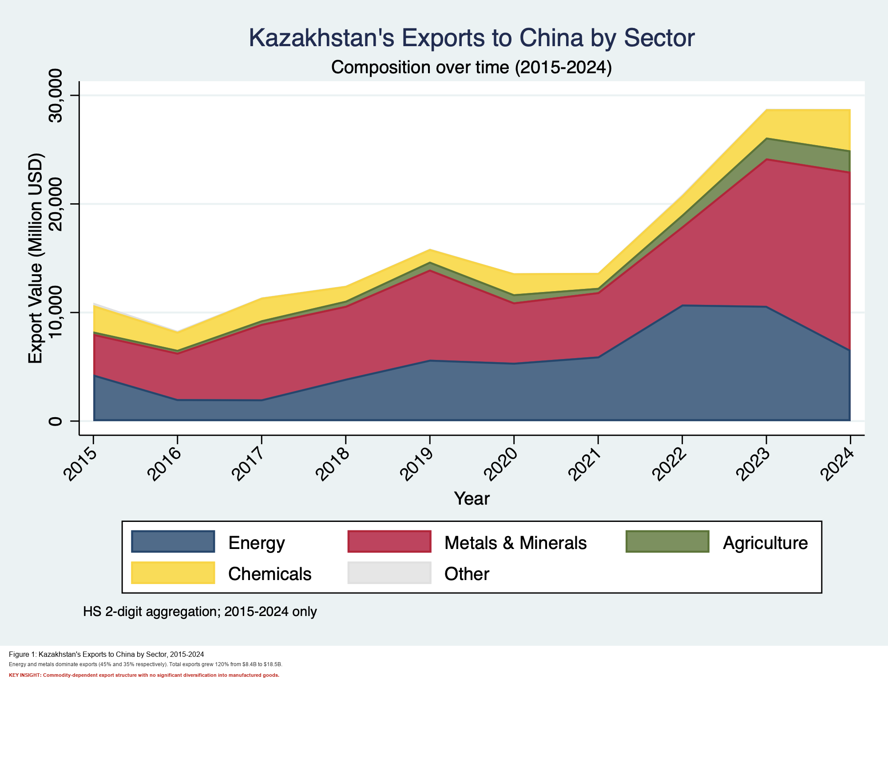
Figure III.2a. Existing project figure: export composition with China.
China's export basket to Kazakhstan presents a diametrically opposite profile of industrial sophistication. Primary exports from China to Kazakhstan in September 2025 consisted of Cars at US$234 million and Telephones at US$87.8 million. Across the 2024 period, passenger vehicles accounted for US$1.05 billion, computers US$985 million, and telephones US$932 million. Chinese automotive brands including JAC Motors, Haval, and Chery have displaced European and Japanese competitors in the Kazakhstani market, supported by the BRI logistics corridor development and targeted localization incentives. This product profile is a near-textbook expression of the commodity-manufacture nexus posited in dependency and core-periphery frameworks: Kazakhstan supplies raw inputs while China captures the value-added processing and distribution rents. The bilateral trade thus constitutes an asymmetric exchange at the level of economic complexity, not merely at the level of monetary value.
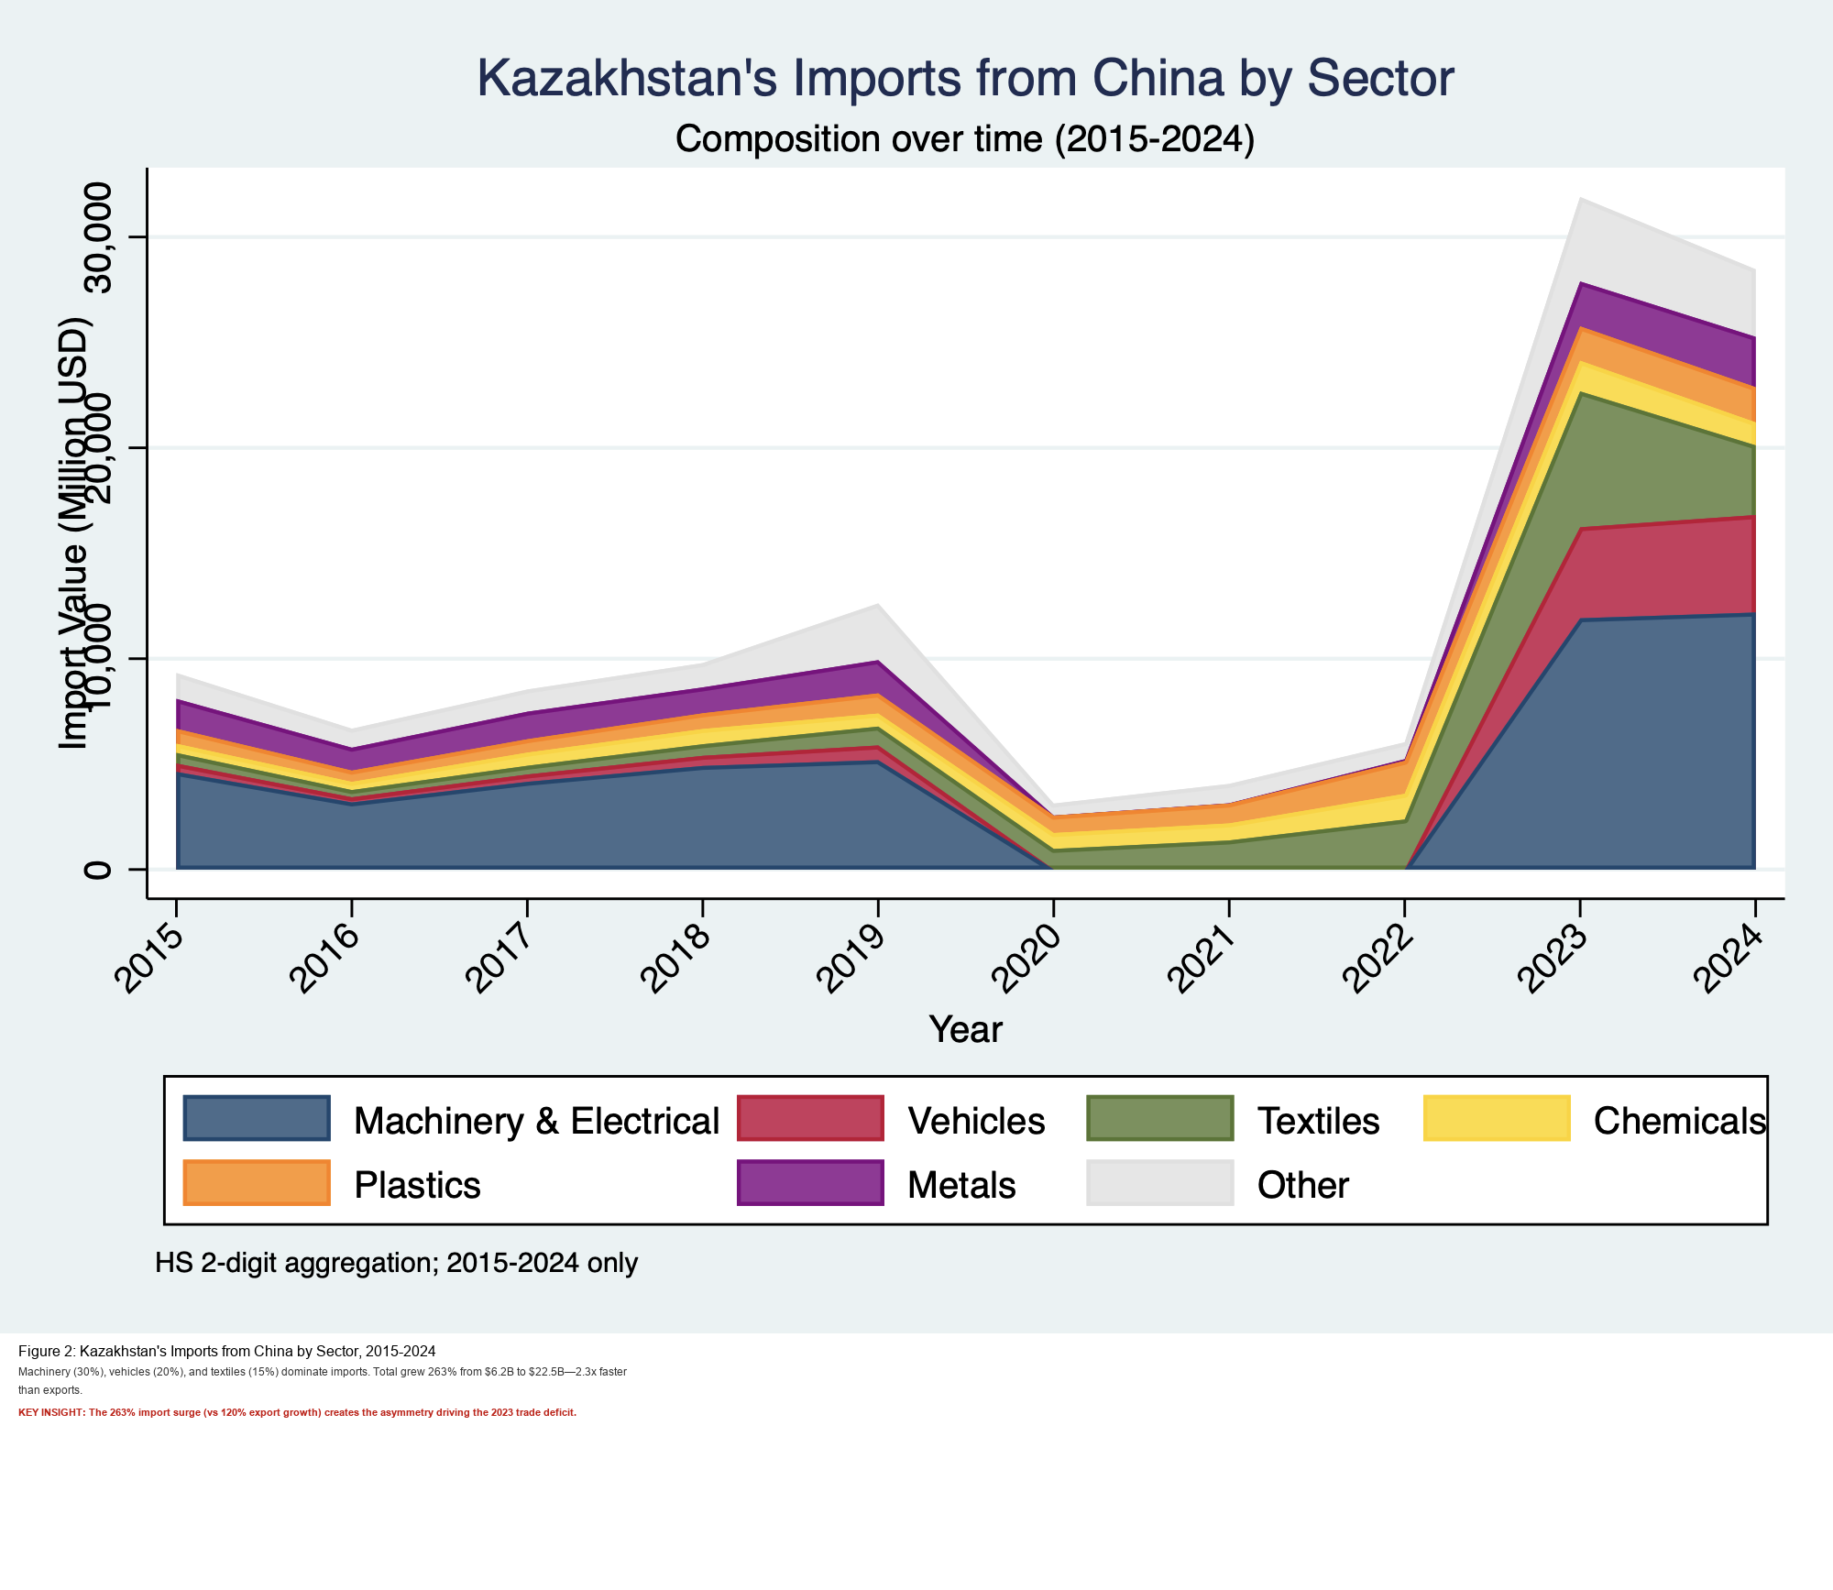
Figure III.2b. Existing project figure: import composition with China.

III.3 The Accelerating Deficit and the Collapse of the "Win-Win" Narrative

The bilateral trade balance between Kazakhstan and China shifted from a condition of relative symmetry in the mid-2010s to one of acute and accelerating asymmetry by 2024 and 2025. For much of the BRI's early period, Kazakhstan maintained a modest trade surplus with China, driven by high global commodity prices and expanding Chinese industrial demand for copper and petroleum products. This surplus provided diplomatic cover for the "win-win" narrative promoted by both governments and sustained scholarly assessments that Kazakhstan had retained meaningful trade autonomy within the BRI framework.
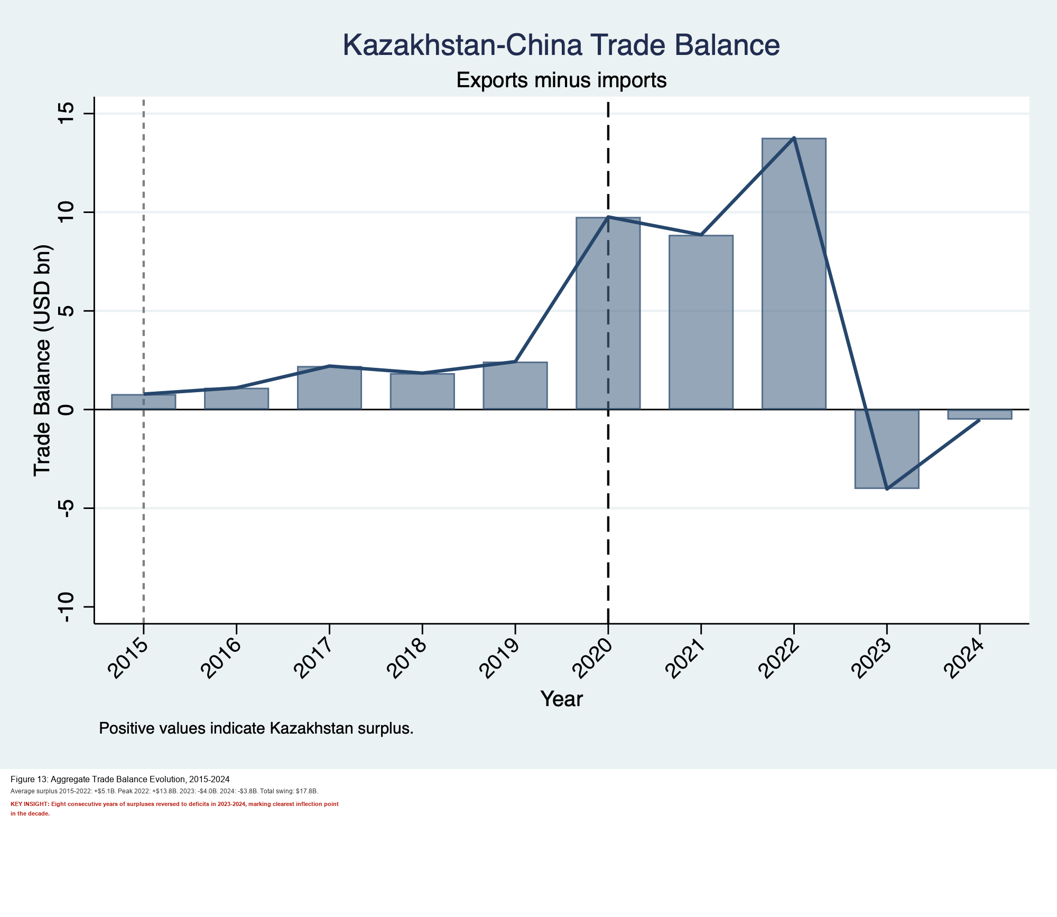
Figure III.3a. Existing project figure: trade balance dynamics.
The structural foundations of this apparent balance were, however, always fragile. Kazakhstan's surplus was a function of commodity price cycles rather than competitive productive capacity, meaning that any sustained decline in Chinese industrial demand or global commodity prices would rapidly erode the bilateral balance. This vulnerability materialized fully in 2024 and 2025. Kazakhstan's trade deficit with China escalated from US$0.4 billion across the entirety of 2024 to US$1.8 billion in the first six months of 2025 alone, representing a fourfold increase within a single year. This acceleration was driven by a 22.8% surge in Kazakhstani imports from China, primarily in vehicles and high-technology goods, combined with a 10% decline in Kazakhstani export revenues attributable to commodity price weakness and reduced Chinese industrial absorption. China's share of Kazakhstan's overall trade turnover simultaneously increased from 20.7% to 22.6% in the first half of 2025, confirming its status as an "economic magnet" whose gravitational pull is intensifying rather than stabilizing.
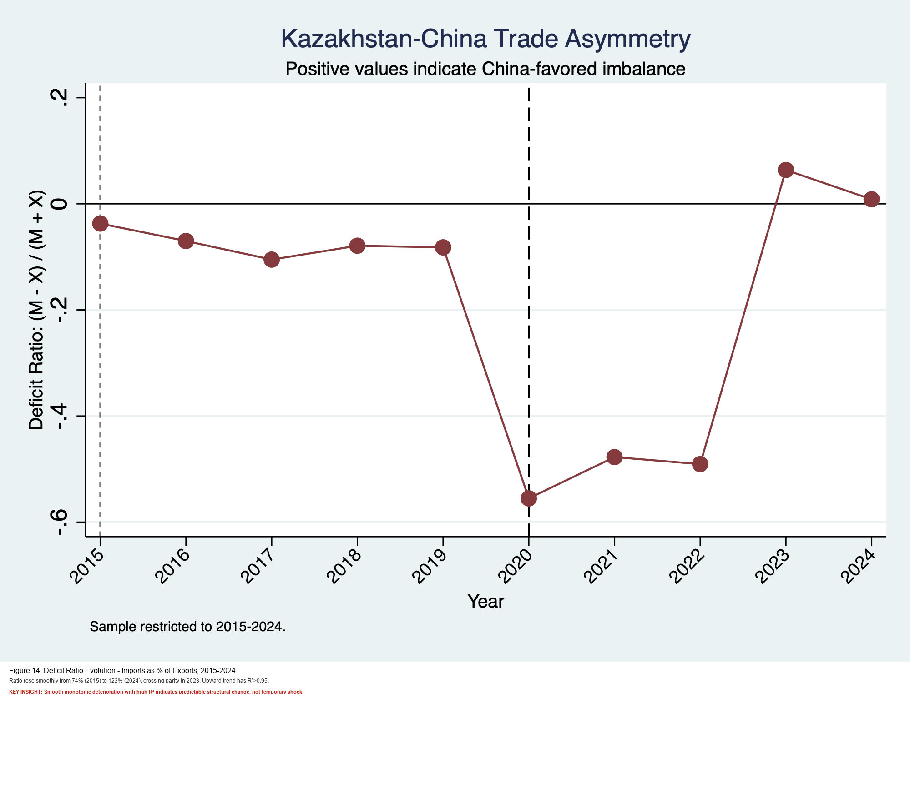
Figure III.3b. Existing project figure: deficit ratio trend.

IV. COMPARING CHINA TO OTHER PARTNERS

IV.1 China versus Russia: Structure, Integration, and Political Conditionality

The comparison between Kazakhstan's trade relationships with China and Russia illuminates the distinctive structural and political dimensions of each partnership. Russia's relationship with Kazakhstan is fundamentally conditioned by the institutional architecture of the EAEU, which creates a common external tariff, harmonized regulatory standards, and a customs union framework that integrates the two economies at the procedural level. Kazakhstan's trade with Russia is relatively diversified in product terms, encompassing agricultural goods, construction materials, processed foods, and light manufactured products in addition to energy inputs, reflecting decades of Soviet-era economic integration and shared industrial infrastructure.

China's trade relationship with Kazakhstan operates through a substantially different institutional logic. Rather than deep regulatory harmonization, the Sino-Kazakh trade framework is built upon bilateral agreements covering customs facilitation protocols, local currency settlement arrangements, and BRI-linked infrastructure co-investments that optimize transaction efficiency without creating the deep regulatory convergence characteristic of EAEU membership. This distinction carries significant analytical weight: while EAEU integration with Russia imposes mutual constraints on Kazakhstan's trade policy autonomy through shared tariff structures, the China-Kazakhstan relationship preserves greater formal policy flexibility while generating deeper structural economic dependencies through investment concentration and market penetration dynamics. Furthermore, China's post-2022 status as the primary beneficiary of Northern Corridor disruption means that it absorbed market share previously held by Russian exporters in Kazakhstan's industrial inputs and consumer goods markets, without taking on the corresponding political and regulatory obligations that came with EAEU membership.

IV.2 China versus the European Union: Technology Content, Standards, and Investment Quality

Kazakhstan's trade relationship with the European Union represents the most technologically asymmetrical of its three primary partnerships but also the relationship most likely to generate productive upgrading pressures on Kazakhstani exporters. EU imports into Kazakhstan consist of capital goods, pharmaceutical products, precision machinery, and specialized industrial equipment carrying significantly higher technological complexity than their Chinese counterparts. These are governed by European standards and certification requirements that, when met by Kazakhstani producers, facilitate market access to the world's largest single-market bloc. Kazakhstan's exports to the EU are concentrated in crude petroleum and refined metals, reflecting the same commodity dependence evident in the Chinese trade relationship. However, the EU's regulatory framework, particularly its emerging Carbon Border Adjustment Mechanism and environmental governance standards, imposes an upgrading logic entirely absent from the China-Kazakhstan trade architecture.
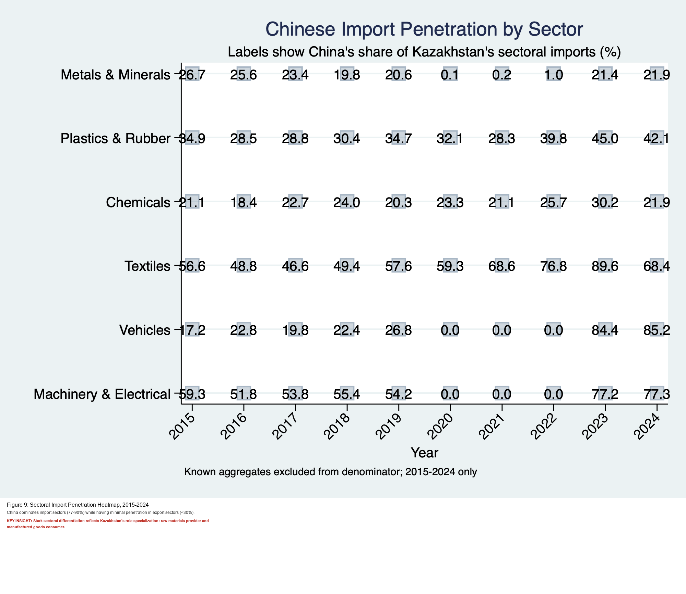
Figure IV.2a. Existing project figure: sectoral penetration comparison.
The investment dimension further distinguishes the Chinese and European partnerships. Chinese FDI in Kazakhstan reached US$11.4 billion by mid-2025, representing 32% of China's total investment in Central Asia and confirming Kazakhstan's position as the leading recipient of Chinese capital in the region. The sectoral composition of this investment has evolved across the decade: the share of extractive industries in total Chinese FDI stock declined from 68% to 54% between 2015 and 2025, while manufacturing's share grew from 13% to 22% and renewable energy expanded from 4% to 12%. European FDI, by contrast, has been more concentrated in finance, services, and technology transfer partnerships, governed by more stringent transparency, environmental, and governance standards that create institutional spillovers for Kazakhstan's regulatory development. The European model of investment offers stronger pathways for regulatory capacity-building, while Chinese investment offers larger absolute volumes and faster deployment timelines. Kazakhstan has sought to manage this trade-off by accepting Chinese finance while simultaneously pursuing EU standards alignment in key export sectors, though the pace and depth of this dual-track strategy remain subjects of ongoing policy contestation.
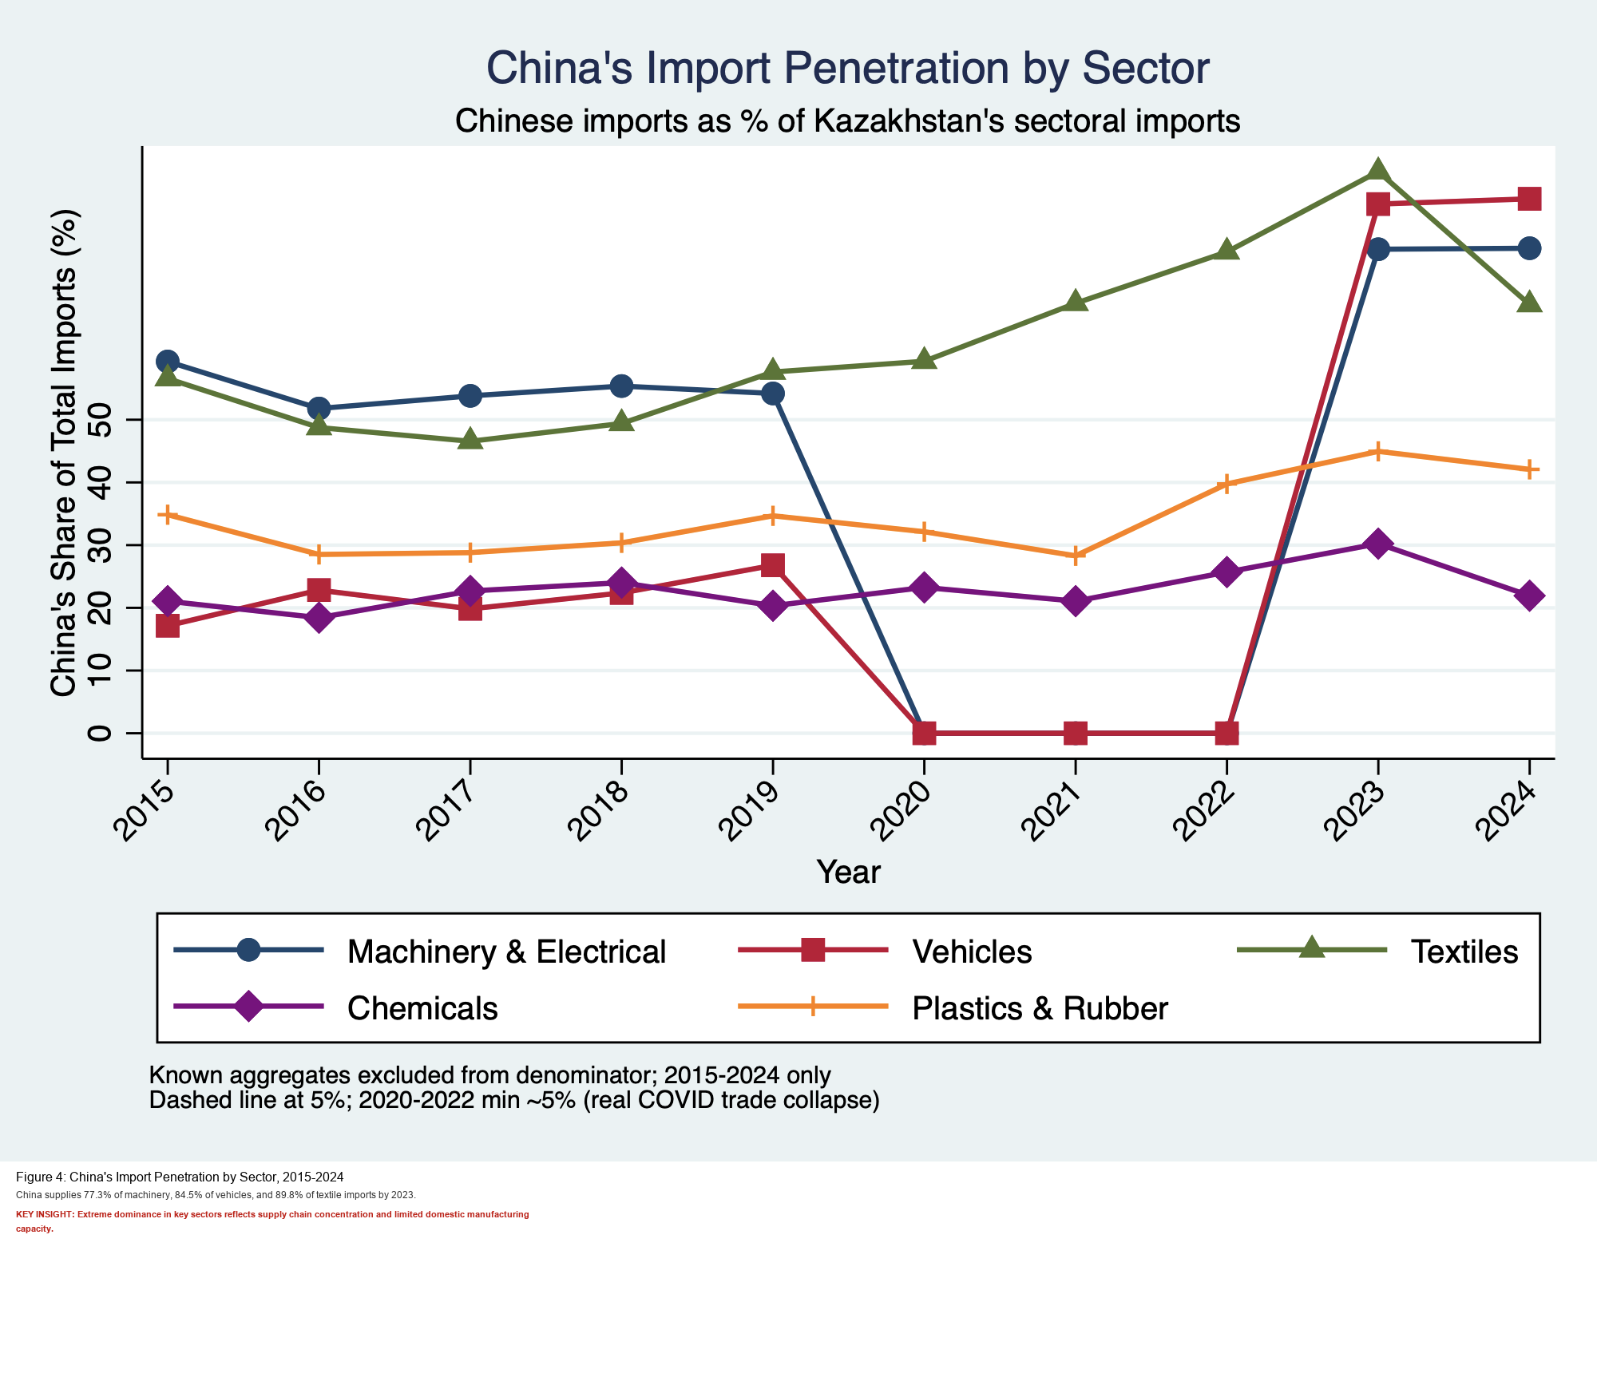
Figure IV.2b. Existing project figure: China import penetration and perceived dependency risk.
IV.3 Dependency, Deindustrialization, and Societal Constraints

The comparative analysis of Kazakhstan's trade relationships with China, Russia, and the EU converges on the question of structural risk and the degree to which each relationship constrains or enhances long-term productive transformation. Among the three major partners, the Sino-Kazakh relationship generates the most acute combination of dependency risks precisely because China's economic weight, competitive manufacturing advantage, and investment penetration operate simultaneously across multiple dimensions of Kazakhstan's economy.

The deindustrialization risk is most directly embodied in the automotive sector. Chinese automotive brands have leveraged Kazakhstan's EAEU membership to establish localization facilities that obtain "Made in Kazakhstan" certification, granting them tariff-free access to the Russian and Central Asian markets. While this has generated investment inflows and employment, it has simultaneously crowded out the development of an independent Kazakhstani automotive supply chain, with the strategic value of the arrangement accruing primarily to Chinese manufacturers accessing the broader EAEU market. This dynamic exemplifies a broader pattern in which Chinese investment instrumentalizes Kazakhstan's institutional and geographic assets to serve Chinese industrial strategy, while Kazakhstan's share of the value created remains confined to lower-complexity production segments.

Societal perceptions of Chinese economic expansion compound the political risks of structural dependency. The "warm politics, cold public" phenomenon, in which high-level diplomatic harmony coexists with deep popular skepticism toward Chinese economic presence, creates a significant constraint on Kazakhstan's ability to fully leverage Chinese investment for diversification purposes. Anti-Chinese protests, most notably the 2016 land reform demonstrations and the recurring opposition to the proposed "55 Factories" plan, reflect popular anxieties about land alienation, labor displacement, and sovereignty erosion that cannot be resolved through diplomatic communication alone. The government's response has oscillated between administrative suppression of protest movements and strategic communication campaigns promoting the developmental benefits of BRI engagement. Neither approach addresses the structural economic grievances underlying public opposition, suggesting that the societal constraints on Kazakhstani economic diplomacy with China are likely to persist and potentially intensify as the trade deficit deepens and Chinese commercial presence becomes more visible in domestic consumer markets.

IV.4 Synthesis: The Multidimensional Dependency and Its Policy Implications

Taken together, the empirical data from Sections II through IV construct a coherent picture of a bilateral relationship that has grown more commercially significant and more structurally asymmetric simultaneously. Kazakhstan is not simply a passive victim of Chinese economic expansion. Its government has actively pursued diplomatic engagement, investment attraction, and regulatory alignment strategies that have shaped the terms of the relationship. Yet the structural outcomes of this engagement, as documented in the partner share data, the bilateral product composition, the accelerating deficit figures, and the societal constraint landscape, reveal the limits of what diplomatic agency can accomplish when underlying productive capacities remain underdeveloped and commodity dependency persists as the organizing logic of the national export economy.

The trajectory charted across these three sections, from the relatively balanced multipolar trade architecture of 2015, through the structural inflection points of 2020 and 2022, to the accelerating asymmetry of 2024 and 2025, constitutes the empirical and analytical foundation upon which the subsequent sections of this paper build their assessments of diplomatic mechanism efficacy, multi-vector policy moderation, and the domestic institutional constraints that have shaped Kazakhstan's strategic choices throughout the study period.

Methodology
This study employs a mixed-methods approach combining quantitative trade analysis with qualitative institutional analysis. The quantitative component establishes empirical trends and tests basic relationships; the qualitative component explores the mechanisms through which institutional constraints limit Kazakhstan's ability to achieve economic diversification.
Data Sources and Quantitative Framework
Trade and investment data derive from the World Bank's World Integrated Trade Solution (WITS) database, covering bilateral Kazakhstan-China flows from 2010 to 2023 (n=14 years). The timeframe captures the full Belt and Road Initiative era beginning with President Xi Jinping's 2013 announcement and includes critical external shocks (the 2014-2016 oil price collapse, the 2020 pandemic, and the 2022 Russia sanctions). Product-level trade data are disaggregated using Harmonized System (HS) codes and classified as either commodity (HS Chapters 01-27 and basic metals 72-81) or non-commodity (all manufacturing, machinery, chemicals). Chinese FDI data derive from the Asian Development Bank and Kazakhstan's National Bank official statistics; commodity price data (oil, copper) are sourced from the International Monetary Fund.
Dependent variables in the quantitative analysis include the bilateral trade balance (annual exports to China minus imports from China, in millions USD) and the non-commodity export share (non-commodity exports as a percentage of total exports to China). The trade balance captures the core asymmetry claim; the non-commodity share directly measures whether institutional mechanisms have facilitated product diversification.
Independent variables include three sets of factors. First, external commodity price shocks: WTI crude oil prices (USD per barrel) and copper prices (USD per pound). These test whether trade balance deterioration reflects commodity market volatility (a structural feature predating BRI) or policy-driven changes. Second, Chinese demand conditions: China's industrial production index and China's merchandise imports as a share of GDP. These proxy for whether weakening Chinese demand explains reduced imports from Kazakhstan. Third, institutional capacity variables: Chinese FDI stock in Kazakhstan (lagged one year, in millions USD), Revealed Comparative Advantage (RCA) in non-commodity sectors, and binary indicators for major policy events (BRI announcement 2013, automotive localization roadmap 2019, Middle Corridor expansion 2022). These test whether investment and diplomatic mechanisms correlate with export performance.
Quantitative Analysis Strategy
The quantitative analysis proceeds in three steps, each addressing one research objective. First, descriptive time-series analysis documents bilateral trade balance trends and structural composition, establishing whether the claimed acceleration of the trade imbalance post-2022 is empirically supported. A Chow structural break test determines whether 2023 represents a statistically significant departure from pre-2023 dynamics, distinguishing structural shifts from cyclical variation.
Second, the analysis decomposes export growth into intensive and extensive margins. The intensive margin captures volume growth in existing product categories (exporting more petroleum, more minerals); the extensive margin captures entry into new product categories (textiles, machinery, chemicals with substantial local content). This decomposition directly tests whether BRI-era mechanisms generated new comparative advantages or merely increased commodity export volumes. If growth is overwhelmingly intensive (>80%), it indicates limited success in economic diversification regardless of absolute growth rates.
Third, a parsimonious regression model tests which factors predict trade balance variation:
Trade Balance(t) = α + β₁Oil Price + β₂China Industrial Production + β₃China FDI Stock + β₄RCA Noncommodity + β₅Policy Event + ε
This specification deliberately omits typical gravity model controls (distance, language, colonial history) because these are time-invariant and do not explain within-country variation over 14 years. Coefficient significance indicates which factors empirically matter. The model is estimated without log transformations to preserve interpretability for policy analysis. If the model's explanatory power (R²) declines substantially when 2023 is excluded, this suggests the trade imbalance is not explained by the included variables, supporting interpretation of 2023 as a structural break rather than predictable outcome.
The sample size (14 annual observations) precludes sophisticated time-series econometrics or vector autoregression. This limitation is acceptable for an IR paper: causal mechanisms are established through qualitative analysis of documents and interviews, not econometric estimation. The quantitative section's role is to document the problem, confirm it is structural rather than cyclical, and test whether observable institutional mechanisms appear to affect trade outcomes. Standard errors are adjusted for heteroskedasticity; robustness is tested by rerunning regression excluding the 2023 outlier.
Qualitative Analysis Strategy
The qualitative analysis addresses Research Objectives 2, 3, and 4 through structured document analysis and expert interviews. Documents include bilateral trade agreements, the Kazakhstan-China "Strategic Partnership" declarations (annual statements 2013-2025), the Automobile Production Development Roadmap 2019-2024, the Middle Corridor Initiative policy papers, and official announcements from Kazakhstan's Ministry of Foreign Affairs and Ministry of Trade and Integration. Content analysis focuses on: (1) stated versus actual provisions in trade agreements, (2) timeline alignment between policy announcements and observable trade shifts, and (3) institutional mechanisms designed to address trade asymmetry (customs facilitation, local currency settlement, localization requirements).
Semi-structured expert interviews (target n=8-10, pending access) with Kazakh policymakers, economists at research institutes, and diplomatic staff serve two purposes. First, they establish the government's reasoning about economic diplomacy: what constraints do officials perceive? What trade-offs exist between short-term benefit and long-term dependency? Second, they illuminate implementation gaps between policy design and outcome. For example, the automotive localization roadmap was formally adopted in 2019; interviews can establish why vehicle exports did not increase proportionally, whether constraints are demand-side (Chinese preference for domestic vehicles), supply-side (Kazakh production capacity), or political (lower priority than energy cooperation).
Regarding Research Objective 4 (non-market constraints), document analysis addresses public opposition to Chinese investment through examination of parliamentary debate records, civil society position papers, and press coverage of protests (2016 land reform controversy, 2022 anti-China demonstrations). This qualitative material cannot be quantified into a regression variable without losing essential nuance, but it can be synthesized into a narrative assessment of whether public opinion has actually constrained implementation of Chinese investment projects.
Limitations
This analysis is intentionally modest in scope. The 14-year sample size and small number of observations limit econometric inference; regression coefficients should be interpreted as associations, not causal effects. The paper does not attempt to explain all variation in Kazakhstan-China trade; rather, it identifies which observable factors are empirically significant and notes when variance remains unexplained.
The qualitative analysis, pending interview access, may be constrained by official opacity regarding trade negotiations and investment decisions. No interview guarantees unfiltered candor from government officials. To mitigate this, analysis prioritizes triangulation: claims are verified against multiple documentary sources and compared to scholarly analysis. Interview data serve primarily to understand decision-makers' stated logic rather than as proof of actual mechanisms.
Finally, this study focuses on the bilateral relationship and does not comprehensively analyze Kazakhstan's broader economic engagement with Russia, the EU, or other partners. Comparative analysis of multi-vector diversification success is limited to basic trade balance comparisons (Kazakhstan's surplus/deficit with China versus Russia versus EU). A full assessment of multi-vector policy effectiveness would require equivalent depth of analysis across all major trading relationships, which exceeds the scope of this paper.
Theoretical Approach
The paper draws on three theoretical streams relevant to understanding medium-power engagement with rising great powers. Complex interdependence theory (Keohane & Nye 1977) provides the framework for understanding why Kazakhstan cannot simply exit the relationship despite imbalances; mutual dependence in multiple channels (energy, finance, logistics, agricultural inputs) constrains options. Asymmetrical interdependence theory (Hirschman 1945, extended by contemporary scholars) explains how the state with fewer alternatives (Kazakhstan) faces structural disadvantage. Economic diplomacy literature (Seabright 2004, Okano-Heijmans 2011) offers analytical tools for assessing whether formal agreements and institutional mechanisms can offset structural imbalances.
The paper is agnostic about whether current outcomes reflect inevitable dependency (as classical dependency theory predicts) or negotiated asymmetrical interdependence (as middle-power theory suggests). Rather, the empirical analysis tests which interpretation the data support: If Kazakhstan's trade diversification improves despite commodity price volatility, it suggests agency and effectiveness of diplomatic mechanisms. If trade remains commodity-dependent and the deficit accelerates despite BRI investment and new institutions, it suggests structural constraints limit diplomatic effectiveness.

Kazakhstan’s exports to China between 2012 and 2024 demonstrate a notable structural shift in composition. While energy exports dominated in the early 2010s, their share declined significantly after 2014, coinciding with global commodity price shocks. From 2016 onwards, metals and minerals emerged as the primary export category, reflecting growing Chinese demand for raw materials, particularly within the context of industrial expansion and the Belt and Road Initiative. Although total export volumes recovered after the mid-decade downturn, the export structure remains highly concentrated in resource-based sectors, with limited growth in chemicals and agriculture. This pattern indicates persistent dependence on low value-added exports and reinforces asymmetrical economic interdependence in Kazakhstan–China trade relations Figure ! .

Kazakhstan’s imports from China over the period 2012–2024 are dominated by machinery and electrical equipment, highlighting strong dependence on Chinese manufactured and high value-added goods. After a temporary decline around 2015–2016, imports show a steady upward trend, accelerating significantly after 2020. Additional categories such as vehicles, textiles, and plastics also expand in recent years, indicating growing diversification of consumer and industrial imports. However, the overall structure remains concentrated in manufactured products, reflecting a structural asymmetry in bilateral trade, where Kazakhstan imports higher value-added goods while exporting primarily raw materials (Figure 2 ).

The sectoral trade balance between Kazakhstan and China reveals persistent structural asymmetries over the period 2012–2024. Kazakhstan maintains a consistent trade surplus in energy and, increasingly, in metals and minerals, reflecting its role as a primary exporter of raw materials. However, this surplus is offset by a growing and sustained deficit in machinery and electrical equipment, as well as in vehicles, indicating strong dependence on Chinese manufactured goods. Notably, the machinery deficit deepens significantly after 2020, contributing to the widening overall trade imbalance. These trends underscore the pattern of asymmetrical interdependence, where Kazakhstan’s export strengths in resource-based sectors are counterbalanced by structural import dependence in higher value-added industries Figure 3 .

This figure presents the Sino–Kazakh Trade Asymmetry Index over time, measuring the relative dynamics of imports and exports between Kazakhstan and China. Positive values indicate that Kazakhstan’s imports from China grow faster than its exports, reflecting increasing dependence on Chinese goods, while negative values suggest relatively stronger export performance.
From 2013 to around 2019, the index remains close to zero, indicating a relatively balanced trade dynamic with minor fluctuations. A noticeable negative dip around 2020 suggests a temporary improvement in Kazakhstan’s export position. However, from 2021 onward, the index turns positive again, culminating in a sharp spike in 2023–2024. This surge signals a significant widening of trade asymmetry, where import growth substantially exceeds export growth.
Overall, the trend highlights increasing asymmetric interdependence, with Kazakhstan becoming more reliant on Chinese imports in recent years, consistent with the framework of sensitivity interdependence (Keohane & Nye) Figure 4.

Conclusion
The Kazakhstan–China economic relationship is undergoing a structural transformation marked by increasing asymmetry and dependency. The failure of multivector policy, combined with sectoral imbalances and rising import reliance, highlights the limitations of existing economic strategies.
Empirical data confirms that Kazakhstan is transitioning from a surplus-driven model to a more fragile, deficit-prone structure.
To fully understand this transformation, a multidimensional methodological approach is required. Psycholinguistic analysis uncovers how diplomacy frames economic reality, expert assessments provide strategic insights, and bibliographic analysis situates the study within broader theoretical debates.
This integrated approach contributes to advancing research on economic diplomacy, particularly for small states navigating asymmetric relationships with major powers.

REFERENCES
The following references are organized alphabetically in APA 7th edition format. References marked [2025–2026] represent the most current scholarship.

Amineh, M. P., & Li, S. (2025). The structural challenges of transnationalizing the China-led BRI: The case of Pakistan. Journal of Contemporary Asia. SAGE Publications. https://doi.org/10.1177/0169796X251369694
Anonymous Authors. (2026, January 22). China's diplomacy in Central Asia: The logic of internal politics coupled with the logic of great power competition. Journal of Contemporary China. Tandfonline. [Received: 24 August 2025; Accepted: 17 January 2026]. https://doi.org/10.1080/24761028.2026.2619803 [2025–2026]
Bitabarova, A. U. (2018). Unpacking Sino-Central Asian engagement: The case of Kazakhstan. Asian Security, 14(1), 30–55. https://doi.org/10.1080/14799855.2018.1433962
Bitabarova, A. U. (2019). Kazakhstan's perspective on the Belt and Road Initiative. Asian Studies Review, 43(4), 595–613.
Blackwill, R. D., & Harris, J. M. (2016). War by other means: Geoeconomics and statecraft. Harvard University Press / Council on Foreign Relations.
Blanchard, J.-M. F., & Flint, C. (2017). The geopolitics of China's Maritime Silk Road Initiative. Geopolitics, 22(2), 223–245. https://doi.org/10.1080/14650045.2017.1291503
Callahan, W. A. (2016). China's 'Asia Dream': The Belt Road Initiative and the new regional order. Asian Journal of Comparative Politics, 1(3), 226–243. https://doi.org/10.1177/2057891116647806
Cannon, B. J., & Rossiter, A. (2025). Rethinking and arresting Eurasian hegemony: The centrality of Central Asia to Indo-Pacific strategies. International Affairs, 101(4), 1193–1212. Oxford Academic. https://doi.org/10.1093/ia/iiaf064 [2025–2026]
Caspian Policy Center (CPC). (2023). China-Kazakhstan bilateral relations. https://www.caspianpolicy.org/research/security-and-politics-program-spp/china-kazakhstan-bilateral-relations
Castellano, A., & Castillo, R. (2024). Chinese state capital as a partner for resource-based structural transformation? The Belt and Road Initiative and downstream linkages in Bolivia and Kazakhstan. The European Journal of Development Research. Springer Nature. https://doi.org/10.1057/s41287-024-00640-1 [2025–2026]
Center for Naval Analyses (CNAS). (2024, November). Russia and China in Central Asia. https://www.cnas.org/publications/reports/russia-and-china-in-central-asia
Chen, X., et al. (2025). The influence of the Belt and Road Initiative on China's advancement in global value chains and developing economies: A systematic review. The Chinese Economy, 58(4), 87–114. Tandfonline. https://doi.org/10.1080/10971475.2025.2526259 [2025–2026]
China-Global South Project. (2026, January 13). China-Central Asia in 2026: From resource access to structured interdependence. https://chinaglobalsouth.com/analysis/2026-outlook-china-central-asia/ [2025–2026]
Clarke, M. (2015). Kazakhstan's multi-vector foreign policy: Diminishing returns in an era of great power 'pivots'? The Asan Forum.
Contessi, N. P. (2015). Foreign and security policy diversification in Eurasia: Issue splitting, co-alignment, and relational power. Problems of Post-Communism, 62(5), 299–311. https://doi.org/10.1080/10758216.2015.1026788
Cooley, A. (2018). Tending the Eurasian garden: Russia, China and the dynamics of regional integration and order. In J. Bekkevold & B. Lo (Eds.), Sino-Russian relations in the 21st century (pp. 113–139). Palgrave Macmillan.
Georgia Foundation for Strategic and International Studies (GFSIS). (2025, March). Current trends in political and economic relations between China and Kazakhstan. https://gfsis.org/wp-content/uploads/2025/03/Current-Trends-in-Political-and-Economic-Relations-Between-China-and-Kazakhstan.pdf [2025–2026]
Haji, A. A., & Khattak, S. H. (2025). Geopolitical chessboard: China's Belt and Road Initiative and shifting power dynamics. Discover Global Society. Springer Nature. https://doi.org/10.1007/s44282-025-00200-w [2025–2026]
Haji, A. A., et al. (2025). Tracing the geopolitical influence and regional power dynamics in Central Asia: A thematic analysis with neorealist perspectives. Discover Global Society. Springer Nature. https://doi.org/10.1007/s44282-025-00269-3 [2025–2026]
Human Rights Watch. (2019). 'Eradicating ideological viruses': China's campaign of repression against Xinjiang's Muslims. Human Rights Watch.
Kassenova, N. (2017). China's Silk Road and Kazakhstan's bright path: Linking dreams of prosperity. Asia Policy, 24(1), 110–116. National Bureau of Asian Research. https://doi.org/10.1353/asp.2017.0028
Laruelle, M., & Peyrouse, S. (2012). The Chinese question in Central Asia: Domestic order, social change, and the Chinese factor. Hurst & Company / Columbia University Press.
Lim, G., Tjia, L. Y.-N., & Murashkin, N. (2025). Opportunities and challenges of China's economic ties with Kazakhstan: Looking back to look forward. The Chinese Economy, 58(1). Tandfonline. https://doi.org/10.1080/10971475.2024.2373643 [2025–2026]
Louthan, T. (2022, January 6). A 'bright path' forward or a grim dead end? The political impact of the Belt and Road Initiative in Kazakhstan. Foreign Policy Research Institute. https://www.fpri.org/article/2022/01/a-bright-path-forward-or-a-grim-dead-end/
Luttwak, E. N. (1990). From geopolitics to geo-economics: Logic of conflict, grammar of commerce. The National Interest, 20, 17–23.
Mackinder, H. J. (1904). The geographical pivot of history. The Geographical Journal, 23(4), 421–437. https://doi.org/10.2307/1775498
Mercator Institute for China Studies (MERICS). (2022). Kazakhstan's three-way balancing act between competing powers is under pressure. MERICS Paper on China: Beyond Blocs. https://merics.org/en/kazakhstans-three-way-balancing-act-between-competing-powers-under-pressure
Neafie, W. (2022). Producing the Eurasian land bridge: A case study of geoeconomic contestation in Kazakhstan. Geopolitics, 29(1), 1–28. https://doi.org/10.1080/14650045.2022.2027289
Pepe, J. M. (2021). The Middle Corridor as part of China's Belt and Road Initiative: Transcontinental infrastructure, geopolitical and geoeconomic dynamics. MERICS — Mercator Institute for China Studies.
Peyrouse, S. (2012). Central Asia's evolving foreign policy: Multi-vectorism, Russia, China, and the West. PONARS Eurasia Policy Memo No. 230.
Primiano, C. B., & Kudebayeva, A. (2025). A bumpy ride for China's Belt and Road Initiative in Kazakhstan: Findings from a university survey. Journal of Current Chinese Affairs. SAGE Publications. https://doi.org/10.1177/18681026231211354 [2025–2026]
Rolland, N. (2017). China's Eurasian century? Political and strategic implications of the Belt and Road Initiative. National Bureau of Asian Research. ISBN: 978-1-939131-50-8
Rustenova, E., et al. (2024). Opportunities for Kazakhstan's agricultural exports to the Chinese market. Journal of Eastern European and Central Asian Research, 11(5). https://ieeca.org/journal/index.php/JEECAR [2025–2026]
Stronski, P. (2022). Kazakhstan navigates its great power dilemma. Carnegie Endowment for International Peace. https://carnegieendowment.org/2022/03/31/kazakhstan-navigates-its-great-power-dilemma
Stronski, P., & Sokolsky, R. (2024, May). China, Russia, and power transition in Central Asia. Foreign Policy Research Institute (FPRI). https://www.fpri.org/article/2024/05/china-russia-and-power-transition-in-central-asia/ [2025–2026]
Summers, T. (2016). China's 'New Silk Roads': Sub-national regions and networks of global political economy. Third World Quarterly, 37(9), 1628–1643. https://doi.org/10.1080/01436597.2016.1153415
United Nations Conference on Trade and Development (UNCTAD). (2023). World Investment Report 2023: Kazakhstan Country Profile. United Nations.
Vanderhill, R., Lutsevych, O., & Buras, P. (2021). How Kazakhstan is navigating its relations with China. International Affairs, 97(5), 1337–1354. https://doi.org/10.1093/ia/iiab094
Wikipedia Contributors. (2026, February). China–Kazakhstan relations. Wikipedia, The Free Encyclopedia. https://en.wikipedia.org/wiki/China%E2%80%93Kazakhstan_relations
World Bank Group. (2020). The Belt and Road Initiative: Kazakhstan country case study. World Bank. https://documents.worldbank.org/curated/en

suggestions
There is no strong methodology that can support your argument; there are only some graphs which are also taken from other sources. I think you must add some equations, such as, comparative advantage, trade intensity index, or revealed comparative index, which can show how important two countries are for each other and what the future outcomes are.

Kazakhstan’s imports from China over the period 2012–2024 are dominated by machinery and electrical equipment, highlighting strong dependence on Chinese manufactured and high value-added goods. After a temporary decline around 2015–2016, imports show a steady upward trend, accelerating significantly after 2020. Additional categories such as vehicles, textiles, and plastics also expand in recent years, indicating growing diversification of consumer and industrial imports. However, the overall structure remains concentrated in manufactured products, reflecting a structural asymmetry in bilateral trade, where Kazakhstan imports higher value-added goods while exporting primarily raw materials .

